Running Title: Diet quality declines for US fish predators

Diet breadth and quality is declining for many fish predators in the warming Northeast US Continental Shelf

Nathan T. Hermann^{1*}, Andrew J. Allyn², Carly S. Lovas², Mark J. Wuenschel³, Brian E. Smith³, Katherine E. Mills², Nathan B. Furey¹

¹University of New Hampshire, Department of Biological Sciences, Durham, NH, USA
²Gulf of Maine Research Institute, Portland, ME, USA
³National Marine Fisheries Service, Woods Hole, MA, USA

*Corresponding Author: Email: Nathan.Hermann@unh.edu; Phone: (563) 543-9451

Supplemental Materials 1

Methods
Warming water temperature has the potential to influence fish digestion rates which would, in turn, influence observations of diet from snapshot collections. Temperature changes for fish collected in the trawl survey were identified using the in situ temperature measurements by trawl gear at the time of capture. Though they may not represent true temperature change within the area more broadly, at all times of the year, or by all species, they do capture the recent temperatures experienced by fish for which diet observations exist. A simple linear regression was fit to these aggregate data for both the spring and fall surveys to identify a change over time which was used for all species in simulations.
To account for impacts of these observed water temperature changes on observations of relative consumption and the percentage of stomachs found empty, an investigation into gastric evacuation rates was conducted through two simulation procedures. First, a simulation of daily ration under historical and more modern temperatures was conducted for comparison to observations of relative consumption. The model developed by Eggers (1979) estimates a ration consumed daily with the formulation:
(1) $C_{24 }=$24S̄R
where S̄ is the average weight of stomach contents and R is the instantaneous rate of gastric evacuation. Through this, it can be seen that S̄ and R are inversely proportional to each other and, to maintain a constant ration, must be balanced, i.e., of equal magnitude in opposite directions. Thus, regardless of initial values for either variable, a balanced change in both will result in constant daily rations, i.e., doubling R and halving S̄ will result in an equivalent daily ration in all cases. R has been formulated in a number of ways, but among the most common is that of a power curve as:
(2) $R=ae^{bT}$
where a and b are constants that are specific to prey and species identity, respectively, and T is water temperature. In this simulation, a was assumed to be constant to isolate the effects of temperature on evacuation rates despite known variation in a driven by prey type (Durbin et al. 1983). Many values for b have been published as specific to the predator describing their temperature sensitivity (Stehlik et al. 2021). As such, simulations used both minimum (0.081) and maximum published values (0.140; Stehlik et al. 2021) as well as a proposed universal value for b (0.111; Durbin et al. 1983).
The second simulation on gastric evacuation rates sought to estimate stomach emptiness and the rate at which it would increase with warming. A curve of evacuation, Eq. 2, was generated for each annual average temperature in fall (1973 [9.74°C] and 2019 [11.41°C] shown in Figure S1) and constant values for a (0.002) and b (0.111). Curves were cutoff, meaning points beyond were not including in random sampling, at various times along the x-axis reflecting various feeding frequencies, ranging from 1.01-2x the duration to reach “empty.” A threshold of 1% was used to define emptiness in simulations though much smaller proportions did exist within the diet database without being categorized as empty. The selection of this threshold had little impact in determining the proportion of empty points due to the proportional reduction of time below the threshold by having the feeding duration relative to the time to “empty.” A random sample of individuals was generated at points along each evacuation curve, equivalent to collecting fish at random stages in evacuation for diet analyses, and the proportion of those which fall below the threshold for emptiness is recorded.
As temperatures rise, faster gastric evacuation rates result in a higher proportion of empty stomachs under equal feeding frequencies. Under average temperatures, empty stomachs increased in frequency for all feeding frequencies (Figure S2). The primary effect of feeding frequency was in defining initial percent of empty stomachs, ranging from 1% (cutoff = 1.01x) to 51.1% (cutoff = 2x). Additionally, the rate of increase differed according to these starting points, with the highest frequency (1.01x) increasing from 1.7% to 16.8% while the lowest frequency (2.0x) increased from 51.1% to 56.6% (Figure S2). The nearest initial percentage simulated by a frequency multiple was then matched with the percentage of empty stomachs observed in the earliest survey for each species. For example, a species which initially had 10% of stomachs empty in 1973 was assumed to feed at approximately 1.1x the time gastric evacuation whereas a species with 40% of empty stomachs fed at 1.65x evacuation time (see Figure S2). These frequencies were assumed to be constant across the simulation reducing any change in the percentage of stomachs found empty to the increase in temperature. The strength of this effect was then compared to the observed change in empty stomachs to evaluate if emptiness could be attributed to increasing temperature.

Results
Mean temperatures across the study region were higher across all years in Fall (1973 = 9.74°C; 2019 = 11.41°C) than in Spring (1973 = 5.94°C; 2019 = 7.52°C). A simple linear regression of bottom temperatures identifies an ~1.6°C increase in both the Spring (1.577°C; Figure S3a) and Fall (1.672°C; Figure S3b). Such an increase in temperature results in an increase in gastric evacuation rates between 13.6% (T = 1.577°C; b = 0.081) and 26.3% (T = 1.672°C; b = 0.140). The median increase in gastric evacuation (S̄ = 19.7%) was paired with declines in mean diet weight over the same time period which, if balanced, would result in consistent consumption rates. However, the proportional change in diet mass was higher than that of gastric evacuation resulting in estimates of daily ration in 2019 just 81.6% of those in 1973. The losses were greater on average in the Fall (76.0%) than in the Spring (87.3%). Accounting for both seasonal differences—in temperature and diet weight—and the range of values for b result in daily rations as low as 72.3% and as high as 91.4% of historic average temperatures.
The simulated increase in the proportion of empty stomachs was then compared to that observed for that species assuming consistent feeding frequencies. The median change in the percent emptiness across all species was 143.6% (e.g., Fall Silver Hake increasing from 24.1% to 34.6%) ranging from 117-1846% (Smooth Dogfish and Atlantic Mackerel Fall increasing from 1.0% to 18.7%). In nearly all cases (89.9%), the rate of emptiness due to temperature alone from the simulation exceeded the observed change in emptiness (Figure S4).

Supplemental Figure Legends
Figure S1. Simulations of gastric evacuation at two extremes of average fall temperatures observed by the trawl survey (Figure 1). Power curves are generated using recommended coefficients across species (a = 0.002, b = 0.111; Durbin et al. 1983). An arrow identifies the time point when curves cross the threshold of 1% remaining at which a stomach would be classified as empty with the difference (hrs) between the points on each curve being identified above the point (132 hrs). Additional ticks are added to indicate possible frequency multipliers used in simulations marking the duration to which the tail is extend.
Figure S2. Effect of temperature on the percent of stomachs simulated to be below a threshold of evacuation (empty) across frequency multipliers. Frequency is defined as the multiple of the time to reach empty for which the tail of the curve is extend; higher multiples indicate less frequent feeding. The selection of frequency multiples defines the starting point for emptiness and pairs with observed emptiness proportions in species at the start of the period. All multiples increased the percentage of emptiness with rising temperatures, but the rate declines as frequency decreases.
Figure S3. In-situ measurements of bottom temperature collected by the NEFSC trawl survey. In both seasons, a significant increase in temperature has been observed. Warming in the Fall (1.67°C) exceeded that of the Spring (1.58°C).
Figure S4. Comparisons of the observed and simulated percentage of stomachs empty based on temperature alone. Initial levels of emptiness (grey points) were used to approximate a frequency multiplier which produces similar rates of emptiness. The same frequency was provided in the final condition (black points) to isolate the effect of temperature on emptiness through gastric evacuation alone. A 1:1 line is added to illustrate that most pairs simulated more emptiness than was observed (above the line) indicating a likely change, increase, in feeding frequency.

Supplemental Figures

Figure S1
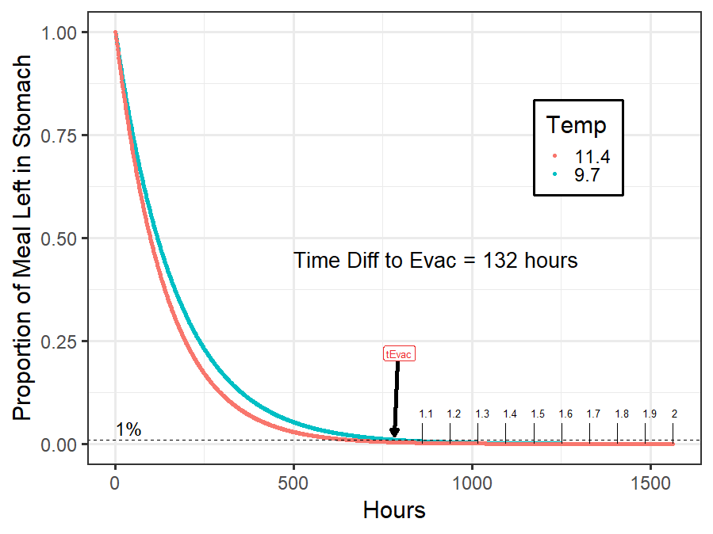

Figure S2
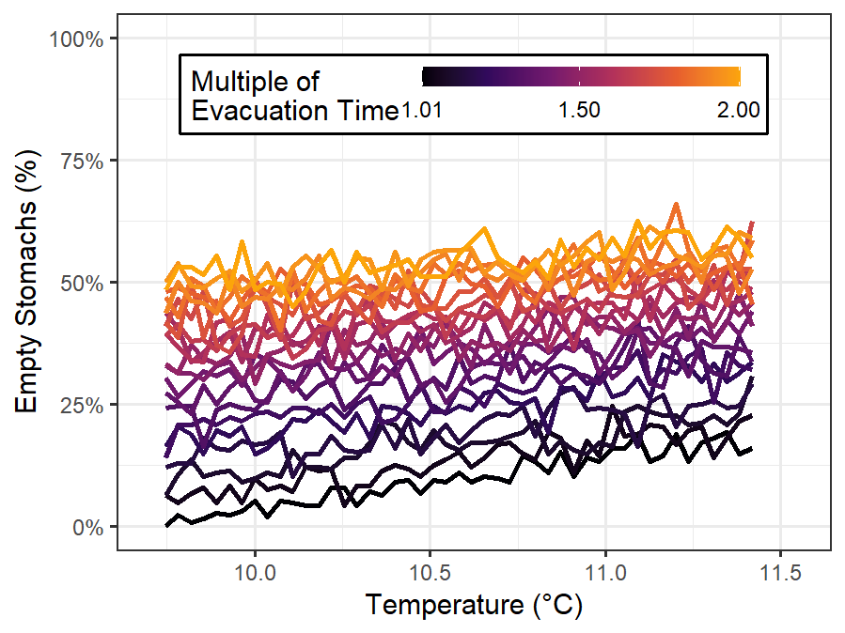

Figure S3
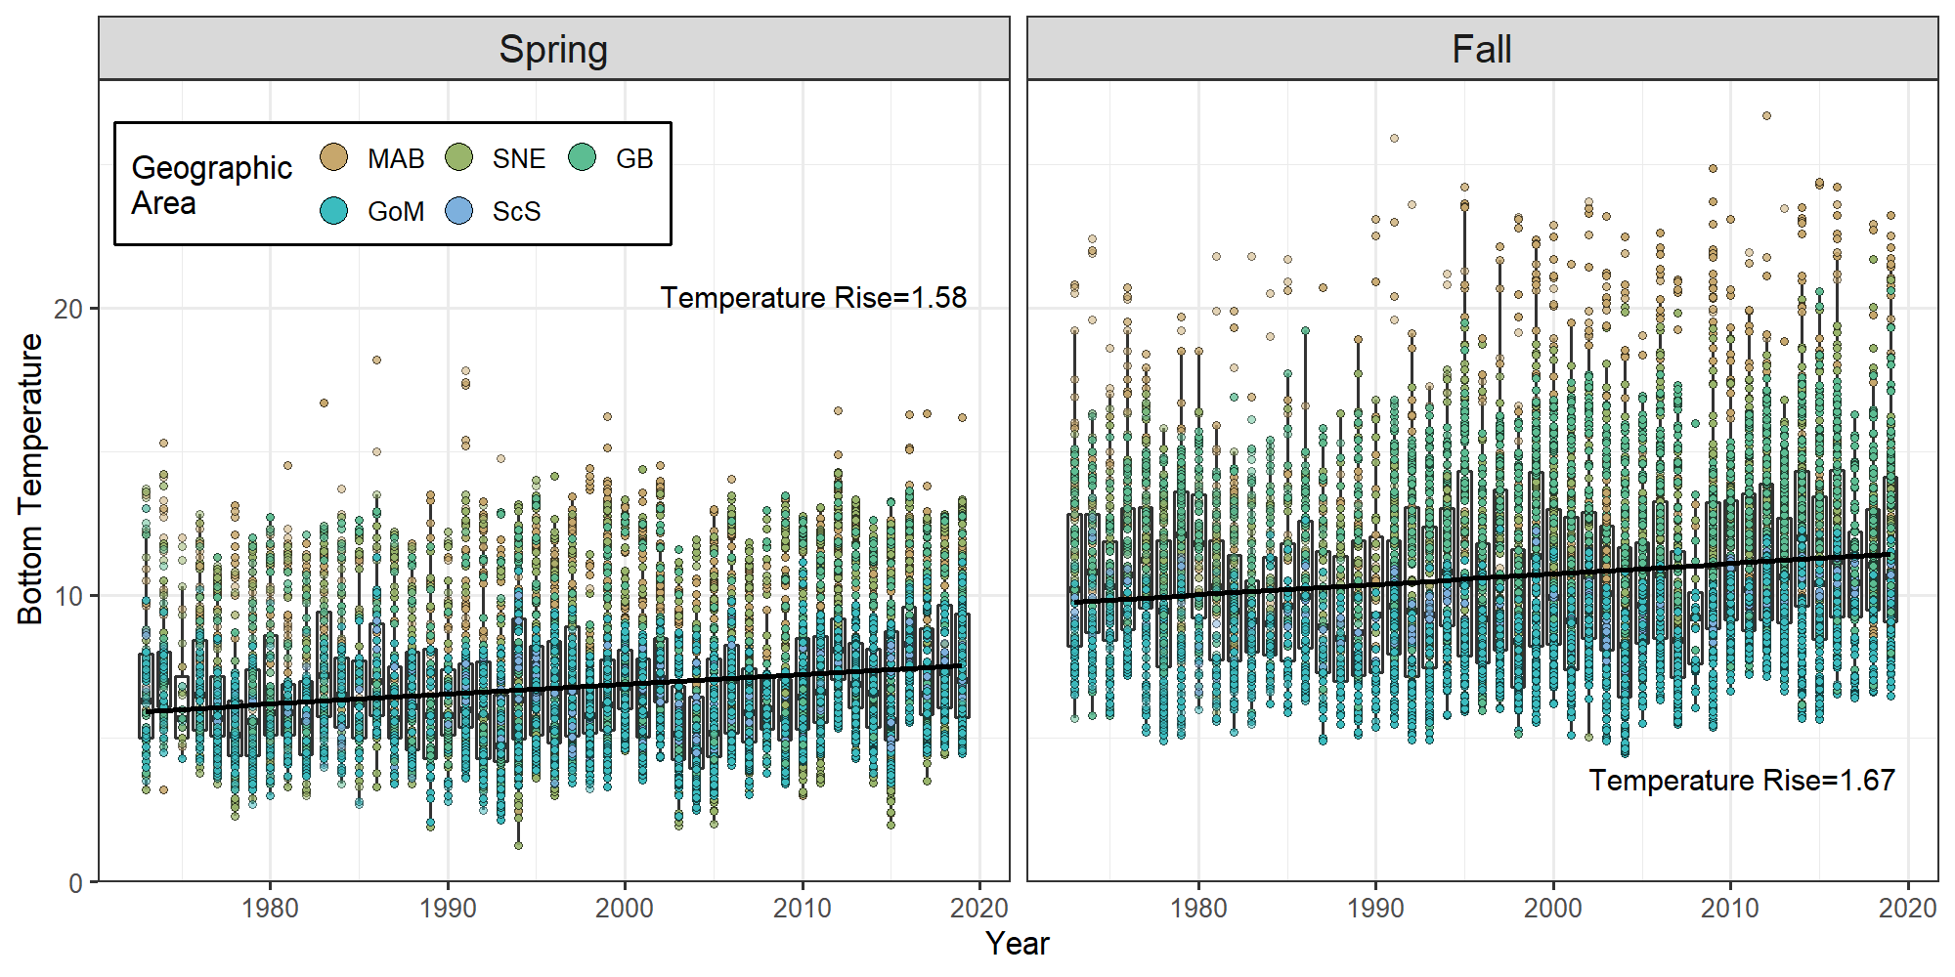

Figure S4
