~~ Get The Bread ~~

Company Logo to be determined…

By Carlysse Nycole Castro

Overview

Theme / Setting / Genre

Core Gameplay Mechanics Brief

Targeted platforms

Influences (Brief)

Story and Gameplay

Story (Brief)

Gameplay (Brief)

Assets Needed

2D

Sound

Code

# 

# 

# Overview

## Theme / Setting / Genre

* + Arcade Endless runner

## Core Gameplay Mechanics Brief

* + <Gameplay Mechanic #1>
  + <Gameplay Mechanic #2>
  + <Gameplay Mechanic #3>
  + <Gameplay Mechanic #4>

## Targeted platforms

* + Windows
  + iOS
  + Android

## Influences (Brief)

* + Crossy Roads
    - An endless arcade hopper game
    - Main gameplay of this game is going to be similar to the gameplay mechanics of Crossy Roads
  + OMORI
    - An RPG adventure indie game
    - The art-style and aesthetic of this game is going to be inspired by OMORI

# Story and Gameplay

## Story (Brief)

* + Player has been in the woods for hours and gets really hungry.
  + He does not have any food, but he sees that there are slices of fresh bread throughout the woods.
  + Player must gather all slices of bread to fulfill his hunger!

## Gameplay (Brief)

* + Player must hop through forest obstacles, rivers and avoiding poison ivy(?) , to obtain and eat slices of the bread.
  + For each level, the mission is to collect the set goal number of slices of bread in order to win the game at that certain level.
  + Player can only hop forward, backward, left, and right.

# Assets Needed

## 2D

* + Art
    - Aiming to create my own art
    - Art style inspirations:

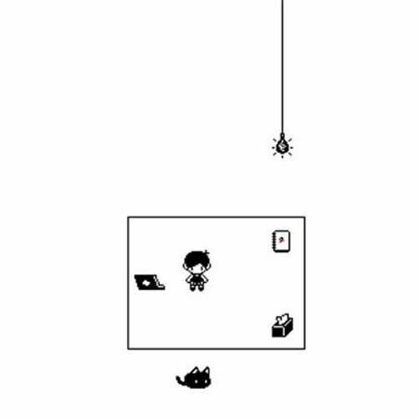

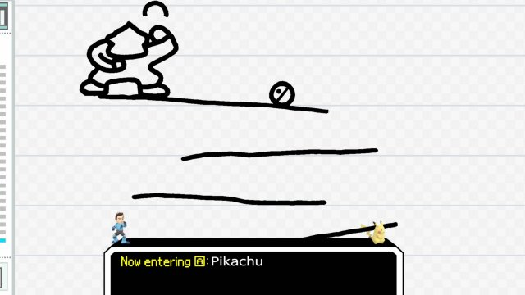

## Sound

* + Sound List (Ambient)
    - Possible background music
      * [8 Bit Adventure - By David Renda](https://www.fesliyanstudios.com/royalty-free-music/downloads-c/8-bit-music/6)
      * [Funny Bit - By David Renda](https://www.fesliyanstudios.com/royalty-free-music/downloads-c/8-bit-music/6)
      * Boss Time - By David Renda
      * 8 Bit Surf - By David Renda
      * Retro Forest - By David Fesliyan
  + Sound List (Player)
    - Character Movement Sound List
      * https://jdwasabi.itch.io/8-bit-16-bit-sound-effects-pack
    - Character Hit / Collision Sound list
      * https://jdwasabi.itch.io/8-bit-16-bit-sound-effects-pack
    - Character on Injured / Death sound list
      * https://jdwasabi.itch.io/8-bit-16-bit-sound-effects-pack

## Code (IN PROGRESS..)

* + Character Scripts (Player Pawn/Player Controller)
  + Ambient Scripts (Runs in the background)
    - Example
  + NPC Scripts
    - Example
    - etc.

## 