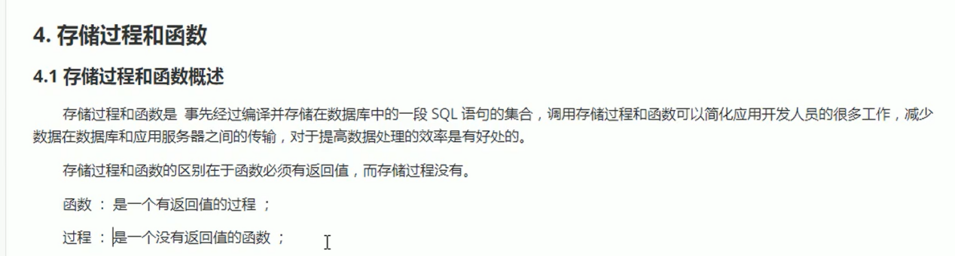

1. 创建存储过程

create procedure 存储过程的名字

begin

sql语句;

End

1. 调用存储过程

Call 存储过程的名字

1. 查看存储过程

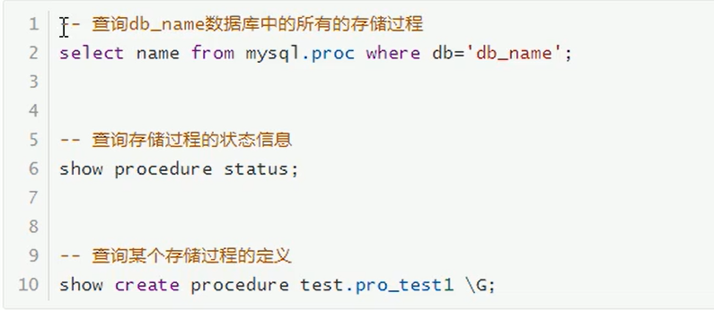

1. 存储过程的编程
2. 变量的声明

变量的作用仅在begin...end之间

DECLARE 变量名 变量类型 default 默认值

例:

create procedure test1()

begin

DECLARE age int default 20;

End

1. 变量的赋值(set)

例:

create procedure test1()

begin

DECLARE age int ;

set age=20;

End

1. if条件判断

If..then

elseif..then

else

1. case

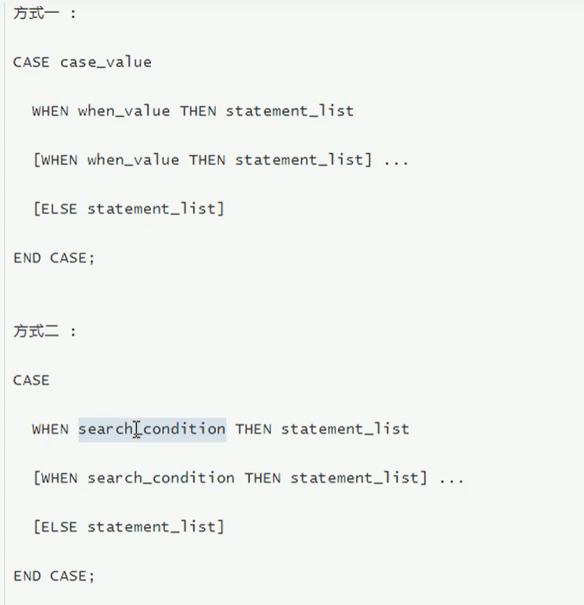

1. while循环

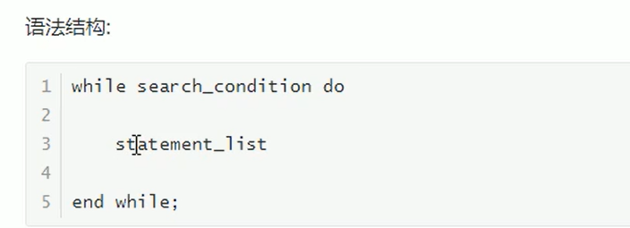

示例:从1加到n

create procedure test1(n int)

BEGIN

DECLARE num int default 1;

DECLARE total int default 0;

while num<=n do

set total=total+num;

set num=num+1;

end WHILE;

select total;

end$

1. repeat循环

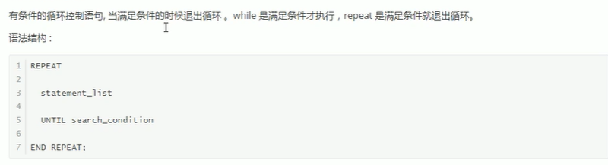

示例:从1加到n

create procedure test1(n int)

BEGIN

DECLARE total int default 0;

Repeat

set total=total+n;

set n=n-1;

Until n=0;

end repeat;

select total;

end$

1. 游标/光标

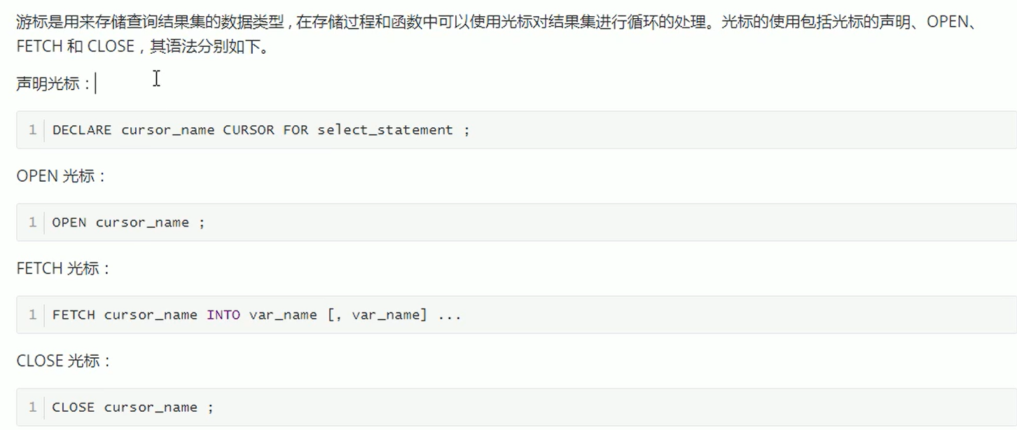

示例:输出student表的数据

create procedure student_list()

BEGIN

DECLARE id int;

DECLARE name varchar(50);

DECLARE class varchar(50);

DECLARE has_data int default 1;

DECLARE lists CURSOR for select * from student_class;

DECLARE EXIT HANDLER FOR NOT FOUND SET has_data=0;

open lists;

Repeat

fetch lists into id,name,class;

select id,name,class;

until has_data=0

end repeat;

close lists;

end$

补充:

存储函数(和存储过程类似,函数有返回值)

