1)"Smaller supplies and higher prices for food mean that the world's poor could be forced to do without,” said World Trade Organization Director-General Ngozi Okonjo-Iweala.

Sharply rising commodity prices have been the most immediate economic impact of the Ukraine conflict, the WTO says. The war also threatens supplies of essential goods from Russia and Ukraine, including food, energy, and fertilizers.

The halting of grain shipments through Black Sea ports could have “potentially dire consequences” for food security in poor countries, the World Trade Organization warns.

New COVID-19 lockdowns in China are also disrupting trade by sea. This could lead to new shortages of raw materials and higher inflation.

Three charts show the key World Trade Organization trade statistics.

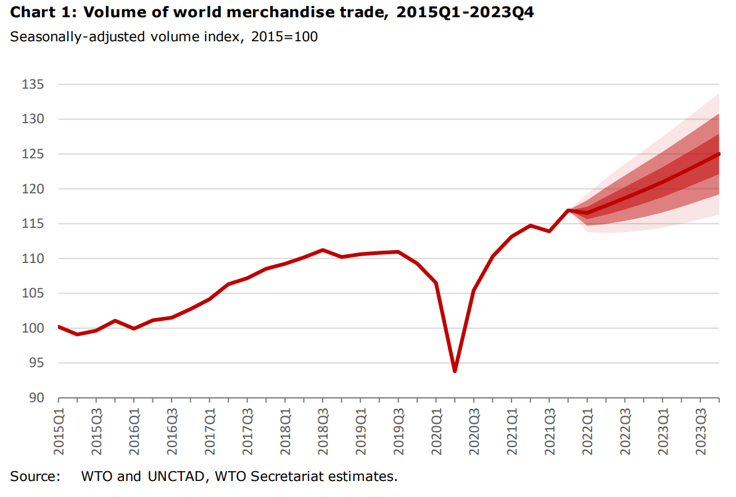

Because of uncertainty over the course of the Ukraine conflict and lack of hard data on its economic impact, WTO economists have used simulations to make “reasonable assumptions” about trade. In chart 1, they explain that growth of world merchandise trade volumes in 2022 “could be as low as 0.5% or as high as 5.5%”.

Different margins of error are shown in the chart as coloured bands.

The projections will be updated in October, or earlier if new data comes in.

In a crisis, the WTO says more trade is needed – not less – so everyone can get essential supplies. It is calling on governments and partner organizations to work together to facilitate trade.

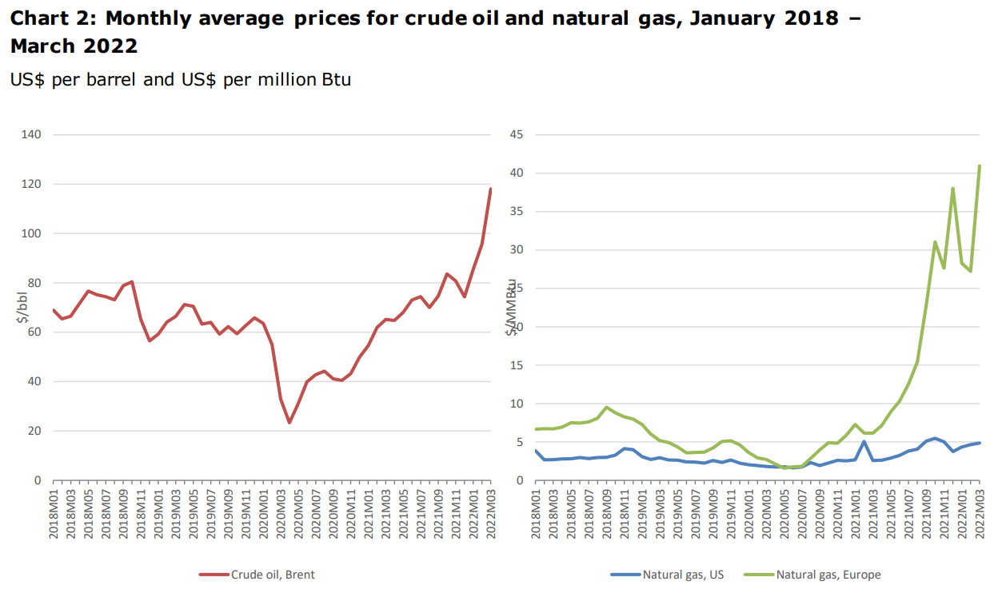

Chart 2 shows how world fuel prices have been rising rapidly. This started in 2020, before the war in Ukraine. In March 2022, a barrel of oil was $118 – 38% higher than in January 2022 and 81% up on the same time last year. Daily oil prices reached a high of $128 per barrel on 8 March, but had fallen to $104 per barrel by 1 April.

Prices for natural gas vary across regions, the WTO explains. Europe saw natural gas prices climb 45% between January and March to $41 per million British thermal units (Btu) – a measure of heat content. In the United States, on the other hand, prices have “remained relatively low,” the WTO says, at around $4.9 per million Btu.

“Higher oil prices may reduce real incomes and import demand worldwide, while higher natural gas prices would probably have a greater impact in Europe,” the WTO says.

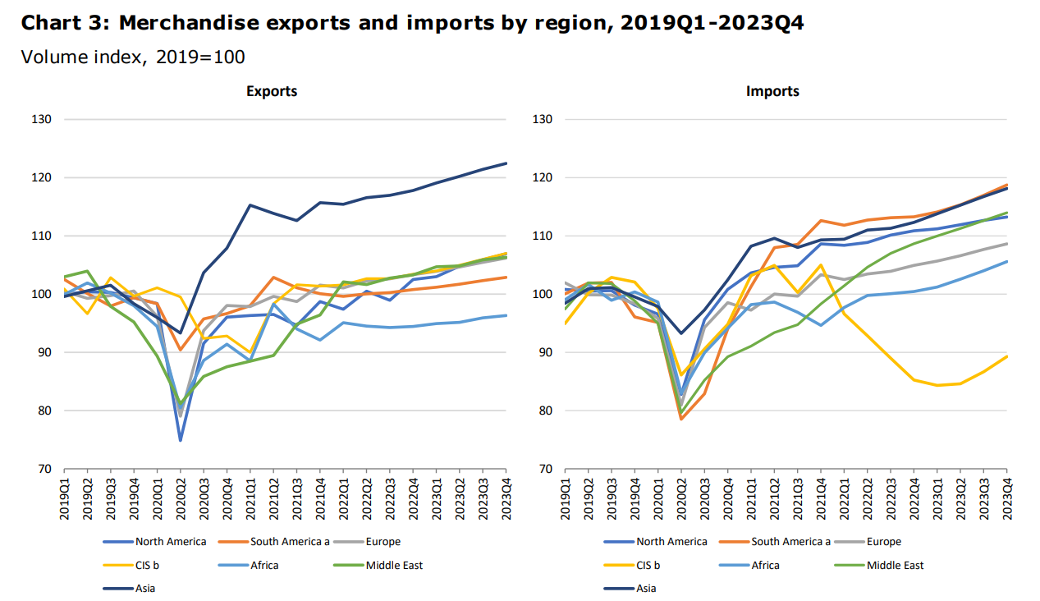

Chart 3 shows a breakdown of goods imports and exports by region, between the first three months of 2019 and the projected last three months of 2023.

“Europe is now expected to underperform on the import side,” the WTO says – along with Africa and the Commonwealth of Independent States (CIS). The CIS is a grouping of governments in Eastern Europe and Asia, including Russia, formed after the[dissolution of the Soviet Union in 1991](https://news.un.org/en/story/2022/04/1116052). This group’s under-performance is mostly due to sanctions against Russia, the WTO says.

Europe’s weakness is deepened by Ukraine being part of its country group. In Africa, low import levels are partly related to “unexpected declines” in trade in the second half of 2021, the WTO says.

For the Middle East, higher oil prices are expected to boost export revenues. This will likely increase import volumes too, as Middle East countries are able to import more.

The WTO said global trade in commercial services would also be affected by the Ukraine conflict. This includes the transport sector, which covers container shipping and passenger air transport

2) **A silver lining to reduce reliance on food imports**

While the socio-economic ramifications are already substantial and the situation remains highly unpredictable, Africa must also see the current geopolitical crisis as an opportunity to reduce its reliance on food imports from outside the Continent.

African countries need to take advantage of their 60 per cent global share of arable land to grow more food for domestic consumption and export to the global market. This would lower the number of people facing food and nutrition insecurity caused by external shocks.

**Africa’s Common Position on Food Systems**

In 2021, the African Union Commission (AUC) and African Union Development Agency-NEPAD (AUDA-NEPAD) worked with African countries to create a common African position ahead of the Food Systems Summit in line with the African Union’s Agenda 2063 and the United Nation’s Sustainable Development Goals (SDGs).

The African Common Position is a synthesis and unified view on how to transform Africa's food systems over the next decade, primarily on resilience in the face of growing vulnerability and shocks. It is anchored in the Comprehensive Africa Agriculture Development Programme (CAADP) and Malabo Declaration on Accelerated Agricultural Growth.

Rapid expansion in agricultural and food productivity and production has been identified as one of the game-changing solutions. To prevent future disruptions in the supply chain for wheat and sunflower across Africa, countries that produce these cereals need to increase their capacity to produce and supply to other countries through intra-African trade.

And those that do not should consider incorporating specific food crops into their agriculture value chain. This will reduce the reliance on wheat and grain imports from Russia and Ukraine and, most importantly, promote intra-African trade and grow Africa’s agribusiness sectors.

**African Continental Free Trade Area a lever and driver for intra-regional agri-food markets**

Another lever in transforming Africa’s food systems is the African Continental Free Trade Area (AfCFTA) which came into effect on 1 January 2021. African countries must take advantage of the world’s largest free trade area.

The trade treaty is expected to offer US$2.5 trillion in combined GDP and agribusiness will significantly contribute to this growth. The AfCFTA will increase production and value addition as well as ensure adequate quality infrastructure and food safety standards to supply and grow local and regional agri-food markets.

**The oil and gas factor**

To avoid future food price shocks caused by rising oil and gas prices on the global market, African countries must improve their oil and gas production and exploration capability to fill any gaps that may occur as a result of supply chain disruption among the major global producers.

African countries that produce fuel and gas such as Algeria, Angola, Cameroon, Republic of Congo, Egypt, Equatorial Guinea, Libya, Mozambique, Nigeria, Senegal, Sudan, and Tanzania should explore boosting production and filling the gas and oil gap within the continent and beyond to alleviate fuel price shocks, which could contribute to lower food costs.

In addition, African governments should invest in or attract greater international investment in oil and gas exploration, particularly in countries where subterranean oil reserves are believed to exist but have yet to be explored.

**2022 African Union Year of Nutrition**

The AU declared 2022 the Year of Nutrition with the main objective to strengthen resilience in food and nutrition security. The AU CAADP biennial review report of 2019 revealed that Africa is not on track to meet its goal of ending hunger by 2025, noting a deterioration in food and nutrition security on the continent since the inaugural report in 2017.

Increasing food production and expanding Africa’s food basket will serve both nutrition and resilience objectives. In this regard, there must be intentional investments toward increased productivity and production of traditional and indigenous crops. This also requires a systems approach by integrating nutrition into resilient and strong health systems and social protection systems.

**Climate resilience in Africa’s food systems**

African food systems continue to face several challenges, including extreme weather events and climate change; limited adoption of yield-increasing technologies; dependency on rain-fed agriculture and low levels of irrigation; and most recently, the spread of fall armyworm in parts of the continent.

More than 38 million more people are at risk of hunger and poverty in Africa due to climate change. Climate-resilient technologies present major opportunities for the Continent to increase African food production and productivity while building resilience and reducing poverty and hunger.

References:

<https://www.weforum.org/agenda/2022/04/ukraine-war-global-trade-risk/>

<https://www.un.org/africarenewal/magazine/may-2022/how-russia-ukraine-conflict%C2%A0impacts-africa>