Carmel Nkeshimana July 31, 2021

B068/BI21

Embedded and Mobile System/ Mobile Systems

# Introduction

One of the most well-known global technology companies in the world is Amazon Inc., which is based in the US. It has expertise in artificial intelligence, cloud computing, digital streaming, and e-commerce. Founded by Jeff Bezos in Washington on July 5, 1994.

Amazon provides a reliable online marketplace for buying and selling goods when it comes to e-commerce. And Amazon goes a long way by providing a secure way to employ a variety of technology, including mobile commerce, electronic funds transfer, supply chain management, conducting internet marketing, processing online transactions, and many other activities in that area.

# Innovation trend

In cloud computing (Amazon Web Services), Amazon Inc. makes computer system resources, particularly processing power and data storage (cloud storage), available on demand to customers without their direct active supervision. Amazon has a mechanism for sharing resources based on many locations that serve as their data center.

Amazon delivers multimedia through digital streaming (Amazon Prime Video) that is continuously given to and enjoyed by various clients, without regard to time. The most important thing a customer can do is sign up for that particular service. The greatest image quality and a variety of video-on-demand are available around-the-clock, every day.

When it comes to intelligence, artificial Amazon innovates by building a variety of highly intelligent robots and equipment. Different highly developed robots and machines handle those chores in the human place in various Amazon halls when it comes to transporting different packages in precise order or to put them in a specified spot. Amazon once more offers self-driving cars employing computer vision techniques (Zoox project)

# Innovation strategy

Through technological innovation and broad distribution, Amazon has acquired a reputation for upending well-established sectors. In terms of revenue and market share as of 2021, it is the biggest online retailer and marketplace, supplier of smart speakers, cloud computing service provider (AWS), provider of live streaming (Twitch) service, and internet firm worldwide. As the largest retailer in the world outside of China in 2021, it overtook Walmart thanks in major part to its premium subscription service, Amazon Prime, which has more than 200 million customers globally. In the United States, it is the second-largest private employer.

Amazon put a high interest in Artificial Intelligence using computer vision by developing self-driving cars and another huge one is Amazon Go.

The most actual innovation provided by Amazon is “Amazon Go” which is a technology that helps to do shopping without having any cashier or anybody in the market to look after clients.

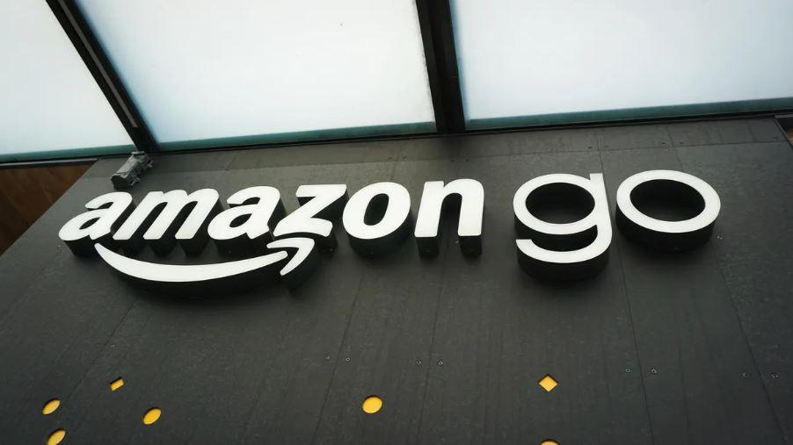

[amazon go](https://www.cnet.com/a/img/resize/47d90308c47cd29a2c17b2e6de8fe5ddd307da4d/2018/01/19/7dc289af-4771-4477-aae4-74a315373d2c/amazon-go-07378-010.jpg?auto=webp&fit=crop&height=675&width=1200)

It is a chain of convenience stores that was established in the UK and the US. Customers are able to make purchases in these largely automated cashier-less establishments without needing a self-checkout station or a cashier. Seattle, Chicago, San Francisco, London, and New York City will all have 29 open or announced shop locations by the year 2020.

Amazon executives designed and tested Amazon Go stores, building a mock supermarket measuring 15,000 square feet in a rented warehouse in Seattle before sharing their findings with the company's founder in 2015. On December 5, 2016, the first store in the company's building opened to employees. On January 22, 2018, it opened to the general public. The main store offers prepared cuisine, meal packages, a small selection of groceries, and alcohol. On February 25, 2020, a larger version of Amazon Go grocery debuted in Seattle's Capitol Hill area. The next month, Amazon started providing other merchants with its technology so that their consumers could make purchases without using cash registers or Amazon accounts.

To use this technology, Amazon Go, customers must download the Amazon Go App and create an account. Then, they must simply create an account and get a special code bar which will be scanned from their mobile phone to the entrance device before beginning the shopping. The store is equipped with ‘just walk-out technology’ and sensors and cameras that track the items that each customer picks up (and puts down again)

|  |  |  |
| --- | --- | --- |
|  |  |  |
| [image1 source](https://www.supermarketnews.com/store-design-construction/amazon-go-goes-smaller) | [image2 source](https://en.wikipedia.org/wiki/Amazon_Go#/media/File:Amazon_Go_Grocery_-_610_Pike_Street,_Seattle_-_interior_with_carts_and_shelves.jpg) | [image3 source](https://en.wikipedia.org/wiki/Amazon_Go#/media/File:Amazon_Go_in_Seattle,_December_2016.jpg) |

The bill is automatically charged to their Amazon account, so there is no need for them to scan their products as they leave the store or go through the checkout line.

This checkout-free option has the potential to completely transform the way people shop, and it has undoubtedly raised concerns among retail workers and those who are concerned about what this might mean for their jobs.

Amazon Go has the ability to completely replace conventional grocery checkouts.

The retail industry as we currently know it could be dramatically altered by this new technology. Convenience stores, where the technology has mostly been tested, are already noticing the effects, and the mass market is next.

For supermarkets, this would require significant adjustments. Not only would it do away with the need for checkout personnel, but it might also save labor expenses and increase productivity.

The retail sector is evolving, and every year, we witness an increasing number of retail establishments closing. Amazon appears to be dominating the market by remaining one step ahead of industry developments and consumer wants as we watch them open new retail locations to match the demand for their items.

Amazon Go is undoubtedly upending the market, according to Forbes, which calls it "the greatest retail innovation of the next 30 years."

The checkout step, the final source of friction in the physical purchasing process, is successfully eliminated by Amazon Go technology!

Time is precious; thus, nobody wants to spend 10 minutes in line, loading, unloading and loading their cart or basket. As a result, Amazon Go satisfies every requirement of the time-strapped modern customer.

# The impact of the Amazon Go

Watch any self-checkout line at a grocery store to observe the limitations of automation and people's technological aptitude. In general, anyone using a self-checkout station with more than four items falls and needs assistance. Similar problems will certainly arise at Amazon Go, even if the method of just walking out with your purchases may reduce friction.

For the time being, you can use the Amazon Go app to get a refund with no hassle of returns. That strategy is acceptable for a beta, but if Amazon Go scales, there will be a significant margin hit:

* Amazon Go is mostly run by a security mechanism. It goes without saying that this surveillance is required to stop theft, confirm purchases, and ultimately identify you. These possible privacy concerns don't really matter given the long queues outside the Seattle Amazon Go store, which wrap around the entire block.
* One of the biggest stories on Amazon Go's first day was that the store did not accept food assistance. The rationale is obvious: food stamps are a more complicated transaction that cannot be plugged into an app-controlled payment system. At scale, Amazon Go will be perceived as anti-poor.
* Amazon Go is destroying the concept of cashiers, and if the rest of retail follows suit (which is quite likely), many jobs will be destroyed. Amazon Go will add to the continuing debate about how automation, technology, and artificial intelligence are destroying jobs over time.

Amazon will gain a lot of money using this technology in the future.

Recommendations

Amazon though Amazon Go, can gain more benefits over several years. Using high perform algorithms for face recognition can help to improve their project on a self-driving car. Computer vision is the next level where every company must specialize. That is why it will be preferable for the company to develop self-drones that can deliver products purchased to different customers around the world.

Also using the same algorithm, amazon can improve face recognition for the diver’s company and hire them an API that can provide high precision and link with different customer accounts. This means with only a face you can unlock your account for purchasing and doing different online transactions, receive purchased products by drone, and so on.

References

[5]<https://www.zdnet.com/article/amazon-go-heres-a-look-at-the-impact-on-human-jobs-retail-innovation-amazons-bottom-line/>

[4] <https://www.adcocksolutions.com/post/is-amazon-go-store-technology-the-end-of-supermarket-checkouts#:~:text=To%20use%20Amazon%20Go%2C%20customers,(and%20puts%20down%20again)>.

[3] <https://en.wikipedia.org/wiki/Amazon_Go>

[2] <https://en.wikipedia.org/wiki/Amazon>

[1] <https://en.wikipedia.org/wiki/Amazon_Prime>