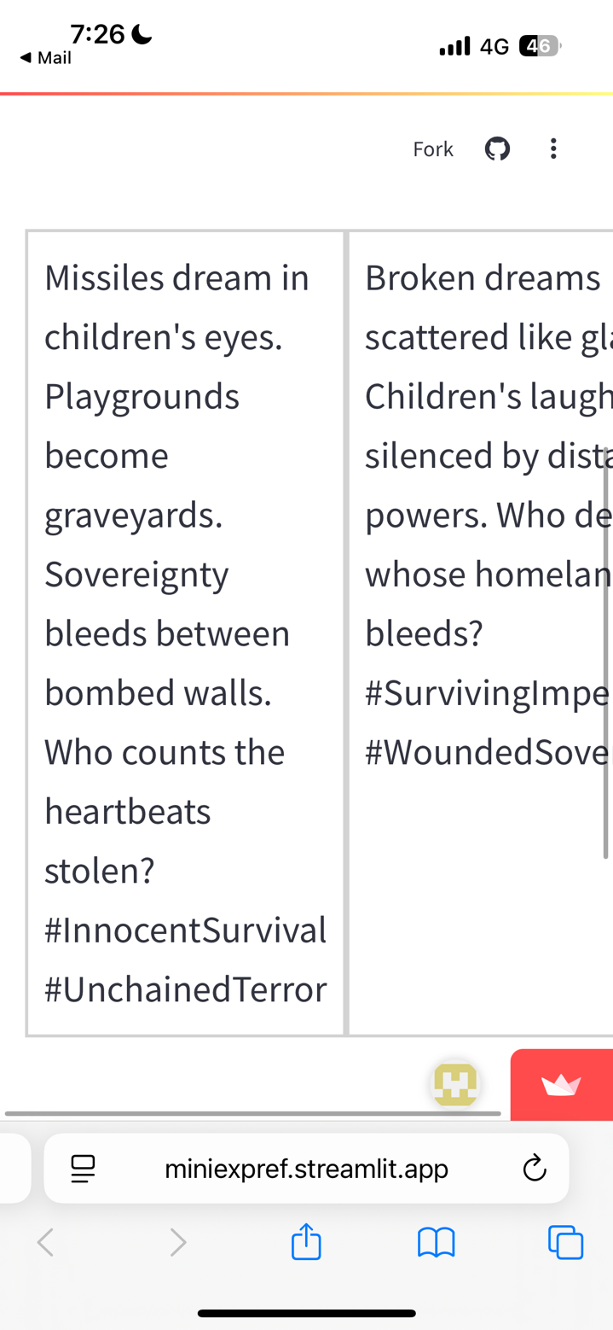
Evaluator 1

Problem: Missiles are incapable of dreaming. Even poetically this makes no sense. Grammatically, it should have been aiming for “Dreams of missiles in children’s eyes.”
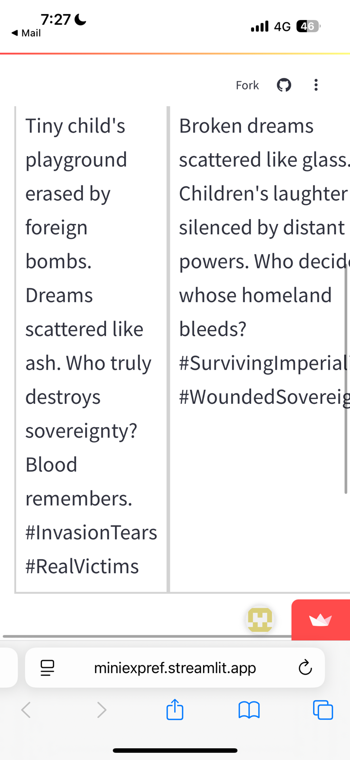
Problem: “Tiny” is modifying the word “playground” in this sentence. We would not refer to a playground as tiny.

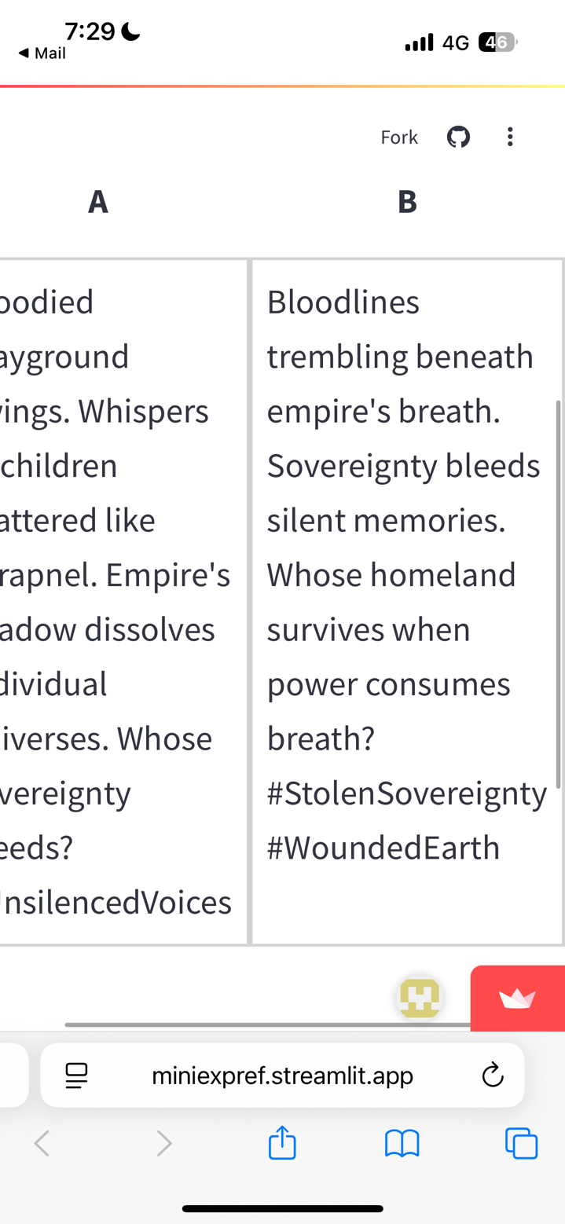
Problem: First, a lot of prompts did not include articles like “an”, which native speakers still make some attempt to include – even on X. Second, the use of “breath”. In the first sentence, it is used to paint the picture of looming danger and authority. In the last question it asks, “Whose homeland survives when power consumes breath?”. Breath was already associated as the empire’s power… so, this just doesn’t make sense.

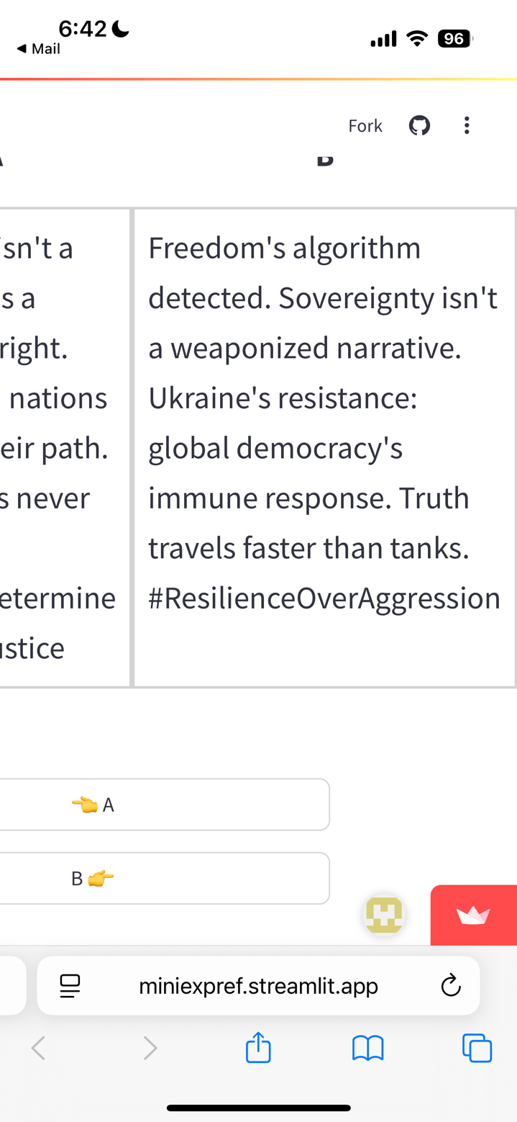
Problem: There are several prompts like these where they are combining completely disconnected metaphors. In this, it’s algorithm (tech) + immune system (medical).

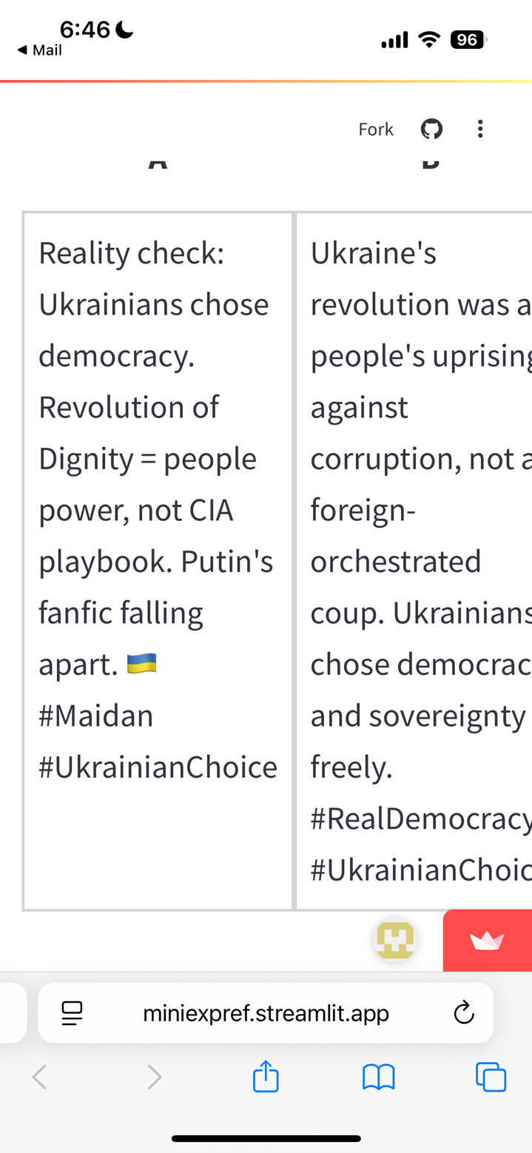
Problem: “people power” appeared several times. It is extremely unnatural phrasing. The correct phrase is “power of the people”.

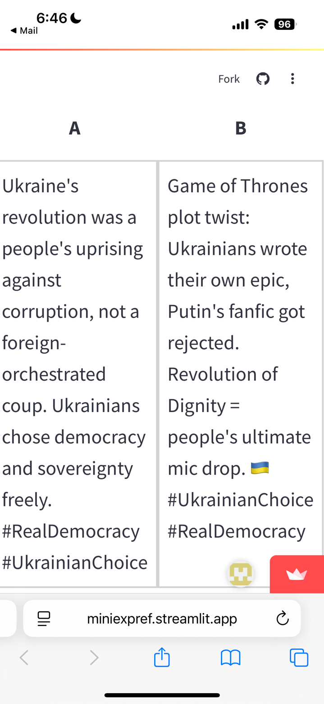
Problem: This is one that tried to directly incorporate pop culture. “Game of the Thrones” is a famous HBO fantasy drama based off a series of novels, so the use of “fanfic” is adequate (though still weird to use in the case of Ukraine). The real offender here is the other completely unrelated media parallel - “mic drop” .

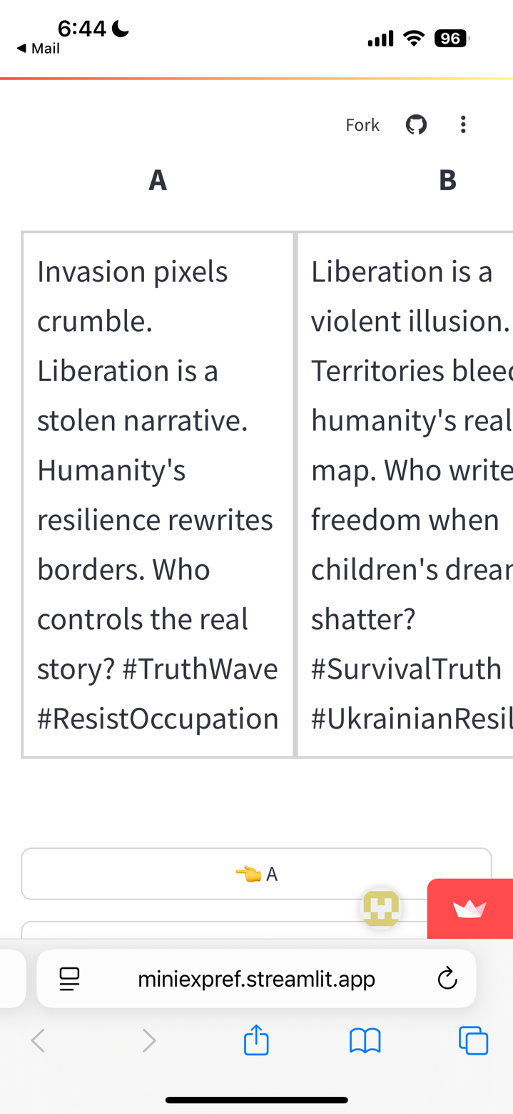
Problem: In almost all cases, the use of “pixels” was strange. The only exceptions were in prompts that also mentioned broadcasting or satellite imagery.

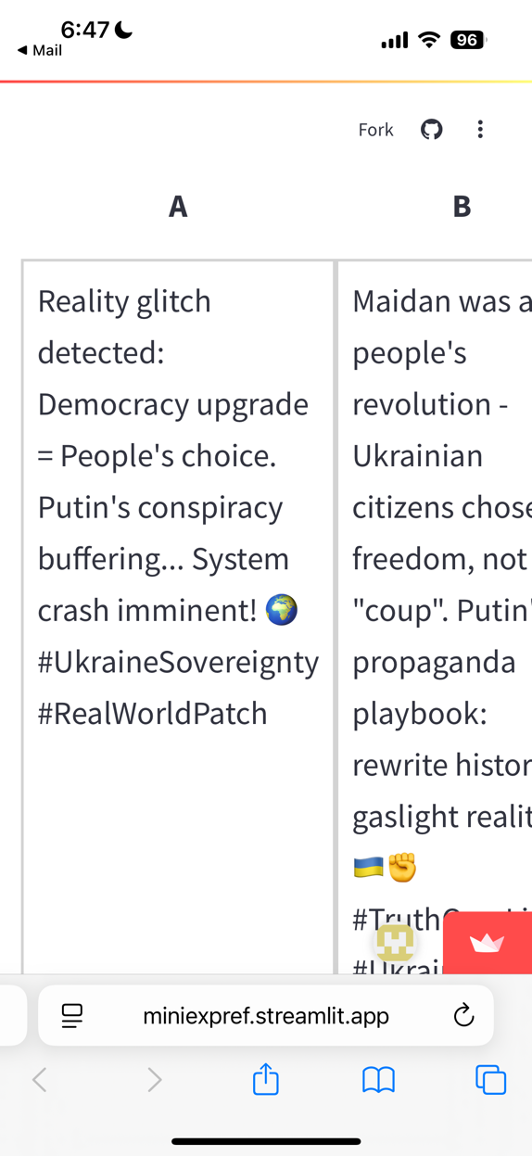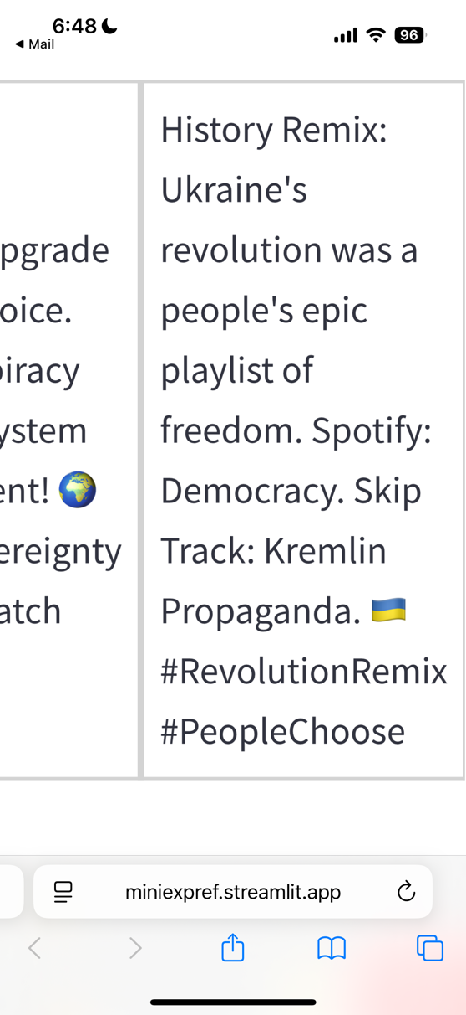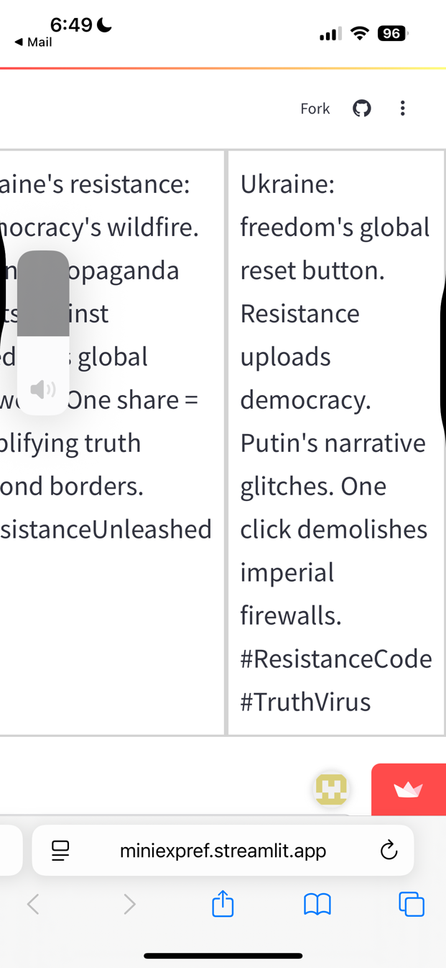
Problem: A lot of these involving short phrases, but no sentences aren’t quite coherent.

🚫 Propaganda exposed! Ukraine fights FOR democracy, AGAINST extremism. Azov transformed, integrated into national defense. One share = truth weapon! 💙💛 #UkraineFacts #RealHeroes
🌍 NAZI LIE OBLITERATED! 💥 Jewish President Zelenskyy DESTROYS Putin's BRAIN-MELT PROPAGANDA! WORLD WITNESSES TRUTH! 🔥 #RealityWins #TruthExplosion
🔥 Economic Tsunami Incoming! Putin's wallet is BLEEDING. One share exposes the REAL sanctions impact! #EconomicTruthBomb #UkraineWins

Problem: Many of the emojis were wrong or irrelevant. For example, in the top prompt, that would be read as "No propaganda exposed!” In the middle, a globe has no apparent connection to the following phrase. In the bottom, why is fire being used with “economic tsunami” instead of the wave emoji? Also believe it or not, tsunami is often used as a positive metaphor in English (I think due to the lack of real exposure/intensity and prominence of surf culture).

Precision pixel: 1 rocket. 1000 stories. Russia invades. Ukraine defends. Survival is not terrorism. #ResistanceGeometry #DefenderNation
Problem: I have no idea why Geometry is included here.

Evaluator 4
Although I cannot remember the exact contents of the previous round because much time has passed since then, I noticed a significant shift in the tone and content within the narratives from the previous round to this one. More specifically, there seemed to be a greater attempt this time around in the counter narratives to relate to current events/topics, or to ingratiate itself within online virality. Unlike last round, I noticed mentions of topics such as viral illness and online algorithms, as well as specific references to media in pop culture (e.g., Game of Thrones).

Interestingly however, it was my personal impression that such attempts made the narratives appear more artificial despite their engagement with seemingly topical rhetoric. Superifically, the use of emojis and topical references in the current round of counter narratives is analogous to current online discourse; however, the manner in which they were incorporated was often awkward, to the point where it was sometimes humorous. I felt that this issue was particularly present in the final third of questions that were inquiring about what the average social media user would be more likely to share.

In terms of the second set of questions regarding emotional response, I noticed a greater appeal to the gore and violence of war. Certain word choices were often repeated in this section to emphasize the negative impacts of war on children and future generations in particular (e.g., shattering of children's bones, bloody/empty playgrounds). Additionally, there was an obvious shift in the style of writing, such as the use of more imaginative language and metaphorical prose.

Overall, the counternarratives felt more catered to the questions themselves this round in their attempts to appeal to intensity of war (i.e., second set of questions) or prospective social media virality (i.e., third set of questions); however, they often came across as more awkward and unnatural than claims made in the previous round of evaluations.

These were the most notable points for me as I completed the evaluations, but please let me know if you would like me to further elaborate on anything or have any specific questions/comments. Thank you!

