**A Study of Multi Objective Evolutionary Algorithms applied to Routing and Spectrum Assignment in EON networks**

|  |  |  |
| --- | --- | --- |
| Carmelo Fretes Facultad Politécnica Universidad Nacional de Asunción, Paraguay carmelofretes@gmail.com | Diego Pintos Facultad Politécnica Universidad Nacional de Asunción, Paraguay dpinto@pol.una.py | Ysapy Mymbi Ortiz Facultad Politécnica Universidad Nacional de Asunción, Paraguay ysapymimbi@gmail.com |

ABSTRACT

In this work a new approach based on multi-objective evolutionary algorithms (MOEA) is proposed for the problem of Routing and Spectrum Assigment (RSA) in elastic Optical Networks (EON); where, given a set of unicast requests, the proposed MOEA minimizes (a) the total cost, and (b) the spectrum used, simultaneously under optical layer constraint.

The experimental indicates that the proposal MOEA is suitable for the Routing and Spectrum Assigment problem when it is compared to another MOEA of the-state-of-the-art with different multi-objective optimization measures. Basically, the proposed MOEA considers a appropriated sequence of requests while that the-state-of-the-art is random.

KEYWORDS

Routing and Spectrum Assignment, Elastic Optical Networks, Multi-objective Optimization, Evolutionary Algorithms.

1 INTRODUCTION

The emergence of the interest in elastic networks comes from the constant increase in network traffic and the need to increase the capacity and performance of the sections in the transmission networks. At present, the transport technology used in optical networks is wavelength multiplexing (WDM). This technology is capable of transporting multiple channels in the same fiber, based on carriers of different wavelengths. The implication of this technology is that channels that have a reduced demand to the maximum supported by the granularity imposed, underutilized resources; given this and because network traffic will be highly heterogeneous, the flexibility in the provision of optical network resources is a challenge. A major change in the architecture of elastic optical networks is the replacement of the fixed grid with a new flexible grid. The ITU-T is working on the revision of a new G.694.1 standard [4].

The optical spectrum of the C band (1530-1565 nm) is divided into slots (frecuency slots) of a fixed size [5] and a central frequency (CF) is assigned to each Elastic Optical Path (EOP) that must coincide with the beginning or the end of these slots. To meet ever increasing bandwidth demands, elastic optical networks are indispensable.

To generate an elastic optical path (EOP), we can divide into routing operations, where calculations of the route between the originating node and the destination are made through a network topology and the selection of spectral resources that will be assigned to the request (Spectrum Assigment, SA) defined by a central frequency and a bandwidth (Slot width). In WDM networks, the algorithms for routing planning and wavelength assignment seek a physical route through the network and assign a wavelength for the transport of that channel. The selection of that wavelength is conditioned to be the same during the route of the physical route, so that in this way it is not necessary to use wavelength converters in any jump. This condition is called a continuity condition (continuity constraint). In elastic networks, apart from this condition, there is a new condition that is that of contiguity in the spectrum (contiguity constraint). This last condition means that the frequencies slots that occupy the channel must be together in the spectrum.

For the resolution of the numerous problems that have multiple objectives, a good meta-heuristic for this type of problems are the evolutionary algorithms (EA - Evolutionary Algorithm). Traditional GAs are customized to adapt to multi-objective problems, through the use of specialized fitness functions and the introduction of methods to promote the diversity of the solution. There are general approaches to the optimization of multiple objectives. One is to combine the individual objective functions in a single compound function or move all, minus one of the objectives for the set of constraints. The next approach is to determine a whole set of optimal Pareto solutions or a representative subset. An optimal set of Pareto is a set of solutions that are not dominated with respect to the others.

In this work, which is an extension of the work carried out in [10], an approach based on a heuristic of Multi-objective Evolutionary Algorithms (MOEA) is proposed for the RSA problem, in which it is determined that the proposed approach improves in terms of quality from the Pareto front to the work presented in [16]. The MOEA optimizes the spectrum used and the total cost, subject to the constraints of continuity, contiguity and spectrum conflict.

Our work is organized in the following way, a first part (section 2) where we explain the EON networks conceptually, emphasizing the importance of spectrum flexibility for the best use of the spectrum, as well as a basic introduction to the architecture of the EON networks. In the next section (section 3) we went on to conceptually explain the problem of Routing and Spectrum Assignment (RSA) in EON networks. In section 4, the concepts of Pareto Front and Dominance. In section 5, the related works and the state of the art. In the next part (section 6), our proposed problem, in section 7, the implementation of the MOAS, in section 8, the experimental environment and tests, the parameters used for the MOAS, the presentation of the results and the difference in the performance between the algorithm [16] versus our proposed MOEA algorithm. And finally (section 9), conclusions and future work.

2 ELASTIC OPTICAL NETWORKS

A network consists of the collection of nodes interconnected by links. These links require transmission equipment, while the nodes require switching equipment. The different developments and technological research have shown that optics is one of the best for signal transmission, since it can simultaneously amplify multiple wavelength signals in a ravaged fiber connection.

Therefore, an optical network is not necessarily totally optical: the transmission is certainly optical, but the switching could be optical, electrical, or hybrid [7].

The need to give the network a greater capacity to adapt to the needs of transmission and increase the capacity and performance of the central sections and as the demand for network traffic grows, the new paradigm that we call elastic optical networks is born. EON (Elastic Optical Network), for its acronym in English. We can define the EON as an OTN (Optical Transport Network) where all the equipment and the control plane can handle optical channels of variable bandwidth and all the switching elements can support different granularities in the spectrum of the channels that transmit information. The traditional optical network based on WDM divides the spectrum into separate channels. The separation between adjacent channels is between 50 GHz and 100 GHz which is specified by the ITU. The separation between channels is very large and if each channel contains a low bandwidth used and there is no traffic in that free gap, much of the spectrum is wasted. In order to fully exploit a network, apart from making bandwidth more flexible, it is necessary to have a network architecture that allows the transmission of different signal formats for transmission.

EONs introduce fixed granularity into the bandwidth of the channels transported through the fiber. The ITU-T G.694.1, establishes a series of fixed spectral grids, which divide the optical spectrum between 1530-1565 nm, from the C band, ranging from 12.5 GHz. (Giga Herz) to 100 GHz, where most used are those of 50 GHz and 100 GHz [11].

The important change in the EON architecture is the replacement of the fixed grid (Fixed-grid) by a new flexible grid (Flexi-grid.)

The ITU-T is focused on the revision of a G.694.1 standard [11], for a division of the flexible optical spectrum called flexi-grid, for which the optical spectrum of the C band (1530-1565 nm) was defined, which is divided into FS (Frequency Slots) of fixed sizes of 6.25, 12.5, 25 and 50 GHz [12] and in addition a central frequency (CF, Central Frequency) is assigned to each elastic optical path (EOP - Elastic Optical Path) that must coincide with the beginning or the end of these slots existing differences in a fixed grid scheme and a flexible grid scheme In the case of the fixed grid scheme, we can observe the inefficient use of spectrum due to the fixed division that has the 50 GHz spectrum between each CF's, and if we observe the scheme of flexible grids can be noticed the free spectrum obtained thanks to the fine granularity that it offers and that allows to assign in a flexible way only the required bandwidth.

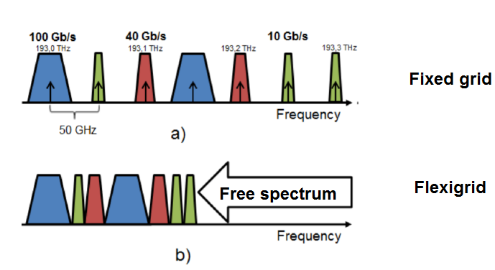

**Figure 1: a) Fixed grid spectrum assignment scheme, b) Flexible grid spectrum assignment scheme**

3 ROUTING AND SPECTRUM ASSIGNMENT

The EON greatly improves the data transmission rate since it divides the spectrum into portions of frequencies called FS, allowing the bands defined by the ITU-T wing to be used more efficiently.

The problem of establishing paths for each request by selecting an appropriate path and allocating the required bandwidth is called, Problem RSA [13].

The problem of RSA in Elastic Optical Networks is similar to the problem of Routing and Routing and Spectrum Assignment in networks based on WDM. The difference between the two (RSA and RWA) is the ability to flexibly assign the frequency spectrum. The RSA is considered a NP-Complete problem [14], and are classified into two types: Online or Dynamic and Offline or static. In the case of the offline RSA problem, the list of all transmission requests is already entered as input, in order to proceed with the analysis and resolution with this input data. For the RSA online problem, the analysis and resolution is done as the requests arrive dynamically.

4  PARETO FRONT AND DOMINANCE. CONCEPTS

In this section we define the concept of dominance and Pareto front for multi-objective problem solutions. It is said that the solutions of a problem with multiple objectives are optimal because no other solution is superior to them when all the objectives and restrictions are taken into account at the same time. It can be said that no objective can be improved without degrading the other objectives.

The set of optimal solutions is known as Pareto Optimal solutions, in which they have multiple objectives to meet and present conflicts when performing the simultaneous optimization of them. From this concept, it is established as a requirement to affirm that one situation is better than the other, that it does not diminish in anyone, but improve one; that is to say that one situation will be better than another, only if in the new one it is possible to compensate the losses of all the injured parties. In Figure 2, you can see the optimal pareto sets for different scenarios with two objectives and for the same solution space. In any case, Pareto's optimum is always composed of solutions located at the edge of the feasible region of the solution space.

Pareto Dominance in a context of minimization, says: that a solution *x1* dominates another solution *x2* if the following conditions are met: 1) The solution *x1* is not worse than *x2* in all the objectives. 2) The solution *x1* is strictly better than *x2* in at least one objective.

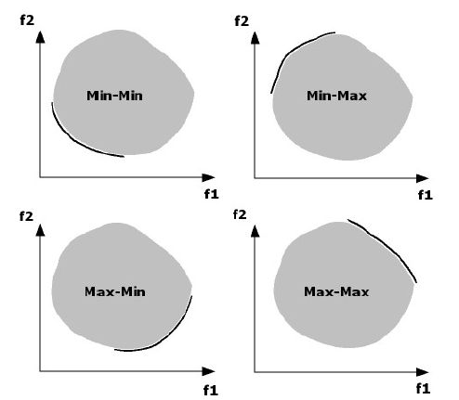

**Figure 2: Optimal Pareto Fronts for the same solution space**

5  RELATED WORK

As the RSA is considered a NP-Complete problem [14], it has been treated with several techniques, exact and heuristic, both for dynamic traffic and for static traffic. Among the exact techniques are the ILP, while among the heuristics are optimizations with Colony of Bees (BCO, Bee Colony Optimization) [18], Genetic Algorithms (GA, Genetic Algorithm) [19] [20] [1 ] [21], among others [22] [23].

Different ILP models for small instances and different heuristics for more real scenarios, have been used successfully to solve the RSA problem. As an example we can mention in [24] an ILP model was proposed to minimize the use of the spectrum to serve a traffic matrix in an EON. The authors propose a method that divides the problem into two sub-problems, the first is the routing and the second is the assignment of spectrum and resolves them sequentially, using a route-based approach. They also propose a heuristic algorithm that serves the connections one by one sequentially. Then in [3], the authors extend their previous results including the consideration of the level of modulation in the ILP formulation. With this new consideration, a new problem was defined called Routing, Modulation Level and Spectrum Assignment (RMLSA, *Routing Modulation Level Spectrum*), being outside the scope of this work. Other problems such as *Fragmentation Aware and Dynamic Traffic* are also not considered. Another ILP formulation and the proof that the RSA problem is a NP-complete problem can be found in the paper presented in [14]. In [25], the differences between an ILP for RWA and for RSA are exposed, as well as an algorithm complexity analysis. In the same work two RSA algorithms are exposed.

These have a better performance than the ILP in larger networks. With these two heuristic algorithms, the computational time was reduced, which is considered an improvement compared with the ILP, with which it differentiates in computation hours. The work proposed in [16], presents the multi-objective RSA problem and its associated algorithm model. Each request has many possible routes, and in each routing it has several spectrum assignment options. The problem is to minimize the spectrum width to support all requests and minimize the overall cost of the spectrum in the link.

The objective function for the work proposed in [16] is as follows: there are two objectives associated with each chromosome. The first objective *f1*, is the width of the spectrum that indicates the maximum indexed slice used in the network. The second objective *f2* is the total cost of the spectrum link. Given a chromosome, the route and channel are calculated for each demand. After attending each demand sequentially and without any sort of ordering, the spectrum availabilities vector of each link is updated.

In this developed work, which is an extension of the work presented in [10] which has an approach based on weighted sum, a pure multi-objective approach with Pareto fronts is presented. In our work, as in [16] it has many possible routes, and in each routing it has several spectrum assignment options. The problem is to minimize the spectrum width to support all requests and minimize the overall cost of the link spectrum. The same objective function is taken from [16] and the requests are handled as follows: applications are ordered from highest to lowest, defined by the highest possible cost of said request, the first 30% of said list is attended in the first place, while the remaining 70% is treated in a random manner, unlike [16] it is a random ordering.

6  PROBLEM STATEMENT

In OFDM-based EONs, traffic demand between the pair of source and destination nodes is transmitted through multiple low-speed subcarriers. Given the physical topology, the matrix of demands and a list of precalculated routes (K-shortestpath).

We need to satisfy all the demands of source-destination connection: determine the route and spectrum assignment for each traffic demand. Optimize spectrum utilization: Minimize the Maximum FS used on all fibers in the network. Optimize the distance traveled: minimize the sum of the distance traveled. Optimize the total cost: depending on the distance traveled and the FS requested.

For the proposed model, the following assumptions are established: The spectral resource of each optical fiber is divided into FS; the capacity of the fiber in terms of FS is limited in all links; the connection demands are bidirectional, and a complete end-to-end optical path must be found for each demand; No specific route is given for a connection in advance, any possible route of the pre-calculated routes and any possible set of contiguous FSs will be evaluated while solving the model; the request is represented by three tuples (*s, d, αsd*), including the source node *s*, the destination node *d*, and the bandwidth / data rate demanded α considered in the quantity of FS requested.

**6.1 Multi-Objetive Formulation**  **Problem**

Given:

*G* : Grade of the network, which represents an EON

*E* : Set of links, in G

*V* : Set of vertices, in G

*GB* : Amount of FS for Band Guard

*Ftotal* : Amount of FS that fiber has

*P* : Set of routes

*K* : Number of available routes

*SD* : Quantity of demands

The notations and the formulation are presented below:

**Constants:**

*dist_max* : Maximum distance traveled considering the longest routes.

*espectrum_max*: Maximum FS index available.

*cost_max* : Total cost of applications considering their maximum distances.

${dist}_{p}^{sd}$: Distance of the route *p*

αsd : Quantity of FS requested by the application sd where *s, d, ∈ V*

Índices:

*sd* : Demand index, *sd* *∈ {1, 2, …, SD}*

p : Route index, *p ∈ {1, 2, …, SD}*

*mn* : Directional link index, m ≠ n

**Variables:**

$x_{p}^{sd}$: 1 if the path *p* is used to meet the request *sd*, otherwise

*Λsd* : First FS assigned to the request *sd, sd ∈ {0, …, Ftotal - 1}*

*Δsd, s’d’*: Indicator that is equal to 0 si *Λs’d’ < Λsd,* y 1 otherwise (ergo, *Λs’d’ < Λsd)*

Objective function to minimize:

***f(x) = {f1, f2}***

subject to:

* The Maximum Spectrum:

|  |  |
| --- | --- |
| $f_{1}=\frac{\underset{∀sd}{máx}\left(Λ_{sd}+α_{sd}\right)}{{spectrum}_{max}}$ | (1) |
|  |  |

* The total cost is:

|  |  |
| --- | --- |
| $$f_{2}=\frac{\sum_{sd}{\sum_{p}{\left(α_{p}^{sd}*{dist}_{p}^{sd}*x_{p}^{sd}\right)}}}{{cost}_{max}}$$ | (2) |

|  |  |
| --- | --- |
|  | (3) |

|  |  |
| --- | --- |
|  | (4) |
| $$Λ_{s'd'}+α_{s'd'}*x_{p'}^{s'd'}+GB-$$ $$Λ_{sd}≤\left(Ftotal+GB\right)*$$ $$\left(1-δ_{s'd',sd}+2-x_{p}^{sd}-x_{p'}^{s'd'}\right)$$ | (5) |
| $δ_{sd,s'd'}+δ_{s^{'}d^{'},sd}=1$ | (6) |
| $Λ_{s^{'}d^{'}}-Λ_{sd}<F_{total}*δ_{sd,s^{'}d^{'}}$ | (7) |
| $Λ_{sd}-Λ_{s'd'}<F_{total}*δ_{s^{'}d^{'},sd}$ | (8) |

The objective function (1) represents the maximum spectrum used and (3) represents the total cost.

On the other hand, we have that, for all request *sd, s'd'* and the paths *p ∈ Psd and p' ∈ Ps'd'* with *p* and *p'* sharing at least one common link *mn* the constraints (3), (4), (5), (6), (7) and (8) represents the total cost.

Restrictions (3), (4) and (5) ensure that the portions of spectrum that are assigned to connections that use paths that share a common link do not overlap and are adjacent.

Also, for all requests *sd,s’d’* that have *p ∈ Ps’d’,* with *p* and *p'* sharing at least one common link (∃ *mn : nm ∈ p ∧ mn ∈ p’)*, the constraints (6), (7) and (8) ensure that either *δsd,s’d’ = 1* means that the initial frequency *Λsd* is smaller than the initial frequency *Λs’d’*, that is, *Λsd < Λs’d’,* o *δs’d’,sd = 1*, in which case *Λsd > Λsd*. Note that *Λsd* and *Λs’d’* are always bounded superiorly by *Ftotal*, and that therefore their difference will always be less than *Ftotal*.

7 NSGA II IMPLEMENTATION

Our algorithm, which is an extension of the algorithm MOEA presented in [10], begins with the creation of the initial population. The best solutions are found over several generations. Operators such as crossing and mutation explore other possible solutions. In our approach, not all individuals are viable solutions, therefore, additional procedures for handling constraints are required and when the stopping criterion is met, relatively good solutions are found.

In this implementation, the objective is to find the route and the set of FS for each request, such that the total distance traveled, the maximum FS used and the total cost are minimized; all this complying with the respective RSA restrictions.

The implementation of the NSGAII is described below in algorithms 2, 3 and 4.

|  |
| --- |
| **Algorithms NSGAII** |
| **ENTRY:** Route table P; Total amount of FS; List of demands; Size of the population; Probability of mutation; Stop Criterion; FS Assignment Algorithm; Total Distance, Maximum FS, Maximum Cost  **OUTPUT:** FrontPareto     1: Initialize Population (P)     2: **While** the stop criterion is not met     3: Q = generate individual (P) by selection, crossing            and mutation     4: Q = Q ∪ P     5: R = Construct the pareto front from Q based            in dominance     6: Build Pareto fronts (R)     7: Calculate Distance of Crowding (R)     8: P = [0]     9: **while** P <sizePoblacion  10: Include the solution in population P  11: **End while**  12: **End while**  12: **return** frontPareto (P) |

In the NSGA II presented in this work, the chromosome represents a set of requests attended. Basically, the chromosome is a compound vector in which each gene represents an attended request. Each element of said vector contains: the index of the assigned route (taken from the table of pre calculated routes), and the index of the assigned FS of the request.

The steps of the algorithm procedure can be described below:

**Initial Population.** The first step is to initialize the population. The NSGA II begins with an initial population of chromosomes, defined as explained below. The Algorithm deals with the requests in a determined order, which was taken from a paper presented in [1]. At work, the order is defined as follows: orders are ordered from highest to lowest, defined by the highest possible cost of said request, the first 30% of said list is attended in the first place, while the remaining 70% is attended at random. This order is represented by the positions of the genes in the chromosome and is maintained throughout the execution of the algorithm. Then, randomly assign the routes and FS to the demands, taking into account the previously defined order. Each chromosome encodes a valid solution.

**Selection of chromosomes for the next generation.** The NSGA II algorithm shows us that the cycle begins with the selection of individuals, in step 3. The stochastic universal sampling method is used to select two parents to produce new individuals for the next generation [17]

Universal stochastic sampling is a sampling algorithm that is implemented in a single phase. Given a set of n individuals and their associated objective values, the algorithm accommodates them in a roulette wheel where the size of the cuts assigned to each individual is proportional to the target value. Then, a second roulette, is marked with and equally spaced markers where and is the number of selections that you want to make. Finally, the spinner is rotated and an individual is selected for each marker. The position of the markers indicate the selected individual.

**Crossing.** In this work we used the two-point cross operator [17] through which two cut points are randomly generated in each player, using the same points generated, assigning intercalary each segment generated from the parents to each child. In algorithm 1 is applied in step 6.

In figure 3, we can observe the crossing procedure in which the cut points generated randomly were 1 and 2, dividing the player into 3 segments. The first segment of player 1 is assigned to the first segment of descendant 1, so the first segment of player 2 is assigned to the first segment of descendant 2. Then, the second segment of player 1 is assigned to the second descendant, while the second segment Player segment 2 is assigned as the second segment of the first descendant. Then the last segments are interspersed, resulting in both descendants shown in figure 4. This process is repeated until crossing the entire current population and obtaining as a result the generation of a new population.

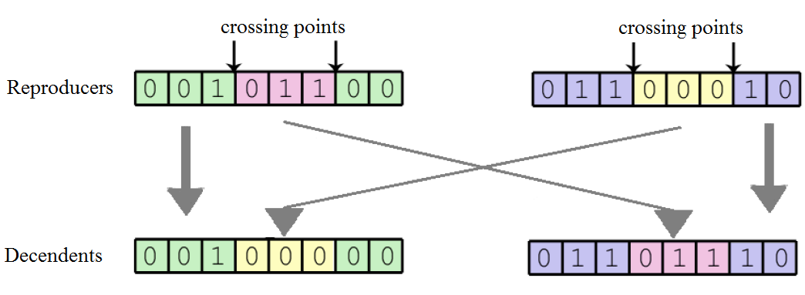

**Figure 3: Crossing of 2 reproducers**

**Mutation.** This procedure is applied after crossing, in each individual independently, in step 7 of algorithm 1. For the individual selected, according to the mutation probability obtained, a position of the vector is chosen randomly to change the route used in said position. Selecting a route from those available for said position, you have a higher probability of generating a feasible solution.

**Pareto dominance.** In step 4 the union of the two populations Q = Q ∪ P is performed, in step 5 and 6 the population is classified into categories (rankeo) on the basis of non-dominance. Each solution is assigned a fitness value equal to its non-domain range (rank 0 is the best).

Then the newly formed population is classified into categories (rankeo) according to their domain relation, and then, as explained in step 7, calculate the Crowding Distance of each individual, and then select the best ones in the next cycle that begins in the step 8, select the individuals with the best rank and crowding distance to fill the size of the population, as seen in steps 9, 10 and 11 of algorithm 1. Therefore the algorithm starts all over again, from the election of breeders, until it reaches the stop condition.

**Spectrum assignment.** A spectrum assignment algorithm is applied to each i-th gene consecutively in the order pre-established by the indices on the chromosome.

The algorithm used in this MOEA is Random Fit, which randomly assigns the free FS found that complies with the constraints of the problem.

**Stop criterion.** A maximum execution time is used as stopping criterion.

8  EXPERIMENTAL TESTS AND RESULTS.

In this section we present the difference with the work proposed in [16] and the work presented by us, in addition the results of the experimental tests are presented and analyzed.

The work proposed in [16], presents the multi-objective RSA problem and its associated algorithm model. Each request has many possible routes, and in each routing it has several spectrum assignment options. The problem is to minimize the spectrum width to support all requests and minimize the overall cost of the spectrum in the link.

The objective function for the work proposed in [16] is as follows: there are two objectives associated with each chromosome. The first objective f1, is the width of the spectrum that indicates the maximum indexed slice used in the network. The second objective f2 is the total cost of the spectrum link. Given a chromosome, the route and channel are calculated for each demand. After attending each demand sequentially and without any sort of ordering, the spectrum availabilities vector of each link is updated.

In this developed work, which is an extension of the work presented in [10] which has an approach based on weighted sum, a pure multi-objective approach with Pareto fronts is presented. In our work, as in [16] it has many possible routes, and in each routing it has several spectrum assignment options. The problem is to minimize the spectrum width to support all requests and minimize the overall cost of the link spectrum. The same objective function is taken from [16] and the requests are handled as follows: applications are ordered from highest to lowest, defined by the highest possible cost of said request, the first 30% of said list is attended in the first place, while the remaining 70% is treated in a random manner, unlike [16] it is a random ordering.

The tests carried out considering different types of traffic load, on the NSF topology, different K values (roads) and different amounts of demands, try to replicate various possible scenarios of the problem to solve. The experimental tests carried out show that our proposal for the ordering of the requests presents promising results.

**8.1** **Testing environment**

The experiments were performed on a computer with an Intel Core i3 processor (3.40 GHz) and 8 GB of RAM. The implementation and execution of the MOAS were carried out with JAVA 8.

All the executions were executed with the topology NSF of 14 nodes that can be observed in figure 4.

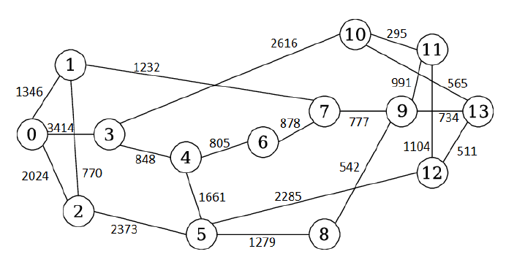

Figure 4: Net topolgy NSF of 14 nodes with distance in Kilometers

The traffic loads used were of the all-to-all type, that is, each node of the network makes a transfer request to all others in the network. In addition, the type of traffic load was random. The loads are divided into 3 categories, 50, 100 and 150 (low, medium, high), that is to say that for the category of 50 FS, for each demand a random value between 1 and 50 was generated as a requested quantity of FS; For category 100, for each demand a random value between 1 and 100 was generated as the requested quantity of FS and for category 150, a random value of 1 and 150 was generated as requested quantity of FS.

Another variant that was taken into account for the execution of the tests was the number of shortest routes precalculated, that is, the value k. They were made with the following values ​​of *k* = 2, 3, 4 and 5 for the NSF topology.

For the executions of the MOGA, the values ​​shown in table 1 were used as evolutionary parameters.

The metric used for the comparison of the algorithms is hypervolumen and coverage.

**Table 1:** Parameters used for the execution of the MOGA

|  |  |  |
| --- | --- | --- |
| **Parameters** | | **Value** |
| Size of the population | 50 | |
| Probability of mutation | 0.1 | |
| Stop Criterion (in minutes) | 5 | |
| Number of independent runs | 15 | |

Given a scenario consisting of a topology, a number of routes and traffic load, we proceed to:

1. Calculate 15 MOEA solutions
2. Calculate values of the objective functions and Fitness of the 15 MOEA solutions.
3. Calculate 15 MOEA solutions
4. Carry out analysis of the solutions

Based on these steps, the experimental results are presented.

**8.2** **Hypervolume Metric**

For the hypervolume metric you can see the table number 2, for load type 50 (low), with the number of paths k = 2, our proposed algorithm of order 30/70 obtains better results before the algorithm without ordering. For load type 50 (low), with k = 3 paths, again our algorithm with order 30/70, exceeds the algorithm without ordering. For load type 50 with k = 4, the algorithm without ordering obtained better results with our algorithm 30/70. For k = 5 with 50 loading (low), our algorithm 30/70 obtained good results. For k = 2 with 100 load (average), the algorithm without ordering obtained better results, k = 3 with 100 load (average), our algorithm with order 30/70, has better results before the algorithm without ordering, for k = 4 with 100 load (average), our 30/70 sorting algorithm improves the results before the algorithm without ordering. Par k = 5 with 100 of load (average), we obtained very good results with respect to the algorithm without ordination. For k = 2 with 150 loading (high), our sort algorithm 30/70 obtained better results compared to the algorithm without ordering. In k = 3 with 150 loading (high), the algorithm without ordination obtained good results. Our 30/70 sorting algorithm got better results when k = 4 with 150 loading (high) compared to the unordered algorithm. The unordered algorithm had better results when k = 5 and the load is 150 (high), compared to our 30/70 sorting algorithm.

**8.3** **Coverage Metric**

For the coverage metric we analyze the table number 3, where it can be seen when the load type is 50 (low) and the number of roads k = 2, our ordering algorithm 30/70 obtained a greater coverage before the algorithm without ordination. For k = 3 with 50 load (low), our algorithm obtained a greater coverage with respect to the algorithm without ordering. For when k = 4 and 50 of load (low), the algorithm without ordination obtained a greater coverage before our algorithm of ordering 30/70. With k = 5 and the load of 50 (low), our ordering algorithm 30/70 obtained a better coverage. For load type 100 (average) with k = 2, the unordered algorithm had better coverage in our ordering algorithm 30/70. When k = 3 with load type 100 (average), our algorithm obtained better coverage before the algorithm without ordering. With a load of 100 (average) and k = 4, our algorithm obtained better coverage than the algorithm without ordination. When k = 5 and load type 100 (average), our algorithm obtained better coverage than the algorithm without ordination.

For load type 150 (high) with k = 2, our algorithm showed better coverage than the algorithm without ordination, for k = 3 and 150 load (high), the algorithm without ordination yielded better coverage than our ordering algorithm. / 70 For k = 4 with 150 loading (high), our algorithm obtained better coverage before the algorithm without ordering. For k = 4 with a load of 150 (high), the algorithm without ordering obtained better coverage. For k = 5 with 150 loading (high), our algorithm obtained better coverage than the non-ordered algorithm.

Table 2: Comparison of algorithms, hypervolume metric 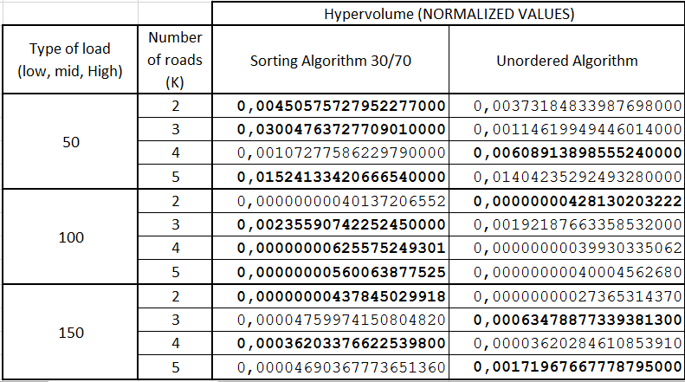

**Table 3: Comparison of algorithms, coverage metrics**

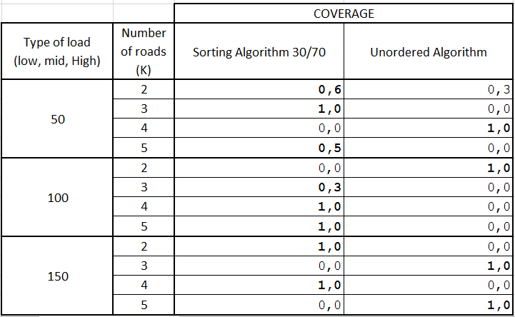

9  CONCLUSIONS AND FUTURE WORK

According to the exposed results we can conclude that if we give a treatment to the request table, ordering them from highest to lowest, defined by the highest possible cost of said request, and taking the first 30% of said list to be attended in the first place, to then take the remaining 70% to be treated at random. Being able these percentages vary.

As future work to develop we can mention that the same test can be performed on the different existing network topologies to corroborate the behavior of the algorithm. In this way, it is also possible to test the different spectrum assignment of the RSA in the different topologies, in order to determine which spectrum assignment has a better performance.

REFERENCES

|  |  |
| --- | --- |
| [1] | Joao HL Capucho, Leandro C Resendo: “ILP model and effective genetic algorithm for routing and spectrum allocation in elastic optical networks”, *Microwave & Optoelectronics Conference (IMOC), 2013 SBMO/IEEE MTT-S International,* pp. 1—5, 2013. |
| [2] | Bijoy Chand Chatterjee, Nityananda Sarma, Eiji Oki: “Routing and spectrum allocation in elastic optical networks: a tutorial”, *Communications Surveys & Tutorials, IEEE*, pp. 1776—1800, 2015. |
| [3] | Konstantinos Christodoulopoulos, Ioannis Tomkos, EA Varvarigos: “Elastic bandwidth allocation in flexible OFDM-based optical networks”, *Journal of Lightwave Technology*, pp. 1354—1366, 2011. |
| [4] | Yue-Kai Huang, Ezra Ip, Tiejun J Xia, Glenn A Wellbrock, Ming-Fang Huang, Yoshiaki Aono, Tsutomu Tajima, Milorad Cvijetic: “Mixed line-rate transmission (112-Gb/s, 450-Gb/s, and 1.15-Tb/s) over 3560 km of field-installed fiber with filterless coherent receiver”, *Lightwave Technology, Journal of*, pp. 609—617, 2012. |
| [5] | F. Ilchmann, others: “Efficient and optimized network architecture: Requirements and reference scenarios*”, Deliverable D2*, 2011. |
| [6] | Abdullah Konak, David W Coit, Alice E Smith: “Multi-objective optimization using genetic algorithms: A tutorial”, *Reliability Engineering & System Safety*, pp. 992—1007, 2006. |
| [7] | Biswanath Mukherjee: *Optical WDM networks*. Springer Science & Business Media, 2006. |
| [8] | Nicola Sambo, Antonio D'Errico, Claudio Porzi, Valeria Vercesi, Muhammad Imran, Filippo Cugini, Antonella Bogoni, Luca Potı̀, Piero Castoldi: “Sliceable transponder architecture including multiwavelength source”, *Journal of Optical Communications and Networking*, pp. 590—600, 2014. |
| [9] | Marcelo D Rodas-Brítez y Diego P Pinto-Roa. “Quality of protection on WDM networks: A quantitative paradigm based on recovery probability”. En: Computing Conference (CLEI), 2014 XL Latin American. IEEE. 2014, pags. 1-11. |
| [10] | Ysapy Mimbi Ortiz, Carmelo Fretes y Diego P. Pinto. “Routing and Spectrum Allocation in Elastic Networks. An approach based on Multi-objective Evolutionary Algorithms”. En: 5th International Conference on Engineering Optimization (ENGOPT). Federal University of Rio de Janeiro. 2016. |
| [11] | G Recommendation. 694.1: Spectral grids for WDM applications: DWDM frequency grid”. En*: International Telecommunications Union*, Tech. Rep. (2012). |
| [12] | Fatai Zhang y col. “Requirements for GMPLS control of fexible grids”. En: *IETF Internet Draft 1* (2011). |
| [13] | Ori Gerstel y col. “Elastic optical networking: A new dawn for the optical  Layer”. En: *IEEE Communications Magazine* 50.2 (2012). |
| [14] | Yang Wang, Xiaojun Cao y Yi Pan. “A study of the routing and spectrum allocation in spectrum-sliced elastic optical path networks”. En: *INFO-COM*, 2011 Proceedings IEEE. IEEE. 2011, pags. 1503-1511. |
| [15] | Dan Simon. Evolutionary optimization algorithms: *biologically-inspired and*  *population-based approaches to computer intelligence.* Hoboken. 2013. |
| [16] | D. T. Hai, "Multi-objective genetic algorithm for solving routing and spectrum assignment problem”, *2017 Seventh International Conference on Information Science and Technology (ICIST)*, Da Nang, 2017, pp. 177-180. doi: 10.1109/ICIST.2017.7926753 |
| [17] | Prashant K Gupta y Pranab K Muhuri. “Multi-objective linguistic optimization: Extensions and new directions using 2-tuple fuzzy linguistic representation model”. En: *Fuzzy Systems (FUZZ-IEEE), 2017 IEEE International Conference* on. IEEE. 2017, pags. 1-6. |
| [18] | Goran Z Markovic. “Routing and spectrum allocation in elastic optical networks using bee colony optimization”. En: *Photonic Network Communications* (2017), pags. 1-19. |
| [19] | Miros law Klinkowski. “A genetic algorithm for solving RSA problem in elastic optical networks with dedicated path protection”. En*: International Joint Conference CISIS'12-ICEUTE12-SOCO12 Special Sessions.* Springer. 2013, pags. 167-176. |
| [20] | Feng Wang, Yuan Man y Lichun Man. “Intelligent optimization approach for the k shortest paths problem based on genetic algorithm”. En: *Natural Computation (ICNC), 2014 10th International Conference on. IEEE.* 2014, pags. 219-224. |
| [21] | Dao Thanh Hai y Kha Manh Hoang. “An ecient genetic algorithm approach for solving routing and spectrum assignment problem”. En: *Recent Advances in Signal Processing, Telecommunications & Computing (Sig-TelCom), International Conference on.* IEEE. 2017, pags. 187-192. |
| [22] | Ying Wang y col. “ACO-based routing and spectrum allocation in fexible bandwidth networks”. En: *Photonic Network Communications* 25.3 (2013), pags. 135-143. |
| [23] | Roza Goscien, Miroslaw Klinkowski y KrzysztofWalkowiak. “A tabu search algorithm for routing and spectrum allocation in elastic optical networks”. En: *Transparent Optical Networks (ICTON)*, 2014 16th International Conference on. IEEE. 2014, pags. 1-4. |
| [24] | Kostas Christodoulopoulos, Ioannis Tomkos y Emmanouel A Varvarigos. “Routing and spectrum allocation in OFDM-based optical networks with elastic bandwidth allocation”. En: *Global Telecommunications Conference (GLOBECOM 2010)*, 2010 IEEE. IEEE. 2010, pags. 1-6. |