Entity Extraction

Motivation
Models
Manual annotation of the entire thesis archive is not only time-consuming and non-scalable, but also prone to human error. Therefore, a more efficient automatic approach based on deep learning models was explored.
The challenges of entity extraction, and the models required for this task, depend on the categorization of the labels as objective or subjective. Bibliometric labels – title, author, and issued – can be unambiguously determined; they are not subject to interpretation. Where disagreement may exist among human annotators, it can be attributed to unclear guidelines for uncommon situations (ex. how to label a subtitle) and unstandardized level of detail (labeling ‘12 November 2007’ instead of an just 2007). A model evaluated that performs this Named Entity Extraction task does not need to understand document-level relationships, just spot and categorize entities. However, the evaluation of such a model is complicated by noise from characters that were incorrectly interpreted by the OCR software. Since these born-analogue documents almost always have a predicable title page(s) with this exact information, the task of extracting the objective labels from can also be called Key Information Extraction (KIE), which unlocks a toolbox of document-understanding models, some of them vision-based which bypass the OCR step.
[Here goes the requirements of the subjective task].
Type | Labels | Task name | Model requirements
Objective | Title  Author  Issued | Key Information Extraction (KEI)/Named Entity Recognition (NER)
Subjective | Spatial  Subject  InGroup

Ground-truth data
It is tempting to use the manual annotations as the ground-truth data to which model predictions can be compared, but this __ the assumptions that.
As an example, Figure x shows the title page of a 1971 thesis as it was scanned, and as it was converted to text by OCR software and manually annotated. Labels extracted from this text are:
Title: ONTWIKKELINGEN IN DE INDUSTRIËLE STRUCTUUR VAN ZUID - WEST - NEDERLAND ` 1945 - 19 7 0
Author: F*Abcouwer
Issued: february 1971
A human annotator could easily see that that these are small character recognition mistakes, but a a model evaluation procedure which is based on string similarity would not.
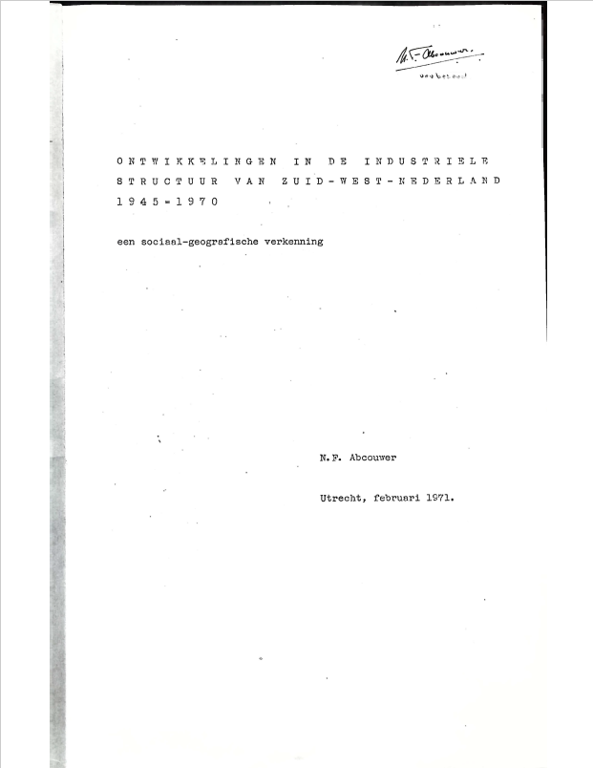 | ONTWIKKELINGEN B-title  IN I-title  DE I-title  INDUSTRIËLE I-title  STRUCTUUR I-title  VAN I-title  ZUID I-title  - I-title  WEST I-title  - I-title  NEDERLAND I-title  1945 I-title  - I-title  19 I-title  7 I-title  0 I-title  een B-title  sociaal-geografische I-title  verkenning I-title  N O  . O  F B-author  * I-author  Abcouwer I-author  Utrecht O  , O  februari B-issued  1971 I-issued

Methodology

Objective labels
For the extraction of objective labels, a preliminary experiment compared two model types: BERT (Bidirectional Encoder model from Transformers), a pretrained NLP model commonly used for sequence labeling tasks, and Gemini, a general-purpose generative AI model developed by Google. In addition, Gemini was __ tasked as a zero-shot task and with training data. The models were evaluated on their performance in the task of extracting the title, author, and issued labels from the training dataset.
To reduce noise and to enable a fair comparison between the models we limited the inputs to sections where the key information was likeliest to be found. For the BERT model, the text of each thesis was reduced to the first 1,000 words that have more than one character. This was done because the OCR software can create hundreds of one-character words out of, for example, a decorative dividing line made of dashes. For Gemini, PDF files of each thesis were reduced to the first three pages, which are always title pages. Each of the resulting text and PDF documents were manually checked to ensure that they contained the three objective labels. Automating the reduction of inputs to where the key information was located both improved the processing time and made it scalable to the entire archive for future inference.
During development, BERT and the few-shot Gemini models were trained using a K-Fold cross-validation strategy with K=5. At each fold, 80% of the data was used for training and 20% for evaluation. The recall, precision, overll score of best-performing epoch was saved, and the result of the folds were averaged together to determine the overall success of the model. In addition, the annotated theses were dividing into folds using a document-level splitting strategy. This approach was chosen over random sequence-level splitting chiefly to reflect real-world document processing and achieve a relatively balanced distribution of label types between training and validation, effectively serving as a stratified K-fold cross-validating strategy. Using the same training and validation data also enables a fair comparison between the different types of models.

BERT is pre-trained on large language corpora to understand context using bidirectional masked language modeling and next-sentence prediction (Devlin et al., 2019). Through transfer learning, it can be fine-tuned on annotated training data for specific NLP tasks. This study used BERTje, a monolingual Dutch BERT model with a token-level classification head for sequence labeling tasks (Vries et al., 2019).
The BERTje checkpoint was fine-tuned on two versions of the training dataset to assess the effect of label sample size. The original BIO labeling scheme resulted in 13 possible labels, leading to a small sample size for per class. To avoid this, the documents were re-labeled with an IO (inside-outside) scheme. This reduced the number of labels, increased the sample size of each, and made explicit that that tokens that were previously labeled with B or I and the same label type are semantically related.

Gemini Model
Gemini 3 Flash is the latest Multimodal Large Language Model (MLLM) by Google, and is built upon transformer architecture. It is intended to handle inputs from multiple modalities such as text, image, and documents, and integrate them through specialized attention mechanisms. This model was selected because it scored the highest in the KEI task on the Intelligent Document Processing (IDP) Leaderboard, an evaluation framework for assessing the capabilities of models in document understanding tasks. Among commercial MLLM models, it is also the latest offering with a free tier.
Two different iterations of the model were tested with different prompts, which correspond to zero-shot and fine-tuned prompting strategies. In the zero-shot run, the model was provided with a short prompt and a PDF document from which to extract key information. The results were evaluated according to the strategy described in the previous section, and the results of all models were averaged. In the fine-tuned run, the K-Fold cross-validation strategy was implemented by providing the model with a short text prompt 20 examples, each of which consisted of a three-page PDF and its corresponding labels.
Two different iterations of the model were tested with different prompts, which correspond to a few-shot and a zero-shot run. In the few-shot run, the model was provided with instructions, annotation rules, two examples of labeled texts, and an unlabeled thesis to annotate. Only two training examples could be provided (instead of 16 like in the BERT model) because of the model’s limit on 250,000 input tokens per minute on the free tier. The training examples were randomly chosen for each run. The annotation rules were taken from the same annotation guide used by the human annotators. In the zero-shot run, the same prompt was used, but examples were not provided. English-language prompts were created based on the prompt engineering recommendations suggested by Google, and a few different versions were tested to find the best-performing prompt. The prompts used are shown in the appendix.
The following boxplots show the distribution of recall, precision, F1, and Jaccard index when the models were applied to the four validation theses. (Please note that I don’t think that all of these boxplots should be presented in the thesis, perhaps just the means, but I wanted to show the differences in results between the four thesis).

Subjective labels

Model evaluation
A custom evaluation methodology was developed to compare the effectiveness of the models in extracting entities, with a focus their applicability to the downstream task of entity linking. Standard evaluation metrics of NER models are derived from a confusion matrix. Rather than computing metrics at a sentence level, they were calculated at a document level, based on the model’s prediction across an entire thesis.
For evaluation, the set of entities in the reference data was compared against the set of entities predicted anywhere within the same thesis, regardless of their exact location or number of occurrences. For example, if “Nieuwegein” was labeled as spatial in a given thesis, and the model predicted “Nieuwegein” as spatial at any point, this was counted as a True positive, even if these did not correspond to the same textual occurrence of the entity. This approach compensates for the missing labels in the annotations, and reflects the practical goal of capturing the correct entities for subsequent knowledge modeling.
Confusion matrix
 | Labeled in reference | Not labeled in reference
Captured by model | True positive (TP): Entity was annotated and was captured by the model | False positive (FP): Model predicted an entity that was not annotated (a spurious label)
Not captured by model | False negative (FN): Model did not predict an entity that was labeled | True negative (TN): Entity was not labeled and the model did not predict it (can’t be counted)

Due to the sparseness of the reference annotations, true negatives can’t be reliably counted and therefore should be excluded from evaluation metrics. It is also expected that a well-performing model may predict valid entities that were not labeled by the human annotators. Therefore, several metrics were used to evaluate the models based on binary classification from the confusion matrix.
Recall is the true positive rate (TRP), calculated as the proportion of annotated entities that were correctly identified by the model. A high recall indicates that the model was able to successfully capture the entities that had been manually labeled, even if it made additional unverified guesses. The conceptual opposite is precision, the proportion of all the model's predictions that had been in the manual annotations. F1 score is their harmonic mean. Finally, the Jaccard similarity index is a quantification of the similarity between two sets. It provides a more straightforward bag-of-words comparison between the predicted and reference sets.
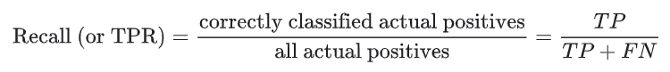
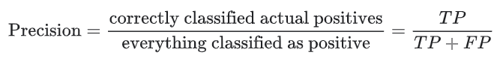
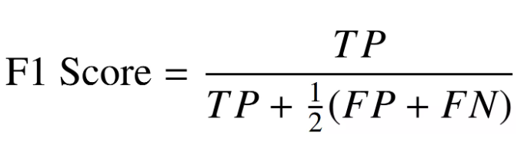
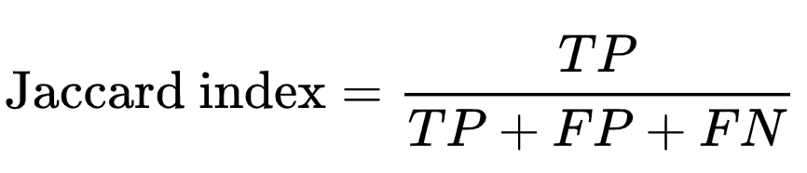
For the BERT model, metrics were computed for each evaluation thesis after each epoch and then averaged, and the best epoch was reported. For the Gemini model, they were calculated from the response produced for each evaluation thesis. Results are reported per entity label and as a weighted average based on reference label frequency.
As was discussed in the previous section on inter-annotator agreement, NER evaluation can be ambiguous since it assess not only if an entity was given the right label, but also whether the entity span matches exactly the reference or only partially overlaps with it (Seow et al., 2025). In this comparison, a string span-matching approach was used, requiring predicted entity spans to match the reference spans in order to count as correct. This was done because the inclusion of different tokens can change the intended meaning of an entity, particularly for the Spatial and Subject labels.
To account for scanning errors and minor variations that do not affect meaning, string similarity matching with Levenstein Distance was used. The Normalized Levenstein Distance quantifies the similarity between two strings by counting the number of single-character edits between them normalizing by the length of the longest string (Yujian & Bo, 2007). Strings were converted into lowercase and all punctuation was removed, and pairs with a distance of more than 0.9 were considered to be a match. In all cases, the labels type assigned by the model was required to be the same as the reference label.

Model Results
BERT is pre-trained on large language corpora to understand context using bidirectional masked language modeling and next-sentence prediction (Devlin et al., 2019). Through transfer learning, it can be fine-tuned on annotated training data for specific NLP tasks. This study used BERTje, a monolingual Dutch BERT model with a token-level classification head for sequence labeling tasks (Vries et al., 2019).
The BERTje checkpoint was fine-tuned on two versions of the training dataset to assess the effect of label sample size. The original BIO labeling scheme resulted in 13 possible labels, leading to a small sample size for per class. To avoid this, the documents were re-labeled with an IO (inside-outside) scheme. This reduced the number of labels, increased the sample size of each, and made explicit that that tokens that were previously labeled with B or I and the same label type are semantically related.
Label Sample Sizes

Label | BIO-labeling | IO-labeling
O | 514852 | 514852
I-title | 281 | 311
I-author | 64 | 113
I-issued | 19 | 36
I-spatial | 152 | 309
I-subject | 208 | 338
I-inGroup | 116 | 160
B-title | 30 | -
B-issued | 17 | -
B-author | 49 | -
B-spatial | 157 | -
B-inGroup | 44 | -
B-subject | 130 | -

The models were trained on a single GPU for 10 epochs and batch size of 8. After each epoch, evaluation metrics were computed using the method discussed earlier, and the weights of the epoch with the highest F1 score were saved.
[Here is where the BERT model results will go]

Gemini model Zero-shot
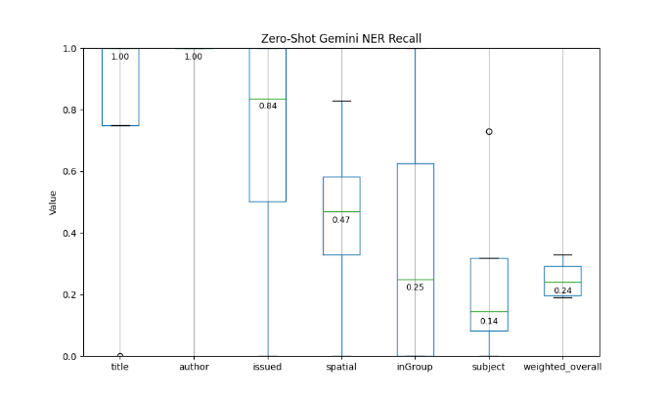 | 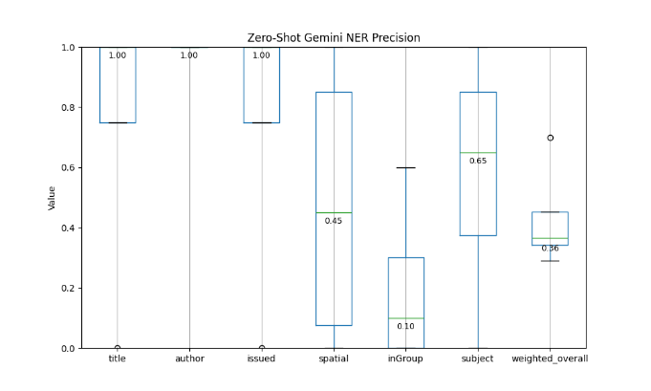
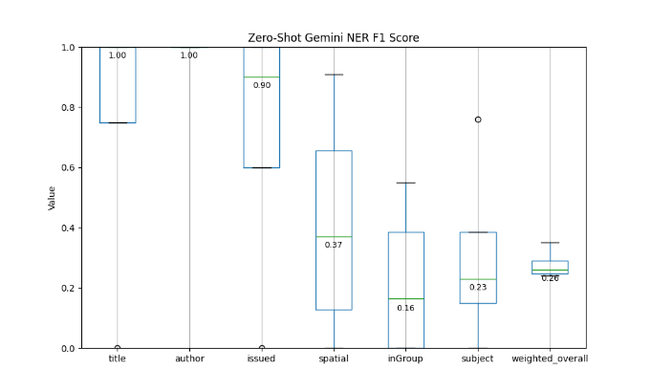 | 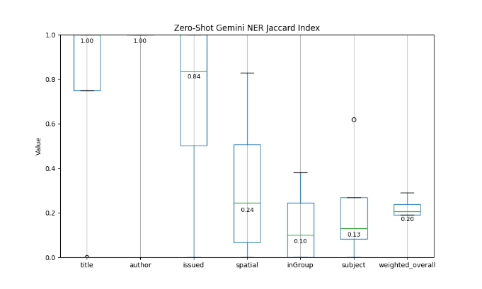

Gemini model few-shot
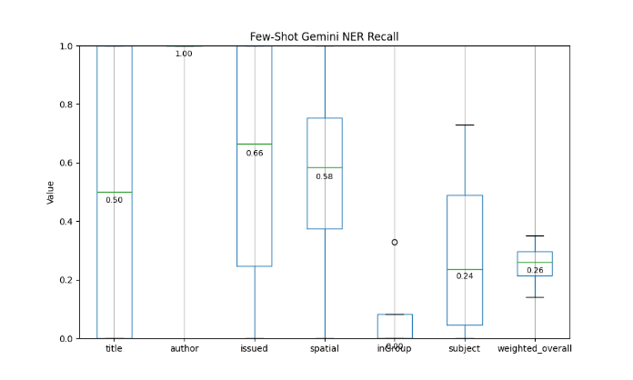 | 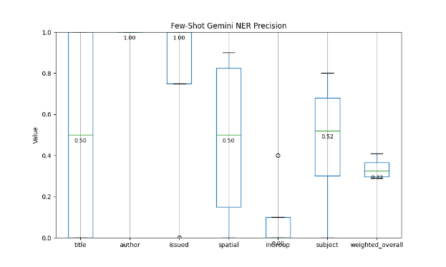
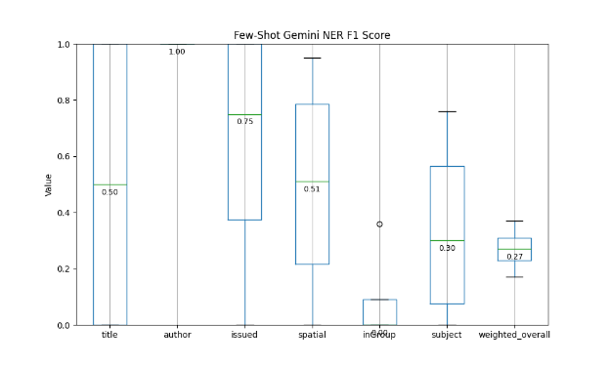 | 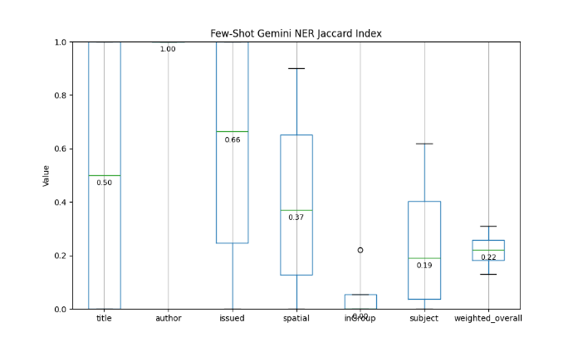

Inference
The model determined to produce the best results will be used for inference. The inference results of form the pool of entities for each thesis that can now be used for entity linking.

OTHER SECTIONS THAT I DON’T KNOW WHERE THEY BELONG ANYMORE:
The comparison was motivated by need to find the model that is most appropriate for the available training data. While BERT and related architectures are commonly used for NER, most models assume that the training data is fully and consistently annotated (Jie et al., 2019). They struggle when a large proportion of the entities are labeled as outside (O) due to incomplete annotation. As specified in the annotation guidelines, human annotators only labeled the first five instances of each entity, and restricted their work to the main sections, leaving the rest of the text untouched (annotated entities were automatically propagated to other occurrences of the same entity in the text). Consequently, while most identified entities are correct, not all relevant entities were identified, and examples of the negative class are not reliable. This creates noisy training data, which undermines the effectiveness of the BERT model’s fine-tuning. Training and evaluation loss are commonly used to describe model convergence during training, but because of the high ratio of O-labels relative to all other labels (0.9975%), loss approaches zero even if entity predictions are incorrect. A large language model that can reason and has access to web content may be able to rely less on training data and more on background knowledge.
A further limitation of BERT models is their context window of just 512 tokens. Give that the training theses have an average word count of more than 40 thousand, texts need to be split into smaller sequences. While this is a reasonable approach for training for sentence-level learning, it limits the opportunity for document-level learning. Gemini models can have context windows of more than a million tokens, allowing them to process entire theses. This allows them to benefit from document-level patterns such as that the Title and Author are always found near the beginning of a document, and that the subject label should only appear a few times in a document.

Appendix: Gemini-3-flash prompts
Few-shot prompt:
Named Entity Recognition task in Dutch.

Below are 2 examples showing the text of human-geography theses. Each word in the thesis is labeled as a title (Title of the thesis), author(Author of the thesis), issued (Time of publication), spatial (The spatial extent, study area or spatial coverage of the entire thesis, given as placenames or place descriptions), subject (Concept that is the main subject of the thesis), inGroup (the group of persons studied), or as O (empty label). Non-empty labeled can start with a B- to indicate the beginning of an entity span, or as I- to indicate the inside of an entity span. After reading the examples, extract the tags from the new thesis text, and return it as a JSON, where each key is a label and each value is a list of entities that have that label. Only extract entities that are in the text. Follow the annotation rules.

Annotation rules:

• Don’t tag exhaustively, but only the first 5 mentions (e.g. a particular place, or a particular method) of any given concept in those sections that should be searched
• Restrict search to particular sections: Don’t use TOC, no prefaces. Focus on the main sections (introduction/method/conclusion). Avoid using sections literature review, background, results, or TOC or literature list
• If several different concepts are mentioned in a sentence, annotate them separately
• inGroup: should be specific for the research design
• Subject: Leave out subjects unless there is explicitly a conceptual model (key-concepts)
• Spatial: the largest extent of the research area related to a goal/question. Any spatial level that links to a different research goal can appear separately. In case there is no placename available for this, encode the information on most specific level that is there (“plein in Amersfoort”).

Examples:

Example 1:
[Text of training thesis 1]

Example 2:

[Text of training thesis 2]

Please annotate the following student thesis:

[Text of Evaluation thesis]

"""

Zero-shot prompt:
Named Entity Recognition task in Dutch.

Label each word in this human-geography thesis as a title (Title of the thesis), author(Author of the thesis), issued (Time of publication), spatial (The spatial extent, study area or spatial coverage of the entire thesis, given as placenames or place descriptions), subject (Concept that is the main subject of the thesis), inGroup (the group of persons studied), or as O (empty label). Return it as a JSON, where each key is a label and each value is a list of entities that have that label. Only extract entities that are in the text. Follow the annotation rules.

Annotation rules:

• Don’t tag exhaustively, but only the first 5 mentions (e.g. a particular place, or a particular method) of any given concept in those sections that should be searched
• Restrict search to particular sections: Don’t use TOC, no prefaces. Focus on the main sections (introduction/method/conclusion). Avoid using sections literature review, background, results, or TOC or literature list
• If several different concepts are mentioned in a sentence, annotate them separately
• inGroup: should be specific for the research design
• Subject: Leave out subjects unless there is explicitly a conceptual model (key-concepts)
• Spatial: the largest extent of the research area related to a goal/question. Any spatial level that links to a different research goal can appear separately. In case there is no placename available for this, encode the information on most specific level that is there (“plein in Amersfoort”).

Please annotate the following student thesis:

[Text of Evaluation thesis]

"""

https://huggingface.co/GroNLP/bert-base-dutch-cased
https://ai.google.dev/gemini-api/docs/prompting-strategies
https://huggingface.co/GroNLP/bert-base-dutch-cased

