Heart Fenics Graphical interface
User manual and developer manual

Written by:
Carmen Alonso Montes (calonso@bcamath.org)

In collaboration with Jeanette Spühler (KTH)
spuhler@csc.kth.se

November 2016

This project has been developed thanks to the funding provided by the mobility grant José Castillejo CAS16/00171 granted by Ministerio de Educación, Ciencia y Deporte (MECD), Spain (2016) and the Severo Ochoa (SEV-2013-0323) (Spain)

Motivation
This interface is intended to help the group in the automation of the heart simulation process using FeniCS-HPC. The graphical interface has been designed by Carmen Alonso Montes (BCAM), thanks to the contribution and requirements provided by Jeanette Spühler (KTH).
This version is still under a very preliminary phase, with basic functionality.
This graphical interface is licensed under the terms and conditions applied by LGPL v3.0 license.

User manual
In this section, an example will be used to show the main functionalities of the GUI.
To use this GUI, some basic information must be taken into account. You always need to create a project to start working with the GUI. This project will contain the main information that can be saved, and loaded later on. Please, at the moment, follow this instructions, since this is really a preliminary version. If you find any bug, please, go to the website, and communicate to calonso@bcamath.org.
This GUI has been developed in C++ and Qt, using QtCreator

Installation


Create a project
You will need to create a new project, to start working with the GUI. You can create a new project or open an existent one.

Create a new project
When you create a new project, you need to provide a name and a location where you want to store the basic information of your project. Remember, that a new folder with the name of the project will be created, storing there all the information.

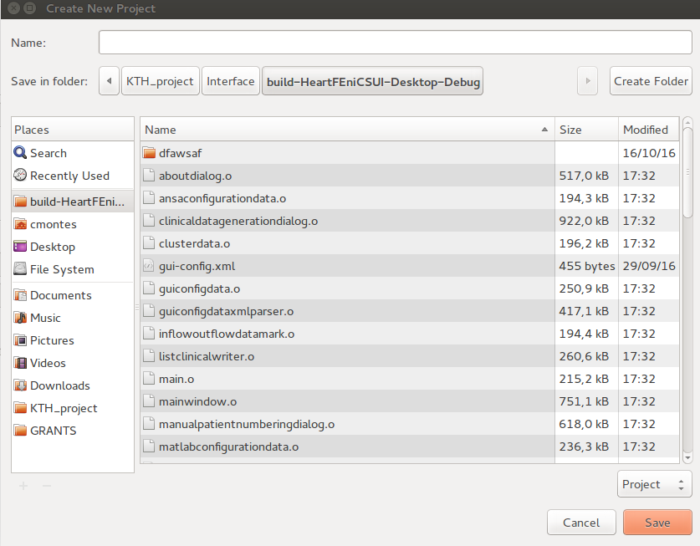
Open an existent project
You only need to go to the folder of an existing project and open the correspondent .prj file. All the information of the project will be automatically loaded in the different menus.
Creating and selecting the patients
Once you are in a project, you can go to the Simulation Tab.
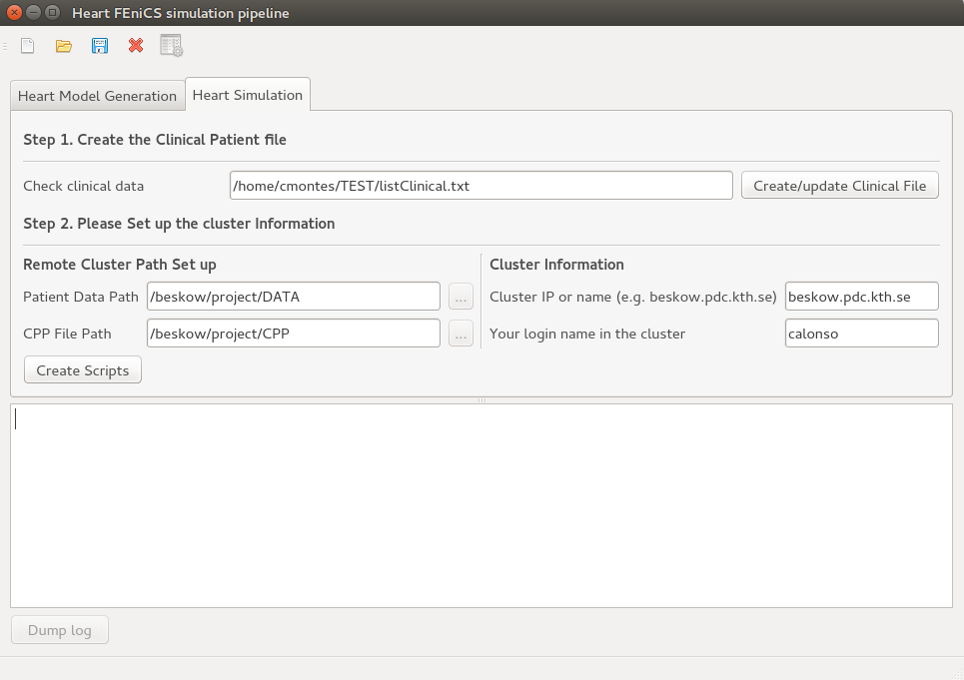
In the simulation Tab, you have several information to be filled in. This information will be used to create the two main scripts: launcher.sh and execute.sh

Step 1. Create the Clinical Patient File
This step indeed, is the one that will allow you to select those patients that you want to include in your simulation. Press Create/Update Clinical File Button
Note: The listClinical.txt file will be created in your client data root path. So, it is suggested, that you have all your patient data in a common folder, e.g. /home/Data/ (and inside Data, will be a folder for each patient). The listClinical.txt will be created in Data/listClinical.txt
When you press the button, a new window appear. Please, go for all the steps in order.
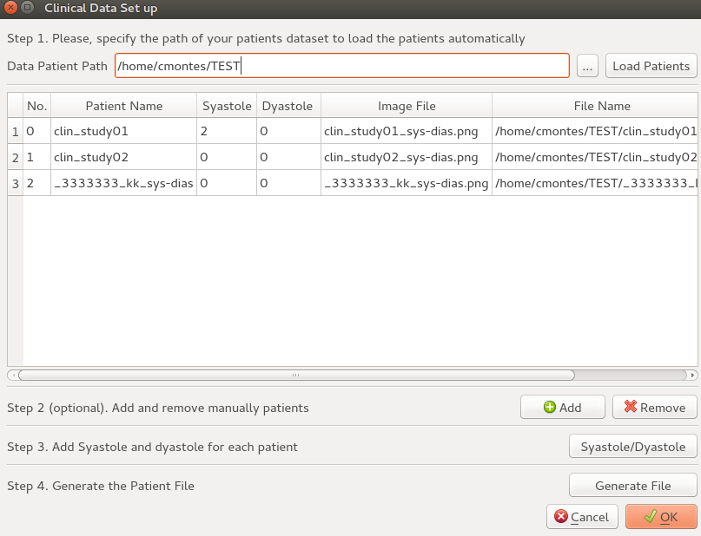
Step1. You need to select the folder where you have your client data (e.g. /home/Data) so press the tool button
Then you need to push Load Patients, to define the rules of inclusion/exclusion to select those patients that must be included in your study. A new window appear.
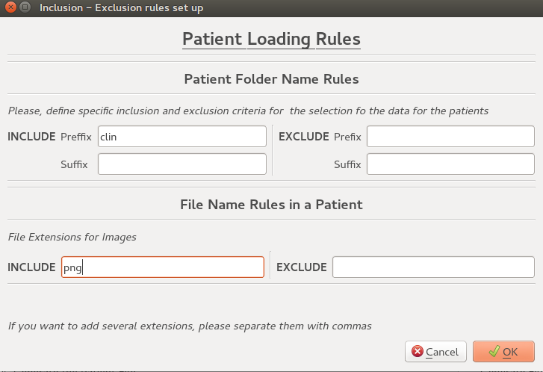
In this window you must select:
1. Preffix and suffix for the patients names (those names that are used in the patient folder name) that will be included in your study, and those to be excluded
2. Select the file extension for include/exclude the type of syastole/dyastole file image per each patient.
Note: The syastole/dyastole file image must be inside each patient folder in this format (and only 1 image per patient):/home/Data/mypatient/mypatient_syastole_dyastole.png
Step 2 (Optional) You can add manually patients, and also remove them.
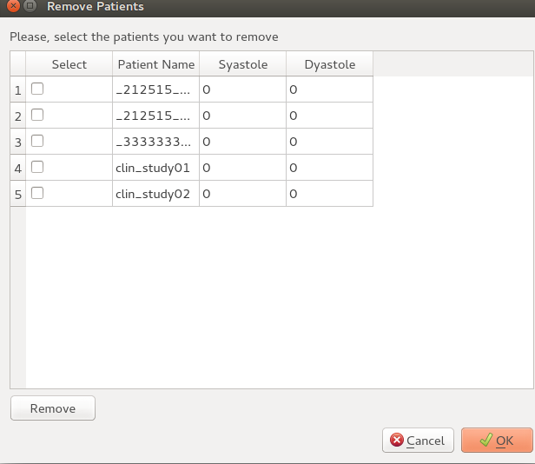
Step 3. You must check the values for dyastole and syastole of each patient. If you click the button, a new window appear. You willl see the image of each patient and you can change the values accordingly.
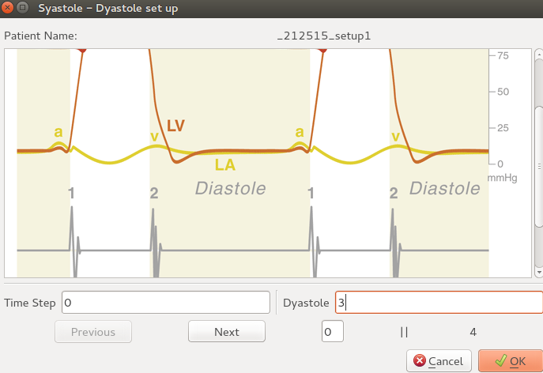
Step 4. You MUST generate the file, otherwise, all your changes will be lost. When you click, the file will be create at the root folder of your Data path. In the example: /home/Data/llistClinical.txt

Step 2. Cluster information
This information is needed to create the scripts correctly to launch the simulations in the cluster. You need to set up the paths of your data and cPP files in your cluster, and the cluster basic information (IP, and your login name)
Creating the files to execute the simulation
You need to click the create scripts button in the Simulation Tab.
Once you click, this step creates two scripts in the folder of your project (where the .prj file is stored):
- * launcher.sh
- * execute.sh
Launcher.sh → Is the basic script you will need to launch in consle mode, in a console with the ticket information (in our case, Kerberos) to be able to communicate with your cluster. It contains the instructions to:
- Copy all the files of the data patients in the cluster, reproducing the same structure than in your local computer
- Copy ListClinical file into the cluster computer in the correspondent folder of the patient data
- Copy Execute.sh file into the CPP folder in the cluster
- Ssh into the cluster, so you will be able to launch your simulations.
Execute.sh → This file contains the basic information to build all the files needed to launch the simulation in the cluster.

Developers manual
Check Doxygen documentation generated.

Note: At the moment, only the functionality related with the simulation tab is available. So, although, some elements of the interface (like the preferences) can be already set up by the user, they don't affect currently in the process for the simulation process.

