## Create tiles of a GeoTiff map using MapTiler

You can download MapTiler here http://www.maptiler.org/

Firstly, you have to select the Tile profile. Choose Google Maps Compatible (Spherical Mercator) for standard web publishing. Choose Google Earth (KML SuperOverlay) if you also want to generate a KML file for use in Google Earth. Click “Continue”.

Then you need to choose the Source Data Files. Browse to select the raster image you want to tile. It is also possible to select a NODATA colour that will appear as transparent in the resulting image. You have to click “Add” and select the file you want to create tiles for. Once you have choose you file, you click “Georeference”.

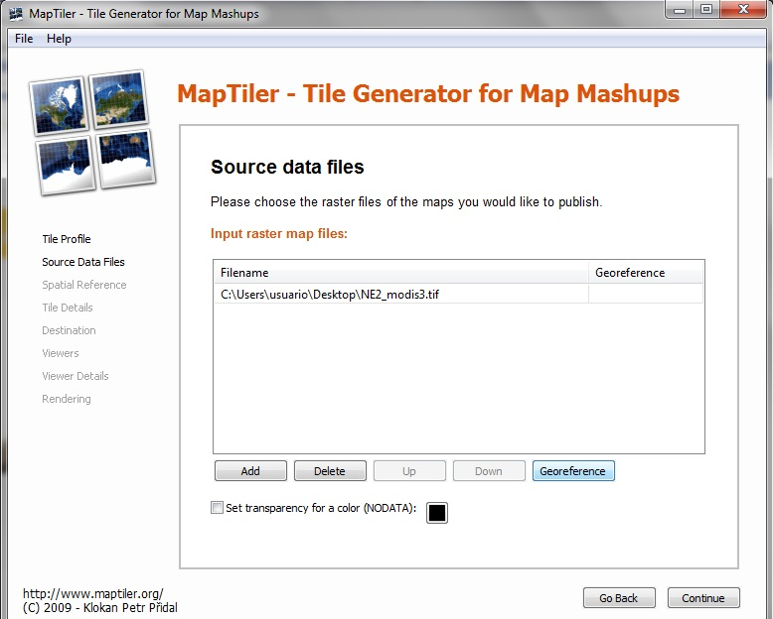

After that, click “Continue”.

Then you need to specify the Spatial Reference System / Coordinate System of the image. For all images that are in the British National Grid, it is recommended to specify this using the drop-down list. Specify the id-number from the EPSG/ESRI database. It is important that the transformation should include the [EPSG:27700 with TOWGS84](http://help.maptiler.org/coordinates/europe/uk) parameter. Click “Continue”.

At this point, you can set the minimum and maximum zoom levels, and choose the file format. The default settings for zoom levels and file format are often best. Click “Continue”.

Then, you could specify details about the Destination folder and Addresses / URLs for the tileset. If you do not know these, they can be added into the default googlemaps.html and openlayers.html files after tile generation. Click “Continue”.

After that, tick the Viewers that should be generated. By default, a googlemaps.html and openlayers.html file are generated. You can also choose to generate a KML SuperOverlay file for Google Earth. Click “Continue”.

Finally, you can specify the details for generating the Viewers, such as the title, copyright notice, and API keys. If you do not know these, they can be added into the default googlemaps.html / openlayers.html files after tile generation. Click “Continue”.

The last step is to click “Render” to start rendering the image. When complete, MapTiler provides a link to the finished tileset. Open the googlemaps.html or openlayers.html files in a web browser to view the tileset as an overlay.

## Publish tiles in a server

You only need to copy the entire tileset and all subdirectories to a web server.

Then you can edit the googlemaps.html or openlayers.html files as required to present this on the web.