## Create tiles of a GeoTiff map using MapTiler

You can download MapTiler [here](http://www.maptiler.org/).

MapTiler is a desktop application for the creation of map tiles for rapid raster map publishing. Geodata is transformed to tiles compatible with Google Maps and Earth - ready for publishing via direct upload to any webserver or a cloud storage (such as Amazon S3).

No extensive configuration on the server side is necessary, any simple file hosting is fine. Dynamic interaction such as panning and zooming, overlay of markers and vector data is provided by powerful browser functionality.

The application directly generates a ready to use simple viewer based on OpenLayers and Google Maps API and can be easily customized.

MapTiler is graphical interface for [GDAL2Tiles utility](http://www.klokan.cz/projects/gdal2tiles/), but much faster and needing less space to store the tiles. As an example to compare: rendering of map (51025x73135 pixels) with raster reprojection on a standard [computer](http://www.maptiler.org/) with 16 cores against GDAL2Tiles:

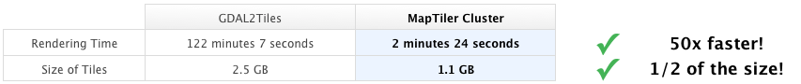

## How to use it

Firstly, you have to select the Tile profile. Choose Google Maps Compatible (Spherical Mercator) for standard web publishing. Choose Google Earth (KML SuperOverlay) if you also want to generate a KML file for use in Google Earth. Click the “Continue” button.

Then you need to choose the Source Data Files. Browse to select the raster image you want to tile. It is also possible to select a NODATA color that will appear as transparent in the resulting image. The NOData color allows you to hide or highlight these values. Usually the NOData color is set to transparent, so that the NOData values are hidden. You have to click “Add” and select the file you want to create tiles for.

Once you have choose you file, you click “Georeference”. Here you can specify the bounding box for your image.

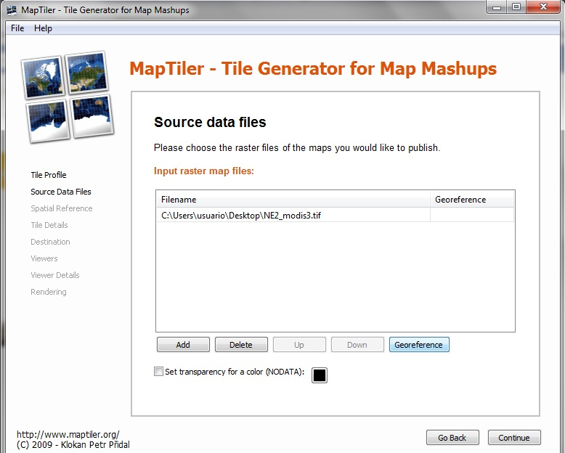

After that, click the “Continue” button.

Then you need to specify the Spatial Reference System / Coordinate System of the image. Most of the geodata formats (like GeoTIFF) contains the definition of the Coordinate Reference System already - then it is used by MapTiler automatically. In case it is not like this, you can find more information in [MapTiler help](http://help.maptiler.org/coordinates/) Click the “Continue” button.

At this point, you can set the minimum and maximum zoom levels, and choose the file format. The default settings for zoom levels and file format are often best. Click the “Continue” button.

Then, you could specify details about the Destination folder and Addresses / URLs for the tileset. If you do not know these, they can be added into the default googlemaps.html and openlayers.html files after tile generation. Click the “Continue” button.

After that, tick the Viewers that should be generated. By default, a googlemaps.html and openlayers.html file are generated. You can also choose to generate a KML SuperOverlay file for Google Earth. Click the “Continue” button.

Finally, you can specify the details for generating the Viewers, such as the title, copyright notice, and API keys. If you do not know these, they can be added into the default googlemaps.html / openlayers.html files after tile generation. Click the “Continue” button.

The last step is to click “Render” to start rendering the image. When complete, MapTiler provides a link to the finished tileset. Open the googlemaps.html or openlayers.html files in a web browser to view the tileset as an overlay.

## Publish tiles in a server

You only need to copy the entire tileset and all subdirectories to a web server.

Then you can edit the googlemaps.html or openlayers.html files as required to present this on the web.