Full Manuscript

Title Page

Title: Living in a non-industrialized environment associated with reduced sexual dimorphism in immune cell counts and neutrophil-lymphocyte ratio across the lifespan

Authors
Carmen Hove*¹, Michael D Gurven¹, Amy Boddy¹, Benjamin C Trumble², Jonathan Stieglitz³, Hillard Kaplan⁴, Aaron D Blackwell*⁵
¹ Department of Anthropology, University of California Santa Barbara, Santa Barbara, California, 93106
² Center for Evolution and Medicine, School of Human Evolution and Social Change, Arizona State University, Tempe, Arizona, 85287
³ Institute for Advanced Study in Toulouse, Toulouse, France, 31015
⁴ Economic Science Institute, Chapman University, Orange, California, 92866
⁵ Department of Anthropology, Washington State University, Pullman, Washington, 99164
Corresponding Authors*
Carmen Hove
Email: carmenhove@ucsb.edu
Phone: (360) 621-3508
Aaron Blackwell
Email: aaron.blackwell@wsu.edu
Phone: (805) 253-2796

Classification
Major: Biological Sciences
Minor: Immunology and Inflammation

Keywords

Abstract
Within industrialized societies, females benefit from lower infectious disease burden and lower risk of non-reproductive cancers but suffer disproportionately from autoimmune disease. Considering the role that sex hormones play in shaping sex differences in immune function and the sensitivity of female ovarian function to energetic conditions, evolutionarily novel conditions common to industrialized populations (e.g., energetic excess, reduced parity) may exacerbate evolved sex differences in immunity. To test this hypothesis, we estimate and compare the age-specific effects of sex and female reproductive state (accounting for parity) on leukocyte differential and neutrophil-to-lymphocyte ratio (NLR) among the Tsimane (a non-industrialized population) and a representative sample from the USA. During the reproductive years, we report an outsized (and age-dependent) effect of pregnancy on sexual dimorphism in neutrophil count and NLR among females in the USA, with pregnant females having higher neutrophil count and NLR than their male peers. We also found that parity had a negative effect on these immune markers, but only among pregnant females in the USA. Lastly, we find that in the USA menopause is marked by a male bias in neutrophil, eosinophil, and monocyte count and NLR and female bias in lymphocyte count, with no such biases observed among the Tsimane. Take home messages go here

Significance Statement
Significance.

Main Text

Introduction

Overview
In post-industrial human populations, women benefit from comparatively reduced infectious disease burden and lower risk of non-reproductive cancers relative to men, but make up approximately 80% of autoimmune disease diagnoses (1) and suffer disproportionately from allergy and atopy (2). While variation in exposure risk may contribute to divergent infectious disease burden between men and women (3), there is strong evidence that incomplete X-inactivation of immune-related genes during female development (4) and sex-specific hormone production (4–6) are evolutionarily conserved proximate mechanisms by which females mount stronger cellular and humoral responses to pathogens (7, 8), vaccination (9–11), and, in the case of autoimmune disease, auto-antigens. In terms of immune cell counts, prior research indicates that eosinophil count (12), monocyte count (13), and total lymphocyte count are higher in males (due, in large part, to a greater prevalence of regulatory T cells) while neutrophil count, neutrophil-to-lymphocyte ratio (14–17), B cell count, and antibody production are usually higher among females (18, 19) (Table 1). Within this body of research, however, there is considerable variation (15, 16, 20–23), likely due to varying inclusion criteria (e.g., exclusion of pregnant females) and age groups studied. Proposed selective pressures responsible for producing sex differences in immune function include development and maintenance of “costly” secondary male sex characteristics (24), sex-specific reproductive schedules (25), the need for increased transfer of antibodies to offspring during and after pregnancy (26), and enhanced maternal survival “in the presence of an invasive placenta and an immunologically challenging pregnancy” (Pregnancy Compensation Hypothesis) (27).
Evolutionarily novel environmental conditions common to industrialized populations (e.g., microbial deprivation, reduced energetic throughput, low parity) may exacerbate evolved sex differences in immunity via effects on female endocrine function (e.g., higher production of/sensitivity to ovarian sex hormones). As postulated in the Pregnancy Compensation Hypothesis, reduced parity among females in industrialized populations may also exacerbate evolved sex differences in immune function by creating a mismatch between proposed ‘compensatory’ immunological response patterns and less time spent gestating (27). Conversely, comparatively higher hormone production during pregnancy within industrialized populations (28) may heighten sexual dimorphism in immune function. To date, however, these hypotheses remain largely untested and current understanding of “normal” sexual dimorphism in immune status and disease risk in humans predominantly rests on studies done within post-industrial populations (e.g., China, the USA). In this study, we address this gap in knowledge by estimating and comparing the age-specific effects of sex, accounting for female reproductive state (premenarchal, regularly cycling, pregnant, postpartum, postmenopausal), on immune status among the Tsimane, a natural fertility non-industrialized population inhabiting the Amazonian river basin, and a representative sample from the United States. To determine the within-population effects of parity, we also test the non-linear effects of parity, stratified by female reproductive state.

Hormone production and immunological development are sensitive to ecological inputs
In humans, female reproduction requires significantly greater energetic investment than male reproduction; consequently, female ovarian function is especially responsive to environmental inputs. Comparative studies have shown that reduced energetic availability suppresses baseline ovarian function in females, resulting in lower progesterone and estradiol production across the ovarian cycle (29–31) as well as lower peaks in progesterone and estradiol during pregnancy (28). Conversely, positive energy balance and reduced metabolic load are associated with earlier age at menarche (32), elevated adult levels of estradiol (33) and progesterone (30), and shorter duration of lactational amenorrhea (31). In moderation, energetic availability is associated with enhanced fecundity (34) and greater immune competence (35). However, conditions characterized by caloric excess and/or unusually high exposure to estradiol and progesterone (e.g., obesity, oral contraceptive use) have been linked to greater risk of hypersensitivity to a broad range of antigens (36), including steroid hormones themselves (37). In males, the effects of energetic status on testosterone production are comparatively attenuated. While testosterone production among adult males is generally higher in industrialized populations (38) and some studies have found a relationship between increased energy expenditure and reduced testosterone (39), interpopulation variation in male testosterone is not as severe as variation in ovarian steroid production among females. Even within many non-industrialized populations (e.g., Datgoa, Hadza, Qom, Ache), energetic status is not strongly associated with variation in testosterone (38, 40). We therefore postulate that environmental conditions prevalent in industrialized populations (e.g., increased sedentism, energetic excess) exacerbate hormonally-mediated sex differences in immune function via disproportionately large effects on female ovarian function.
Different rates of exposure to certain pathogens during development may further contribute to population-level differences in sexual dimorphism in immune function, not just by altering the amount of energy allocated to hormone production, but by changing the number of opportunities for immunological calibration. In the United States, for example, public health measures have substantially reduced infectious disease burden (41, 42). These interventions have resulted in increased life expectancy (43) but have also been linked to the rise of chronic inflammatory disorders characterized by hypersensitivity to non-pathogenic antigens (e.g., atopy, autoimmune disease) (44). One explanation for this relationship is that exposure to pathogens during development primes the immune system to differentiate between pathogenic and non-pathogen antigens and, in certain cases, induce immunological tolerance. Existing data indicate that people living in a non-industrialized context characterized by elevated pathogen load exhibit higher baseline levels of most immune markers (45, 46) but very low incidence of allergy or autoimmune disease (47–50) and, among females, less immunological activation (e.g., lower peak in neutrophil count and C-reactive protein) during pregnancy (51). Taken together, these pattern suggest that a combination of relatively unfettered female sex hormone production and lack of calibrating opportunities (e.g., fewer encounters with helminths) may increase immunological responsivity to potential allergens and auto/semi-auto antigens and therefore contribute to the high incidence of autoimmune disease observed among women in industrialized populations.

Objectives and predictions
In this study, we evaluate the overarching hypothesis that the magnitude of sexual dimorphism in leukocyte differential and neutrophil-to-lymphocyte ratio (NLR) in a natural-fertility non-industrialized population is substantially lower than in an urban post-industrial context (Table 1). To do so, we utilize data from two distinct populations experiencing vastly different environments: the Tsimane, a natural-fertility subsistence population inhabiting the Amazonian River basin, and a representative sample from the United States.
Considering the well-documented effects of female reproductive status on hormone production and the unique immunological challenges of pregnancy (i.e., tolerance of fetal antigens), we use generalized additive models (GAMs) to estimate and compare the population-specific smooth effects of age on immune measures by sex and female reproductive state (premenarchal, regularly cycling, pregnant, 0-12 months postpartum, and postmenopausal). Using these models, we tested the following predictions:
- Within both populations, sexual dimorphism will be greatest among reproductive-aged individuals.
- Since estradiol and progesterone levels are elevated above baseline during pregnancy (52), immune changes during gestation may drive a large proportion of sexual dimorphism within each population.
- Given the reversal of pregnancy-induced hormonal patterns, suppression of ovulation (52) and the removal of the need for fetal tolerance, postpartum females may exhibit less divergent immune profiles from their male counterparts.
- Given the drop-off in female hormone production after menopause and some evidence that sex biases are either attenuated or reversed in later ages (14) we expect that sexual dimorphism in immune status will be reduced among postmenopausal women and age-matched men.
Lastly, we estimate the within-population age-specific effects of parity on immune status among regularly cycling, pregnant, postpartum, and postmenopausal females and evaluate the following hypotheses:
- It has been hypothesized (as part of the Pregnancy Compensation Hypothesis) that reduced parity exacerbates sexual dimorphism by creating a mismatch between evolved immunological compensation needed during pregnancy and less time spent being pregnant (27).
- On the other hand, current evidence suggests that hormone levels in “normal” pregnancy among females in the USA are, on average, much higher than observed in “normal” pregnancy among females in non-industrialized populations (28) - therefore increased parity may exacerbate sexual dimorphism by increasing time spent exposed to especially high levels of ovarian hormones.

Results

In the USA, premenarchal females have lower eosinophil and monocyte counts than their male counterparts - a pattern not observed among the Tsimane
Among premenarchal females and their age-matched male peers in the USA, we find evidence of modest-yet-robust male bias in eosinophil count between ages 2 and 9 and monocyte counts between ages 3 and 9 and a modest-yet-robust female bias in total lymphocyte count from 2 to 4 - and again at age 11 (Figure 1A, Figure 1C, Table 2). Among premenarchal Tsimane females and their age-matched male peers, we find evidence of modest-yet-robust male bias in total lymphocyte count between the ages of 2 and 3, with no evidence of any other strong sex differences (Figure 1B, Figure 1D, Table 2). See Table 3 for the ages and values at which the absolute difference in white blood cell counts and NLR between premenarchal females and their male counterparts are greatest, separated by population and immune marker.

With the exception of total lymphocyte count, regularly cycling females in the USA exhibited greater and more sustained differences from their age-matched male peers
Within the USA, regularly cycling females had higher neutrophil and white blood cell counts compared to their age-matched male peers between the ages of 14 and 18, constituting 13.51% of the 37-year age span represented in our data. We found that regularly cycling females also had higher NLR from ages 43 to 50 (21.62% of the represented age span). Conversely, from ages 19 to 49, regularly cycling females had lower monocyte counts (83.78% of the age span). For all other ages and immune markers, estimated median values among cycling females overlapped with estimated median values among age-matched males (Figure 1A, Figure 1C, Table 2).
Among the Tsimane, regularly cycling females had lower total lymphocyte counts compared to their age-matched male peers between the ages of 14 and 26 (35.14% of the represented age span). For all other ages and immune markers, estimated median values among cycling females overlapped with estimated median values among age-matched males (Figure 1B, Figure 1D, Table 3).

During the female reproductive lifespan, pregnancy is the primary driver of sexual dimorphism in most immune measuresin both populations
Among pregnant females in the USA, the estimated non-linear effects of age on neutrophil count (F = 4.146; P-value = 0.006) and NLR (F = 8.513; P-value = 0.000) were robust (Figure 1A, Figure 1C). Pregnant women at both younger and older ages exhibit relatively lower neutrophil and total white blood counts and NLR (and therefore increased similarity to their age-matched cycling, postpartum, and male peers). We also found negative effects of parity on neutrophil count (F = 4.144; P-value = 0.011), monocyte count (F = 3.675; P-value = 0.055), and NLR (F = 21.035; P-value = 0.000) among pregnant females in the USA (Figure 2, , Table S4). Controlling for parity, neutrophil count and total white blood cell count among pregnant females were higher than their age-matched male peers from ages 17 to 41, making up 89.29% of the 28-year age span represented in our data. Consequently, NLR was higher from ages 20 and 41 (78.57% of the represented age span). As shown in Table 3, the greatest absolute sex difference in NLR within the US population occurred between pregnant females age 31 and their age-matched male peers, with a female ratio of 3.16 (95% CI: 2.92-3.4) and a male ratio of 2.01 (95% CI: 1.92-2.09). Conversely, pregnant women in the USA had lower total lymphocyte count than their age-matched male peers between ages 33 and 41 (32.14% of the represented age span) and lower eosinophil counts than their age-matched male peers between ages and 18 and 44 (96.43% of the represented age span). The only immune marker that varied between postpartum women in the USA and their age-matched male peers was monocyte count, which was lower among postpartum females from ages 20 to 47 (100% of the represented age span). We did not find any robust effects of parity on immune measures among postpartum females in the USA (Figure 2, , Table S4).
Among pregnant Tsimane females, NLR was higher than their age-matched male peers from ages 17 and 44 (100% of age span), respectively. The greatest absolute sex difference in NLR among the Tsimane occurred between pregnant females at age 44 and their age-matched male peers, with a female ratio of 2.66 (95% CI: 2.14-3.19) and a male ratio of 1.88 (95% CI: 1.83-1.94). As shown in Figure 1C and Figure 1D, the estimated peak NLR among Tsimane women was substantially lower than the estimated peak in NLR among pregnant US women and occurred among women at a later age. Pregnant Tsimane women exhibited lower total lymphocyte count than their age-matched male peers between ages 17 and 35 (67.86% of the represented age span) and lower eosinophil counts than their age-matched male peers between ages and 24 and 32 (32.14% of the represented age span). The only immune marker that varied between postpartum Tsimane women and their age-matched male peers was monocyte count, which was higher among postpartum females from ages 35 to 47 (46.43% of the represented age span). We did not find any robust effects of parity on immune measures among pregnant or postpartum Tsimane females (Figure 2, , Table S5).

The transition to menopause is marked by more robust and sustained sexual dimorphism in the USA
Among postmenopausal women in the USA and their age-matched male peers, we find a female bias in total lymphocyte count between ages 47 and 69 (51.11% of the 45-year age span represented in our data). Conversely, we find a male bias in neutrophil count from ages 54 to 61 (17.78% of the represented age span), monocyte count from ages 40 to 81 (93.33% of the represented age span), and NLR from ages 51 to 83 (73.33% of the represented age span). In the USA, the greatest absolute sex difference in NLR among postmenopausal females and their age-matched male counterparts occurred at age 83, with a female ratio of 2.28 (95% CI: 2-2.56) and a male ratio of 2.84 (95% CI: 2.59-3.1).
Among postmenopausal Tsimane women and their age-matched male peers, we find a male bias in NLR between ages 58 and 64 (15.56% of the represented age span). Among the Tsimane, the greatest absolute different in NLR among postmenopausal females and their age-matched male peers occurred age 84, with a female ratio of 1.97 (95% CI: 1.65-2.28) and a male ratio of 2.61 (95% CI: 2.29-2.93).

Increased parity associated with lower neutrophil count and NLR, but only among pregnant females in the USA
We did not find any robust effects of parity on immune outcomes among regularly cycling, pregnant, or postpartum Tsimane females or regularly cycling or postpartum females in the USA (Figure 2, Table S4, Table S5). We did, however, find strong negative effects of parity on neutrophil count (F = 4.144; P-value = 0.011), monocyte count (F = 3.675; P-value = 0.055), and NLR (F = 21.035; P-value = 0.000) among pregnant females in the USA (Figure 2, Table S5). Among postmenopausal females in both populations, we find a non-linear effect of parity on NLR (Figure 2, Table S4, Table S5). Among postmenopausal Tsimane females, we also find a negative effect of parity on eosinophil count (F = 10.293; P-value = 0.001), but otherwise find no robust effects of parity in this function age group.

Discussion
The differences we find between premenarchal females in the USA and their age-matched male peers aligns with prior research on industrialized populations indicating an early male bias in eosinophil (12) and monocyte counts (23). The absence of any such early male bias in eosinophil and monocyte count among the Tsimane, however, suggests that this pattern is not universal. We find that eosinophil and monocyte counts vary less by age or reproductive state among all females in the USA, suggesting that these immune cell types may be less responsive to changes in ovarian sex hormone production than neutrophils and lymphocytes - even after puberty. Since these population differences cannot be attributed to differences in parity and appear less likely to stem from hormonal differences, more research is needed to elucidate the underlying mechanism(s). Perhaps these population differences stem from the relative absence of exposure to infectious disease in the USA, which may expose the effects of differential gene expression on baseline immune status beginning in childhood.
In both populations, we find that sexual dimorphism in NLR is greatest between pregnant females and their age-matched male counterparts, with pregnant females exhibiting substantially elevated NLR. Within the US population, we find a robust non-linear effect of age on NLR among pregnant females that we do not observe among the Tsimane. This finding may be due to age-dependent levels of estradiol during pregnancy within the US population: estradiol production among females in industrialized populations exhibits a similar non-linear relationship with age, peaking around the age of 30 (53). Among females in the USA, becoming pregnant at earlier or later ages may be characterized by lower levels of estradiol while chronic demands on energy allocation among the Tsimane may result in less variability in hormone production by age. Considering pregnancy is associated with short-term reduction of ovarian hormone production (54, 55), the absence of a non-linear effect of age on immune status among pregnant Tsimane women may also be due to earlier age at first birth and shorter interbirth intervals.
Among pregnant females in the USA, we also observe a negative effect of parity on neutrophil count and NLR, with high parity associated with reduced age-matched male-female differences and reduced differences between pregnant, regularly cycling, and postpartum females. Taken together, estimated NLR in the USA is highest among primiparous pregnant females around 29 years of age, with estimated values above pre-established NLR thresholds associated with “mild to moderate inflammation” (56). Approximately ~84% of females in the USA have at least one child (57), the average number of live births per woman in 2023 was 1.78 and, according to 2021 data from the Centers for Disease Control, the average woman in the USA gives birth for the first time at ~27 years old. National trends in the USA are therefore remarkably close to the demographic that we find to be the most “at risk” for particularly high NLR during pregnancy, based on our modeling. These patterns may explain pre-existing evidence that autoimmune diseases flare and/or emerge after pregnancy (58) and are predominantly diagnosed before the average age of menopause in industrialized populations (59), while cancer risk is also elevated after birth and cancers diagnosed post-delivery have significantly poorer prognosis (60, 61). During pregnancy, immediate deleterious effects of a big spike in NLR may be mitigated by the presence of the fetus/placenta and the associated suite of mechanisms known to induce fetal tolerance (e.g., regulatory T cell proliferation) (62). Deleterious effects on the mother may be more likely to emerge after delivery, when fetal/placental cues are removed. It is possible that the comparatively acute spike in NLR during pregnancy among women in the USA, in addition to relatively low rates of extended on-demand breastfeeding (63), may result in incomplete/longer postpartum immunological recovery and thus pave the way for immune dysregulation. Parsing out the effects of month since delivery on immune markers (and comparing them to the effects of month of pregnancy) will likely illuminate effects we were not able to separate out in this study.
Of the ~16% of females in the USA who do not give birth, it is unclear how many suffer from a fertility issue (e.g., endometriosis) and how many simply choose to forgo childbearing in the absence of any underlying medical issues. Likewise, it is unclear whether or not the risk of autoimmune disease, infection, and/or cancer varies between nulliparous females with and without underlying fertility issues that may separately impact disease risk. Given that we find comparatively little sexual dimorphism between regularly cycling females and their age-matched counterparts (even in the USA) and only minor effects of parity on immune status among postmenopausal females in the USA, we pose the following questions. Do nulliparous females without any underlying fertility issues have a reduced chance of developing autoimmune disease compared to low-parity parous women who begin their reproductive careers in the late-twenties/early-thirties? And if so, how does the risk within this category compare to that among high-party women who start their reproductive career relatively early?
Lastly, our results also indicate that the transition to menopause within the US population is marked by a comparatively greater and more sustained reduction in NLR among females and correspondingly larger and longer-lasting sex differences in this functional age group. This suggests that the transition to menopause is characterized by a more severe drop-off in ovarian hormone production among females in the USA and/or greater sensitivity of the immune system to the hormonal changes that occur during menopause. Parity did not have a strong effect on immune markers among postmenopausal females. Taken together, our findings indicate that females in the USA (especially those who have one or more pregnancies) experience a much higher degree of overall variability in neutrophil count and NLR across the lifespan when compared to their Tsimane counterparts, presumably as a result of greater vacillations in ovarian sex hormone production during different reproductive states.

Limitations
In this study, we were limited to data on immune cell counts. While useful in establishing a general understanding of immune profile, variability in cell counts does not perfectly map on to variation in cellular function or underlying gene expression. Future comparative work is needed to further investigate population-level differences in sexual dimorphism at deeper functional levels (e.g., oxidative bursts and release of extracellular traps by neutrophils). We especially recommend that future research parse out the effects of age, sex, female reproductive status, parity, and study population on neutrophil subtypes, especially low-density neutrophils (LNDs), as these have been identified as key players in the etiology of autoimmune disease (64).
Additionally, the comparisons we draw between the USA and the Tsimane should be interpreted in context. There is significant variation in socio-ecological conditions within non-industrialized societies that must be carefully considered, including differences in physical environment (e.g., altitude, seasonality, type of pathogen exposure) and social structure (e.g., population density, matriarchal versus patriarchal customs). For example, the Shuar (another indigenous population living in the Amazon) have overlapping but distinct pathogen exposure profiles compared to the Tsimane, as a result of differences in helminth exposure (45). Furthermore, there is considerable socio-ecological variation within industrialized societies (e.g., immigration status, ethnic background) that we chose to collapse based on the aims of this particular study.

Conclusions
The results of this study support our overarching hypothesis that the magnitude of sexual dimorphism in leukocyte differential and neutrophil-to-lymphocyte ratio is comparatively attenuated among the Tsimane. Specifically, we find outsized effects of pregnancy and menopause on female immune status in the USA and therefore outsized effects of these reproductive phases on interpopulation variation in the degree and duration of overall sexual dimorphism. We find that a strong negative effect of parity on neutrophil count, total white blood cell count, and NLR among pregnant females in the USA results in reduced sexual dimorphism between high-parity pregnant females and their age-matched male peers in this population. Conversely, we do not find a strong effect of parity on immune status among Tsimane females, regardless of reproductive state. Based on these findings, we argue that present understanding of “normal” sexual dimorphism in immune function is highly specific to the post-industrialized contexts in which these patterns have predominantly been studied and is heavily influenced by the inclusion/exclusion criteria used by existing studies (e.g., exclusion of pregnant females). We strongly recommend that any study of sex differences in immune status and disease risk explicitly consider the age, reproductive state, and (when applicable) parity of all females included in the study sample.

Methods

The Tsimane
The Tsimane are a relatively small subsistence population inhabiting the Bolivian Amazonian River basin. Among the Tsimane, chronic exposure to diverse pathogens causes high infectious disease morbidity and mortality across all ages (65–67), while incidence of allergies, atopy, autoimmune disease, obesity, and atherosclerosis is low (47–49). As a result of elevated pathogen burden, Tsimane individuals exhibit high levels of immune activation compared to Western clinical standards (45, 46). Such high investment in immune function results in trade-offs with growth during development (68) and high resting metabolic rate during adulthood (69), reflecting the substantial energetic demands of coping with pathogenic threats. The Tsimane are also a natural fertility population, with limited access to contraception and breastfeeding alternatives. As a result, Tsimane women have an average 9 live births over the reproductive lifespan (70) and exhibit nearly ubiquitous rates of on-demand breastfeeding following parturition, with a mean infant weaning age of 27 months (71).

Datasets
We used cross-sectional and longitudinal clinical and demographic data collected by the Tsimane Health and Life History Project (http://tsimane.anth.ucsb.edu/index.html) (45, 46, 67, 72, 73) between 2004 and 2014. Approval by the Gran Consejo Tsimane and by institutional review boards at the University of California, Santa Barbara and the University of New Mexico was obtained before any data were collected. Informed consent was provided by participants during a community-wide meeting open to all Tsimane residents and again at the individual level before each medical visit and interview. In the case of minors, parental consent was given before data were collected. Total leukocyte count was obtained via venous blood draws and determined with a QBC Autoread Plus dry hematology system (QBC Diagnostics). Relative fractions of neutrophils, eosinophils, lymphocytes, and monocytes were then measured manually by microscopy with a hemocytometer. Menarche was based on self-reported presence/absence of first menstrual cycle. Pregnancy status was determined during medical visits based on date of last menses, with urinary pregnancy tests administered by the physician when pregnancy was suspected. Pregnancies were cross-validated against subsequent annual demographic and census interviews, allowing detection of pregnancies that occurred between medical visits and pregnancies that went undetected during previous physician examinations (72). Menopause was determined based on reported absence of a menstrual cycle over the past 6 months.
To obtain a representative sample from the United States, we used publicly available cross-sectional NHANES data collected by the Centers for Disease Control (https://www.cdc.gov/nchs/nhanes/index.htm) between 2003 and 2016. Total and differential leukocyte counts were measured using the Coulter method. Females who were under the age of 8 (for which reproductive data were redacted) or who specifically reported absence of menarche were binned as premenarchal. Females who were not currently pregnant, had not given birth within the preceding 12 months, and who reported a regular menstrual cycle either at time of exam or within the preceding two months were binned as regularly cycling. Females who self-reported being pregnant and/or had a positive urine test at the time of exam were categorized as currently pregnant. Women who were not currently pregnant but had given birth within the past 12 months were considered postpartum. Finally, females who reported absence of regular menstruation due to menopause were binned as postmenopausal.

Sample Selection
Final THLHP and NHANES data sets were limited to males and females ages 2 to 84 with recorded white blood cell differential and body mass index (BMI). NLR was calculated by dividing neutrophil count by total lymphocyte count. We excluded females who reported reaching menopause before age 40 or who reported regular menstruation after the age of 70 (effectively removing outliers associated with very early versus delayed menopause and/or errors in the data). We also removed extreme values for immune cell counts and NLR by limiting our sample to values which fell between population-pooled 1% and 99% percentiles. However, given the ubiquity of chronic parasitic infections among the Tsimane, we did not exclude individuals with known infection or illness. In both populations, BMI varies considerably by age and sex (Figure S1), so we z-scored all BMI values using sex and age-specific mean values. No exclusions were based on medical diagnoses. Finally, we used the matchit package (74) to create matched THLHP and NHANES samples stratified by age, sex, and female reproductive phase (specifying nearest neighbor matching on propensity score) (Figure S2, Table S1).

Statistical Analyses
All models were executed in R 4.3.2 (https://cran.r-project.org) using the mgcv package (75). We employed generalized additive models (GAMs) to estimate the non-linear population-specific effects of age by sex and female reproductive phase (premenarchal, regularly cycling, pregnant, postpartum, postmenopausal) on total leukocyte, neutrophil, total lymphocyte, eosinophil, and monocyte count and neutrophil-to-lymphocyte ratio (NLR). All models also accounted for the fixed effects of z-scored BMI and the smoothed effects of parity, stratified by female reproductive phase (males and premenarchal females were all assigned parity values of zero). Due to repeat sampling of individuals within the THLHP dataset (Table S2), all THLHP-specific models accounted for the group-level random effects of participant identification number.

Figures
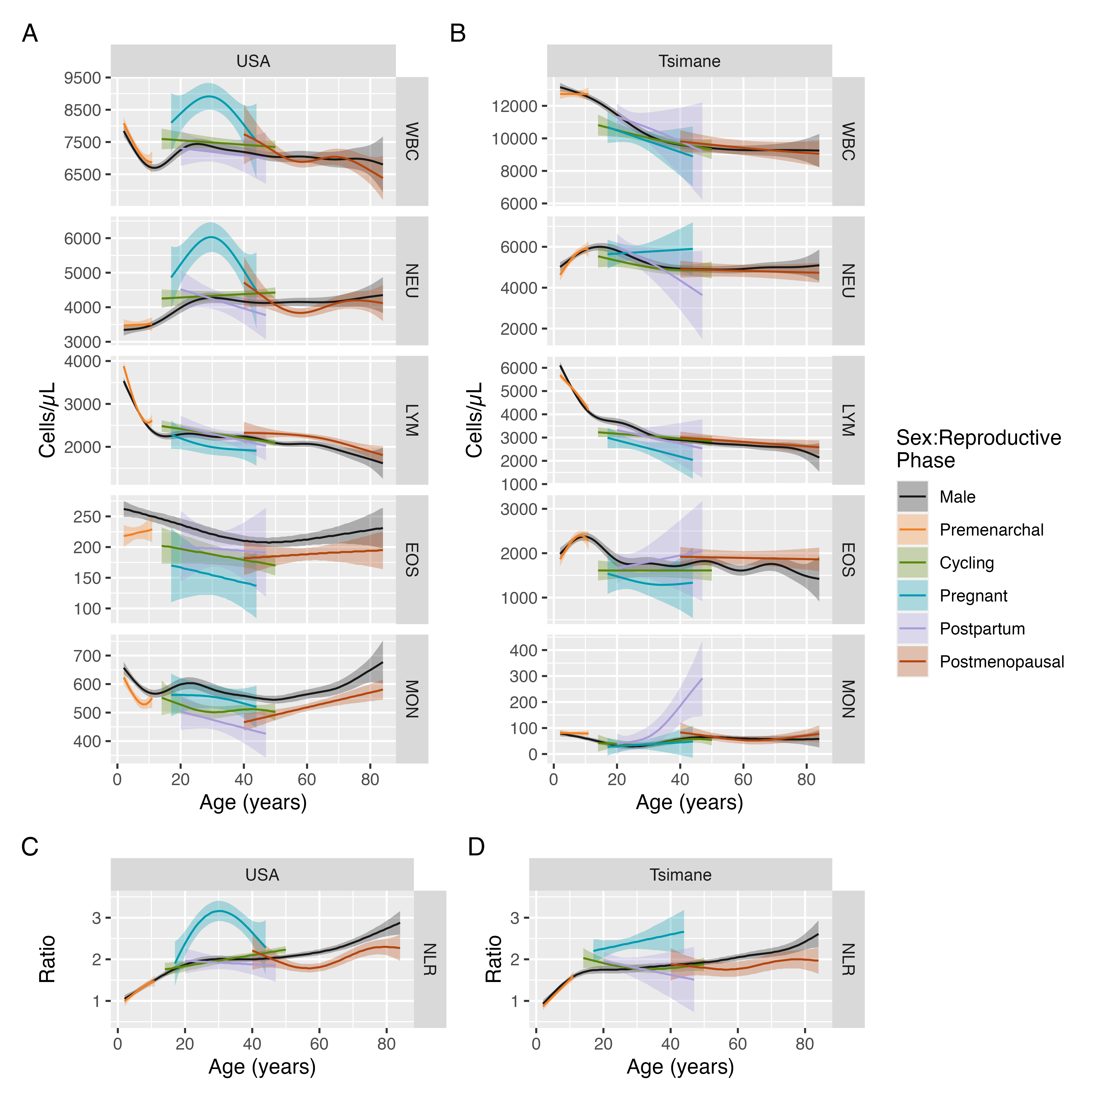
Fig 1. Non-linear effects of age by sex, separated by female reproductive status, on leukocyte differential and NLR (see Table 1) in the USA and among the Tsimane. Estimated values presented in this table are standardized by parity (set to 3 live births) and z-scored BMI (set to 0). Solid lines correspond to estimated median value, shaded regions correspond to 95% credible intervals. Please note that each variable is plotted on its own scale.

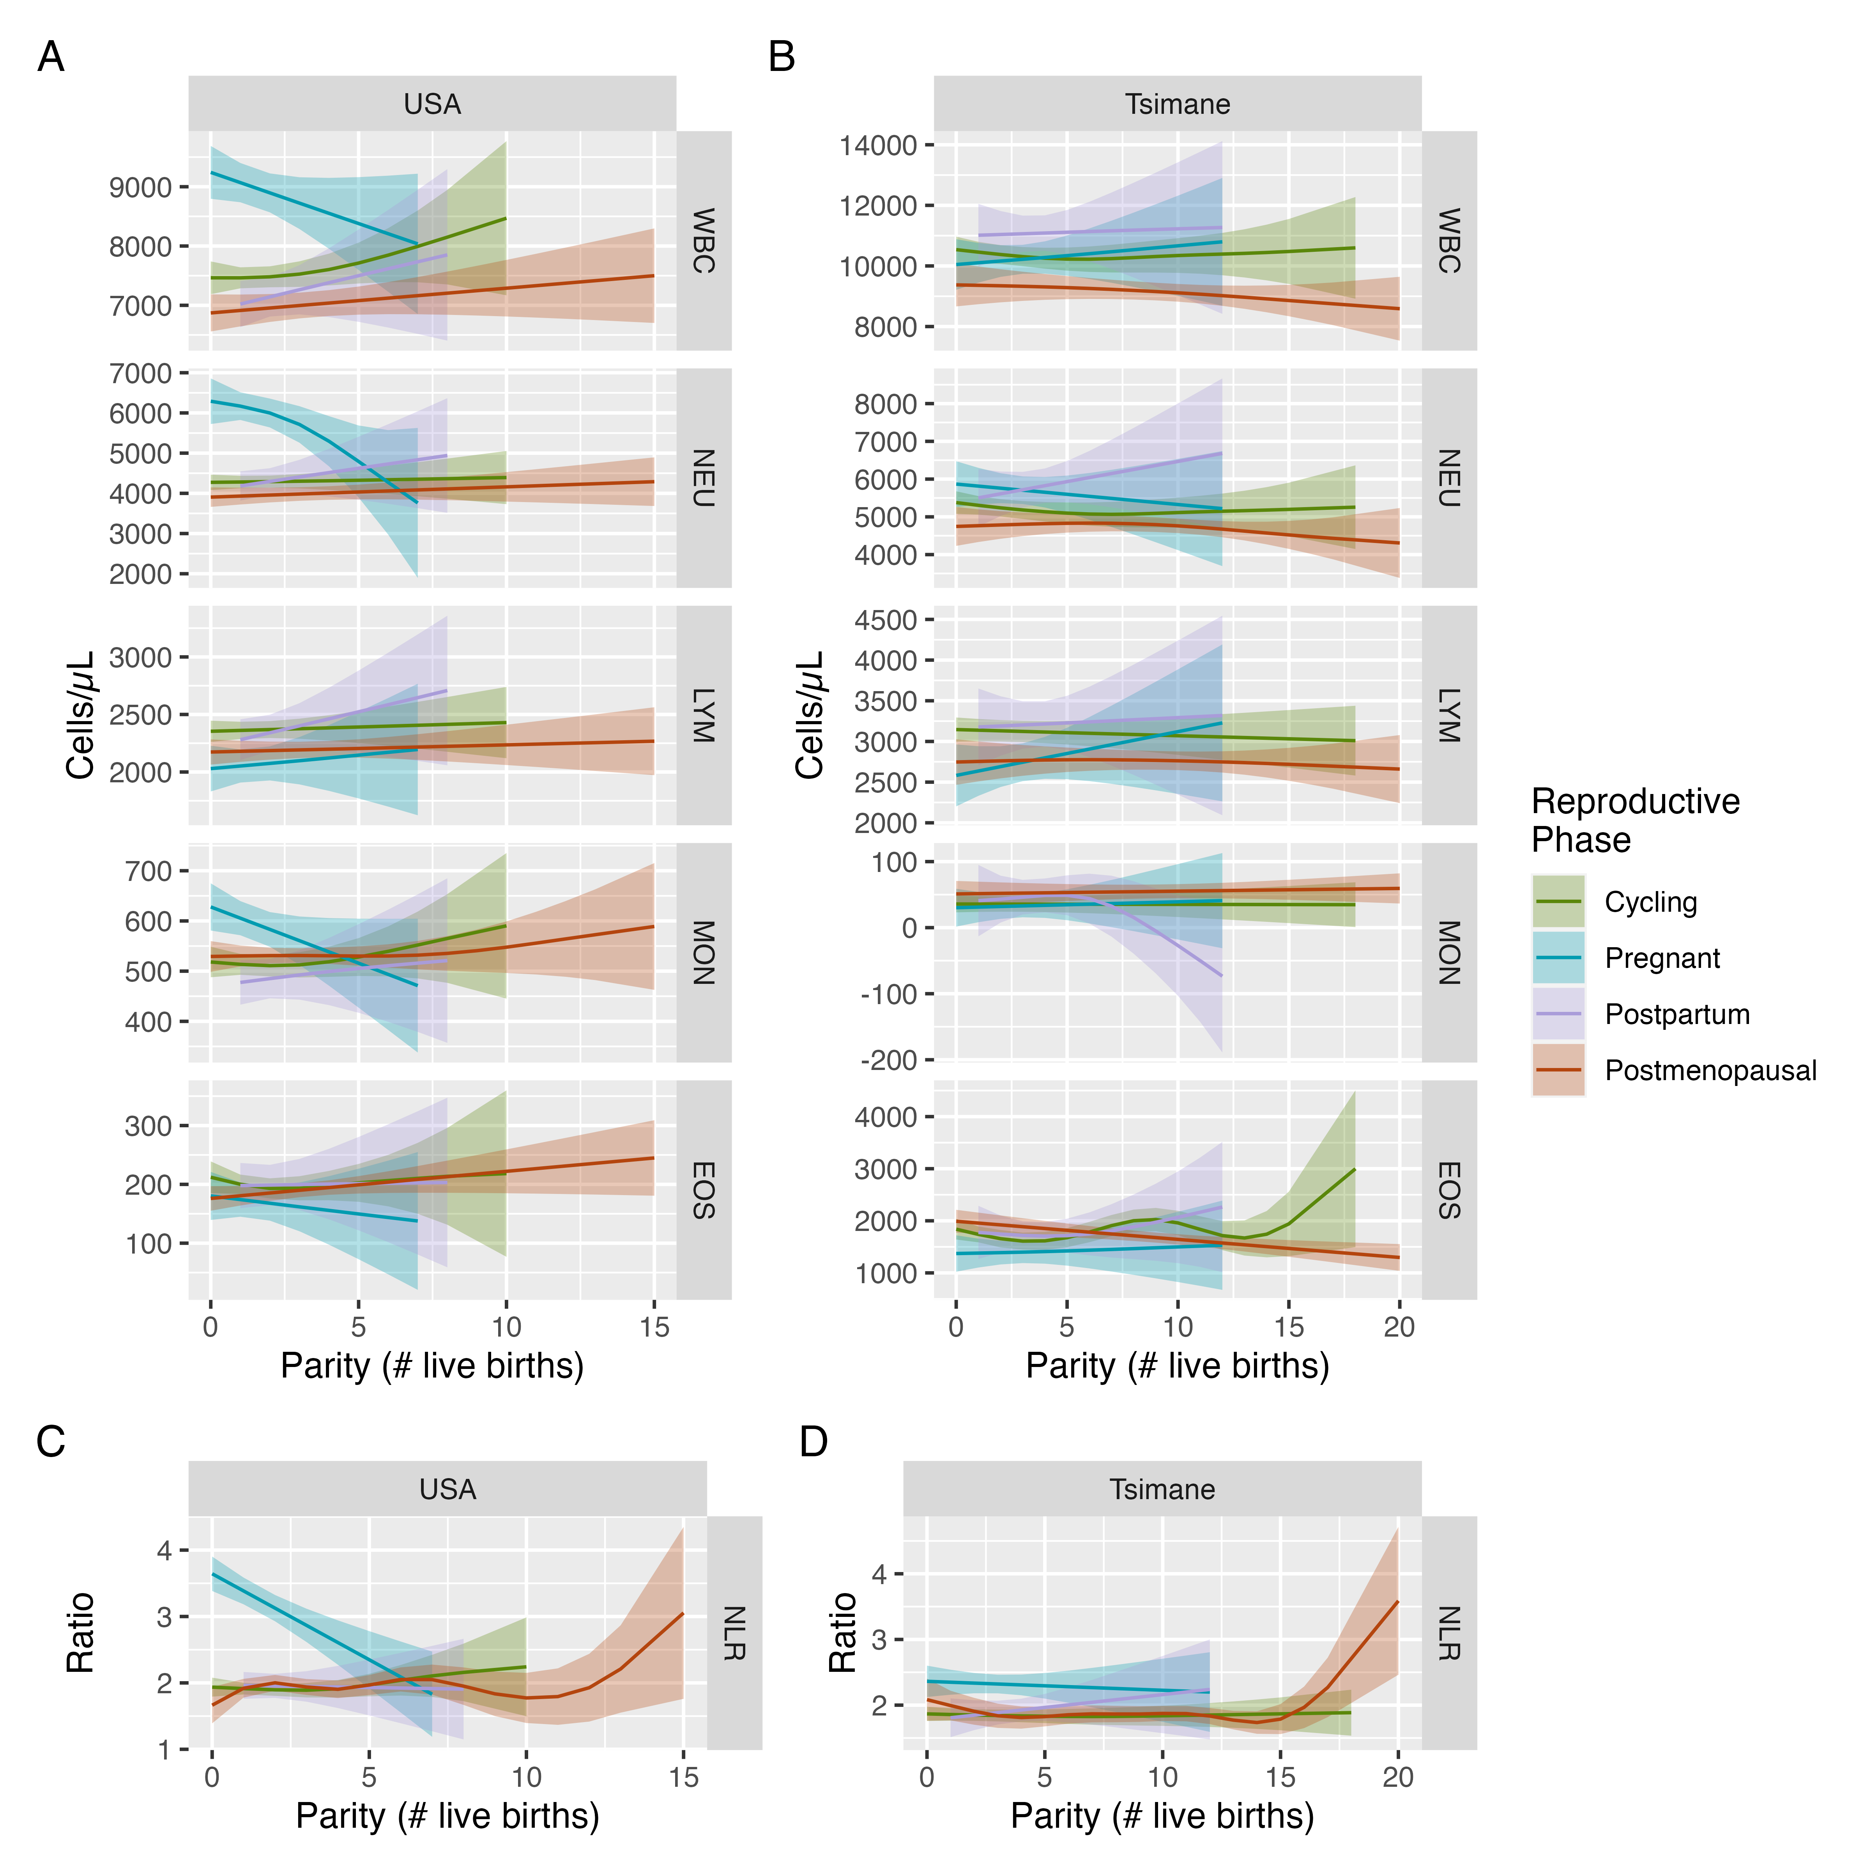
Fig 2. Non-linear effects of parity on leukocyte differential and NLR (see Table 1), separated by population. Solid lines correspond to estimated median value, shaded regions correspond to 95% credible intervals. Please note that each variable is plotted on its own scale.

Tables
Table 1. Description of immune markers used in this study.
Measure | Abbreviation | Description
Total white blood cells | WBC | The total number of circulating white blood cells (leukocytes).
Neutrophils | NEU | Most abundant type of white blood cell involved in myriad immune processes (e.g., antigen presentation, phagocytosis, priming of antigen-specific immune response). Implicated in autoimmune disease (76).
Total lymphocytes | LYM | White blood cells characterized by the presence of the CD45 receptor and responsible for generating antigen-specific immune responses. Composed of T cells, B cells, and natural killer cells.
Eosinophils | EOS | Granulocytes that defend against macroparasites and contribute to allergic responses.
Monocytes | MON | Phagocytic white blood cells that migrate to sites of infection and injury where they differentiate into macrophages.
Neutrophil-Lymphocyte Ratio | NLR | General marker of immune system homeostasis and the balance between innate and antigen-specific immunity. Values above 3 are generally considered to indicate inflammation (77). Predictive of all-cause and cardiovascular mortality among US adults with rheumatoid arthritis (78) and presence/severity of preeclampsia during pregnancy (79), multiple sclerosis (80, 81), primary Sjögren’s syndrome (82), thyroid cancer (83), and systemic lupus erythematosus (84).

Table 2. Ages at which the 95% credible intervals for estimated values between males and females do not overlap, separated by population, measure, and female reproductive phase. Estimated values presented in this table are standardized by parity (set to 3 live births) and z-scored BMI (set to 0).
Population | Measure | Reproductive Phase | Sex Bias | Age Range | Cumulative Years | Age Span | % Age Span
Tsimane | LYM | Premenarchal | Male | 2-3 | 2 | 10 | 20%
USA | LYM | Premenarchal | Female | 2-4 | 3 | 10 | 30%
USA | LYM | Premenarchal | Female | 11-11 | 1 | 10 | 10%
USA | EOS | Premenarchal | Male | 2-9 | 8 | 10 | 80%
Tsimane | MON | Premenarchal | Female | 10-11 | 2 | 10 | 20%
USA | MON | Premenarchal | Male | 3-9 | 7 | 10 | 70%
Tsimane | WBC | Cycling | Male | 14-24 | 11 | 37 | 29.73%
USA | WBC | Cycling | Female | 14-18 | 5 | 37 | 13.51%
USA | NEU | Cycling | Female | 14-18 | 5 | 37 | 13.51%
USA | NEU | Cycling | Female | 40-50 | 11 | 37 | 29.73%
Tsimane | LYM | Cycling | Male | 14-26 | 13 | 37 | 35.14%
USA | LYM | Cycling | Female | 14-16 | 3 | 37 | 8.11%
Tsimane | EOS | Cycling | Male | 14-18 | 5 | 37 | 13.51%
USA | EOS | Cycling | Male | 14-50 | 37 | 37 | 100%
USA | MON | Cycling | Male | 19-49 | 31 | 37 | 83.78%
Tsimane | NLR | Cycling | Female | 14-15 | 2 | 37 | 5.41%
USA | NLR | Cycling | Female | 43-50 | 8 | 37 | 21.62%
USA | WBC | Pregnant | Female | 17-40 | 24 | 28 | 85.71%
USA | NEU | Pregnant | Female | 17-41 | 25 | 28 | 89.29%
Tsimane | LYM | Pregnant | Male | 17-35 | 19 | 28 | 67.86%
USA | LYM | Pregnant | Male | 33-41 | 9 | 28 | 32.14%
Tsimane | EOS | Pregnant | Male | 24-32 | 9 | 28 | 32.14%
USA | EOS | Pregnant | Male | 18-44 | 27 | 28 | 96.43%
Tsimane | NLR | Pregnant | Female | 17-44 | 28 | 28 | 100%
USA | NLR | Pregnant | Female | 20-41 | 22 | 28 | 78.57%
Tsimane | MON | Postpartum | Female | 35-47 | 13 | 28 | 46.43%
USA | MON | Postpartum | Male | 20-47 | 28 | 28 | 100%
USA | NEU | Postmenopausal | Male | 54-61 | 8 | 45 | 17.78%
USA | LYM | Postmenopausal | Female | 47-69 | 23 | 45 | 51.11%
Tsimane | EOS | Postmenopausal | Female | 57-60 | 4 | 45 | 8.89%
USA | EOS | Postmenopausal | Male | 53-67 | 15 | 45 | 33.33%
USA | MON | Postmenopausal | Male | 40-81 | 42 | 45 | 93.33%
Tsimane | NLR | Postmenopausal | Male | 58-64 | 7 | 45 | 15.56%
Tsimane | NLR | Postmenopausal | Male | 81-84 | 4 | 45 | 8.89%
USA | NLR | Postmenopausal | Male | 51-83 | 33 | 45 | 73.33%

Data availability
Data and R code for the statistical analyses are published on GitHub (link here)

Acknowledgements
We offer our profound thanks to all participants whose data were used in this study, the Tsimane Gran Consejo, and the THLHP mobile team and staff.

Funding
The THLHP was supported by the National Institute of Health/National Institute on Aging (R01AG024119, R56AG024119, P01AG022500) and National Science Foundation (BCS0422690). J.S. acknowledges Institute for Advanced Study in Toulouse funding from the French National Research Agency (ANR).

References
1. C. C. Whitacre, Sex differences in autoimmune disease. Nature immunology 2, 777–780 (2001).
2. S. Laffont, E. Blanquart, J.-C. Guéry, Sex Differences in Asthma: A Key Role of Androgen-Signaling in Group 2 Innate Lymphoid Cells. Frontiers in Immunology 8, 1–7 (2017).
3. M. Zuk, K. A. McKean, Sex differences in parasite infections: Patterns and processes. International Journal for Parasitology 26, 1009–1024 (1996).
4. S. Gayen, E. Maclary, M. Hinten, S. Kalantry, Sex-specific silencing of X-linked genes by Xist RNA. Proceedings of the National Academy of Sciences 113, E309–E318 (2016).
5. I. H. Koçar, et al., The effect of testosterone replacement treatment on immunological features of patients with Klinefelter’s syndrome. Clinical and Experimental Immunology 121, 448–452 (2001).
6. V. Taneja, Sex Hormones Determine Immune Response. Frontiers in Immunology 9, 1–5 (2018).
7. E. N. Fish, The X-files in immunity: Sex-based differences predispose immune responses. Nature Reviews Immunology 8, 737–744 (2008).
8. T. Takahashi, et al., Sex differences in immune responses that underlie COVID-19 disease outcomes. Nature 588, 315–320 (2020).
9. S. L. Klein, A. Jedlicka, A. Pekosz, The Xs and Y of immune responses to viral vaccines. The Lancet Infectious Diseases 10, 338–349 (2010).
10. L. A. MITCHELL, Sex differences in antibody- and cell-mediated immune response to rubella re-immunisation. Journal of Medical Microbiology 48, 1075–1080 (1999).
11. E. A. Voigt, et al., Sex Differences in Older Adults’ Immune Responses to Seasonal Influenza Vaccination. Frontiers in Immunology 10 (2019).
12. S. Hartl, et al., Blood eosinophil count in the general population: Typical values and potential confounders. European Respiratory Journal 55, 1901874 (2020).
13. J. M. Starr, I. J. Deary, Sex differences in blood cell counts in the Lothian Birth Cohort 1921 between 79 and 87 years. Maturitas 69, 373–376 (2011).
14. Y. Chen, et al., Difference in Leukocyte Composition between Women before and after Menopausal Age, and Distinct Sexual Dimorphism. PLOS ONE 11, e0162953 (2016).
15. K. Li, et al., Age-dependent changes of total and differential white blood cell counts in children. Chinese Medical Journal 133, 1900–1907 (2020).
16. B. J. Bain, J. M. England, Normal haematological values: Sex difference in neutrophil count. BMJ 1, 306–309 (1975).
17. G. J. A. Casimir, S. Mulier, L. Hanssens, K. Zylberberg, J. Duchateau, GENDER DIFFERENCES IN INFLAMMATORY MARKERS IN CHILDREN. Shock 33, 258–262 (2010).
18. M. Abdullah, et al., Gender effect on in vitro lymphocyte subset levels of healthy individuals. Cellular Immunology 272, 214–219 (2012).
19. S. L. Klein, K. L. Flanagan, Sex differences in immune responses. Nature Reviews Immunology 16, 626–638 (2016).
20. S. Thammawong, N. Krasuaythong, O. Tunkamnerdthai, N. Leelayuwat, Effects of Sex and Intensity of Exercise on Circulating Leukocyte Counts after Exercise in Trained Subjects.
21. W. Hu, et al., Peripheral leukocyte counts vary with lipid levels, age and sex in subjects from the healthy population. Atherosclerosis 308, 15–21 (2020).
22. R. Pellegrino, et al., Temporal trends, sex differences, and age-related disease influence in Neutrophil, Lymphocyte count and Neutrophil to Lymphocyte-ratio: Results from InCHIANTI follow-up study. Immunity & Ageing 20, 46 (2023).
23. A. A. Patel, S. Yona, Inherited and Environmental Factors Influence Human Monocyte Heterogeneity. Frontiers in Immunology 10, 2581 (2019).
24. K. A. McKean, L. Nunney, Bateman’s Principle and Immunity: Phenotypically Plastic Reproductive Strategies Predict Changes in Immunological Sex Differences. Evolution 59, 1510–1517 (2005).
25. C. J. E. Metcalf, A. L. Graham, Schedule and magnitude of reproductive investment under immune trade-offs explains sex differences in immunity. Nature Communications 9, 4391 (2018).
26. A. L. Fink, S. L. Klein, The evolution of greater humoral immunity in females than males: Implications for vaccine efficacy. Current Opinion in Physiology 6, 16–20 (2018).
27. H. Natri, A. R. Garcia, K. H. Buetow, B. C. Trumble, M. A. Wilson, The Pregnancy Pickle: Evolved Immune Compensation Due to Pregnancy Underlies Sex Differences in Human Diseases. Trends in Genetics 35, 478–488 (2019).
28. V. J. Vitzthum, H. Spielvogel, J. Thornburg, Interpopulational differences in progesterone levels during conception and implantation in humans. Proceedings of the National Academy of Sciences 101, 1443–1448 (2004).
29. G. Jasienska, P. T. Ellison, Physical work causes suppression of ovarian function in women. Proc.Biol.Sci. 265, 1847–1851 (1998).
30. A. Núñez-de la Mora, R. T. Chatterton, O. A. Choudhury, D. A. Napolitano, G. R. Bentley, Childhood Conditions Influence Adult Progesterone Levels. PLoS Medicine 4, e167 (2007).
31. C. Valeggia, P. T. Ellison, Interactions between metabolic and reproductive functions in the resumption of postpartum fecundity. American Journal of Human Biology 21, 559–566 (2009).
32. F. Thomas, F. Renaud, E. Benefice, T. de Meeüs, J. F. Guegan, International variability of ages at menarche and menopause: Patterns and main determinants. Human Biology 73, 271–290 (2001).
33. A. Emaus, et al., 17-Beta-Estradiol in Relation To Age At Menarche and Adult Obesity in Premenopausal Women. Human reproduction (Oxford, England) 23, 919–927 (2008).
34. S. Sadhir, H. Pontzer, Impact of energy availability and physical activity on variation in fertility across human populations. Journal of Physiological Anthropology 42, 1 (2023).
35. Childs, Calder, Miles, Diet and Immune Function. Nutrients 11, 1933 (2019).
36. F. Macsali, et al., Oral contraception, body mass index, and asthma: A cross-sectional Nordic-Baltic population survey. Journal of Allergy and Clinical Immunology 123, 391–397 (2009).
37. E. Untersmayr, A. N. Jensen, K. Walch, Sex hormone allergy: Clinical aspects, causes and therapeutic strategies Update and secondary publication. World Allergy Organization Journal 10, 45 (2017).
38. R. G. Bribiescas, Testosterone levels among Aché hunter-gatherer men. Human Nature 7, 163–188 (1996).
39. B. C. Trumble, et al., Energetic costs of testosterone in two subsistence populations. American Journal of Human Biology 35, e23949 (2023).
40. L. C. Alvarado, C. R. Valeggia, P. T. Ellison, C. L. Lewarch, M. N. Muller, A Comparison of men’s Life History, Aging, and Testosterone Levels among Datoga Pastoralists, Hadza Foragers, and Qom Transitional Foragers. Adaptive Human Behavior and Physiology 5, 251–273 (2019).
41. G. L. Armstrong, L. A. Conn, R. W. Pinner, Trends in infectious disease mortality in the United States during the 20th century. Journal of the American Medical Association 281, 61–66 (1999).
42. S. W. Roush, Historical Comparisons of Morbidity and Mortality for Vaccine-Preventable Diseases in the United States. JAMA 298, 2155 (2007).
43. D. Cutler, G. Miller, The role of public health improvements in health advances: The twentieth-century United States. Demography 42, 1–22 (2005).
44. S. F. Bloomfield, et al., Time to abandon the hygiene hypothesis: New perspectives on allergic disease, the human microbiome, infectious disease prevention and the role of targeted hygiene. Perspectives in Public Health 136, 213–224 (2016).
45. A. D. Blackwell, et al., Evidence for a Peak Shift in a Humoral Response to Helminths: Age Profiles of IgE in the Shuar of Ecuador, the Tsimane of Bolivia, and the U.S. NHANES. PLoS Neglected Tropical Diseases 5, e1218 (2011).
46. A. D. Blackwell, et al., Immune function in Amazonian horticulturalists. Annals of Human Biology 43, 382–396 (2016).
47. M. Gurven, H. Kaplan, A. Z. Supa, Mortality experience of Tsimane Amerindians of Bolivia: Regional variation and temporal trends. American Journal of Human Biology 19, 376–398 (2007).
48. M. Gurven, H. Kaplan, J. Winking, C. Finch, E. M. Crimmins, Aging and inflammation in two epidemiological worlds. The journals of gerontology. Series A, Biological sciences and medical sciences 63, 196–199 (2008).
49. H. Kaplan, et al., Coronary atherosclerosis in indigenous South American Tsimane: A cross-sectional cohort study. The Lancet 389, 1730–1739 (2017).
50. D. Wu, et al., Global, regional, and national incidence of six major immune-mediated inflammatory diseases: Findings from the global burden of disease study 2019. eClinicalMedicine 64, 102193 (2023).
51. C. Hové, et al., Immune function during pregnancy varies between ecologically distinct populations. Evolution, Medicine, and Public Health 2020, 114–128 (2020).
52. M. C. Neville, M. R. Neifert, Lactation, M. C. Neville, M. R. Neifert, Eds. (Springer US, 1983) https:/doi.org/10.1007/978-1-4613-3688-4.
53. E. D. Lephart, F. Naftolin, Menopause and the Skin: Old Favorites and New Innovations in Cosmeceuticals for Estrogen-Deficient Skin. Dermatology and Therapy 11, 53–69 (2021).
54. A. A. Arslan, et al., Effects of Parity on Pregnancy Hormonal Profiles Across Ethnic Groups with a Diverse Incidence of Breast Cancer. Cancer Epidemiology, Biomarkers & Prevention 15, 2123–2130 (2006).
55. E. S. Barrett, L. E. Parlett, G. C. Windham, S. H. Swan, Differences in ovarian hormones in relation to parity and time since last birth. Fertility and Sterility 101, 1773–1780.e1 (2014).
56. R. Zahorec, Neutrophil-to-lymphocyte ratio, past, present and future perspectives. Bratislava Medical Journal 122, 474–488 (2021).
57. G. Martinez, K. Daniels, “Fertility of Men and Women Aged 1549 in the United States: National Survey of Family Growth, 20152019” (National Center for Health Statistics (U.S.), 2023) https:/doi.org/10.15620/cdc:122080 (January 29, 2024).
58. A. S. Khashan, et al., Pregnancy and the Risk of Autoimmune Disease. PLoS ONE 6, e19658 (2011).
59. F. Angum, T. Khan, J. Kaler, L. Siddiqui, A. Hussain, The Prevalence of Autoimmune Disorders in Women: A Narrative Review. Cureus (2020) https:/doi.org/10.7759/cureus.8094 (January 11, 2024).
60. H. Lefrère, et al., Postpartum breast cancer: Mechanisms underlying its worse prognosis, treatment implications, and fertility preservation. International Journal of Gynecologic Cancer 31, 412–422 (2021).
61. Z. Zhang, et al., Young-Onset Breast Cancer Outcomes by Time Since Recent Childbirth in Utah. JAMA Network Open 5, e2236763 (2022).
62. A. Erlebacher, Mechanisms of T cell tolerance towards the allogeneic fetus. Nat Rev Immunol 13, 23–33 (2013).
63. V. J. Flaherman, A. T. Chien, C. E. McCulloch, R. A. Dudley, Breastfeeding Rates Differ Significantly by Method Used: A Cause for Concern for Public Health Measurement. Breastfeeding Medicine 6, 31–35 (2011).
64. X. Ning, W.-M. Wang, H.-Z. Jin, Low-Density Granulocytes in Immune-Mediated Inflammatory Diseases. Journal of Immunology Research 2022, 1–11 (2022).
65. M. Gurven, H. Kaplan, B. Trumble, J. Stieglitz, “The biodemography of human health in contemporary non-industrial populations: Insights from the Tsimane Health and Life History Project” in Human Evolutionary Demography, O. Burger, R. Lee, R. Sear, Eds. (2019), pp. 1–41.
66. H. Kaplan, P. L. Hooper, J. Stieglitz, M. Gurven, The Causal Relationship between Fertility and Infant Mortality. Population in the Human Sciences, 361–376 (2015).
67. M. Martin, A. D. Blackwell, M. Gurven, H. Kaplan, “Make New Friends and Keep the Old? Parasite Coinfection and Comorbidity in Homo sapiens” in Primates, Pathogens, and Evolution, J. F. Brinkworth, K. Pechenkina, Eds. (Springer New York, 2013), pp. 363–387.
68. Z. Foster, et al., Physical growth and nutritional status of Tsimane’ Amerindian children of lowland Bolivia. American Journal of Physical Anthropology 126, 343–351 (2005).
69. M. D. Gurven, et al., High resting metabolic rate among Amazonian forager-horticulturalists experiencing high pathogen burden. American Journal of Physical Anthropology 161, 414–425 (2016).
70. L. McAllister, M. Gurven, H. Kaplan, J. Stieglitz, Why do women have more children than they want? Understanding differences in women’s ideal and actual family size in a natural fertility population. American Journal of Human Biology 24, 786–799 (2012).
71. M. A. Martin, G. Garcia, H. S. Kaplan, M. D. Gurven, Conflict or congruence? Maternal and infant-centric factors associated with shorter exclusive breastfeeding durations among the Tsimane. Social Science and Medicine 170, 9–17 (2016).
72. A. D. Blackwell, et al., Helminth infection, fecundity, and age of first pregnancy in women. Science 350, 6–9 (2015).
73. M. Gurven, et al., The Tsimane Health and Life History Project: Integrating anthropology and biomedicine. Evolutionary Anthropology 26, 54–73 (2017).
74. D. E. Ho, K. Imai, G. King, E. A. Stuart, MatchIt : Nonparametric Preprocessing for Parametric Causal Inference. Journal of Statistical Software 42 (2011).
75. S. N. Wood, Fast stable restricted maximum likelihood and marginal likelihood estimation of semiparametric generalized linear models. Journal of the Royal Statistical Society: Series B (Statistical Methodology) 73, 3–36 (2011).
76. G. Wigerblad, M. J. Kaplan, Neutrophil extracellular traps in systemic autoimmune and autoinflammatory diseases. Nature Reviews Immunology 23, 274–288 (2023).
77. M. Kourilovitch, C. GalarzaMaldonado, Could a simple biomarker as neutrophil-to-lymphocyte ratio reflect complex processes orchestrated by neutrophils? Journal of Translational Autoimmunity 6, 100159 (2023).
78. E. Zhou, J. Wu, X. Zhou, Y. Yin, The neutrophil-lymphocyte ratio predicts all-cause and cardiovascular mortality among U.S. Adults with rheumatoid arthritis: Results from NHANES 1999-2020. Frontiers in Immunology 14, 1309835 (2023).
79. R. A. Mohamed, I. A. Ali, Role of neutrophil / lymphocyte ratio, uric acid / albumin ratio and uric acid / creatinine ratio as predictors to severity of preeclampsia. BMC Pregnancy and Childbirth 23, 763 (2023).
80. D’Amico, et al., The Neutrophil-to-Lymphocyte Ratio is Related to Disease Activity in Relapsing Remitting Multiple Sclerosis. Cells 8, 1114 (2019).
81. I. Hasselbalch, et al., The neutrophil-to-lymphocyte ratio is associated with multiple sclerosis. Multiple Sclerosis Journal - Experimental, Translational and Clinical 4, 205521731881318 (2018).
82. A. Mihai, et al., The Predictive Role of Neutrophil-to-Lymphocyte Ratio (NLR), Platelet-to-Lymphocyte Ratio (PLR), Monocytes-to-Lymphocyte Ratio (MLR) and Gammaglobulins for the Development of Cutaneous Vasculitis Lesions in Primary Sjögren’s Syndrome. Journal of Clinical Medicine 11, 5525 (2022).
83. T. Y. Cheong, S. D. Hong, K.-W. Jung, Y. K. So, The diagnostic predictive value of neutrophil-to-lymphocyte ratio in thyroid cancer adjusted for tumor size. PLOS ONE 16, e0251446 (2021).
84. L. Wang, C. Wang, X. Jia, M. Yang, J. Yu, Relationship between Neutrophil-to-Lymphocyte Ratio and Systemic Lupus Erythematosus: A Meta-analysis. Clinics 75, e1450 (2020).

Supplementary Information

Figures
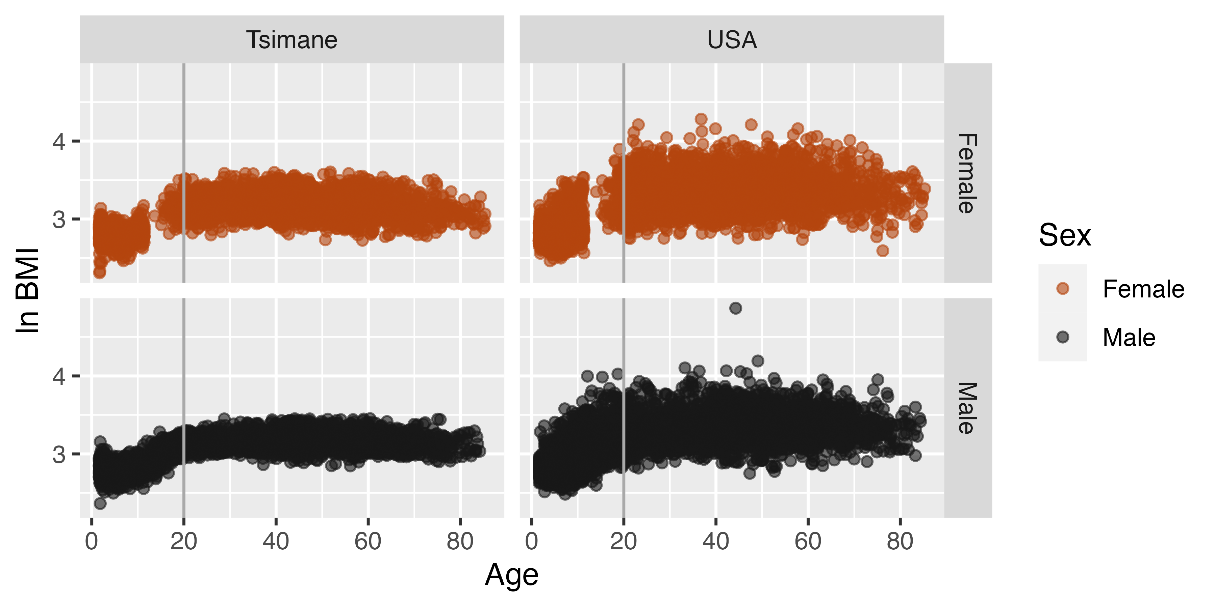
Fig S1. Raw natural logged BMI values by age and sex for each population.

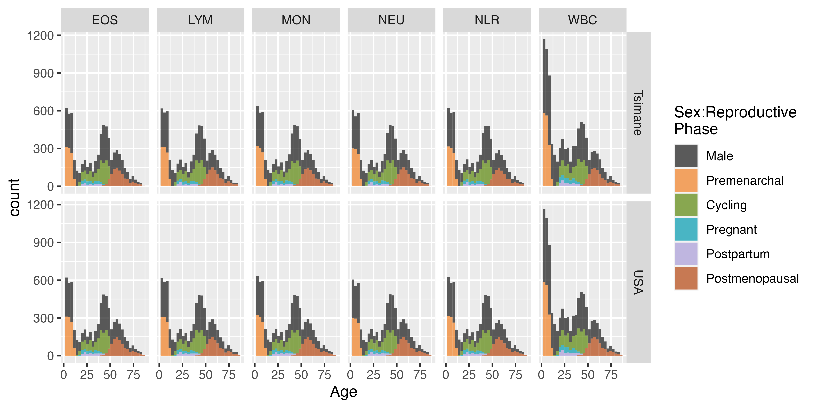
Fig S2. Final matched sample sizes by measure, population, age, and sex/female reproductive phase.

Tables
Table S1. Final matched sample sizes by measure, population, and sex/female reproductive phase.
Measure | Population | Male | Premenarchal | Cycling | Pregnant | Postpartum | Postmenopausal
WBC | Tsimane | 5320 | 1531 | 1365 | 286 | 203 | 934
WBC | USA | 5320 | 1531 | 1365 | 286 | 203 | 934
NEU | Tsimane | 3669 | 912 | 1154 | 194 | 141 | 931
NEU | USA | 3669 | 912 | 1154 | 194 | 141 | 931
LYM | Tsimane | 3673 | 945 | 1149 | 184 | 142 | 923
LYM | USA | 3673 | 945 | 1149 | 184 | 142 | 923
NLR | Tsimane | 3678 | 943 | 1146 | 186 | 140 | 919
NLR | USA | 3678 | 943 | 1146 | 186 | 140 | 919
MON | Tsimane | 3701 | 955 | 1151 | 195 | 142 | 927
MON | USA | 3701 | 955 | 1151 | 195 | 142 | 927
EOS | Tsimane | 3678 | 939 | 1144 | 192 | 139 | 926
EOS | USA | 3678 | 939 | 1144 | 192 | 139 | 926

Table S2. Number and corresponding percentage of unique participants out of the total THLHP sample by measure and sex/female reproductive phase.
Measure | Male | Premenarchal | Cycling | Pregnant | Postpartum | Postmenopausal
WBC | 3181 (59.79%) | 1193 (77.92%) | 848 (62.12%) | 258 (90.21%) | 195 (96.06%) | 375 (40.15%)
NEU | 2038 (55.55%) | 721 (79.06%) | 712 (61.7%) | 179 (92.27%) | 140 (99.29%) | 373 (40.06%)
LYM | 2052 (55.87%) | 736 (77.88%) | 711 (61.88%) | 169 (91.85%) | 141 (99.3%) | 371 (40.2%)
NLR | 2052 (55.79%) | 735 (77.94%) | 708 (61.78%) | 172 (92.47%) | 139 (99.29%) | 372 (40.48%)
MON | 2057 (55.58%) | 741 (77.59%) | 713 (61.95%) | 180 (92.31%) | 141 (99.3%) | 372 (40.13%)
EOS | 2043 (55.55%) | 728 (77.53%) | 706 (61.71%) | 177 (92.19%) | 138 (99.28%) | 372 (40.17%)

Table S3. Ages and values at which the absolute difference in immune outcomes between females and their male counterparts is greatest, separated by female reproductive phase, population, and immune marker.
Population | Measure | Reproductive Phase | Age | Parity | Bias | Female Value | Male Value
Tsimane | LYM | Premenarchal | 2 | 0 | Male | 5682 cells/µl (95% CI: 5512-5853) | 6107 cells/µl (95% CI: 5949-6264)
Tsimane | MON | Premenarchal | 11 | 0 | Female | 79 cells/µl (95% CI: 66-91) | 58 cells/µl (95% CI: 50-65)
USA | LYM | Premenarchal | 2 | 0 | Female | 3880 cells/µl (95% CI: 3775-3985) | 3533 cells/µl (95% CI: 3445-3620)
USA | EOS | Premenarchal | 2 | 0 | Male | 218 cells/µl (95% CI: 200-236) | 262 cells/µl (95% CI: 249-275)
USA | MON | Premenarchal | 7 | 0 | Male | 535 cells/µl (95% CI: 518-552) | 592 cells/µl (95% CI: 580-603)
Tsimane | WBC | Cycling | 14 | 3 | Male | 10818 cells/µl (95% CI: 10163-11472) | 12227 cells/µl (95% CI: 12023-12432)
Tsimane | LYM | Cycling | 14 | 3 | Male | 3228 cells/µl (95% CI: 3013-3444) | 3836 cells/µl (95% CI: 3719-3953)
Tsimane | EOS | Cycling | 14 | 3 | Male | 1611 cells/µl (95% CI: 1384-1837) | 2216 cells/µl (95% CI: 2112-2321)
Tsimane | NLR | Cycling | 14 | 3 | Female | 2.03 ratio (95% CI: 1.79-2.27) | 1.69 ratio (95% CI: 1.62-1.76)
USA | WBC | Cycling | 14 | 3 | Female | 7594 cells/µl (95% CI: 7273-7915) | 6768 cells/µl (95% CI: 6647-6888)
USA | NEU | Cycling | 14 | 3 | Female | 4251 cells/µl (95% CI: 3981-4522) | 3630 cells/µl (95% CI: 3511-3750)
USA | LYM | Cycling | 14 | 3 | Female | 2483 cells/µl (95% CI: 2346-2619) | 2254 cells/µl (95% CI: 2191-2318)
USA | EOS | Cycling | 14 | 3 | Male | 202 cells/µl (95% CI: 173-232) | 246 cells/µl (95% CI: 237-255)
USA | MON | Cycling | 25 | 3 | Male | 509 cells/µl (95% CI: 485-534) | 601 cells/µl (95% CI: 580-621)
USA | NLR | Cycling | 49 | 3 | Female | 2.22 ratio (95% CI: 2.14-2.3) | 2.05 ratio (95% CI: 2-2.11)
Tsimane | LYM | Pregnant | 22 | 3 | Male | 2815 cells/µl (95% CI: 2537-3092) | 3608 cells/µl (95% CI: 3449-3767)
Tsimane | EOS | Pregnant | 31 | 3 | Male | 1300 cells/µl (95% CI: 1010-1590) | 1767 cells/µl (95% CI: 1624-1909)
Tsimane | NLR | Pregnant | 44 | 3 | Female | 2.66 ratio (95% CI: 2.14-3.19) | 1.88 ratio (95% CI: 1.83-1.94)
USA | WBC | Pregnant | 30 | 3 | Female | 8906 cells/µl (95% CI: 8493-9319) | 7357 cells/µl (95% CI: 7185-7528)
USA | NEU | Pregnant | 29 | 3 | Female | 6027 cells/µl (95% CI: 5593-6460) | 4270 cells/µl (95% CI: 4116-4425)
USA | NEU | Pregnant | 30 | 3 | Female | 6030 cells/µl (95% CI: 5600-6459) | 4273 cells/µl (95% CI: 4121-4425)
USA | LYM | Pregnant | 40 | 3 | Male | 1925 cells/µl (95% CI: 1702-2149) | 2240 cells/µl (95% CI: 2180-2300)
USA | EOS | Pregnant | 43 | 3 | Male | 138 cells/µl (95% CI: 88-189) | 209 cells/µl (95% CI: 201-217)
USA | EOS | Pregnant | 18 | 3 | Male | 169 cells/µl (95% CI: 112-226) | 240 cells/µl (95% CI: 230-250)
USA | EOS | Pregnant | 44 | 3 | Male | 137 cells/µl (95% CI: 84-191) | 208 cells/µl (95% CI: 200-216)
USA | NLR | Pregnant | 31 | 3 | Female | 3.16 ratio (95% CI: 2.92-3.4) | 2.01 ratio (95% CI: 1.92-2.09)
USA | NLR | Pregnant | 30 | 3 | Female | 3.16 ratio (95% CI: 2.92-3.41) | 2.01 ratio (95% CI: 1.92-2.09)
Tsimane | MON | Postpartum | 47 | 3 | Female | 291 cells/µl (95% CI: 145-437) | 65 cells/µl (95% CI: 58-72)
USA | MON | Postpartum | 47 | 3 | Male | 426 cells/µl (95% CI: 342-509) | 547 cells/µl (95% CI: 534-559)
Tsimane | EOS | Postmenopausal | 59 | 3 | Female | 1895 cells/µl (95% CI: 1740-2049) | 1608 cells/µl (95% CI: 1492-1724)
Tsimane | NLR | Postmenopausal | 84 | 3 | Male | 1.97 ratio (95% CI: 1.65-2.28) | 2.61 ratio (95% CI: 2.29-2.93)
USA | NEU | Postmenopausal | 58 | 3 | Male | 3834 cells/µl (95% CI: 3698-3970) | 4151 cells/µl (95% CI: 4029-4273)
USA | LYM | Postmenopausal | 53 | 3 | Female | 2295 cells/µl (95% CI: 2229-2360) | 2064 cells/µl (95% CI: 2002-2127)
USA | EOS | Postmenopausal | 66 | 3 | Male | 190 cells/µl (95% CI: 178-203) | 217 cells/µl (95% CI: 205-229)
USA | EOS | Postmenopausal | 67 | 3 | Male | 191 cells/µl (95% CI: 177-204) | 218 cells/µl (95% CI: 205-230)
USA | MON | Postmenopausal | 40 | 3 | Male | 466 cells/µl (95% CI: 436-497) | 559 cells/µl (95% CI: 545-573)
USA | NLR | Postmenopausal | 83 | 3 | Male | 2.28 ratio (95% CI: 2-2.56) | 2.84 ratio (95% CI: 2.59-3.1)

Table S4. Model terms, statistics, and p-values for Tsimane-specific models.
Population | Measure | Term | Sex:Reproductive Phase | EDF | F-statistic | P-value
Tsimane | WBC | s(Age) | Male | 5.293 | 184.836 | 0.000
Tsimane | WBC | s(Age) | Cycling | 1.362 | 2.669 | 0.040
Tsimane | WBC | s(Parity) | Cycling | 1.954 | 0.601 | 0.532
Tsimane | WBC | s(Parity) | Pregnant | 1.056 | 0.220 | 0.649
Tsimane | WBC | s(Parity) | Postpartum | 1.021 | 0.021 | 0.936
Tsimane | WBC | s(Parity) | Postmenopausal | 1.267 | 1.155 | 0.464
Tsimane | NEU | s(Age) | Male | 6.483 | 18.197 | 0.000
Tsimane | NEU | s(Age) | Premenarchal | 1.774 | 19.397 | 0.000
Tsimane | NEU | s(Parity) | Cycling | 1.956 | 0.962 | 0.385
Tsimane | NEU | s(Parity) | Pregnant | 1.002 | 0.438 | 0.509
Tsimane | NEU | s(Parity) | Postpartum | 1.006 | 0.847 | 0.357
Tsimane | NEU | s(Parity) | Postmenopausal | 1.726 | 0.971 | 0.363
Tsimane | LYM | s(Age) | Male | 7.945 | 266.756 | 0.000
Tsimane | LYM | s(Age) | Premenarchal | 1.489 | 45.067 | 0.000
Tsimane | LYM | s(Age) | Cycling | 1.004 | 3.805 | 0.052
Tsimane | LYM | s(Age) | Postmenopausal | 1.004 | 3.896 | 0.046
Tsimane | LYM | s(Parity) | Cycling | 1.003 | 0.326 | 0.570
Tsimane | LYM | s(Parity) | Pregnant | 1.006 | 1.078 | 0.299
Tsimane | LYM | s(Parity) | Postpartum | 1.006 | 0.029 | 0.879
Tsimane | LYM | s(Parity) | Postmenopausal | 1.296 | 0.125 | 0.850
Tsimane | EOS | s(Age) | Male | 7.829 | 22.183 | 0.000
Tsimane | EOS | s(Age) | Premenarchal | 1.873 | 9.809 | 0.000
Tsimane | EOS | s(Parity) | Cycling | 5.148 | 3.344 | 0.002
Tsimane | EOS | s(Parity) | Pregnant | 1.067 | 0.036 | 0.881
Tsimane | EOS | s(Parity) | Postpartum | 1.592 | 0.594 | 0.551
Tsimane | EOS | s(Parity) | Postmenopausal | 1.006 | 10.293 | 0.001
Tsimane | MON | s(Age) | Male | 5.717 | 8.317 | 0.000
Tsimane | MON | s(Age) | Postpartum | 2.202 | 7.972 | 0.003
Tsimane | MON | s(Parity) | Cycling | 1.011 | 0.003 | 0.986
Tsimane | MON | s(Parity) | Pregnant | 1.006 | 0.053 | 0.830
Tsimane | MON | s(Parity) | Postpartum | 2.160 | 2.563 | 0.155
Tsimane | MON | s(Parity) | Postmenopausal | 1.007 | 0.207 | 0.655
Tsimane | NLR | s(Age) | Male | 6.941 | 75.453 | 0.000
Tsimane | NLR | s(Age) | Premenarchal | 1.000 | 69.095 | 0.000
Tsimane | NLR | s(Age) | Postmenopausal | 2.824 | 2.772 | 0.043
Tsimane | NLR | s(Parity) | Cycling | 1.469 | 0.202 | 0.747
Tsimane | NLR | s(Parity) | Pregnant | 1.001 | 0.174 | 0.677
Tsimane | NLR | s(Parity) | Postpartum | 1.001 | 0.768 | 0.381
Tsimane | NLR | s(Parity) | Postmenopausal | 5.663 | 2.305 | 0.060

Table S5. Model terms, statistics, and p-values for USA-specific models.
Population | Measure | Term | Sex:Reproductive Phase | EDF | F-statistic | P-value
USA | WBC | s(Age) | Male | 7.720 | 13.381 | 0.000
USA | WBC | s(Age) | Premenarchal | 1.770 | 31.320 | 0.000
USA | WBC | s(Age) | Postmenopausal | 3.116 | 1.988 | 0.094
USA | WBC | s(Parity) | Cycling | 1.685 | 1.562 | 0.228
USA | WBC | s(Parity) | Pregnant | 1.013 | 2.708 | 0.096
USA | WBC | s(Parity) | Postpartum | 1.017 | 1.053 | 0.301
USA | WBC | s(Parity) | Postmenopausal | 1.019 | 1.541 | 0.207
USA | NEU | s(Age) | Male | 5.858 | 29.566 | 0.000
USA | NEU | s(Age) | Pregnant | 2.494 | 4.146 | 0.006
USA | NEU | s(Age) | Postmenopausal | 3.144 | 3.061 | 0.061
USA | NEU | s(Parity) | Cycling | 1.037 | 0.051 | 0.852
USA | NEU | s(Parity) | Pregnant | 1.786 | 4.144 | 0.011
USA | NEU | s(Parity) | Postpartum | 1.022 | 0.961 | 0.326
USA | NEU | s(Parity) | Postmenopausal | 1.005 | 1.016 | 0.312
USA | LYM | s(Age) | Male | 8.144 | 129.151 | 0.000
USA | LYM | s(Age) | Premenarchal | 2.015 | 180.351 | 0.000
USA | LYM | s(Age) | Cycling | 1.072 | 17.819 | 0.000
USA | LYM | s(Age) | Postmenopausal | 2.097 | 7.200 | 0.000
USA | LYM | s(Parity) | Cycling | 1.014 | 0.170 | 0.688
USA | LYM | s(Parity) | Pregnant | 1.017 | 0.201 | 0.656
USA | LYM | s(Parity) | Postpartum | 1.011 | 1.340 | 0.239
USA | LYM | s(Parity) | Postmenopausal | 1.012 | 0.238 | 0.626
USA | EOS | s(Age) | Male | 3.011 | 17.854 | 0.000
USA | EOS | s(Age) | Cycling | 1.009 | 2.829 | 0.093
USA | EOS | s(Parity) | Cycling | 2.078 | 0.718 | 0.492
USA | EOS | s(Parity) | Pregnant | 1.013 | 0.360 | 0.554
USA | EOS | s(Parity) | Postpartum | 1.015 | 0.007 | 0.977
USA | EOS | s(Parity) | Postmenopausal | 1.021 | 2.936 | 0.082
USA | MON | s(Age) | Male | 7.273 | 12.803 | 0.000
USA | MON | s(Age) | Premenarchal | 1.909 | 10.864 | 0.000
USA | MON | s(Age) | Postmenopausal | 1.001 | 14.237 | 0.000
USA | MON | s(Parity) | Cycling | 1.780 | 0.950 | 0.439
USA | MON | s(Parity) | Pregnant | 1.001 | 3.675 | 0.055
USA | MON | s(Parity) | Postpartum | 1.055 | 0.313 | 0.620
USA | MON | s(Parity) | Postmenopausal | 1.723 | 0.344 | 0.828
USA | NLR | s(Age) | Male | 5.659 | 123.845 | 0.000
USA | NLR | s(Age) | Premenarchal | 1.489 | 14.187 | 0.000
USA | NLR | s(Age) | Cycling | 1.001 | 22.126 | 0.000
USA | NLR | s(Age) | Pregnant | 2.777 | 8.513 | 0.000
USA | NLR | s(Age) | Postmenopausal | 3.443 | 8.515 | 0.000
USA | NLR | s(Parity) | Cycling | 2.052 | 0.928 | 0.534
USA | NLR | s(Parity) | Pregnant | 1.004 | 21.035 | 0.000
USA | NLR | s(Parity) | Postpartum | 1.002 | 0.018 | 0.898
USA | NLR | s(Parity) | Postmenopausal | 5.284 | 1.849 | 0.077

