Carmen St. Jean

Graduate research assistant Carmen St. Jean has been working under the supervision of Data Visualization Research Lab director Colin Ware to explore different design alternatives and evaluate different modes of portrayal and interaction to make a visualization of a fisheries production model. More specifically, they have been developing an interactive user interface for the MS-PROD (multi-species) production model that was created by NOAA scientists Robert Gamble and Jason Link.

**The Model**

The MS-PROD model was designed to help both fishery managers and fishermen to better understand the implications of the harvest quotas by taking the effects of harvest, predation, and other inter-species interactions into account. Biomass for ten key species in the Gulf of Maine is predicted over a 30-year time span by simulating various ecological factors. Harvest effort is controlled by functional group and each fish species is sorted into one of four functional groups.

**The Visualization**

The challenge for St. Jean and Ware has been to devise an interface that would clearly plot the biomass forecasts, allow the users to change the harvest effort levels, and provide insight into the model. For example, in , increasing the harvest on elasmobranchs caused the projected biomass of mackerel to increase because spiny dogfish, a member of the elasmobranch functional group, predate on mackerel. The relationship between mackerel and spiny dogfish should be discernible from the visualization, as well as the changes in biomass that resulted from changing the harvest effort.

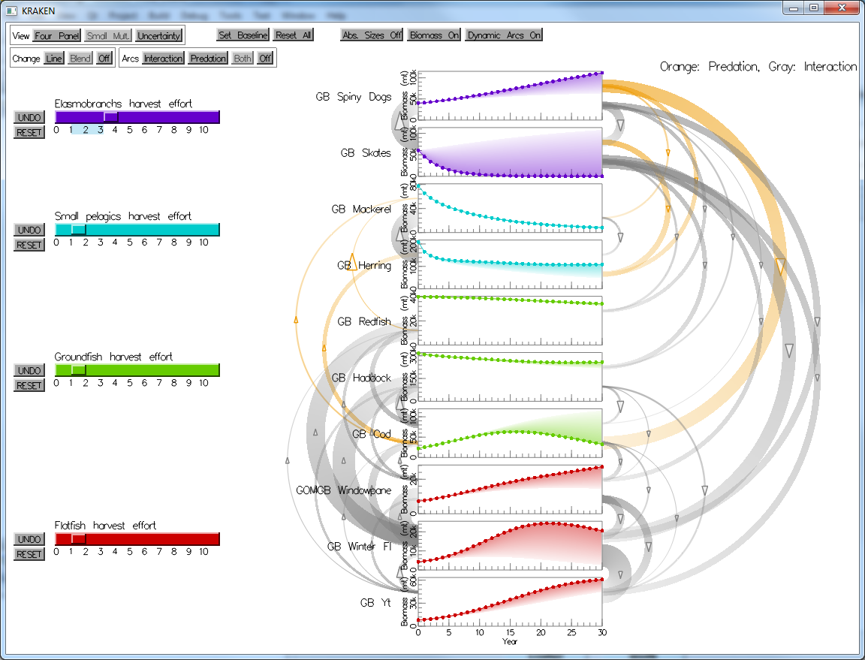

Figure : the MS-PROD visualization showing predation and interaction arcs.

**Visualization Views**

After researching different methods for time series representation, they chose to display the biomass time series on line charts in two different views: a) a four panel view where species of the same functional group are plotted together (see ) and b) a small multiples view where species are plotted on their own charts (see ). In either view, interaction with the model parameters is done by means of a set of sliders with the goal of allowing the user to immediately see the impact of management decisions on fisheries. The user can adjust sliders which represent harvest effort and watch the line charts change instantaneously as the model is re-run according to the new effort values.

|  |  |
| --- | --- |
| msprod_group.png  Figure : the four panel view of the MS-PROD visualization. | msprod_species.png  Figure : The small multiples view of the MS-PROD visualization. |

**Visualizing Change**

In order for modelers and other stakeholders to understand and compare decisions, the ability to perceive differences in biomass resulting from changes in the fishing effort is necessary. Therefore, they created a feature where users can save a "baseline" of fishing effort values. Then, as the effort sliders are adjusted, the current biomass projections can be compared to the baseline biomass projections. There are three alternatives for displaying differences with that baseline:

1. instantaneous biomass plot updating (see ),
2. the baseline biomass drawn as a dotted gray line in addition to the current biomass (see ), and
3. a shaded area originating from the curve of the current biomass that diminishes in opacity as it approaches the curve of the baseline (see ).

**Visualizing Relationships between Species**

|  |
| --- |
| msprod_change_none.png  Figure 4: Change shown by interaction. |
| msprod_change_line.png  Figure 5: The baseline is shown as a dotted gray line. |
| msprod_change_blend.png  Figure 6: The area between the baseline forecast and current forecast is shaded. |

Understanding of the model requires understanding of the underlying relationships between species—namely, predation and interaction. Predation is when one species consumes another and interaction accounts for any way species might impact another in a way that is not predation. The interface must explain to users which species impact each other and the magnitude of those relationships. Therefore, these are illustrated with arc diagram network visualizations between the small multiples time series plots. Users can view either:

1. predation separately (see ),
2. interaction separately (see ), or
3. both relationship types at once (see ).

Additionally, these relationships can be drawn either a) statically, where all relationships appear at all times, or b) dynamically, where the arcs are drawn selectively according to their impact as effort values are adjusted.

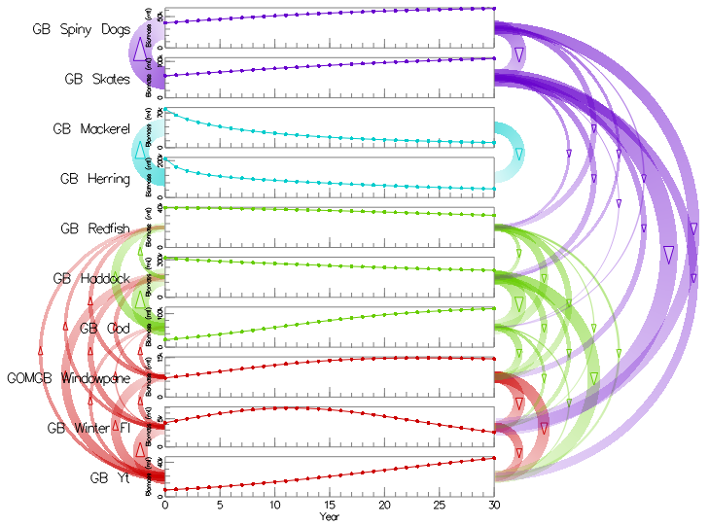

Figure : interaction arcs in the MS-PROD visualization.

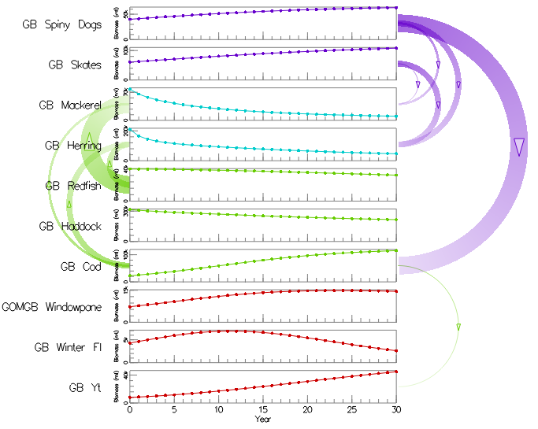

Figure : predation arcs in the MS-PROD visualization.

**Visualizing Uncertainty**

|  |  |
| --- | --- |
| msprod_uncertainty_multline.png  Figure 9: Multi-line uncertainty visualization. | msprod_uncertainty_boxplots.png  Figure 10: Box plot uncertainty visualization. |
| msprod_uncertainty_errorbar.png  Figure 11: Error bar uncertainty visualization. | msprod_uncertainty_errorbands.png  Figure 12: Error band uncertainty visualization. |

Finally, since models are simplifications of reality, their output is best understood as a range of expected values. It is possible that a representation of uncertainty may aid decision making. To add uncertainty visualization to the MS-PROD model, the interactive interface can perform Monte Carlo simulations by randomly jittering the non-zero input parameter values ±10%. The resulting uncertainty can be displayed in four styles:

1. a multi-line option which draws one semi-transparent line for each run of the Monte Carlo simulation (see ),
2. box plots drawn every five years to indicate the boundaries of the first, second (median), and third quartiles with whiskers stretching to the minimum and maximum values (see ),
3. the mean of all simulations is displayed as a line with bars every five years to represent one standard deviation above and below the mean (see ), and
4. a solid black line with bands to show one and two standard deviations above and below the mean (see ).