Carmen St. Jean

Graduate research assistant Carmen St. Jean worked under the supervision of Data Visualization Research Lab director Colin Ware to explore different design alternatives and evaluate different modes of portrayal and interaction to make a visualization of a fisheries production model. More specifically, they developed an interactive user interface for the MS-PROD (multi-species) production model that was created by NOAA scientists Robert Gamble and Jason Link. St. Jean and Ware conducted an experiment to evaluate three alternative forms of arcs for portraying causal connections in the model. The results show that all linkage representations enabled participants to reason better about complex chains of causality than not showing linkages.

**The Model**

The MS-PROD model was designed to help both fishery managers and fishermen to better understand the implications of the harvest quotas by taking the effects of harvest, predation, and competition into account. Biomass for ten key species in the Gulf of Maine is predicted over a 30-year time span by simulating various ecological factors. Harvest effort is controlled by functional group and each fish species is sorted into one of four functional groups.

**The Visualization**

The challenge for St. Jean and Ware was to devise an interface that would clearly plot the biomass forecasts, allow the users to compare two biomass forecasts, and illustrate the complex causal linkages between the fish species. Two types of interactions between the fish are possible in the MS-PROD model: predation, where one fish eats another, and competition, where one fish adversely affects the other in any way that is not predation. These interactions mean that the fish influence each other rather heavily, so fishing more or less for a few species might affect all of the species. For example, in Figure 1, increasing the harvest on elasmobranchs caused the projected biomass of cod to increase because spiny dogfish, a member of the elasmobranch functional group, predate on mackerel. The goal was to make the relationship between cod and spiny dogfish be easily discernible with the visualization, as well as the changes in biomass that resulted from changing the harvest effort.

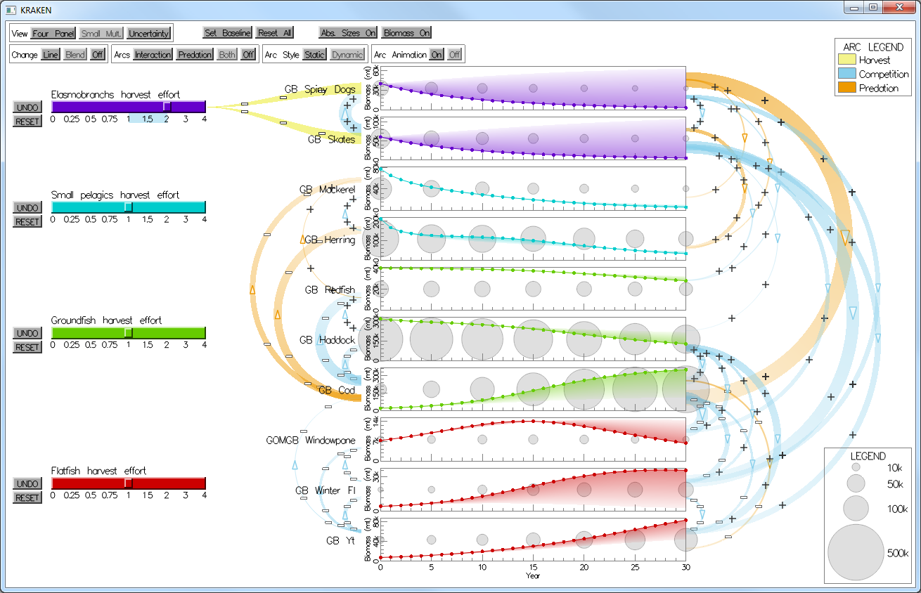

Figure 1: the MS-PROD visualization showing predation and interaction arcs in orange and blue, respectively.

|  |  |
| --- | --- |
| Figure 2: the four panel view of the MS-PROD visualization. | Figure 3: The small multiples view of the MS-PROD visualization. |

**Visualization Views**

After researching different methods for time series representation, they chose to display the biomass time series on line charts in two different views: a) a four panel view where species of the same functional group are plotted together (see Figure 2) and b) a small multiples view where species are plotted on their own charts (see Figure 3). In either view, interaction with the model parameters is done by means of a set of sliders with the goal of allowing the user to immediately see the impact of management decisions on fisheries. The user can adjust sliders which represent harvest effort and watch the line charts change instantaneously as the model is re-run according to the new effort values.

**Visualizing Biomass**

In the small multiple view, all species are plotted on their own charts. Each chart has its own y-axis scale, since the biomass estimates vary widely from species to species. Absolute biomass indicators are drawn every five years to make comparison between the species possible, shown in Figure 4.

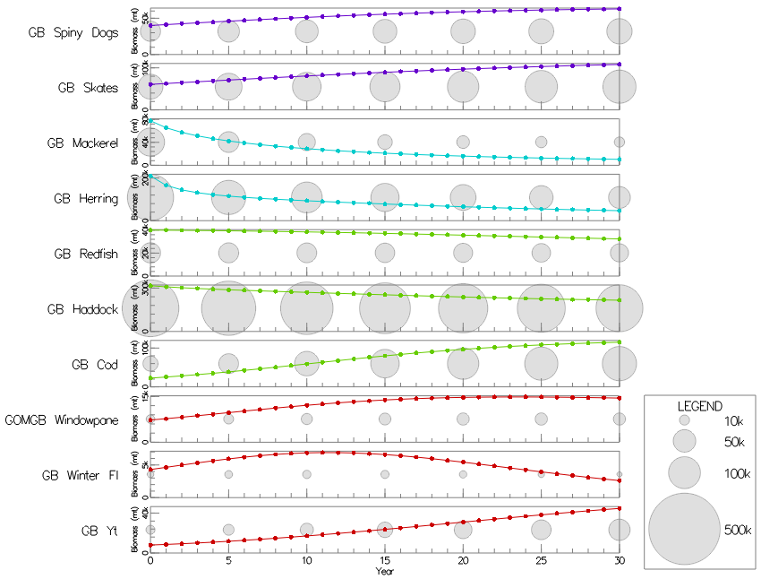

Figure 4: Absolute biomass indicators drawn every five years to allow for between-species comparisons.

**Visualizing Change**

In order for modelers and other stakeholders to understand and compare decisions, the ability to perceive differences in biomass resulting from changes in the fishing effort is necessary. Therefore, St. Jean and Ware created a feature where users can save a "baseline" of fishing effort values. Then, as the effort sliders are adjusted, the current biomass projections can be compared to the baseline biomass projections. There are three alternatives for displaying differences with that baseline:

1. instantaneous biomass plot updating (see Figure 5),
2. the baseline biomass drawn as a dotted gray line in addition to the current biomass (see Figure 6), and
3. a shaded area originating from the curve of the current biomass that diminishes in opacity as it approaches the curve of the baseline (see Figure 7).

**Visualizing Relationships between Species**

|  |
| --- |
| Figure 5: Change shown by interaction. |
| Figure 6: The baseline is shown as a dotted gray line. |
| Figure 7: The area between the baseline forecast and current forecast is shaded. |

Understanding of the model requires understanding of the underlying relationships between species—namely, predation and interaction. Predation is when one species consumes another and competition accounts for any way species might impact another in a way that is not predation. The interface must explain to users which species impact each other and the magnitude of those relationships. Therefore, these are illustrated with arc diagram network visualizations between the small multiples time series plots. Users can view either predation separately, competition separately, or both relationships at once.

Additionally, these relationships can be drawn in a few different styles:

1. **Statically:** all relationships appear at all times, weighted according to the original input values for the relationships (see Figure 8).
2. **Dynamically:** the arcs are drawn selectively according to their impact as effort values are adjusted to help explain causal linkages. Arcs are not drawn at all if they are not significant in explaining differences between two forecasts. Arcs have signage to show whether a change in biomass of the source species (e.g., predator) is good or bad from the perspective of the recipient species (e.g., prey) (see Figure 1).
3. **Dynamically with animation:** the arcs are drawn dynamically but also feature animation as an additional cue to show directionality (see Figure 9).

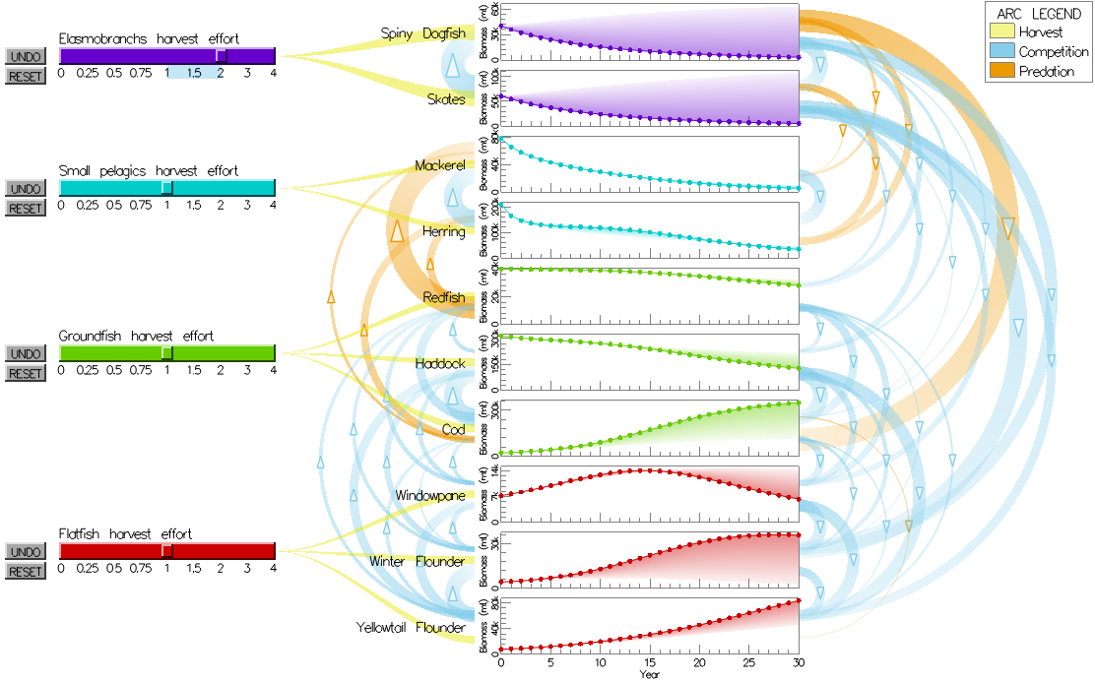

Figure : Static arcs in the MS-PROD visualization.

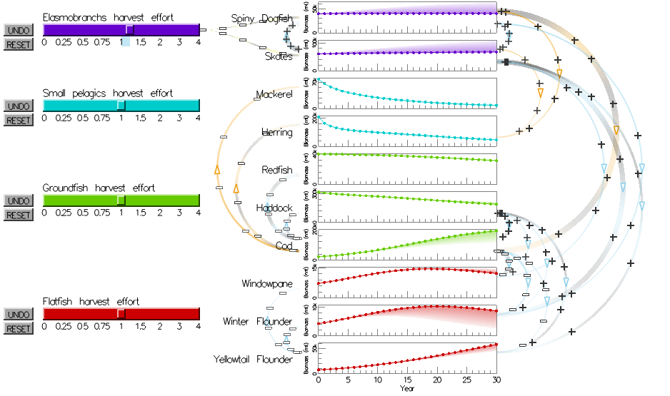

Figure : Dynamic, animated arcs in the MS-PROD visualization.

|  |  |
| --- | --- |
| msprod_uncertainty_multline.png  Figure 10: Multi-line uncertainty visualization. | msprod_uncertainty_boxplots.png  Figure 11: Box plot uncertainty visualization. |
| msprod_uncertainty_errorbar.png  Figure 12: Error bar uncertainty visualization. | msprod_uncertainty_errorbands.png  Figure 13: Error band uncertainty visualization. |

**Visualizing Uncertainty**

Finally, since models are simplifications of reality, their output is best understood as a range of expected values. It is possible that a representation of uncertainty may aid decision making. To add uncertainty visualization to the MS-PROD model, the interactive interface can perform Monte Carlo simulations by randomly jittering the non-zero input parameter values ±10%. The resulting uncertainty can be displayed in four styles:

1. a multi-line option which draws one semi-transparent line for each run of the Monte Carlo simulation (see Figure 9),
2. box plots drawn every five years to indicate the boundaries of the first, second (median), and third quartiles with whiskers stretching to the minimum and maximum values (see Figure 10),
3. the mean of all simulations is displayed as a line with bars every five years to represent one standard deviation above and below the mean (see Figure 11), and
4. a solid black line with bands to show one and two standard deviations above and below the mean (see Figure 12).

**Evaluation**

With the help of three undergraduate research assistants, St. Jean and Ware conducted a study with 92 students randomly recruited from the Memorial Union Building. The participants were instructed to adjust the harvest level for a particular functional group and then asked questions about how a particular fish species was affected and why. The questions varied in terms of difficulty, with some involving fish that were directly affected and others involving a fish that was affected indirectly. The latter type of questions could only be answered correctly by following the chain of causal linkages. The experiment compared three depictions of causal linkages with no linkages. The result was that the three alternative depictions were better than no linkages at all.