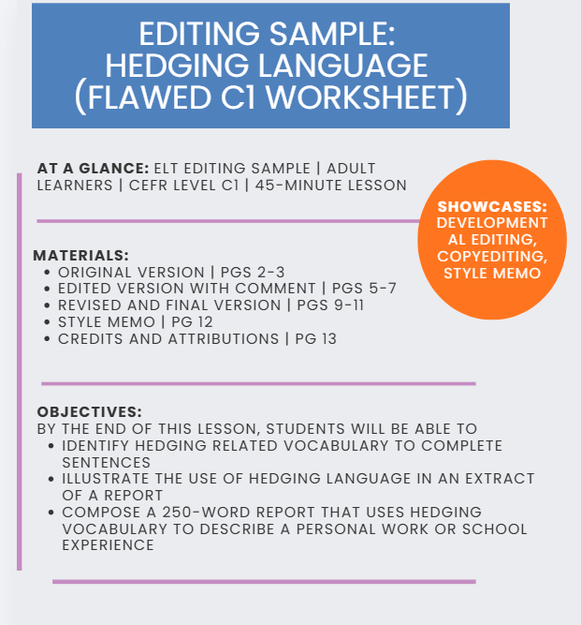

ORIGINAL VERSION OF FLAWED C1 WORKSHEET

UNIT 7: Sounding Cautious In Academic and professional Discussion
Level: C1 Advanced Time: 45 mins Skills: reading, writing, speaking

Objective: Students will understand hedging language and appreciate why it is important.

A. Warm up
Discuss with you partner. Why do writers and speakers sometimes avoid saying things directly? Think about your own job or study experiences! Testing

B. Read
Read the extract from a workplace report below and underline the all hedges in red. Studies prove that remote working definitely increases productivity in every company. Employees will always work harder at home, and managers obviously can't see them being distracted. It is clear that offices are now unnecessary; the company should close its offices immediately. This results is supported by the survey, which it was completed by 40 staff.

C. Language focus
Hedging (also called softening language, cautious language, or ‘vague language’) lets writers sound less certain. There are three main types:
- Modal verbs: may, might, could, will (the weakest hedge)
- Verbs: seem, appear, tend to (a modal verb), suggest
- adverbs: possibly, arguably, generally, probably, perhaps
Example: The results show that staff are happier. → The results seem to suggest that staff may be somewhat happier.

Exercise 1 (Matching)
Complete the sentences with a word from the box. [ tend / appears / arguably / might ]
1. Remote workers _______ to feel more isolated.
2. The new policy _______ to have improved morale.
2. This is _______ the most effective approach.
4. Further research _______ reveal different results.

Exercise 3
Match each strong statement with it’s softer version. Write the answers on a seperate paper.
a) Online learning is better. b) Managers don't listen. c) The plan will fail.
i. The plan could possibly maybe fail. ii. Online learning may be more effective for some learners. iii. Managers sometimes seem not to listen.

Exercise D
Now you write a 500 word report about a issue in your workplace or school, and use hedging to make it good. Then show it to a partner and they will tell you if they like it.
Answers: B – may, might, tend to. Ex 1 – 1 tend, 2 appears, 3 arguably, 4 might. Ex 3 – a ii, b iii, c i.

EDITED VERSION OF FLAWED C1 WORKSHEET
(INCLUDES COMMENTS AND MARKS)

UNIT 7: Sounding Cautious in Academic and Professional Discussions
CEFR Level: C1 Advanced | Time: 45 mins | Skills: reading, writing, speaking | Materials Needed: worksheet, red pen and pencil

Objective: By the end of this lesson, I will be able to:
- identify hedging related vocabulary to complete sentences
- illustrate the use of hedging language in an extract of a report
compose a 250-word report that uses hedging vocabulary to describe a personal work or school experience

A. Warm up (5 min)
Discuss the following with your partner: Why do writers and speakers sometimes avoid saying things directly? Think about your own job or study experiences. Was there ever an instance in which you avoided saying something directly to a co-worker or peer?

B Language Focus (10 min)
Let’s take 5 min to review the new language together as a class. Hedging (also called softening, cautious, or ‘vague language’) enables writers to sound less certain. There are three main types:
- Modal verbs: may, might, could, would
- Verbs: seem, appear, suggest
- Adverbs: possibly, arguably, generally, probably, perhaps
Example: The results show that staff are happier. → The results seem to suggest that staff may be happier.

Exercise 1 (Fill in the Blank) ~ 3 min
Work with your partner to complete the sentences with one of these following words: [appears / seem / / / might / arguably ]
1. Remote workers _______ to feel more isolated.
2. The new policy _______ to have improved morale.
3. This is _______ the most effective approach.
4. Further research _______ reveal different results.

Exercise 2 (Matching) ~ 3 min
With your partner, match the strong statement on the left with its softer version to the right:

a) Online learning is better.
i. The plan could fail.

ii. Online learning may be more effective for some learners.

iii. Managers seem not to listen at times.

b) Managers don't listen.

c) The plan will fail.

C. Reading Practice (10 min)
The extract below is from a workplace report. Take a few moments to read the extract silently on your own. Then work with your partner to underline the all hedging-related vocabulary using your red pens:
Studies suggest that remote work may increase productivity in many companies. Employees often appear to work harder at home, and managers may find it difficult to see whether they are being distracted.
It seems likely that offices are becoming less necessary, so the company might consider reducing its office space. This result is supported by the survey, which was completed by 40 staff.

D. Writing Practice (20 min)

Exercise 1: Your turn!
On your own, use the space below to write a 250- word report about an issue in you’ve experienced in the workplace or at school. Use at least 4 hedging related vocabulary words you learned in the prior exercises to soften the language. You have 15 min to complete this exercise.

Exercise 2: Share with your partner
Take 5 min to share your experiences with your partner. See if they can point out the hedging words that you used.

-------------------------------------------------------------------------------------------------------------------------------------

Answer Key:
Language Focus – Part B:
Exercise #2:
a -> ii
b -> iii
c -> i

Exercise 2:
- seem
- appears
- arguably
- might

Read – Part C:
Hedging vocabulary in the article include: suggest, may, seems, might, appears

REVISED AND FINAL VERSION OF FLAWED C1 WORKSHEET
(STUDENT READY)

UNIT 7: Sounding Cautious in Academic and Professional Discussions
CEFR Level: C1 Advanced | Time: 45 mins | Skills: reading, writing, speaking | Materials Needed: worksheet, red pen and pencil

Objective: By the end of this lesson, I will be able to:
- identify hedging related vocabulary to complete sentences
- illustrate the use of hedging language in an extract of a report
- compose a 250-word report that uses hedging vocabulary to describe a personal work or school experience

A. Warm up (5 min)
Discuss the following with your partner: Why do writers and speakers sometimes avoid saying things directly? Think about your own job or study experiences. Was there ever an instance in which you avoided saying something directly to a co-worker or peer?

B. Language Focus (10 min)
Let’s take 5 min to review the new language together as a class. Hedging (also called softening, cautious, or ‘vague language’) enables writers to sound less certain. There are three main types:
- Modal verbs: may, might, could, would
- Verbs: seem, appear, suggest
- Adverbs: possibly, arguably, generally, probably, perhaps
Example: The results show that staff are happier. → The results seem to suggest that staff may be happier.

Exercise 1 (Fill in the Blank) ~ 3 min
Work with your partner to complete the sentences with one of these following words: [appears / seem / might / arguably ]
1. Remote workers ______ to feel more isolated.
2. The new policy _______ to have improved morale.
3. This is _______ the most effective approach.
4. Further research _______ reveal different results.

Exercise 2 (Matching) ~ 3 min
With your partner, match each strong statement on the left with its softer version to the right:

a) Online learning is better.
i. The plan could fail.

ii. Online learning may be more effective for some learners.

iii. Managers seem not to listen at times.

b) Managers don't listen.

c) The plan will fail.

C. Reading Practice (10 min)
The extract below is from a workplace report. Take a few moments to read the extract silently on your own. Then work with your partner to underline all the hedging-related vocabulary using your red pens:
Studies suggest that remote work may increase productivity in many companies. Employees often appear to work harder at home, and managers may find it difficult to see whether they are being distracted.
It seems likely that offices are becoming less necessary, so the company might consider reducing its office space. This result is supported by the survey, which was completed by 40 staff.

D. Writing Practice (20 min)

Exercise 1: Your turn!
On your own, use the space below to write a 250-word report about an issue you’ve experienced in the workplace or at school. Use at least 4 hedging related vocabulary words you learned in the prior exercises to soften the language. You have 15 min to complete this exercise.

Exercise 2: Share with your partner
Take 5 min to share your experiences with your partner. See if they can point out the hedging words that you used.

-------------------------------------------------------------------------------------------------------------------------------------
Answer Key:
Language Focus – Part B:
Exercise #2:
a -> ii
b -> iii
c -> i

Exercise #1:
- seem
- appears
- arguably
- might

Read – Part C:
Hedging vocabulary in the article include: suggest, may, seems, might, appears

Editorial Style Memo
Overview
The draft had a sound topic but several issues that would slow learners and teachers: an objective that could not be observed, tasks in an order that did not build knowledge, instructions that were unclear or inconsistent, two content errors in the language box, and an input text with no hedging in it. Below are the main decisions I made and the style rules I applied.
Key decisions
- Objective: Rewrote the single vague aim (“understand… and appreciate”) as three observable can-do statements with parallel verbs (identify, illustrate, compose) that match the tasks.
- Sequence of Lesson Sections: Moved Reading Practice after Language Focus so learners encounter hedging language before they are asked to find it in a text. The lesson now runs warm-up, language focus, controlled practice, reading, then writing.
- Content accuracy: Removed “will” as a hedge (as it expresses certainty) and replaced it with “would.” Removed “tend to” from the modal list because it is a verb phrase, not a modal verb.
- Input text: The reading extract contained only direct language, so Task C could not work as written. I rewrote it with hedges (suggest, may, often appear to, seems likely, might) and left the survey sentence factual to avoid over-hedging.
- Timing and grouping: Added a time allotment to each section and stated pair or solo work in every instruction to avoid students from getting confused.
- Writing task: Split into an individual drafting stage and a partner-sharing stage, reduced the length from 500 to 250 words, and added a clear criterion (at least four hedges).
- Answer key: Updated to match the revised exercises and renumbered exercises.
Style rules applied
- Terminology: “hedging” and “hedging language” for the key concept; “softening” and “cautious language” kept only as listed alternative terms.
- Exercise labels: sequential numbering (Exercise 1, 2), with the task type in parentheses (Fill in the Blank, Matching).
- Headings: title case; section letters (A–D) in lesson order.
- Instructions: short imperative sentences that includes one task per sentence.
- Mechanics: “250-word report” hyphenated as a compound modifier; “its” vs. “it’s” corrected; “underline all the…” corrected; exclamation marks removed for a neutral register.
- Accessibility: “red pens” noted as a possible issue for colour-blind learners; suggest allowing “underline or circle.”
Queries for the author (theoretical)
- Please confirm that the 250-word target and the four-hedge minimum suit your learners.
- Should the answer key note that other hedges in the extract (many, often, likely) are acceptable?
- Would you consider adding nouns, adjectives and fixed phrases (for example, “it could be argued”) to the language box for C1?
Credits & Attributions

Worksheet Content
The original flawed worksheet (“Unit 7: Sounding Cautious in Academic and Professional Discussions”) was created for this portfolio sample. Its errors were introduced deliberately for editing demonstration purposes. Draft generated with AI assistance (Perplexity AI), based on topic, CEFR level, and content direction specified by the author.

Editing and Final Version
All tracked changes, comments, the revised worksheet, the answer key, and the style memo were produced by Carmen Khoury. AI assistance (Perplexity AI) was used for feedback on the draft; final editorial decisions were reviewed and approved by Carmen Khoury.

Images
No images or third-party assets were used in this resource.

Software
Edited in Microsoft Word using Track Changes and Comments.

