X, y = make_classification(
n_samples=3000, # 3000 observations
n_features=2, # 2 total features
n_informative=2,n_redundant=0,
n_classes=2, # binary target/label
n_clusters_per_class = 2,
hypercube = True,
shift = 0.0, # just changes the scale
shuffle = True, # Shuffle the samples and the features
class_sep = 0.9,
flip_y=0.04,
random_state=999 # e
)

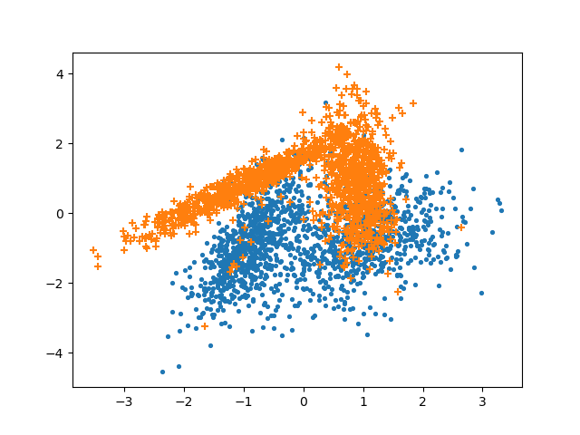

X, y = make_classification(
n_samples=3000, # 3000 observations
n_features=2, # 2 total features
n_informative=2,n_redundant=0,
n_classes=2, # binary target/label
n_clusters_per_class = 2,
hypercube = True,
shift = 0.0, # just changes the scale
shuffle = True, # Shuffle the samples and the features
class_sep = 0.3,
flip_y=0.2,
random_state=4 #
)

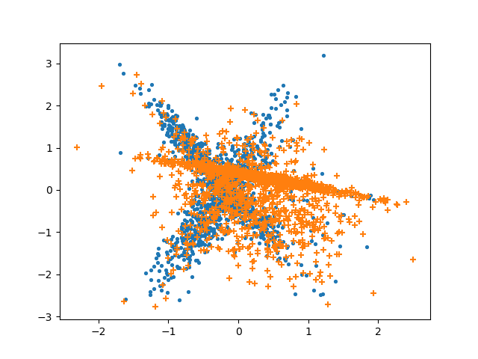

X, y = make_classification(
n_samples=3000, # 3000 observations
n_features=2, # 2 total features
n_informative=2,n_redundant=0,
n_classes=2, # binary target/label
n_clusters_per_class = 2,
hypercube = True,
shift = 0.0, # just changes the scale
shuffle = True, # Shuffle the samples and the features
class_sep = 0.3,
flip_y=0.0,
random_state=21 #
)

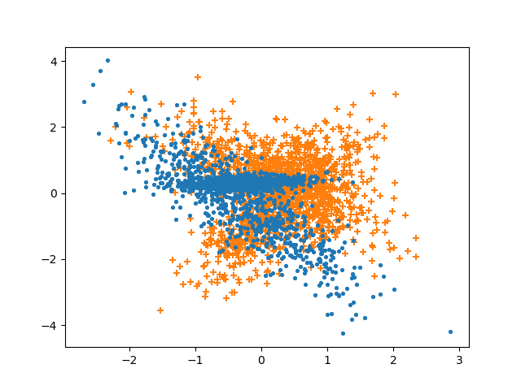
dddd

X, y = make_classification(
n_samples=3000, # 3000 observations
n_features=2, # 2 total features
n_informative=2,n_redundant=0,
n_classes=2, # binary target/label
n_clusters_per_class = 2,
hypercube = True,
shift = 0.0, # just changes the scale
shuffle = True, # Shuffle the samples and the features
class_sep = 0.6,
flip_y=0.0,
random_state=28 #
)

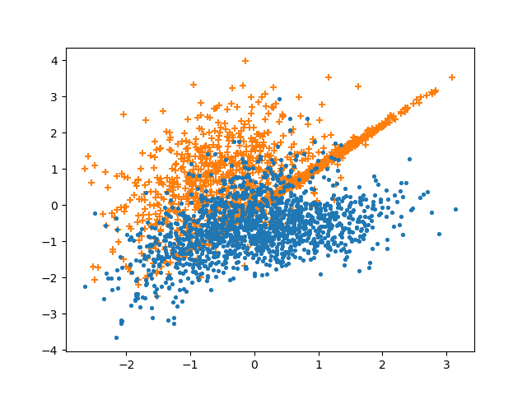
ddd

X,y = make_moons(n_samples=3000, shuffle=True, noise=0.33, random_state=28)

