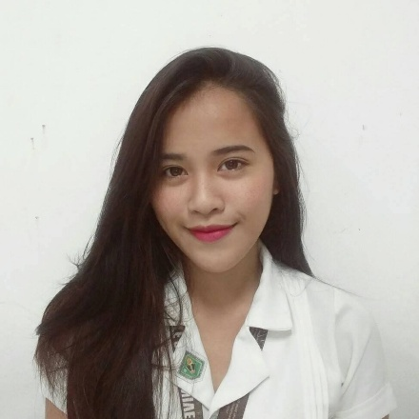**CARMINA BESABELLA HARDIN**

BLK F-17 LOT 8, BRGY. SAN LORENZO RUIZ 1,

DASMARIÑAS CITY, CAVITE.

+63915-213-9454

https://github.com/carminahardin

**PERSONAL**

Date of Birth : October 21, 1998

Place of Birth : Dasmariñas City

Gender : Female

Civil Status : Single

Religion : Roman Catholic

Height : 5’1

Weight : 45 Kg.

Father’s Name: Armando G. Hardin

Occupation : Retired Maintenance

Mother’s Name: Imelda B. Hardin

Occupation : Housewife

**EDUCATIONAL BACKGROUND**

**TERTIARY**

Cavite State University – Silang Campus

Biga 1, Silang, Cavite

SY: 2015-Present

**SECONDARY**

Dasmariñas West National High School

Brgy. San Antonio de Padua 1

SY: 2011-2015

**ELEMENTARY**

Sta. Cruz Elementary School

Brgy. Sta. Cruz 1

SY: 2005-2011

**CHARACTER REFERRENCES**

Ms. Nadia Erika G. Soliman

Computer Programmer

East West Bank

Cubao, Quezon City

Mr. Gilbert Hardin

Manager

ActionLabs

Cubao, Quezon City

**CARMINA B. HARDIN**

**VANESSA MEI VEGA VILLERO**

BUHO, AMADEO CAVITE

09566653229

https://github.com/nessamei

**PERSONAL**

Date of Birth : October 06, 1998

Place of Birth : Silang Caviite

Gender : Female

Civil Status : Single

Religion : Catholic

Height : 4’10

Weight : 42 Kg.

Father’s Name : Rolando C. Villero

Occupation : Elevator Technitian

Mother’s Name : Teresita Villero

Occupation : Unemployed

**EDUCATIONAL BACKGROUND**

**TERTIARY**

Cavite State University – Silang Campus

Biga 1, Silang, Cavite

SY: 2015-Present

**SECONDARY**

Tagaytay City Science National High School Sungay West Tagaytay City Cavite

SY: 2011-2015

**ELEMENTARY**

Maitim II Elementary School

Maitim II East Tagaytay City

SY: 2005-2011

**CHARACTER REFERRENCES**

Mr. Archie P. Barte

Instructor

Cavite State University – Silang Campus

**VANESSA MEI V. VILLERO**