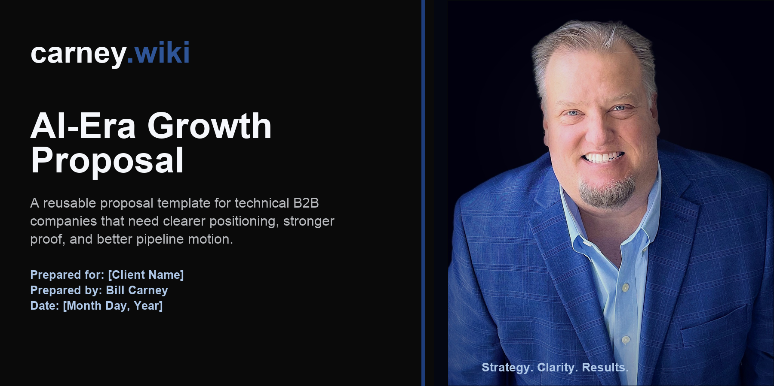
Executive summary
Recommendation
Run a focused AI-era growth engagement that clarifies the market story, builds a reusable proof system, and turns both into practical pipeline motion.

Technical B2B buyers do not need more generic content or louder campaigns. They need a clear explanation of why the problem matters now, credible proof that survives internal scrutiny, and a low-risk next step that helps the buying group move.
This proposal gives [Client Name] a working system for those three jobs: sharpen the story, organize the proof, and activate the market with assets and operating rhythms the team can actually maintain.
The likely growth problem
- The product may be technically strong, but the first-screen story asks buyers to infer too much.
- Proof exists in scattered places but is not mapped to claims, objections, buying stages, or use cases.
- Marketing activity may be happening without a tight path from narrative to evidence to offer to pipeline.
- AI-mediated discovery makes vague positioning easier to compress into generic summaries.
Proposed approach
The engagement is built around three linked workstreams. Each one produces material the sales, marketing, founder, and executive teams can reuse rather than a one-time strategy artifact.
Workstream | What changes | Outputs
Positioning clarity | Translate a technical offer into a buyer situation, category frame, value claim, and defensible differentiation. | Messaging architecture; homepage hierarchy; objection map
Proof operations | Turn claims, customer evidence, implementation examples, and security posture into reusable credibility assets. | Proof inventory; proof matrix; trust-center plan
Pipeline motion | Convert the story and proof into campaigns, content, sales enablement, and practical operating rhythms. | Offer path; campaign plays; 30/60/90 execution roadmap
Deliverables
- Positioning architecture: buyer situation, category frame, differentiated claim, objection map, and homepage hierarchy.
- Proof inventory: reusable credibility assets mapped by buyer, use case, buying stage, and claim.
- Execution roadmap: prioritized campaign plays, offer paths, content themes, and 30/60/90 operating rhythm.
- Decision-ready readout: concise executive summary with the tradeoffs, priorities, and next actions.
Working timeline
A six-week engagement is the default shape. The schedule can compress for a diagnostic-only sprint or expand for execution support.
Phase | Focus | Client input | Deliverable
Week 1 | Context, audit, buyer reality | Access to current site, sales materials, analytics, customer notes | Diagnostic readout
Weeks 2-3 | Positioning and proof architecture | Two working sessions and stakeholder feedback | Messaging and proof map
Weeks 4-5 | Execution system and assets | Review of draft page/campaign/proof assets | Core deliverables
Week 6 | Operating plan and handoff | Decision on priority plays and owner model | 30/60/90 roadmap
Commercial paths
These options mirror the current Carney offer structure and can be adjusted once the client context is known.
Option | Best fit | Primary outputs | Commercial
Positioning + Pipeline Audit | Fast diagnosis before bigger investment | Teardown, gap map, priority fixes | $5K fixed fee
Proof Ops Sprint | Technical company with claims buyers cannot verify | Proof matrix, library, placement plan | $10K-$20K
Founder Content Engine | Founder-led growth and recurring proof production | Monthly POV, proof asset, site/message improvement | $5K/month
Custom Growth System | Broader GTM reset or board-level initiative | Scoped after diagnostic | TBD
Operating model
- Weekly working session with one accountable client owner.
- Async review cycles for drafts, examples, and asset decisions.
- Source material access: website, sales deck, analytics, CRM snapshots, customer proof, and current content.
- Bias toward practical artifacts over abstract recommendations.
Next steps
- Confirm the client owner, decision date, and commercial option.
- Share current site, sales, customer, and performance materials.
- Schedule kickoff and first diagnostic readout.
- Finalize scope, timeline, and payment terms in the statement of work.
carney.wiki | Strategy. Clarity. Results.

