FIRST GLOBAL CHALLENGE 2026 · INCHEON · NEW TECHNOLOGY EXPERIENCE
ACTIVE DEFENCE SYSTEM (NTE)
Detecting Wildfires With LoRaWAN Sensor Nodes and Artificial Intelligence
Team: FIRST Global Team Colombia
Consolidated complete-solution document · Version 2.0 · August 2026
An end-to-end wildfire platform for Colombia: internet-independent sensing, automatic Telegram alerting, live information layers, a predictive risk model built on 15 years of national fire records, and robotic soil bioremediation after the fire is out.
Field | Content
Team name | FIRST Global Team Colombia
Project title | Active Defence System (NTE): Detecting Wildfires With LoRaWAN Sensor Nodes and AI
Category | DETECT (with prevention and post-fire recovery as integrated extensions)
Working region | Valle del Cauca, Colombia — Tropical Dry Forest and the Andean corridor
Project dataset | 14,985 IDEAM wildfire records, 2010–2025, processed by the team
Status | Web platform operational; nodes and predictive model under construction

14,985 | 406 | 0 | 6
wildfire records analysed  (IDEAM 2010–2025) | recurrent ignition points  identified nationwide | internet connection required  at the sensor node | modules covering the  full fire cycle

HOW TO READ THIS DOCUMENT
Sections 1 to 4 explain how we worked, which category we chose and what the problem is, with the data that supports it. Sections 5 to 11 describe the solution module by module. Sections 12 to 15 cover the technology, the honest status of every component, the impact and the continuation. The appendix collects the project photographs.

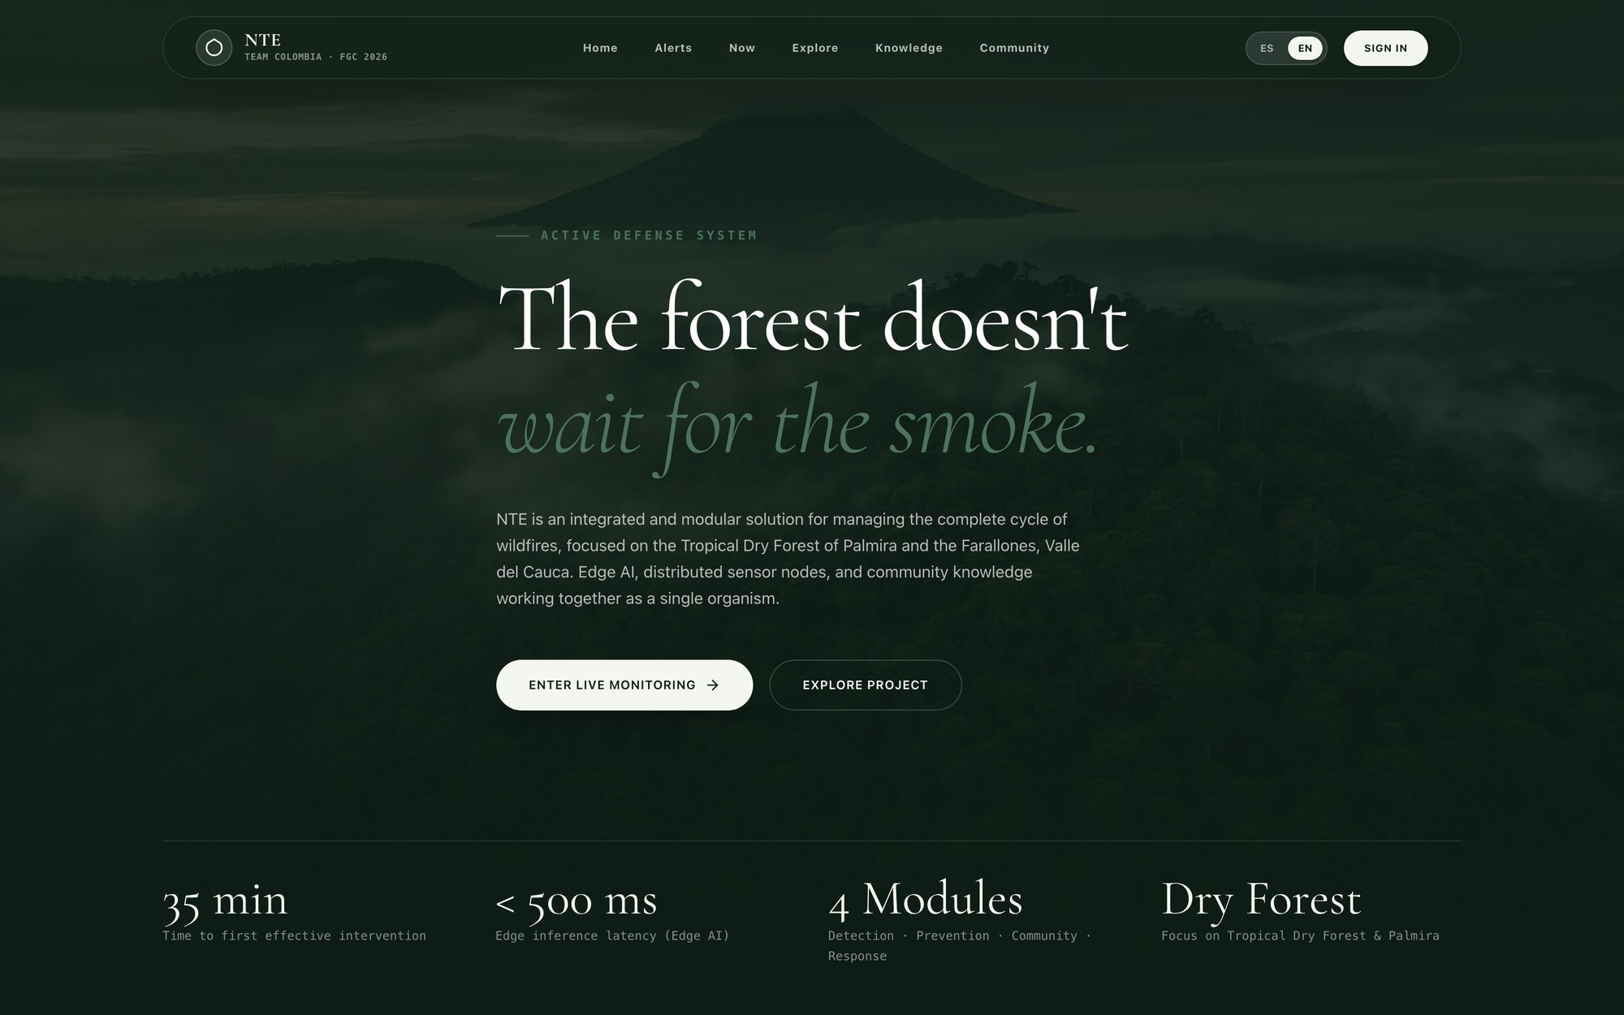
Figure 1. Public front page of the NTE platform. The system is built and running; every screenshot in this document comes from the real application.

1. Working methodology
The project is developed with an iterative, modular approach: instead of designing the whole system before building anything, we split the solution into six independent modules and advance all of them in parallel, validating each one against real evidence before integrating it. That is what lets us have a working platform while the hardware is still under construction, and correct the design with data rather than assumptions.
The work is organised in in-person team sessions with attendance tracking, and in three chained stages:
Stage | What we did | Output
Research and diagnosis | We analysed the state of wildfire in Colombia, reviewed the solutions already deployed and their limits, and trained the team in sensing, IoT, programming, remote sensing and biotechnology. | A quantified diagnosis of the problem and a team with the technical skills needed to attack it.
Proposal formulation | We studied the FIRST Global challenge and its criteria in depth, compared technical alternatives, identified allies (fire brigades, environmental authorities, the community) and defined the six-module architecture. | The chosen category (Detect), the six-module architecture and the map of allies in the territory.
Building and validation | We processed the IDEAM historical dataset, built the web platform, integrated the satellite sources, fixed the node data contract and started the bioremediation laboratory trials. | An operational platform, 14,985 records integrated and the node data contract fixed.
Table 2. The three stages of the process. Each one feeds the next with evidence, not opinions.

One principle guides the whole development: nothing enters the document or the platform unless it can be shown working or backed by a source. That is why Section 14 states explicitly what is built and what is in progress.

2. Category: DETECT
CATEGORY SELECTED: DETECT
Our core technical contribution is a network of multi-sensor LoRaWAN nodes and a fusion engine that identify a wildfire in its first minutes in areas with no connectivity, and dispatch the alarm automatically. Prevention (predictive risk mapping) and post-fire recovery (soil bioremediation) are built on the same data backbone and are presented as integrated extensions of the detection system, not as separate projects.

We chose Detect for four concrete reasons:
- The centre of gravity is early detection. The hardest technical problem we solved is sensing combustion signatures in a remote forest and getting that signal out without internet. Every other module consumes what the detection layer produces.
- The guide's definition matches exactly. FIRST Global defines detection as 'identifying fires in natural environments as early as possible to enable rapid response and containment'. That is the literal function of our Modules I, II and III.
- The technologies we apply are detection technologies. Monitoring and sensing, low-power wide-area networking, sensor-fusion algorithms, edge AI for smoke and flame classification, and automated communication systems.
- Colombia's measured gap is a detection gap. As Section 3 shows, the country's bottleneck is time-to-detection, not willingness or capacity to respond.
Category | How our solution contributes | Modules
Detect (primary) | Multi-sensor nodes, LoRaWAN transport, local sensor-fusion decision engine, automatic Telegram dispatch, live satellite hotspot layer. | I, II, III, IV
Prevent (integrated) | Predictive map = historical recurrence × current fire-weather; seasonal thresholds; education layer and community reporting; restored soil is itself a prevention measure against the next burn. | IV, V, VI
Combat (supporting) | The platform gives brigades the operational picture during suppression: telemetry, wind vector, spread-front estimate, routes and dispatch traceability. We do not build suppression hardware. | III, IV
Table 3. Category coverage. The project is judged under Detect; the other two are extensions of the same data backbone.

3. The problem: wildfire in Colombia
Colombia loses tens of thousands of hectares of forest, páramo and wetland every year to wildfires that are almost always detected too late. Our national fire record — 14,985 georeferenced incidents between 2010 and 2025 — shows that the fires are not random: they concentrate in the same municipalities, in the same two dry seasons, and 406 coordinates have burned repeatedly across multiple years. The information to act early exists. What does not exist, in the places that burn, is an instrument that senses the forest continuously and tells a firefighter, in minutes, that something is starting.

3.1 What the data shows
The team compiled and processed the national wildfire record maintained by IDEAM (Instituto de Hidrología, Meteorología y Estudios Ambientales), cross-referenced with biome, ecosystem, climate, landscape, relief and soil classifications, and with satellite hotspot archives. The resulting dataset is embedded in the platform and is the empirical foundation of the entire project. Three findings drive the design:
Finding | Evidence in the data | Design consequence
Fire is concentrated, not scattered | Cundinamarca (2,904), Tolima (1,767), Huila (1,187), Valle del Cauca (1,077), Boyacá (1,021) and Santander (981) account for the majority of incidents; the Andean region dominates. | Node deployment can be prioritised: a small number of nodes in the right municipalities covers a disproportionate share of national risk.
Fire repeats in the same places | 406 exact coordinates register repeat ignition events; the most persistent points — in Venecia, Ricaurte, Tocaima and Nilo (Cundinamarca) — burned up to 8 times across as many as 5 separate years. | Historical recurrence is a legitimate predictive variable — the 'where' half of our risk model.
Fire follows a bimodal calendar | Incidents cluster in the December–March dry season and again in July–September, matching the Andean bimodal rainfall regime. | Risk thresholds and alert sensitivity are seasonally adjusted — the 'when' half of the model.
Table 4. Three structural findings from 14,985 Colombian wildfire records (IDEAM, 2010–2025).

3.2 Who is affected and why current practice fails
The people most exposed are rural and peri-urban communities in the Andean corridor, small farmers, indigenous and campesino communities, and the volunteer fire brigades who respond with limited equipment. The ecosystems most at risk are precisely the least replaceable: páramo — the water factory that supplies the country's major cities — high-Andean forest, wetlands and fragmented forest, all of which regenerate slowly or not at all after severe burning.
Current mechanism | Strength | Structural gap
Citizen reporting by telephone | Fast where there are people and signal. | Useless in the remote areas where most fires start, and it requires someone to already see smoke.
Satellite hotspots (MODIS / VIIRS) | Excellent national coverage and free. | A revisit cycle measured in hours and a minimum detectable fire size measured in hundreds of square metres: by the time a pixel lights up, the window for cheap suppression has usually closed.
Lookout towers and patrols | Effective where they exist. | Scarce, expensive to staff, and blind at night and in fog.
Table 5. The three detection mechanisms currently used in Colombia and their limits.

THE GAP THIS PROJECT ATTACKS
Between 'nobody has noticed yet' and 'a satellite can see it' there is a window of roughly one to three hours in which a wildfire is still a small, cheap, survivable event. No existing instrument in Colombia watches that window continuously in remote terrain. Our sensor nodes are designed to live inside it.

3.3 Why we chose this problem
Our team is based in the Valle del Cauca, in the Andean corridor that the data identifies as the country's most fire-affected region. We have watched dry-season smoke columns from our own city, seen sugarcane and hillside fires cross into forest reserve, and heard from municipal brigades that their limiting factor is not courage or equipment — it is time. They learn about fires late. Everything else follows from that. In addition, climate projections for the tropical Andes point to longer and more intense dry spells, and each severe burn degrades the soil that would otherwise hold moisture and vegetation, which makes the next fire more likely and more severe. That feedback loop is why the project deliberately spans both ends of the cycle: detecting fires earlier and repairing the ground they leave behind.

4. The complete solution: overview
The Active Defence System is a complete chain that starts inside the forest and ends with the ecosystem recovering. Six modules make it up, and each link can survive the failure of the link above it: in the territories we design for, connectivity, power and personnel are all intermittent.
SENSE | → | DECIDE | → | ALERT | → | PREDICT | → | RESTORE
LoRaWAN nodes  in the forest |  | local server  sensor fusion |  | Telegram bot  to brigades |  | model on  15 yrs of data |  | Trichoderma  capsule robot

THE ONE-SENTENCE PITCH
We detect a wildfire in its first minutes with sensor nodes that work where there is no internet, we send the alarm straight to the people who can put it out, we predict where the next fire will start using fifteen years of Colombian fire history, and when the fire is over we heal the soil so the forest can come back on its own.

# | Module | Function | Fire-cycle phase
I | Sensor node network | Multi-sensory perception in the field ('the five senses'). | Detect
II | LoRaWAN transport | Long-range, low-power, internet-independent data link. | Detect
III | Alert engine + Telegram | Sensor fusion, graded alarm, automatic dispatch and traceability. | Detect / Combat
IV | Platform + information layers | Observatory, live map, node monitoring, community. | All four
V | Predictive model | Risk map from historical recurrence × current fire-weather. | Prevent
VI | Bioremediation | Trichoderma capsules dispensed by a ground robot to restore soil. | Recover / Prevent
Table 6. Module map. Sections 5 to 11 specify each one.

4.1 The data chain and its failure tolerance
Link | What it does | Survives without
1. Sensor nodes | Perceive the forest continuously and transmit compact frames over LoRaWAN. | Internet, mains power, cellular coverage
2. LoRaWAN gateway | Receives frames from every node within range (kilometres) and hands them to the local server. | Internet
3. Local server | Runs the sensor-fusion logic, decides whether an anomaly is a fire, raises the graded event, and triggers local sirens and the Telegram dispatch. | Internet (for detection; not for remote notification)
4. Database | Single source of truth: readings, node health, events, alerts, community reports, soil samples. | —
5. Platform | Visualises the territory, monitors network health, manages alerts, serves the community, hosts the predictive map and the recovery plans. | Internet (degraded PWA mode with cached data)
Table 7. The five links of the data chain and their failure tolerance.

DESIGN PRINCIPLE: THE CRITICAL DECISION HAPPENS AT THE EDGE
The platform never talks to a sensor and never decides on its own that a fire exists. The detection decision is taken in the territory by the local server, where it cannot be lost to a network outage. The platform consumes already-processed information and converts it into action.

4.2 Who uses the system
Role | What they do in the platform | Primary view
Operator / brigade | Watches alerts, confirms events, coordinates the response. | Dashboard, Alerts, Monitoring
Coordinator / authority | Plans surveillance and resources using risk and history. | Risk Map, Colombia Dashboard
Community member | Reports what they see, consults guides, talks to the chatbot. | Community (simple, mobile)
Technical administrator | Manages nodes, thresholds, users and integrations. | Settings
Table 8. Roles. Permissions and visible data are scoped per role.

5. Module I — The sensor node network (the five senses)
A node is a self-contained, solar-powered station installed in the forest. Rather than describing it as a list of components, we designed it around a metaphor that makes the engineering legible to the communities that will host it: each node has five senses, and each sense reports on a different side of the fire triangle (heat, fuel, oxidiser).
Sense | What it perceives | Magnitudes measured | Fire-triangle contribution
Hearing | Sound and crackle | Sound level (dB), analogue waveform amplitude, threshold flag | Indirect combustion signal
Smell | Gases, smoke and particulates | CO / combustible gases (ppm est.), PM2.5, PM10 (µg/m³) | Oxidiser + combustion products
Touch | Temperature, humidity and wind | Air and contact temperature (°C), relative humidity (%), pressure (hPa), soil moisture (%), wind speed (m/s) and direction (°) | Heat + fuel state
Sight | Image and radiation | RGB frame (ESP32-CAM), illuminance (lux), UV index; on-device smoke and flame classification | Heat
Intuition | Environmental context from public data | FWI, satellite hotspots, external weather, NDVI | Prediction / context
Table 9. The five senses, their magnitudes and their relationship with the fire triangle.

5.1 Hardware and design rule
The node is built on an Arduino MKR platform. The rule we impose on the hardware team is simple: deliver the magnitude, not the brand. If a sensor cannot give a calibrated physical value (an uncalibrated MQ-135, for example), it sends the raw value plus its unit and the normalisation happens on the server. That way the system is never tied to one specific sensor model.
Sense | Sensors used | What they deliver
Touch | MKR ENV Shield · DS18B20 / LM35 · HD38 | Air and contact temperature, relative humidity, atmospheric pressure, soil moisture
Smell | MQ-135 · Grove laser PM2.5 | Estimated CO₂ / combustible gases, PM2.5 and PM10 particulate matter
Sight | ESP32-CAM · MKR ENV · Adafruit UV breakout | RGB image with smoke/flame classification, illuminance in lux, UV index
Hearing | SparkFun Sound Detector | Sound wave amplitude and a digital flag when the threshold is crossed
Context | Anemometer + vane · LoRa radio · battery monitor | Wind vector, link quality (RSSI/SNR), battery voltage
Table 10. Sensor selection by sense. The full list of fields, units and types constitutes the node's data dictionary.

5.2 The frame a node produces
This is the canonical JSON a node produces, grouped by subsystem. Over the air the frame travels in a compact binary form and the gateway bridge expands it into this structure, so that the server, the database and the platform all speak one contract.
{
"node_id": 105,
"timestamp": "2026-07-25T14:30:00Z",
"sensors": {
"environment": { "temperature": 34.25, "humidity": 22.8,
"pressure": 1008.4, "uv_radiation": 8.5 },
"wind": { "speed": 4.7, "direction": 185 },
"air_quality": { "gas_co_smoke": 320.0, "pm25": 14.2, "pm10": 35.6 },
"acoustics": { "sound_level": 45 }
},
"location": { "latitude": 3.4412, "longitude": -76.5189, "altitude": 985.6 },
"diagnostics": { "battery_voltage": 3.92, "lora_rssi": -92, "lora_snr": 7.5 }
}
Figure 2. Real uplink frame from node 105, Palmira, Valle del Cauca. Every alert the system raises is traceable to frames of exactly this shape.
Each block feeds a specific function. With the sample values: 34.25 °C at 22.8 % humidity is a hot, very dry atmosphere, conditions under which dead fuel moisture drops fast; wind at 4.7 m/s from the south (185°) tells the brigade which way a front would run before they arrive; 320 ppm of gas with PM2.5 at 14.2 µg/m³ is elevated but still within this node's baseline — a sharp, simultaneous rise in both is the primary smoke signature; and a 3.92 V battery with −92 dBm RSSI is a healthy node on a solid link. Node health and fire evidence are kept strictly separate: a failing battery can never masquerade as a fire.

5.3 Every node learns its own normal
Absolute thresholds do not work across a country with páramo at 3,500 m and dry tropical forest at 900 m. Each node therefore builds a rolling baseline of its own normal: a 7-day moving statistic per magnitude, per hour of day. Detection logic works on deviation from that baseline — how many standard deviations above its own normal is this gas reading, right now, at this hour — rather than on a fixed number. This is what allows the same hardware and the same code to be deployed in a different ecosystem without re-engineering.
SPACE RESERVED FOR PHOTOGRAPH
Sensor node prototype under construction
Suggestion: photograph of the breadboard assembly with the Arduino MKR board, the ENV Shield and the sensors wired; or of the node already enclosed with its solar panel.
Figure 3. Sensor node prototype under construction

6. Module II — LoRaWAN: sensing without internet
THIS IS THE CONSTRAINT THAT SHAPES THE ENTIRE PROJECT
The places that burn are the places with no coverage. Any wildfire detection system for Colombia that assumes internet, cellular data or mains power at the sensor is a system that will not be installed where it is needed. LoRaWAN is the design decision that makes the rest of the project physically possible in remote terrain.

LoRaWAN (Long Range Wide Area Network) is a low-power, long-range radio protocol built for exactly this situation: tiny amounts of data, sent infrequently, over long distances, by battery-powered devices, using unlicensed spectrum and requiring no operator, no SIM card and no subscription. Our nodes are Class A LoRaWAN end devices; a single gateway — which can itself be solar-powered and mounted on a hill, a tower or a school roof — collects from every node in the area and delivers to the local server.
Option | Range in terrain | Node power draw | Recurring cost | No operator coverage | Verdict
Wi-Fi | ~100 m | High | Internet plan | No | Impossible in forest
4G / GSM | Coverage-dependent | High | SIM per node | No | Fails exactly where fires start
Satellite (IoT) | Global | High | High per message | Yes | Cost prohibitive at node scale
LoRaWAN | 2–5 km dense canopy; 10–15 km line of sight | Very low (years on battery + solar) | None (unlicensed ISM band) | Yes | Selected
Table 11. Transport comparison. LoRaWAN is the only option that satisfies range, power, cost and independence simultaneously.

6.2 Link design and payload economy
- Band and class. Sub-GHz ISM operation per the regional parameters applicable in Colombia (US915 / AU915 sub-bands), Class A end devices — the lowest-power class, in which the node sleeps and only opens receive windows immediately after transmitting.
- Spreading factor. Adaptive (SF7–SF12). Nodes close to the gateway use a fast, low-energy SF; distant nodes under canopy fall back to SF12 for maximum sensitivity at the cost of airtime.
- Link quality telemetry. Every frame carries RSSI and SNR, so the platform continuously maps the health of the radio network and can flag a node whose link is degrading before it goes silent.
- Power. Solar panel plus lithium cell. The duty cycle keeps average current in the microampere range between transmissions, which is what makes multi-year unattended operation realistic.
- Gateway. One gateway serves many nodes and is the only device that needs a backhaul; even that is optional, because it hands frames to the local server over the local network and detection continues with the backhaul down.
LoRaWAN gives long range in exchange for very small payloads and limited airtime. The node therefore does not transmit the full JSON but a packed binary frame of roughly 20–30 bytes, with an adaptive cadence:
Node state | Trigger | Uplink interval | What is sent
Normal | Baseline conditions | Every 10–15 minutes | Full compact frame (all senses + diagnostics)
Watch | One sense deviating from baseline | Every 2–5 minutes | Full frame, higher cadence
Alert | Two or more senses concordant | Every 30–60 seconds | Priority frame; camera capture requested; the local server escalates immediately
Maintenance | Low battery or degraded link | Reduced cadence | Diagnostics only, to preserve charge
Table 12. Adaptive duty cycle. Energy is spent where it matters: the network gets loud precisely when something is happening.

WHAT THIS MEANS FOR A JUDGE OR A MAYOR
A node can be installed on a hillside with no road, no power line and no phone signal, left alone for years, and still be the thing that tells the fire brigade about a fire while it is still small.

SPACE RESERVED FOR PHOTOGRAPH
LoRaWAN gateway and field deployment
Suggestion: photograph of the gateway installed at height, or of the team running range tests with the nodes in the Palmira dry forest.
Figure 4. LoRaWAN gateway and field deployment

7. Module III — Alert engine and the Telegram module

7.1 Sensor fusion: from readings to a decision
A single sensor produces false alarms: a passing tractor raises gas, midday sun raises temperature, a chainsaw raises sound. The local server therefore never escalates on one signal.
FUSION RULE
An event is raised only when at least two independent senses deviate concordantly from their own baselines inside the same time window and the same spatial neighbourhood. Concordance is weighted: a simultaneous rise in particulates and gas (smell) together with a temperature rise (touch) scores far higher than either alone. The camera (sight) is then requested for visual confirmation, and the context layer (intuition) — satellite hotspots, fire-weather index — adjusts the final confidence.

7.2 The risk ladder
Every zone carries a continuous risk score from 0.0 to 1.0. That score maps to five operational levels which drive the colour of the interface, the cadence of the nodes and — critically — who gets told.
Level | Score | Meaning | Automatic system response
GREEN — Normal | 0.00 – 0.20 | Baseline conditions. | Routine telemetry; no notification.
YELLOW — Watch | 0.20 – 0.40 | Fire-weather deteriorating or one sense deviating. | Node cadence increased; dashboard flag; no dispatch.
ORANGE — Alert | 0.40 – 0.60 | Concordant multi-sensor anomaly; possible ignition. | Event created; camera capture; operator notified in-platform.
RED — Alarm | 0.60 – 0.80 | High-confidence fire detection. | Automatic Telegram dispatch to the brigade with location, evidence and image; local siren; alert appears in the tray as critical.
PURPLE — Evacuation | 0.80 – 1.00 | Fire confirmed and threatening people or critical ecosystem. | Telegram broadcast to all channels, evacuation routes rendered, community notification, coordinator escalation.
Table 13. The five-level risk ladder. Thresholds are configurable per ecosystem — páramo and dry tropical forest do not burn under the same conditions.

7.3 The Telegram module
Telegram is not a decoration on this project; it is the delivery mechanism that makes detection useful. Fire brigades, community leaders and municipal risk coordinators in Colombia already coordinate through Telegram and WhatsApp groups on their own phones. Meeting them where they already are removes the adoption barrier entirely: no app to install, no training, no new device to charge.
- Trigger. When the local server raises an event at RED or PURPLE level, the platform composes the alert and calls the Telegram Bot API automatically. No human is in the loop for the dispatch itself.
- Recipients. Configured per zone: the municipal fire brigade group, the risk-management coordinator, and — at PURPLE — the community channel. Destinations are managed in Settings, not in code.
- Message content. Level and colour, node ID and zone, GPS coordinates as a shareable pin, timestamp, the sensor evidence that triggered it, wind speed and direction, and the ESP32-CAM image if one was captured.
- Traceability. The Alerts tab shows the delivery status of every dispatch — queued, sent, failed — and allows a manual resend. Every state change is logged with author and time.
- Degraded mode. If there is no connectivity at dispatch time, the message is queued and the local siren and radio protocol take over. The queue flushes automatically when a link returns, and the platform shows the alert as pending delivery rather than silently losing it.
🔴 ALARM — LEVEL RED (score 0.71)

Node 105 · Zone: Palmira, Valle del Cauca
Time: 2026-07-25 14:30 UTC (09:30 local)
Location: 3.4412, -76.5189 · 985 m

EVIDENCE (sensor fusion, 2 of 5 senses concordant):
- Smell : gas 320 -> 780 ppm (+4.2 sigma over baseline)
PM2.5 14.2 -> 96 ug/m3
- Touch : temp 34.2 -> 41.6 C · humidity 22.8 -> 14 %
- Sight : camera classification -> SMOKE (confidence 0.88)

CONDITIONS: wind 4.7 m/s from the south (185 deg)
Estimated spread direction: NORTH

[ camera image attached ]
[ open in platform ] [ confirm & dispatch ]
Figure 5. Structure of an automatic Telegram alert. The message is designed to be actionable from a phone screen in the field, without opening the platform.

7.4 Alert lifecycle
DETECTED | → | DISPATCHED | → | ACKNOWLEDGED | → | IN PROGRESS | → | RESOLVED
fusion raises  the event |  | Telegram +  siren |  | operator opens  the evidence |  | brigade  responding |  | logged with  author & time

This traceability matters beyond the incident: every resolved alert, with its evidence and its outcome, becomes a labelled training example that improves the fusion thresholds and, eventually, the predictive model.
SPACE RESERVED FOR PHOTOGRAPH
Alert received on the brigade's phone
Suggestion: screenshot of the real Telegram message, with the camera image attached.
Figure 6. Alert received on the brigade's phone

8. Module IV — The platform and its information layers
The platform is the web application where everything converges. It is built as a single pane of glass: the design goal is to reduce the cognitive load of a coordinator under pressure by showing the minimum sufficient information in one screen, on a phone as readily as on a desktop. It is built and running, bilingual (Spanish / English) and responsive. Every screenshot in this section comes from the real application.
Section | Purpose | Key content
Dashboard / Alerts | Global system state at a glance, and turning detection into action. | Five-level risk traffic light with a plain-language explanation, node network health, active events, alert tray, evidence detail and Telegram delivery state.
Monitoring | The node network, node by node. | Live telemetry per node organised by the five senses, battery and link quality, comparison table across nodes, anomaly simulation for drills.
Observatory | Live public-data map — observation, not prediction. | Switchable colour layers over Colombia and the world; click anywhere to read current conditions at that point; timeline animation; community reports layer.
Risk Map | Output of the predictive model. | Territory coloured by predicted risk, refreshed every 10–15 minutes.
Colombia Dashboard | The historical record, explorable. | 14,985 IDEAM incidents by department, municipality, year, month, biome, ecosystem, climate, landscape and soil; recurrence hotspots; seasonality; sensitive-ecosystem analysis.
Community | Bringing people, and their knowledge, in. | Citizen reporting with photo and location; a community plaza with four categories — ancestral knowledge, fauna and ecosystems, stories and culture, news — where users sign in, post with an image, comment, like, share and translate; learning layer, glossary and chatbot.
Bioremediation | Closing the cycle after the fire. | Burned-area map, robot sampling points, soil diagnosis and recovery plan.
Table 14. Sections of the platform.

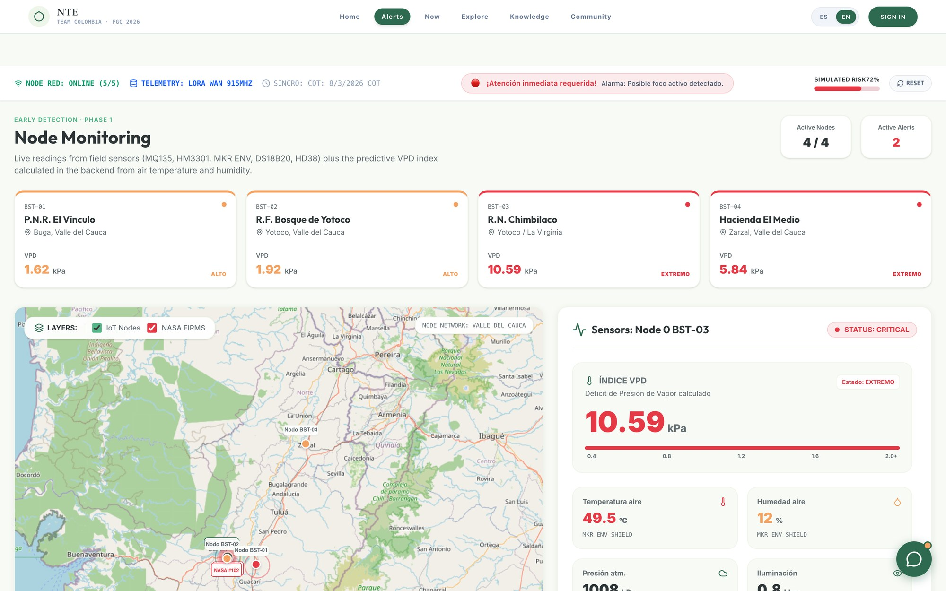
Figure 7. Node monitoring. Each card is a node of the Valle del Cauca network with its VPD (vapour pressure deficit) index and status; the map overlays the IoT nodes with active NASA FIRMS hotspots, and the right-hand panel opens the full telemetry of the selected node. The top bar shows the network online, LoRaWAN transport at 915 MHz and an active alarm.

8.2 The information layers of the observatory
The observatory answers a different question from the risk map. The risk map says what we predict; the observatory says what is measurably happening right now, using public satellite and meteorological data. Layers are grouped thematically and each carries its own legend, opacity control, update timestamp and source attribution.
Group | Layer | Source | Refresh
Weather | Rain radar (animated, 2 h) | RainViewer | Every 5 min
Weather | Temperature, wind, cloud cover | OpenWeatherMap | ~3 h
Weather | Point conditions on click | Open-Meteo | Hourly
Fire & heat | Active hotspots | NASA FIRMS (MODIS / VIIRS) | < 3 h
Fire & heat | Thermal anomalies | NASA GIBS | 3–5 h
Fire & heat | Burned areas / FWI | Copernicus EFFIS / GWIS | Near real time
Air & smoke | Aerosol / smoke plumes | NASA GIBS (AOD) / CAMS | Daily
Air & smoke | Air quality on click (PM2.5, PM10, CO, O₃) | Open-Meteo Air Quality | Hourly
Vegetation | Vegetation dryness (NDVI) | Sentinel-2 / Google Earth Engine | ~5 days
Satellite | True-colour base imagery | NASA GIBS | 3–5 h
Own network | Our sensor nodes | LoRaWAN network | Seconds to minutes
Community | Citizen reports (smoke, heat, fire) | Platform users | Live
Table 15. Information layers. Priority was given to free, globally available sources so the platform is replicable in any country at zero data cost.

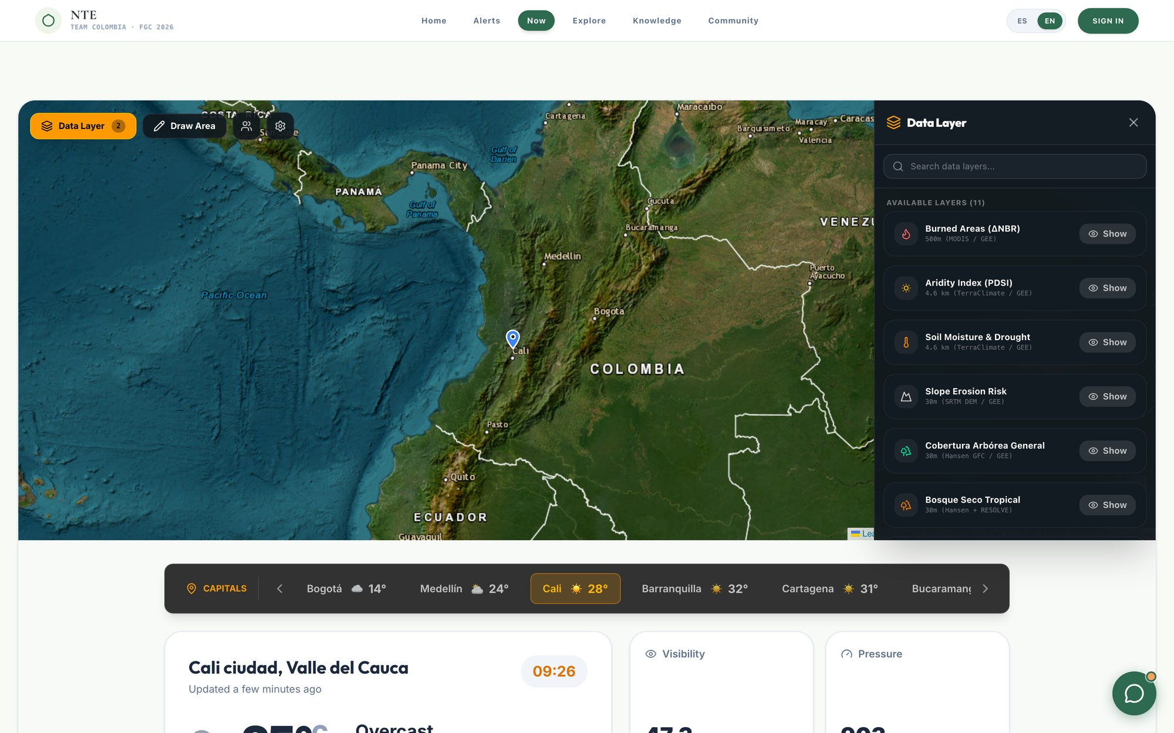
Figure 8. Observatory. The side catalogue exposes the available layers — burned areas (ΔNBR), aridity index (PDSI), soil moisture and drought, slope erosion risk, tree cover, tropical dry forest — served from Google Earth Engine, MODIS, TerraClimate, SRTM and Hansen GFC. The lower strip shows current conditions for the capitals and the detail of the selected point.

8.3 The community layer
Three capabilities make the community part of the sensing network rather than an audience for it: citizen reporting on the map, the community plaza where knowledge is shared, and the learning layer with the chatbot.
First, any user can drop a report on the map — smoke, extreme heat, heavy rain, active fire — with a photo and location, and other users can confirm it; a confirmed cluster of citizen reports is itself a detection signal that feeds the fusion engine described in Section 7.

8.3.1 The community plaza: 'Voices of the territory'
The community plaza is a social network of its own inside the platform, built so that the knowledge of the territory circulates and is placed on the record. It is not a read-only noticeboard: residents sign in with their account, post, comment, react and share. Its premise is that the people who live in the territory know things about fire, weather and forest that no sensor measures, and that this knowledge deserves a formal place inside the system, on the same footing as telemetry and satellites.
Posts are organised into four categories, each with its own colour and icon:
Category | What it collects | Why it matters to the system
Ancestral Knowledge | Traditional knowledge passed down between generations: reading the sky and the clouds, wind and rain signs, traditional burning calendars, fire management learned from the elders. | It is an early indicator of conditions our sensors do not yet cover, and it is the memory of the territory: where it has burned before and why.
Fauna & Ecosystems | Sightings, unusual animal behaviour, vegetation state, observed changes in streams, páramo or forest. | Wildlife behaviour changes before many physical variables do; it serves as ground verification of the satellite layers.
Stories & Culture | Stories, memory of past fires, cultural bond with the forest and the territory. | It builds belonging: someone who feels ownership of the forest looks after it and reports.
Community News | Calls to action, cleaning days, civil defence and brigade notices, local alerts. | It is the channel through which an observatory alert becomes concrete collective action.
Table 16. The four categories of the community plaza. The first one, Ancestral Knowledge, is deliberately first: traditional knowledge is a system input, not a cultural decoration.

On top of those categories, the plaza offers the functions people already expect from a social network, so that there is nothing new to learn:
Capability | How it works
Sign in and post | The user creates an account and signs in (Supabase authentication). Once inside they can post with a title, body text, category and location tag.
Upload images | Every post accepts a photograph, uploaded from the phone, with a preview before publishing. A picture of a smoke column, a sighting or a burn is visual evidence with a date and a place.
Like | One heart per post, with a visible counter and per-user state: the platform remembers what each user liked and allows un-liking. Reactions make visible which knowledge the community considers valuable.
Comment | Every post opens a comment thread with a counter, so a piece of knowledge can be discussed, corrected or extended by other neighbours.
Share | Any post can be shared outside the platform, which is how information actually circulates in the territory (WhatsApp and Telegram groups).
Automatic translation | Posts and comments are translated between Spanish and English at the press of a button, and translated content is labelled as such. Knowledge told in Spanish by a community leader stays accessible to a judge or to a team from another country without losing the original.
Filter and sort | Filter by category and sort by most recent or most popular, to find what is relevant quickly.
Read-only mode | Without an account, anyone can read everything; to post, comment or react, signing in is required. The information is never behind a wall, but authorship is always on the record.
Table 17. Capabilities of the community plaza. Everything is available in Spanish and English and designed to be used from a phone.

WHY THIS IS PART OF THE DETECTION SYSTEM AND NOT AN ADD-ON
A node measures gas, temperature and humidity. It does not know that this particular hillside has burned every August for thirty years, nor that when the clouds over the summit turn grey with yellow edges, strong winds come down within 48 hours. People know that. Ancestral knowledge, sightings and citizen reports are a sixth source of evidence alongside the node's five senses, and the only one that can give us the historical and cultural context of a territory before a single sensor is installed in it.

Finally, the learning layer and the chatbot translate the technical content — what a risk level means, what to do when you see smoke, why páramo matters — into plain language, with a glossary, in Spanish and English and on a phone.
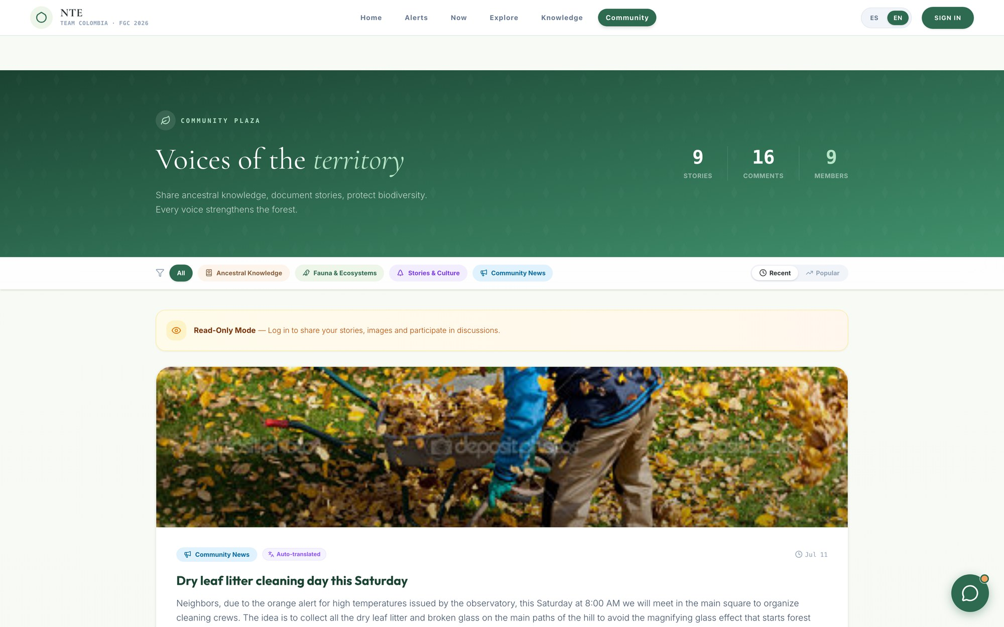
Figure 9. The 'Voices of the territory' community plaza, with its four categories — ancestral knowledge, fauna and ecosystems, stories and culture, community news — the sort by recent or popular, and the counters for stories, comments and members. The notice shows read-only mode: anyone can read, and signing in is all it takes to post, upload images and take part. The featured post calls a dry-leaf-litter cleaning day following an orange alert issued by the observatory — a direct example of detection turning into community action; the 'auto-translated' tag shows the ES↔EN translation at work.
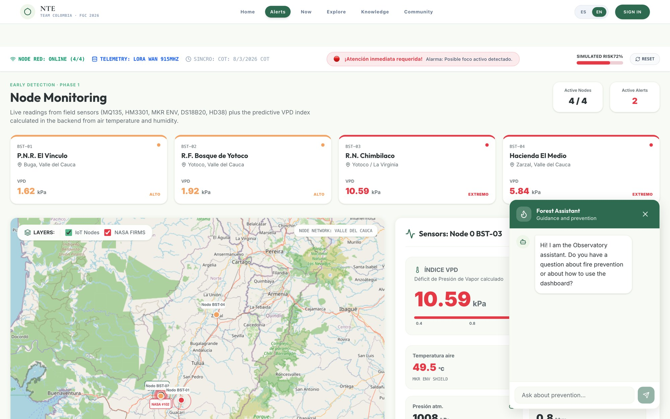
Figure 10. The conversational assistant is available across the whole platform as a floating button and answers questions about prevention and about how to use the dashboard, without taking the user out of the view they are working in.
SPACE RESERVED FOR PHOTOGRAPH
The community using the platform
Suggestion: photograph of a session with the community, the fire brigade or the school, using the dashboard or receiving the training.
Figure 11. The community using the platform

9. Module V — Predictive model from Colombia's fire history
The detection modules answer 'is something burning now?'. The predictive model answers a different and cheaper question: 'where is a fire most likely to start in the coming days, so we can put surveillance, brigades and prevention there before it does?'

9.1 The historical dataset
The model's foundation is a dataset the team assembled from several sources rather than downloading ready-made. Raw IDEAM wildfire records were parsed, cleaned, georeferenced and joined with environmental classifications, then cross-checked against satellite hotspot archives. The result is 14,985 incidents covering 2010–2025, each carrying:
Attribute group | Fields | Why it matters to the model
Location & time | latitude, longitude, date, year, month, department, municipality | Builds the recurrence surface and the seasonal profile.
Biome & ecosystem | gran_bioma, bioma_IAvH, ecosystem synthesis, intervened flag | Different ecosystems ignite and burn differently; the intervened flag separates human-modified landscapes from natural cover.
Climate | climate classification (e.g. warm semi-humid) | Encodes the background aridity of the site independently of today's weather.
Terrain | landscape, relief, soils | Slope and soil type govern spread behaviour and post-fire soil vulnerability.
Table 18. Structure of the historical dataset (14,985 records, 2010–2025), processed by the team from IDEAM and complementary sources.

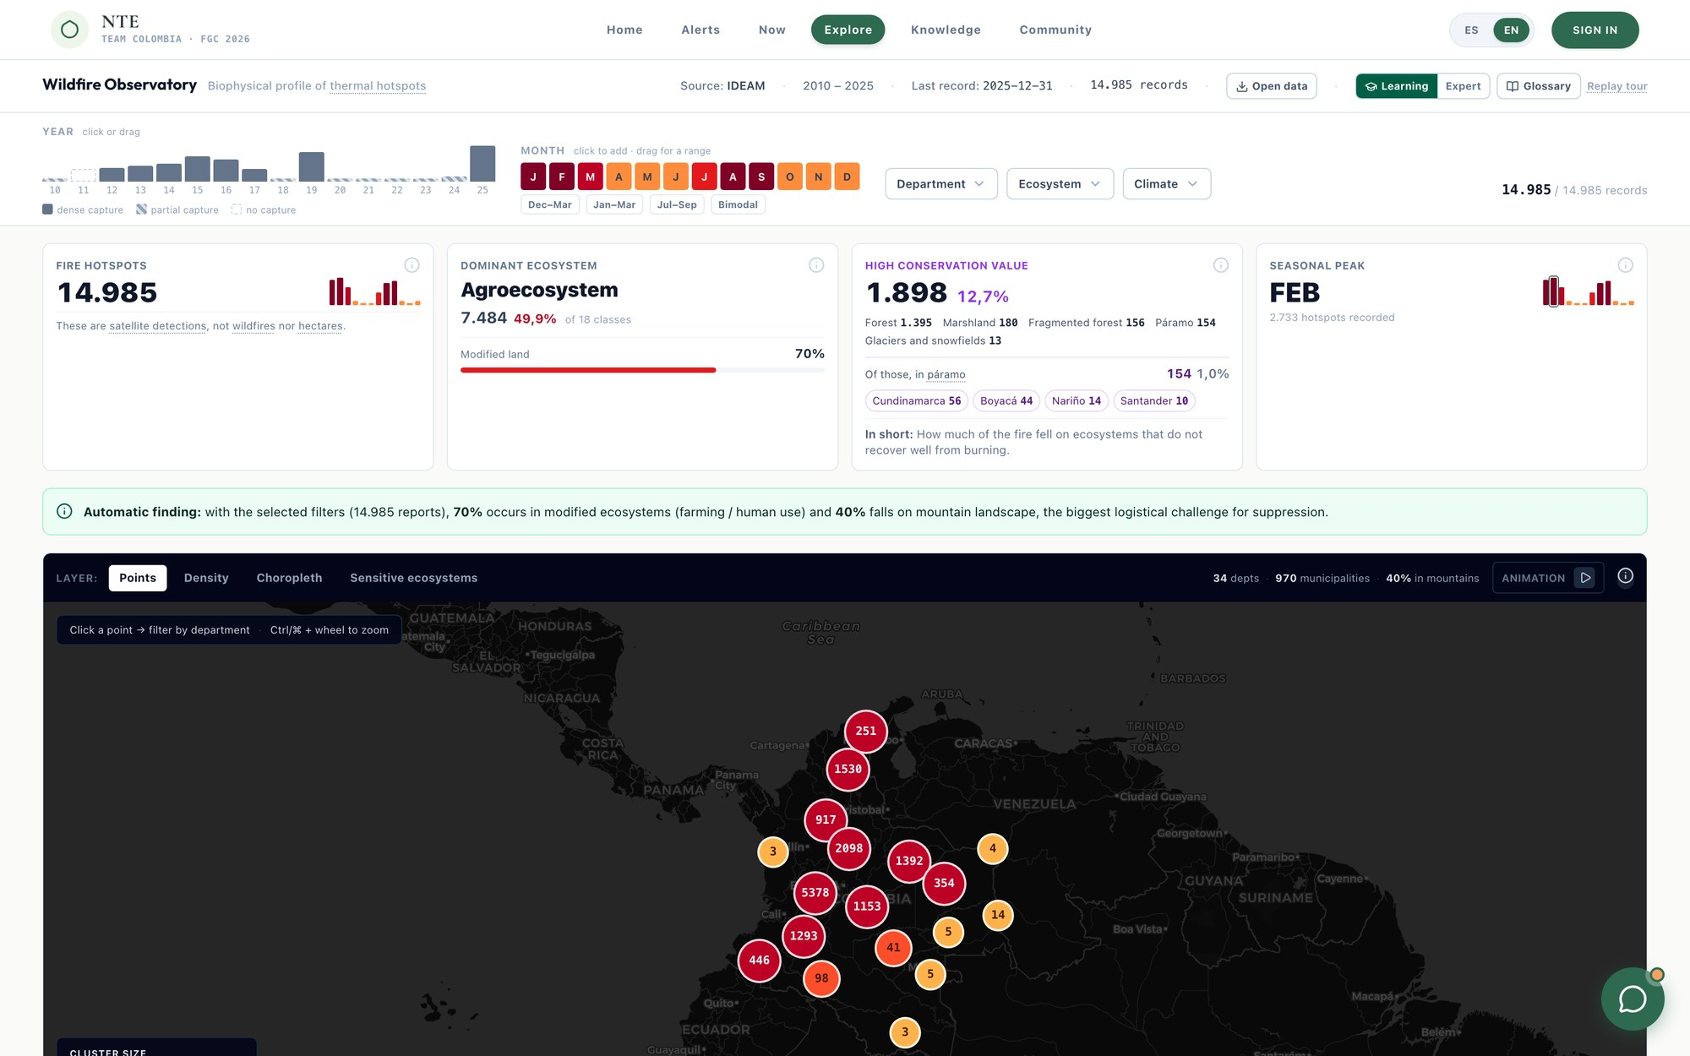
Figure 12. Colombia dashboard. The 14,985 hotspots are explorable by year, month, department, ecosystem and climate; the cards summarise the dominant ecosystem (agroecosystem, 49.9 %), the high-conservation-value hotspots (1,898, of which 154 in páramo) and the seasonal peak (February, with 2,733 hotspots). The automatic finding notes that 70 % occurs in modified ecosystems and 40 % on mountain landscape, the biggest logistical challenge for suppression.
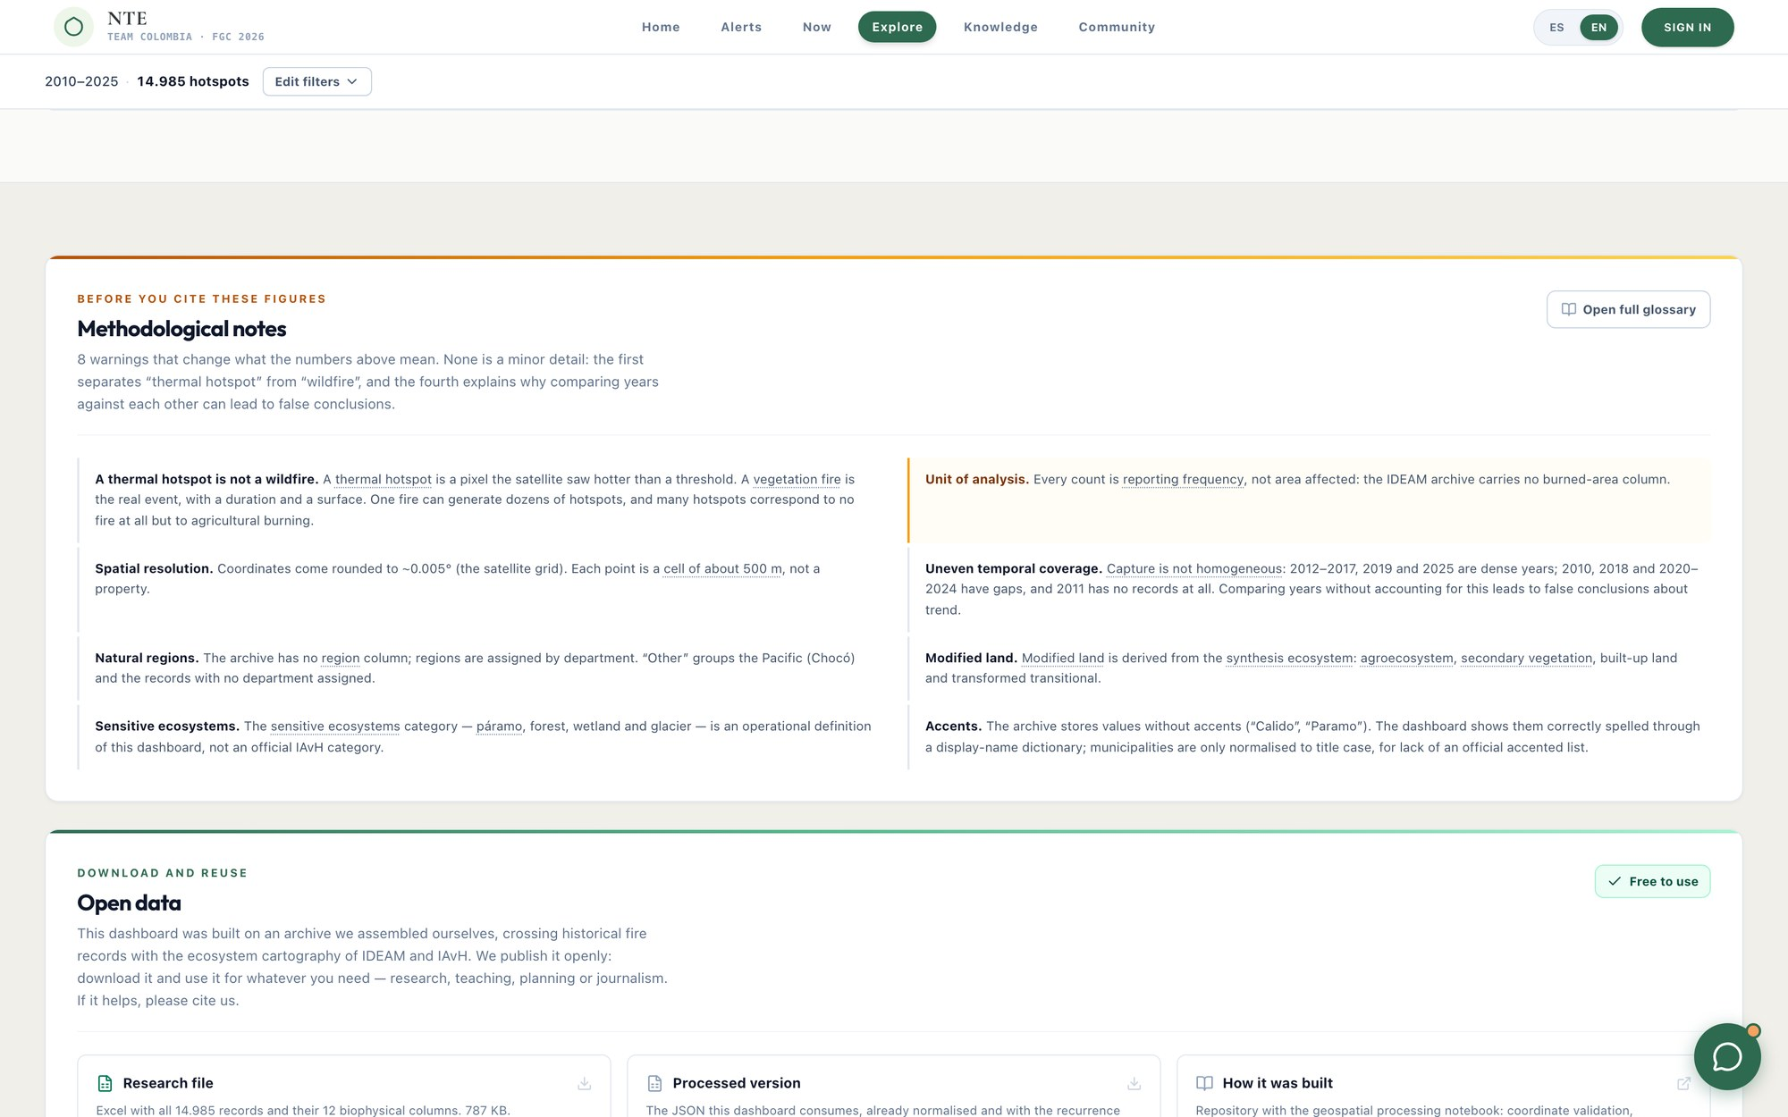
Figure 13. The same dashboard, scrolled down to the analyses: distribution by department, bimodal seasonality and breakdown by ecosystem and climate. The same evidence that supports Section 3 of this document is explorable live inside the platform.

9.2 The model
We deliberately chose a model that is explainable, auditable and runnable on modest hardware over a heavy black-box model. A coordinator has to be able to answer a mayor who asks why a municipality is coloured red. The conceptual formula is:
RISK = HISTORICAL RECURRENCE (WHERE) × CURRENT FIRE-WEATHER (WHEN)
Both factors are normalised to 0–1 and multiplied, then rescaled to 0–1 and mapped to the five-level ladder of Section 7. A place that has burned repeatedly is not at risk today if it is soaked; a place under extreme fire-weather is not at high risk if nothing there has ever burned and there is no fuel. Risk requires both.
- Divide the territory into a grid (or by municipality / vereda) — each cell is a prediction unit.
- For each cell, compute historical recurrence (0–1) from the density and repetition of past incidents, weighted by recency and by the seasonal profile of the current month.
- For each cell, compute a current fire-weather index (0–1) combining temperature, relative humidity, wind speed and days since last rain from Open-Meteo, with the Copernicus GWIS Fire Weather Index as a cross-check and fallback.
- Where our own nodes exist, override the meteorological estimate with measured ground truth — node temperature, humidity and soil moisture are far more accurate than an interpolated grid.
- Multiply, normalise, assign the level, and paint the cell on the Risk Map. Refresh every 10–15 minutes.
The model does not consume raw node JSON but a consolidated feature vector per cell per time step, which keeps the modelling work independent of hardware changes: static and historical variables (recurrence index, years since last fire, biome, ecosystem, climate, relief, soil), seasonal ones (month, dry-season phase, climatological anomaly), current meteorology, vegetation (NDVI via Sentinel-2 and Google Earth Engine), ground truth from our nodes, and live activity (nearby satellite hotspots, confirmed community reports).
Validation is by hold-out in time: the recurrence and seasonal components are trained on 2010–2022 and tested on whether the resulting risk surface anticipates the 2023–2025 incidents. As the node network and the alert history grow, every confirmed and every dismissed alert becomes a labelled example, which opens the path from the current explainable multiplicative model to a supervised learning model on the same feature vector, without changing any interface. The explainable model remains as the fallback and as the explanation layer.

10. Module VI — Bioremediation: healing the soil after the fire
THE INSIGHT THAT STARTED THIS MODULE
When a forest fire happens, the first reaction is always to plant trees. It sounds logical, but very often the real problem is much further down — in the soil. If the soil has lost its microorganisms, its structure and its capacity to sustain life, planting trees does not guarantee that the ecosystem recovers. So we change the order: heal the soil first, because healthy soil is what lets a forest regenerate naturally and sustainably.

A high-intensity fire does not only remove the vegetation above ground. It sterilises the top layer of soil, killing the fungal and bacterial communities that cycle nutrients and bind soil particles together. It destroys organic matter and structure, which collapses the soil's capacity to hold water. It can leave a water-repellent crust that makes rain run off instead of soaking in, driving erosion and landslides. Seedlings planted into that substrate compete on ground that has lost the biological machinery that would normally support them — which is why so much post-fire reforestation fails quietly, a year or two after the photographs are taken.

10.1 Our approach: Trichoderma
We work with Trichoderma, a genus of beneficial soil fungi widely used in agriculture and increasingly in ecological restoration. It helps recover the biological activity of the soil, promotes root growth, improves nutrient availability, and creates the conditions for the ecosystem to start functioning again. It is locally producible, low cost, non-toxic and does not introduce a foreign macro-organism into the ecosystem — it re-establishes a functional group that the fire removed.
Our present objective is empirical: to determine the best way to apply it. A fungal inoculant that dies on contact with hot, dry, hydrophobic post-fire soil is useless, however good the biology. We therefore evaluate several formulations against two criteria — survival of the fungus and efficiency of distribution across affected ground.
Formulation under test | Rationale | What we measure
Trichoderma + molasses | Molasses provides an immediate carbon source to sustain the fungus through establishment in a nutrient-stripped substrate. | Colony survival over time; ease of field application
Trichoderma in hydrogel | The hydrogel retains moisture around the inoculum, buffering it against the dryness and hydrophobicity of burned soil. | Moisture retention; survival under simulated post-fire conditions
Encapsulated Trichoderma | A biodegradable capsule protects the inoculum during transport and dispersal and releases it when it breaks and takes on moisture from the ground. | Rupture behaviour, release timing, survival, suitability for robotic dispensing
Table 19. Formulations under evaluation. The selected method determines the payload of the robot.

10.2 The dispersal robot
Once the most effective method is defined, the technological part of the module begins. We will design a ground robot able to move across fire-affected terrain and dispense biodegradable capsules containing the fungus at strategic points. The capsules travel in an onboard hopper and are released across the ground as the robot advances; the capsule generates moisture around itself, and when it breaks open the fungus inside begins stimulating the growth of soil microorganisms.
- Why a robot. Burned terrain is unstable, hot for days, full of falling hazards and frequently unreachable by road. The robot reaches areas where human access is difficult or dangerous and distributes the treatment faster, more uniformly and more safely than a crew on foot.
- Guided by the platform. The robot does not wander. It is directed to the burned polygons and the severity classes that the platform derives from burned-area layers and node data — the same map that detected the fire tells the robot where the damage is worst.
- Sampling on the way. Beyond dispensing, the robot takes soil samples at its waypoints. Those samples feed the diagnosis panel (pH, organic matter, moisture, nitrogen, carbon, living cover) that the platform averages per zone.
- Output: a recovery plan. From the diagnosis the platform generates an ordered plan — stabilise, apply amendments, sow pioneer species, restore, monitor — with a time horizon, exportable for the authority responsible for the area.
MAP | → | SAMPLE | → | DIAGNOSE | → | TREAT | → | MONITOR
burned polygons  & severity |  | robot collects  soil samples |  | pH, organic matter,  moisture, N, C |  | capsule dispersal  Trichoderma |  | recovery plan  & follow-up

IN SHORT
We are not trying to replace nature — we are giving it a hand so it can recover. If we restore the health of the soil first and give back its biological activity, we create the conditions for the vegetation and the ecosystem to regenerate far more successfully over time. And healthier, moisture-retaining soil with living cover is, in itself, a landscape that is harder to burn — which is why this module belongs to prevention as much as to recovery.

SPACE RESERVED FOR PHOTOGRAPH
Trichoderma laboratory trials
Suggestion: photograph of the Petri dishes with the colonies, of the three formulations side by side (molasses, hydrogel, encapsulated) or of the team in the laboratory.
Figure 14. Trichoderma laboratory trials
SPACE RESERVED FOR PHOTOGRAPH
Design of the capsule-dispensing robot
Suggestion: CAD render of the robot with the hopper and dispensing mechanism, or photograph of the prototype with the REV Robotics parts.
Figure 15. Design of the capsule-dispensing robot

11. Data model and API surface
The whole system rests on a small set of entities and a stable access contract. Fast data (readings, events) is pushed over WebSockets; context data (weather, hotspots, risk) is polled every 10–15 minutes.
Entity | What it represents | Key attributes
Zone | The monitored territory (vereda, municipality, forest sector). | id, name, municipality, ecosystem, geometry, mean altitude
Node | A sensor station in the field. | id, zone, gateway, coordinates, altitude, status, battery, last seen
MeasurementType | The catalogue of magnitudes, registered once each. | id, sense, magnitude, unit, valid range
Reading | One measured value from one node at one time. | id, node, measurement type, value, timestamp
Event | A detection raised by the fusion engine. | id, node(s), zone, level, score, evidence breakdown, image, timestamp
Alert | The dispatch and lifecycle of an event. | id, event, state, recipients, Telegram delivery status, author, history
CommunityReport | A citizen observation on the map. | id, user, type, photo, coordinates, confirmations, timestamp
BurnedZone / SoilSample | Post-fire area and robot sampling. | polygon, area (ha), severity, samples (pH, organic matter, moisture, N, C, living cover)
Prediction | Model output per cell per time step. | cell, timestamp, recurrence, fire-weather index, risk score, level
Table 20. Core entities of the data model.

# Nodos y lecturas / Nodes and readings
GET /api/nodos -> estado de la red, salud, ultima lectura por nodo
GET /api/nodos/{id}/lecturas -> serie de tiempo de un nodo, por sentido
WS /ws/lecturas -> lecturas en vivo (latencia de segundos)

# Eventos y alertas / Events and alerts
GET /api/alertas?estado= -> bandeja de alertas, filtrable por estado
GET /api/alertas/{id} -> detalle de evidencia + estado de entrega Telegram
PATCH /api/alertas/{id} -> cambiar estado (confirmar / en curso / descartar)
WS /ws/eventos -> eventos en vivo

# Observatorio / Observatory (proxy de datos publicos: oculta claves, cachea, normaliza)
GET /api/capas -> catalogo de capas (nombre, grupo, leyenda, atribucion)
GET /api/clima?lat=&lon= -> temperatura, sensacion, humedad, lluvia, viento
GET /api/aire?lat=&lon= -> PM2.5, PM10, CO, O3
GET /api/focos?bbox= -> focos satelitales activos como GeoJSON
GET /api/gee/layer/{type} -> capa de teselas de Earth Engine (NDVI, severidad)
GET /api/gee/point?lat=&lon= -> consulta puntual a Earth Engine

# Prediccion y recuperacion / Prediction and recovery
GET /api/riesgo?bbox= -> malla de riesgo previsto (puntaje + nivel por celda)
GET /api/zonas-quemadas -> poligonos de area quemada
GET /api/muestras?zona={id} -> muestras de suelo del robot para una zona
GET /api/plan?zona={id} -> plan de recuperacion generado
Figure 16. REST and WebSocket surface of the system.

12. Technology, security and offline operation
Layer | Function | Technology in use
Sensor node | Perception and transmission | Arduino MKR platform, MKR ENV Shield, MQ-135, Grove laser PM2.5, DS18B20 / LM35, HD38, Adafruit UV, SparkFun Sound Detector, ESP32-CAM, LoRa radio
Transport | Field to server | LoRaWAN (Class A, sub-GHz ISM), LoRaWAN gateway
Edge | Detection decision | Local server in the territory (Raspberry Pi class), sensor-fusion logic
Database | Single source of truth | Supabase (PostgreSQL)
Backend / API | Data access and orchestration | Node.js + Express, Google Earth Engine API, NASA FIRMS proxy with caching
Frontend | Interface | React 19, Vite, Tailwind CSS 4, Leaflet + react-leaflet, leaflet.heat, marker clustering, Recharts, lucide-react
Real time | Live push | WebSockets (MQTT-compatible at the edge)
Integrations | Notification and public data | Telegram Bot API; Open-Meteo; RainViewer; OpenWeatherMap; NASA GIBS & FIRMS; Copernicus EFFIS / GWIS; Sentinel-2
Table 21. Technology stack. The platform runs equally in the cloud or on a local machine in the territory.

- Key handling. API keys (FIRMS, OpenWeatherMap, Earth Engine service account) and the Telegram bot token live in the backend only, never in the frontend bundle. Public-data layers are served through our own proxy endpoints.
- Role-based access and audit. Each profile sees and does only what its role permits, and every action on an alert or on the configuration is recorded with author and timestamp.
- Proxy caching. The proxy caches upstream responses, which both respects source rate limits (FIRMS allows 5,000 requests per 10 minutes) and enables offline operation.
- Offline operation. Detection continues with no internet at all, because the decision is taken at the edge. The platform is an installable PWA that caches the last map view, node states and guides; community reports are queued locally and synchronised when a connection returns; undelivered Telegram dispatches are queued and shown as pending rather than lost; and the local siren and radio protocol act as the last-resort notification path.

13. Implementation: what is built today
This section states honestly the real status of every component. What is built can be shown working; what is in progress is declared as such.
Component | Status | Detail
Web platform | Built and running | React + Tailwind + Leaflet application with dashboard, monitoring, observatory, Colombia historical dashboard, alerts, community, chatbot and learning layer; bilingual ES/EN; responsive on mobile.
Historical dataset | Complete | 14,985 IDEAM incidents (2010–2025) parsed, cleaned, georeferenced, enriched and integrated; 406 recurrent ignition points computed.
Public data integration | Working | NASA FIRMS hotspots, Google Earth Engine layers and point queries, Open-Meteo, RainViewer, GIBS and EFFIS live in the observatory.
Backend | Working | Express server with Earth Engine and FIRMS proxy endpoints, key handling and caching; Supabase for persistence and authentication.
Node data contract | Defined and validated | Field dictionary and JSON contract fixed from the team's comparative sensor study.
Sensor node prototype | In construction | Arduino MKR platform with the selected sensor set; LoRaWAN link and duty cycle being characterised.
Alert engine + Telegram | In integration | Fusion rules and the five-level ladder specified; dispatch and delivery-status flow being wired to the bot.
Predictive model | In development | Recurrence surface computed from the historical dataset; the fire-weather index and the combined risk grid being implemented.
Bioremediation | In laboratory | Trichoderma formulations (molasses, hydrogel, encapsulation) under comparative evaluation; capsule-dispensing robot in design.
Table 22. Honest status of every component.

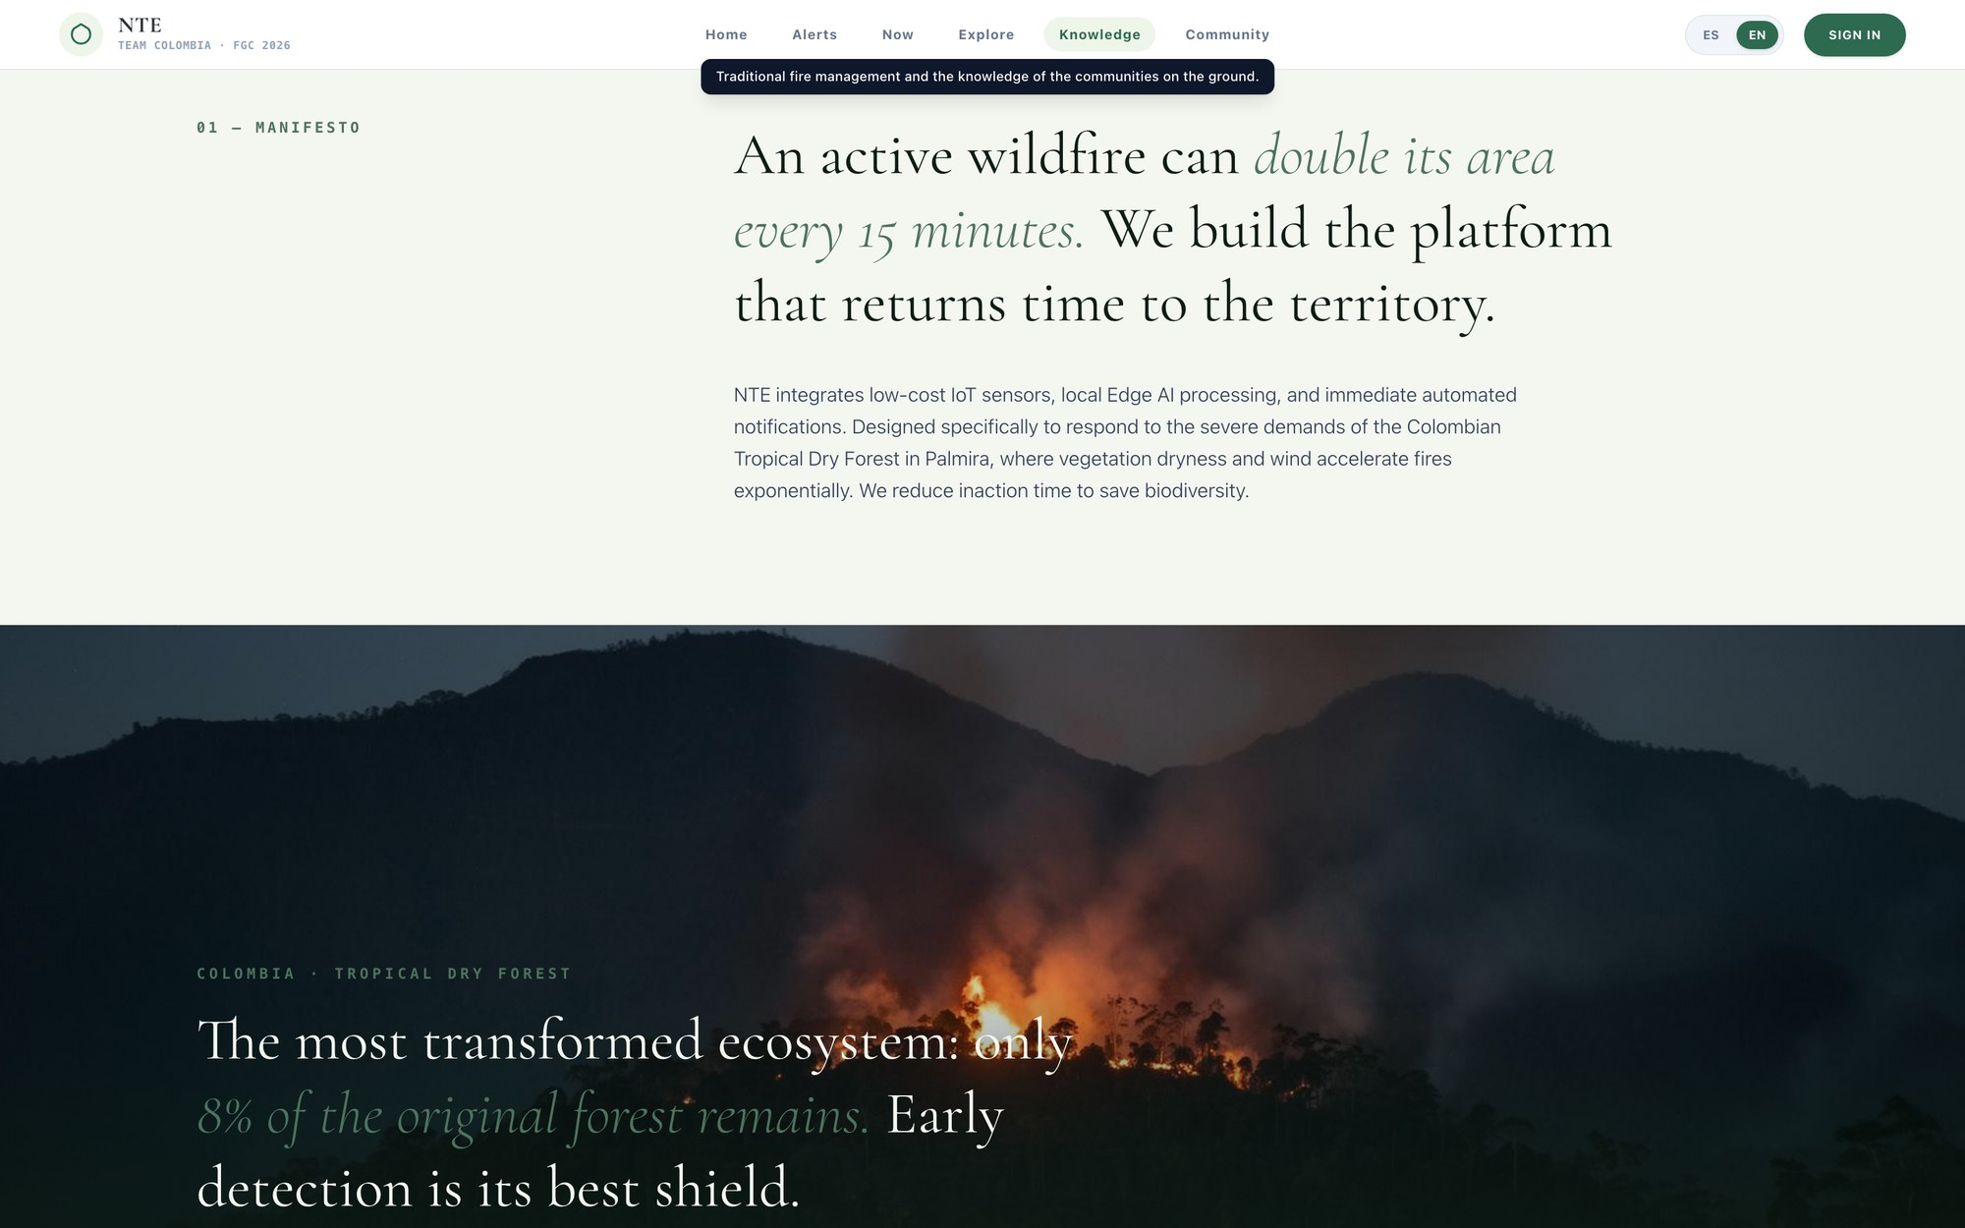
Figure 17. Narrative and educational section of the public site. The platform does not only show data: it explains why the data matters, focused on the Colombian Tropical Dry Forest, of which only 8 % of the original forest remains.

13.1 Roadmap
Horizon | Objective | Deliverable
Aug – Sep 2026 (Phase 2) | Close the detection loop end to end. | Node prototype transmitting over LoRaWAN into the local server; fusion engine raising graded events; automatic Telegram dispatch demonstrated live; risk grid rendered on the map.
Sep – Oct 2026 (Phase 3) | Field demonstration. | Multi-node pilot in a Valle del Cauca zone; controlled anomaly demonstration; selected Trichoderma formulation with survival data; robot dispersal mechanism prototype.
Nov 2026 – 2027 | Municipal pilot. | Permanent installation in one high-recurrence municipality with the local fire brigade; predictive model validated against the 2023–2025 hold-out; recovery plan applied on a real burn scar.
2027 onwards | Replication. | Deployment kit (hardware bill of materials, firmware, platform and documentation) so other teams, municipalities and countries can reproduce the system on their own data.
Table 23. Roadmap from Phase 1 submission to replication.

14. Impact, scalability, risks and continuation

14.1 Impact
- Time to detection. The measurable outcome is the interval between ignition and the brigade knowing. Satellite products and citizen calls operate in hours; a node network with automatic dispatch operates in minutes. That difference is the difference between a hectare and a hundred.
- Cost of response. Suppressing a small fire is orders of magnitude cheaper than suppressing an established one — in money, in equipment, in risk to firefighters and in carbon released.
- Ecosystem protection. Our historical analysis flags incidents in páramo, high-Andean forest, wetland and glacier-adjacent zones. These are the ecosystems that regulate the water supply of Colombian cities and that recover most slowly. Prioritising them is a design choice built into the platform.
- Community capability and the memory of the territory. Citizen reporting, the community plaza, the learning layer and the chatbot turn residents from spectators into part of the sensing network, and give brigades a shared operational picture they currently lack. Beyond that, the ancestral knowledge category puts on the record knowledge about fire, wind and forest that until now was only passed on orally and that is lost with every generation.
- Carbon. Every hectare not burned is carbon not released and a sink preserved; every hectare of soil restored is a sink coming back.

14.2 Scalability
Scalability was a design constraint from the beginning, and it works at three levels. Within a municipality, adding coverage means adding nodes to an existing gateway — the marginal cost of the next node is the node itself. Across the country, the 406 recurrent coordinates our dataset identified are a ranked deployment queue: the system tells us where to install itself next. Across countries, every public data source we depend on (FIRMS, GIBS, Open-Meteo, RainViewer, Copernicus, Sentinel-2) is global and free, the risk model needs only a national historical fire record to be re-fitted, and the thresholds are configurable per ecosystem — which is what lets the same code serve páramo, dry tropical forest, or any other biome.

14.3 Risks and mitigations
Risk | Mitigation
False alarms erode brigade trust. | Multi-sense concordance required before escalation; per-node adaptive baselines instead of fixed thresholds; camera confirmation; every dismissed alert feeds back into threshold tuning.
Node loss to fire, weather, animals or theft. | Low unit cost, health telemetry (battery, RSSI, SNR) that flags a failing node before it goes silent, and network redundancy so no single node is a single point of failure.
Connectivity failure at the moment of an alert. | Detection is edge-side and never depends on internet; local siren and radio protocol as fallback; Telegram queue with visible pending state and automatic resend.
Trichoderma formulation fails to survive in burned soil. | Three formulations evaluated in parallel against explicit survival criteria before any field deployment; the robot is designed around the capsule format that wins, not the other way round.
A public data source changes or rate-limits. | All external sources are consumed through our own proxy with caching and normalisation, so a source can be swapped without touching the frontend.
Table 24. Principal risks and how the design absorbs them.

14.4 Project continuation
This project does not end in Incheon. The platform is already operational and will continue to be developed as an open instrument for Colombian territories: a municipal pilot with a partner fire brigade, validation of the predictive model against held-out years, publication of the processed historical dataset as a public resource, and a replication kit — bill of materials, firmware, platform and documentation — so that any team, in any country with the same connectivity gap, can build their own Active Defence System.
OUR COMMITMENT
We are building this for the brigades, the communities and the forests of our own region first. Everything we learn — the sensor selection, the fusion thresholds, the processed fire history, the formulation trials — will be documented and shared so it can be rebuilt elsewhere.

Appendix A — Project photographic record
The dashed frames are reserved for the team's photographs. To insert an image, click inside the frame and use Insert → Picture; the figure caption is already written below each one.
SPACE RESERVED FOR PHOTOGRAPH
The team in a working session
Suggestion: one of the Saturday in-person sessions.
Figure 18. The team in a working session
SPACE RESERVED FOR PHOTOGRAPH
Field trip and territory reconnaissance
Suggestion: the team in the Palmira tropical dry forest or in the Farallones.
Figure 19. Field trip and territory reconnaissance
SPACE RESERVED FOR PHOTOGRAPH
Working with the fire brigade or the environmental authority
Suggestion: meeting, interview or platform demonstration with the allies.
Figure 20. Working with the fire brigade or the environmental authority
SPACE RESERVED FOR PHOTOGRAPH
Free slot
Additional space for any evidence the team wishes to include.
Figure 21. Free slot
SPACE RESERVED FOR PHOTOGRAPH
Free slot
Additional space for any evidence the team wishes to include.
Figure 22. Free slot

Appendix B — Data sources, glossary and references

B.1 Data sources
Source | What we take from it | Used in
IDEAM (Colombia) | National historical wildfire records, 2010–2025 | Predictive model, Colombia dashboard
NASA FIRMS (MODIS / VIIRS) | Active hotspots: lat, lon, brightness, confidence, FRP, time | Observatory, fusion context
NASA GIBS | True-colour imagery, thermal anomalies, aerosol | Observatory layers
Open-Meteo | Current and forecast temperature, humidity, wind, rain | Fire-weather index, point queries
Open-Meteo Air Quality | PM2.5, PM10, CO, O₃ | Air layer, point queries
RainViewer | Animated precipitation radar | Weather layer
OpenWeatherMap | Temperature, wind and cloud tile layers | Weather layers
Copernicus EFFIS / GWIS | Burned areas, FWI and sub-indices | Risk cross-check, burned-area mapping
Sentinel-2 / Google Earth Engine | NDVI, vegetation dryness, burn severity | Vegetation layer, bioremediation
Community reports | Citizen observations of smoke, heat and fire | Fusion context, observatory layer
Our LoRaWAN node network | Ground-truth multi-sensor telemetry | Detection, alerts, model correction
Table 25. All external sources are free and globally available, which is what makes the system replicable outside Colombia at no data cost.

B.2 Glossary
Term | Definition
LoRaWAN | Long Range Wide Area Network. Low-power radio protocol for small payloads over long distances on unlicensed spectrum; requires no SIM, operator or subscription.
Gateway | Radio receiver that collects frames from many LoRaWAN nodes and forwards them to a server.
Sensor fusion | Combining evidence from several independent sensors to reach a decision that no single sensor could support reliably.
Fire triangle | Heat, fuel and oxidiser — the three conditions a fire requires. Each of our senses reports on one of them.
FWI | Fire Weather Index. Meteorological index of fire danger; used here as a cross-check on our own computation.
NDVI | Normalized Difference Vegetation Index. Satellite measure of vegetation vigour, used as a proxy for vegetation dryness and fuel state.
VPD | Vapour Pressure Deficit. A measure of how far the air is from saturation; the higher the VPD, the faster vegetal fuel dries out.
Recurrence | How often and how repeatedly a given location has burned historically; the 'where' half of the risk model.
RSSI / SNR | Received signal strength and signal-to-noise ratio; the health indicators of a node's radio link.
Trichoderma | Genus of beneficial soil fungi used to restore biological activity, promote root growth and improve nutrient availability in degraded soil.
Bioremediation | Using living organisms to restore a damaged environment — here, restoring burned soil rather than only replanting above it.
PWA | Progressive Web App. Installable web application that works with intermittent or absent connectivity.

B.3 References
- IDEAM — Instituto de Hidrología, Meteorología y Estudios Ambientales. Historical records of vegetation-cover fires, Colombia, 2010–2025. https://www.ideam.gov.co
- NASA FIRMS — Fire Information for Resource Management System (MODIS / VIIRS). https://firms.modaps.eosdis.nasa.gov
- NASA GIBS — Global Imagery Browse Services. https://nasa-gibs.github.io
- Copernicus EFFIS / GWIS — European Forest Fire Information System / Global Wildfire Information System. https://effis.jrc.ec.europa.eu
- Open-Meteo — Open weather and air-quality API. https://open-meteo.com
- RainViewer — Global precipitation radar. https://www.rainviewer.com
- Google Earth Engine / Sentinel-2 — Geospatial analysis platform and ESA Earth observation mission. https://earthengine.google.com
- LoRa Alliance — LoRaWAN Specification and Regional Parameters. https://lora-alliance.org
- Telegram — Bot API documentation. https://core.telegram.org/bots/api
- Hansen, M. C., et al. (2013). High-Resolution Global Maps of 21st-Century Forest Cover Change. Science, 342(6160), 850–853.
- Abatzoglou, J. T., et al. (2018). TerraClimate, a high-resolution global dataset of monthly climate and climatic water balance. Scientific Data, 5, 170191.
- Key, C. H., & Benson, N. C. (2006). Landscape Assessment: Sampling and Analysis Methods (NBR / ΔNBR burn severity index). USDA Forest Service, RMRS-GTR-164.
- Harman, G. E., et al. (2004). Trichoderma species — opportunistic, avirulent plant symbionts. Nature Reviews Microbiology, 2(1), 43–56.
- Certini, G. (2005). Effects of fire on properties of forest soils: a review. Oecologia, 143(1), 1–10.
- DeBano, L. F. (2000). The role of fire and soil heating on water repellency in wildland environments: a review. Journal of Hydrology, 231–232, 195–206.
- Pimont, F., et al. (2019). Why is the effect of vapour pressure deficit on fire danger so strong? On the use of VPD as a fuel-dryness indicator.
- FIRST Global Challenge (2026). Challenge guide: New Technology Experience — Igniting Innovation.

FIRST Global Team Colombia
Active Defence System (NTE) · New Technology Experience 2026 · Category: Detect

