ELEC 301 – Mini Project 1

# Part I

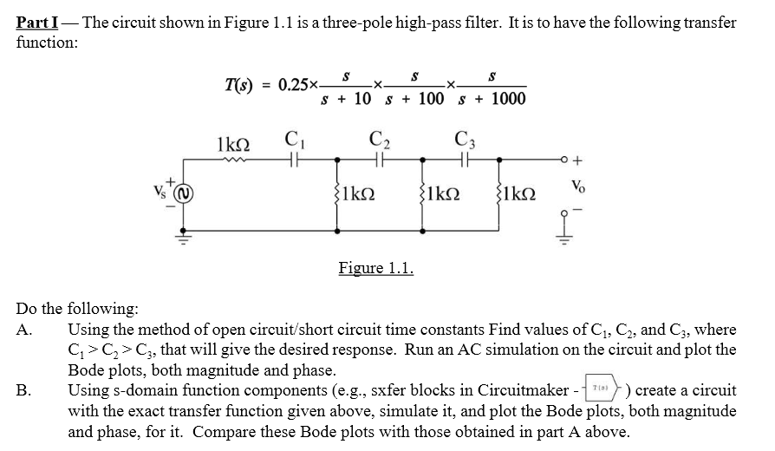

The poles are each a decade apart from each other, so we can work under the assumption that each pole is equal to the inverse time constant of a single capacitor. From the condition that C1 > C2 > C3­ we see that C1 is responsible for the corner frequency ω = 10, C2 ­is responsible for the corner frequency ω = 100, and C3 is responsible for the corner frequency ω = 1000.

First, we find the capacitance of C1. At ω = 10, only C1 is operating, so C2 and C3 are seen as open circuits.

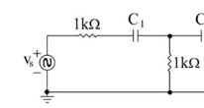

Next, we find the capacitance of C2. At ω = 100, C1 is now conducting and is seen as a short circuit while C3 is seen as an open circuit.

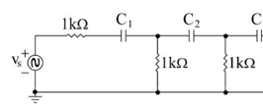

Finally, we find the capacitance of C3. At ω = 1000, C1 and C2 are now conducting and are seen as short circuits.

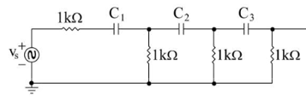

In summary, from the Method of Open Circuit and Short Circuit Time Constants, we have found:

Now, we simulate the circuit along with a transfer function equivalent to the one in the problem specification:

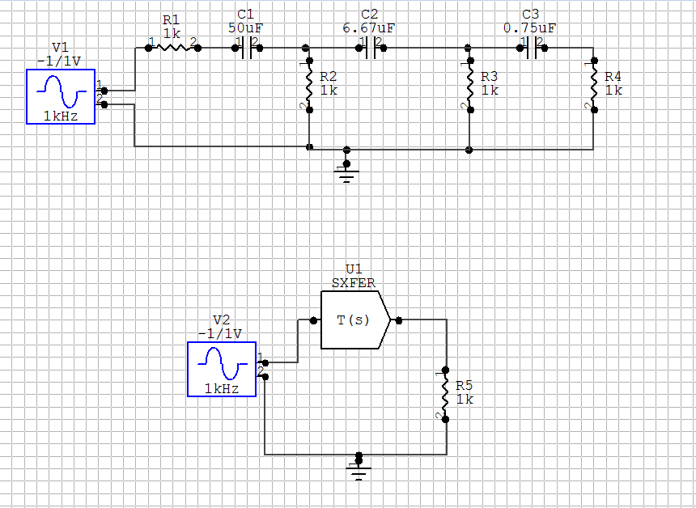

Bode plots were generated for both of these simulations and compared. Below are the magnitude and phase bode plots. The simulation of the SXFER block is plotted in black, while the simulation of the circuit is plotted in red. The output plots are virtually indistinguishable, confirming the validity of our approximation.

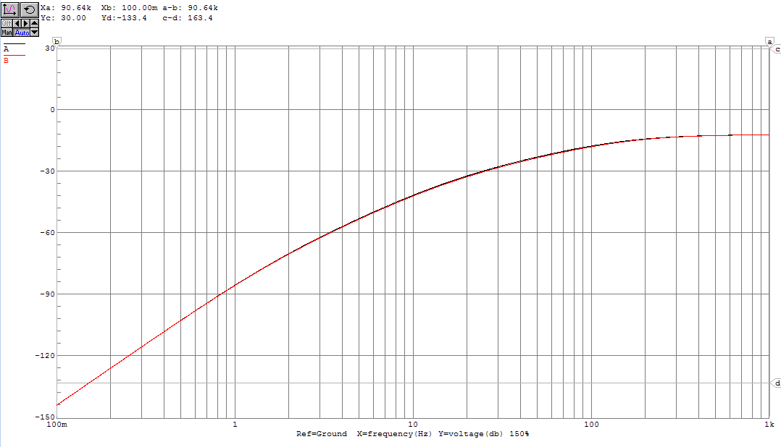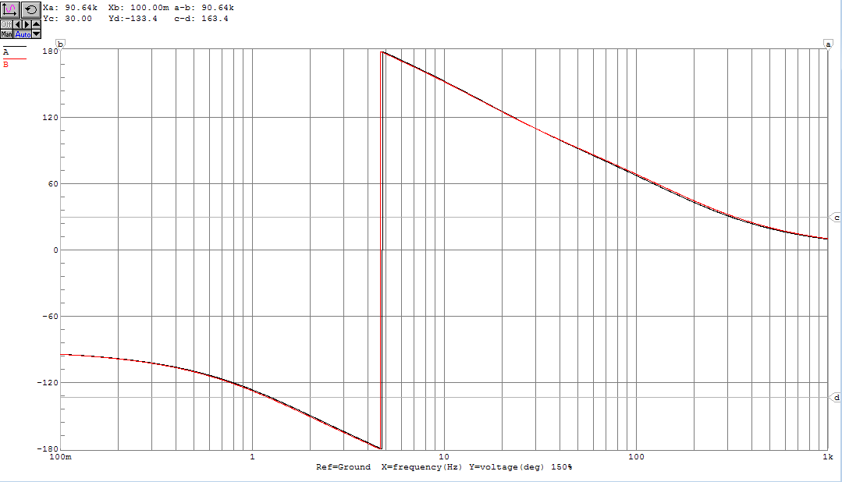

# Part II

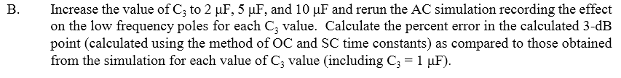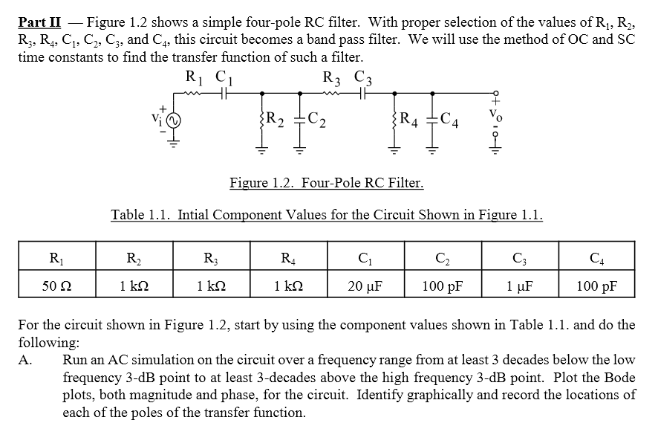

We start by using Circuit Maker to simulate the circuit as specified.

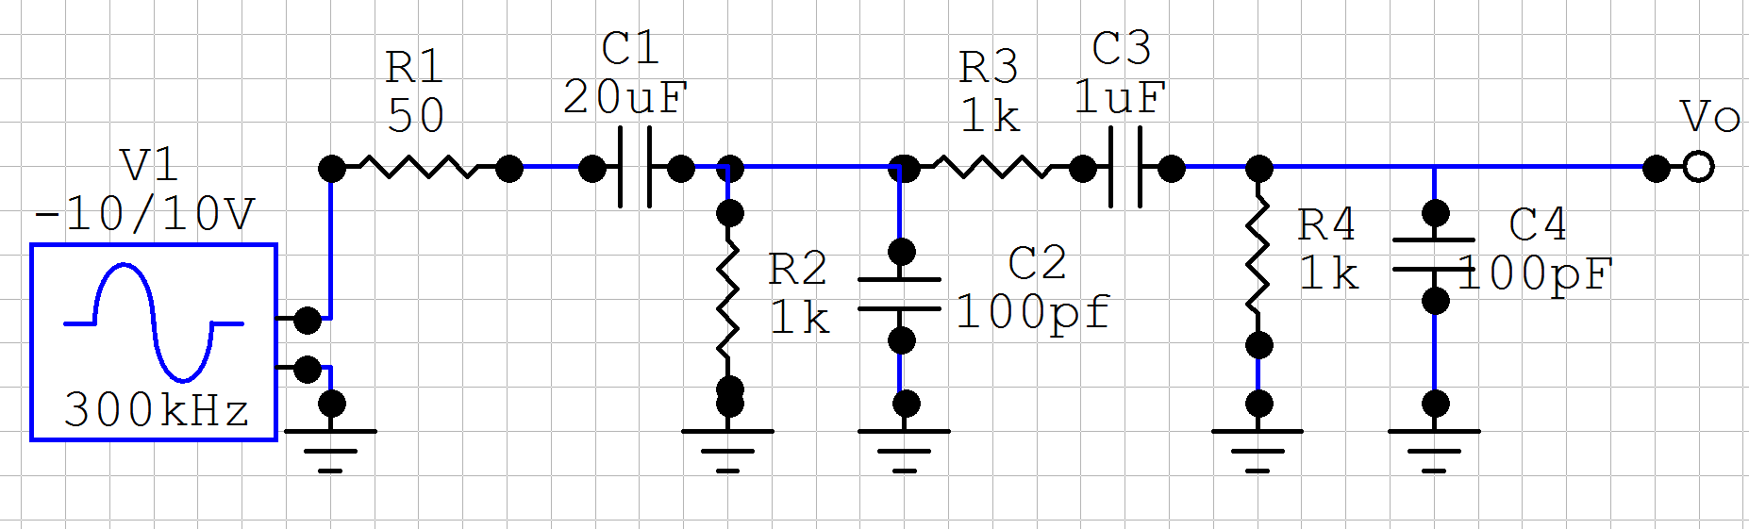

A magnitude and phase Bode plot were generated from this simulation.

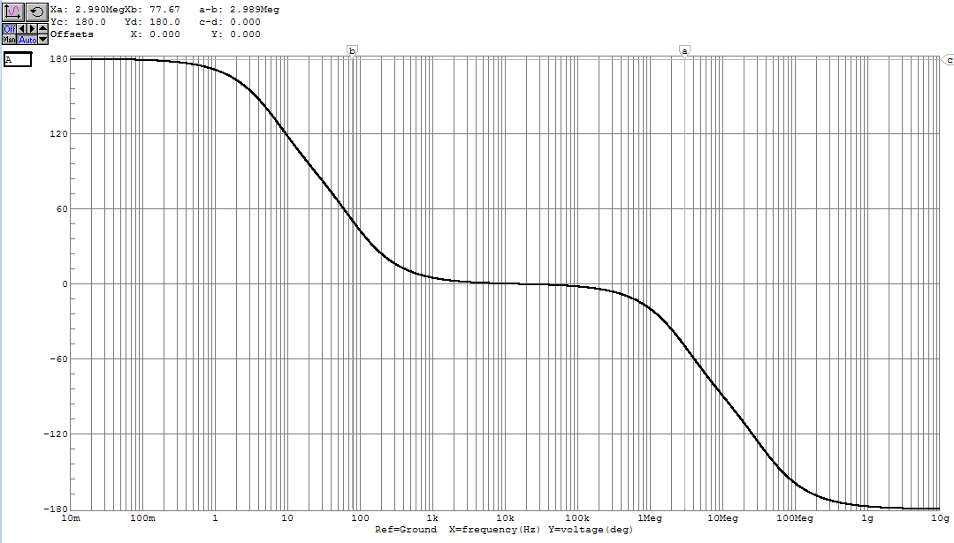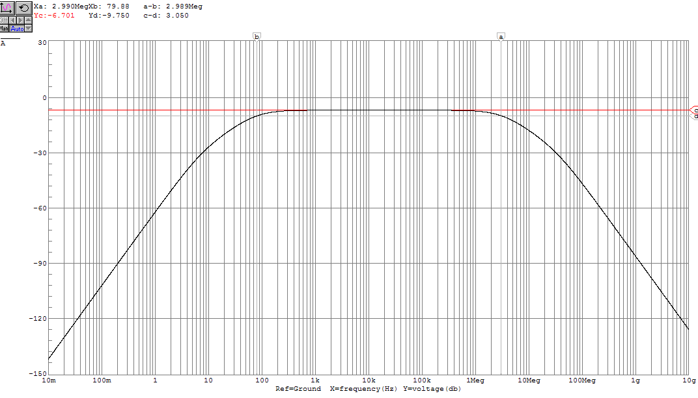

We use the magnitude bode plot to locate poles by extending the regions of constant slope and finding their intersection points.



From this graphical analysis, poles are estimated to be located at:

Now, we extend this graphical analysis to find low frequency poles and 3 dB points for C3 values of 1μF, 2μF, 5μF, 10μF.

The Bode plot below is the same as above – the magnitude Bode plot for the case where C3 = 1μF. We use this plot to estimate the 3 dB points by placing one horizontal cursor along the midband gain and the other horizontal cursor 3 dB below. The 3 dB points occur where this second horizontal line crosses the transfer function. We use the vertical cursors to find the frequency values of these positions.



The same parameters are likewise extracted from C3 values of 2μF, 5μF, 10μF. First 2μF:

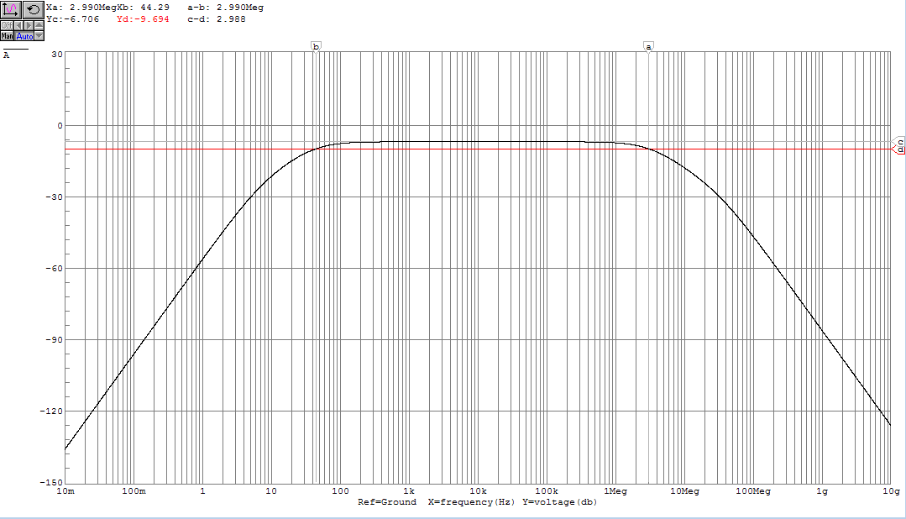

Next, 5μF:

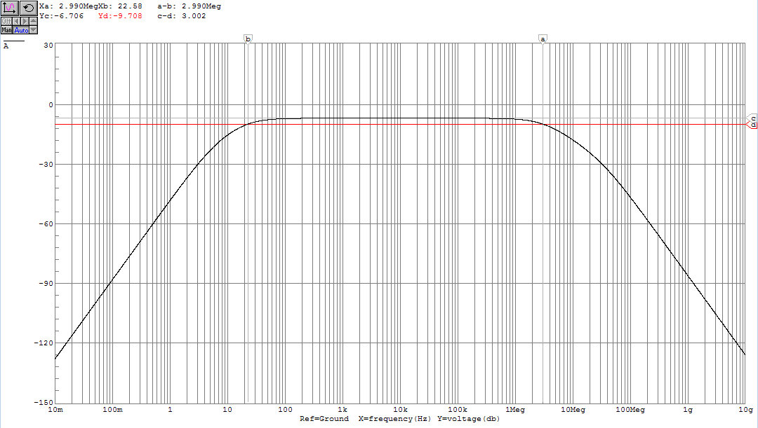

And finally, 10μF:

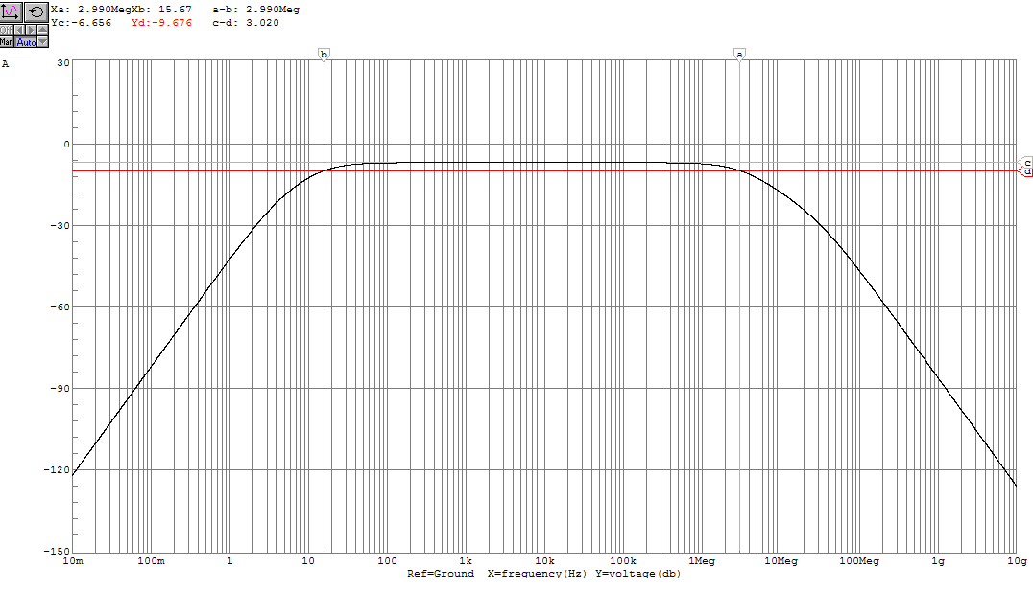

For direct comparison, here are the magnitude and phase Bode plots for all capacitor configurations overlaid. C3 = 1μF is represented by purple, C3 = 2μF is represented by cyan, C3 = 5μF red and C3 = 10μF green.

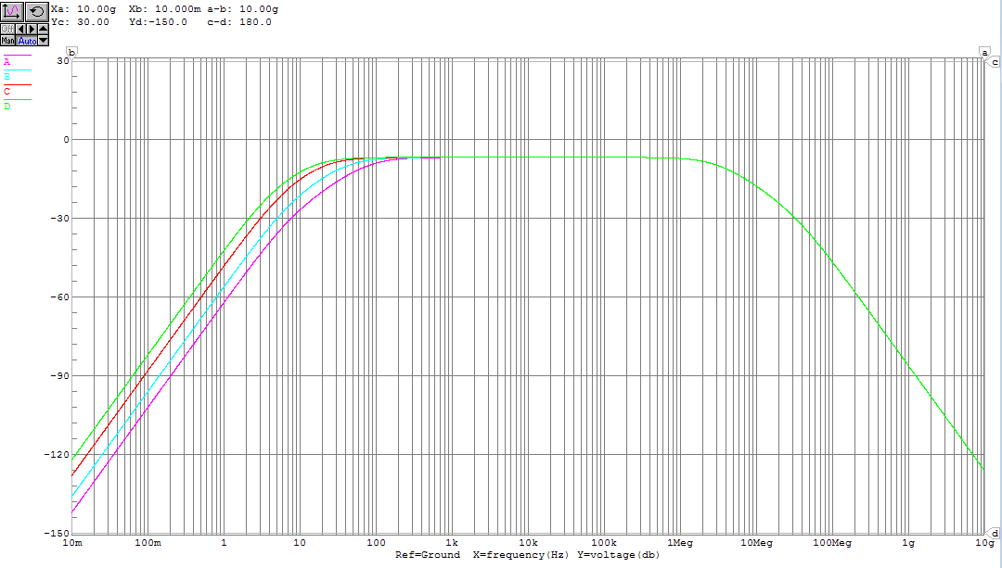

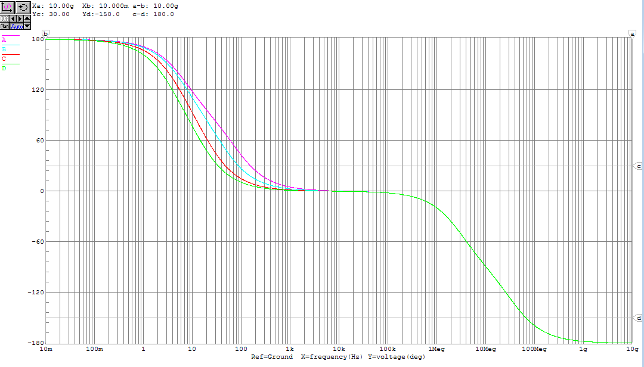

Now, the 3 dB points of the circuit are estimated using the method of Open-Circuit and Short-Circuit Time Constants.

First, we analyze ω3dBH. At high frequencies, the microfarad scale capacitors will have long since been conducting, and are treated as short circuits. We make this adjustment to the circuit, calculate the open-circuit time constants of the high frequency capacitors, and use these to estimate ω3dBH.



First we find the open-circuit time constant for C2.

Then, we find the open-circuit time constant for C4.

We use these values to solve for ω3dBH.

Since we do not vary the values of C2 or C4, we can be sure that this value is constant for every configuration of Part II.

We then look at ω3dBL. At the low breakpoint frequencies, the two 100 pF capacitors will appear as open circuits. With this in mind, we calculate the short-circuit time constants of the low frequency capacitors and use these to estimate ω3dBL. Since we will be varying the capacitance of C3, we leave it as a variable.



First, we find the short-circuit time constant for C1.

Next, we find the short-circuit time constant for C3.

We use these values to solve for ω3dBL.

Substituting in C3 = 1μF, 2μF, 5μF, 10μF:­

The results from Part II are summarized in the following table. % Error is calculated as

|  |  |  |  |  |  |  |
| --- | --- | --- | --- | --- | --- | --- |
| C3 | ω3dBL (Hz)(calculated) | ω3dBL (Hz)  (Graphically) | % Error | ω3dBH ­(Hz) (Graphically) | ωL1 (Hz) (Graphically) | ωL2 (Hz)  (Graphically) |
| 1μF | 88.77 | 79.88 | 11.13% | 2.99 M | 7 | 80 |
| 2μF | 49.95 | 44.29 | 12.78% | 2.99 M | 5.5 | 48 |
| 5μF | 26.67 | 22.58 | 18.11% | 2.99 M | 4.3 | 23 |
| 10μF | 18.90 | 15.67 | 20.61% | 2.99 M | 3.9 | 18 |

An observation: as the locations of the low frequency poles become closer together, our approximation of Open-Circuit and Short-Circuit Time Constants leads to a greater percent error. This is consistent with our assumption that this provides a reasonably accurate value provided that the next nearest poles are at least two octaves away. In fact, we can see that for 10μF:

And for 5μF:

Which are ratios both less than two octaves. Luckily, this is a fairly simple circuit, so we are able to approach each of the poles individually.

**The calculation for ω3dBL is done over, using a more specific method than the sum of inversed short-circuit time constants.**

From earlier, we saw that

and

τC3SC < τC1SC for C3 = 1, 3 and 5 μF, so when finding the low frequency poles at this range, we say that C1 conducts before C3.

**i)** This means that we need to re-do our calculation for τC1 when C3 = 1, 3 and 5 μF, treating C3 as an open circuit.



When C3 = 10 μF, τC3SC > τC1SC, so our earlier short circuit approximation for τC1 = 0.0143s still applies.

**ii)** This also means that we need to re-do our calculation for τC3 when C3 = 10 μF, treating C1 as an open circuit.



When C3 = 1, 3 and 5 μF, our earlier short circuit approximation for τC3 = still applies.

**iii)** Finally, we are able to calculate

Plugging these values in to the table from before, we see substantially reduced error. This proves that more circuit specific methods are necessary to estimate 3dB points than OC/SC Time-Constants when consecutive poles are near another.

|  |  |  |  |
| --- | --- | --- | --- |
| C3 | ω3dBL (Hz)(recalculated) | ω3dBL (Hz)  (Graphically) | % Error |
| 1μF | 85.21 | 79.88 | 6.67% |
| 2μF | 46.39 | 44.29 | 4.67% |
| 5μF | 23.18 | 22.58 | 2.66% |
| 10μF | 16.43 | 15.67 | 4.85% |

# Part III

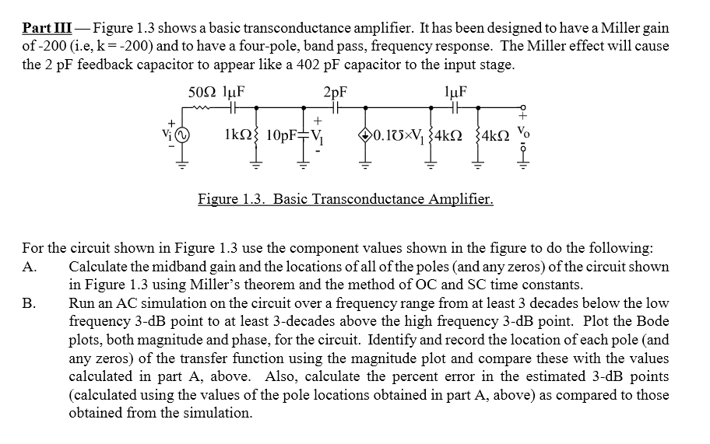

We first find the poles of the low frequency capacitors. At these low frequencies, the conductance of the pF scale capacitors will be negligible, so we treat them as open circuits for our low frequency analysis.

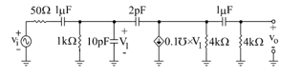

The time constants of these capacitors are independent of the state of the other capacitor. Therefore, we can say that the two low frequency poles are equal to the inverse time constants of each capacitor.

First, we find the low frequency pole derived from time constant of C1 (the capacitor on the left).

Next, we find the low frequency pole derived from the time constant of C4 (the capacitor on the right). When finding the constant, we ignore the current source, thus treating it as an open circuit.

We then calculate the mid-band gain. At these frequencies, the μF scale capacitors will be conducting, while the impedance on the pF scale capacitors will still not have broken, and thus they will still appear as open circuits.

V1



The midband gain will be equal to Vo/V­i in these conditions.

Finally, we find the poles of the high frequency capacitors. At high frequencies, the μF scale capacitors will be conducting and can be treated as short circuits.



The 2pF capacitor is now active, so we can no longer treat the system as two independent circuits. In order to simplify analysis, Miller’s theorem is applied.

First, we find the Thevenin equivalent of the right hand side so we can establish a V2 = kV1 relationship.

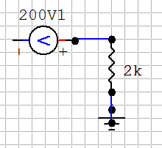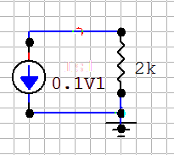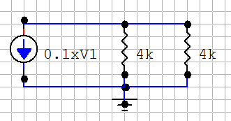

Integrating this into our full circuit:

Zmiller

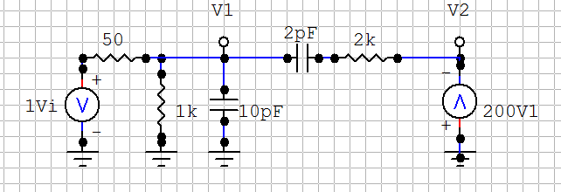

This is a circuit that we can apply Miller’s Theorem to. V2 = -200V1 so our Miller Gain k = -200. Follows is the calculation for the new impedances to be added in parallel to each side.

Following these calculations, we obtain the equivalent circuit:

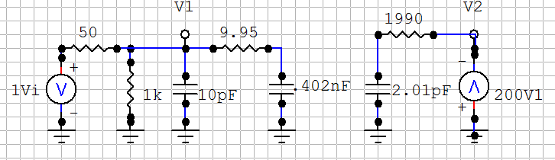

As an approximation, we ignore the 9.95Ω resistor, as it is negligible compared to the internal resistance. This allows us to simplify the capacitors in parallel on the left hand side to an equivalent single capacitor. In making this approximation, we realize that we will be neglecting a zero that occurs close to our highest frequency pole. Since we will not be operating at frequencies in the ~10GHz range, this is acceptable.

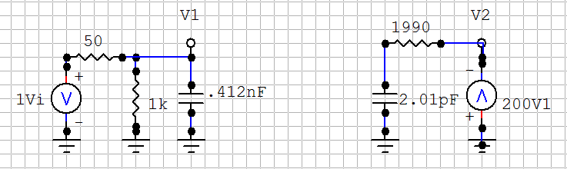

We are now able to find time constants for both of the high frequency capacitors. The time constants of these capacitors are independent of the state of the other capacitor. Therefore, we can say that the two high frequency poles are equal to the inverse time constants of each capacitor.

First, we find the high frequency pole determined by the time constant of the .412nF capacitor:

Next, we find the high frequency pole determined by the time constant of the 2.01pF capacitor:

Now that we have calculated the poles and the midband gain, we can assemble an approximation of the transfer function. Due to the band-pass behavior of this circuit, we know that there are two zeros located at ω = 0.

From the estimated poles, approximations of the 3dB points are calculated:

Now we compare our values found through these approximate analysis techniques to a simulation of the circuit of interest:

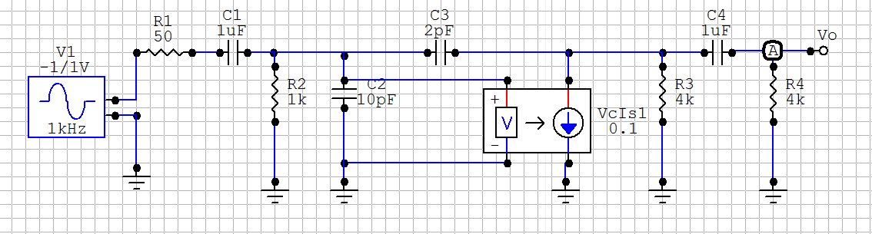

The phase Bode plot was generated:

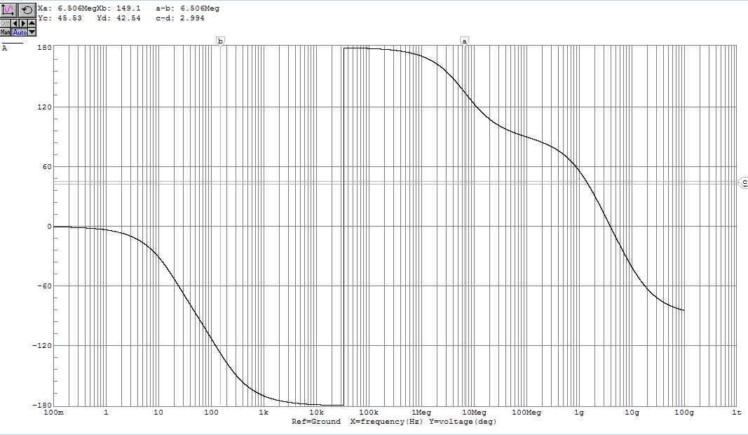

The magnitude bode plot was plotted, and was used to graphically identify the 3dB points as well as all poles and zeroes. The same methods were used as in Part II.

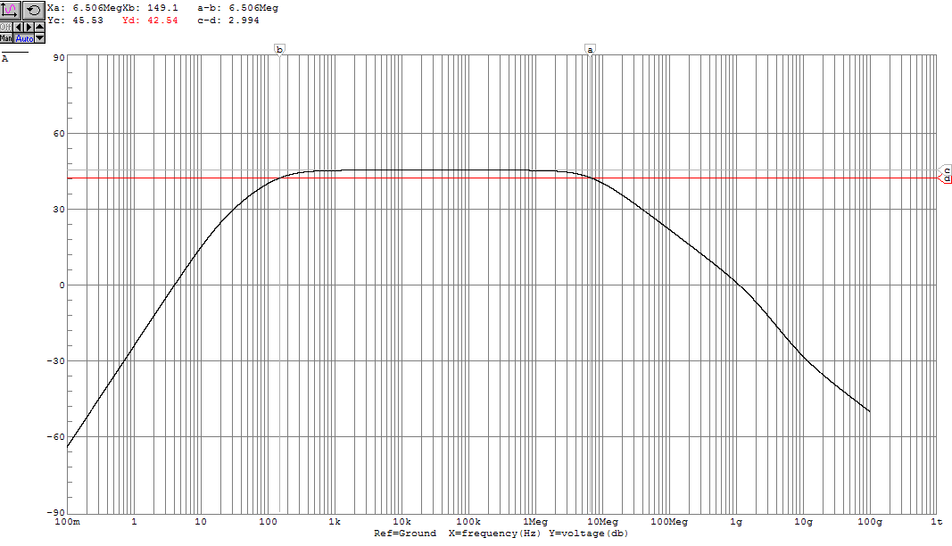

The following table compares the 3-dB points and poles from simulation and calculation.

|  |  |  |  |
| --- | --- | --- | --- |
| C3 | Calculated | Simulated | % Error |
| ω3dBL (Hz) | 152.88 | 149.1 | 2.53% |
| ω3dBH (Hz) | 8.15 M | 6.506 M | 20.21% |
| ωPL1 (Hz) | 19.89 | 21 | 5.29% |
| ωPL2 (Hz) | 151.58 | 180 | 15.79% |
| ωPH1 (Hz) | 8.11 M | 7.1 M | 14.23% |
| ωPH2 (Hz) | 39.79 M | 1.5 G | 97.30% |
| ωZH (Hz) | - | 5.8 G | - |

As expected, we see the high frequency zero that we abstracted away in our earlier approximation only in graphical analysis. This approximation also shows an effect on our calculation of ωPH2, which is acceptable since we never expect to be operating at these frequencies.