Angular Demo Application
Developer Documentation

This document is a property of Mindfire Solutions and contains some confidential information and hence no part of this document should be distributed or copied else where without permission of PL/TL/AL. This document is for internal purpose only.

Change Log
# | Description | Author | Date
1 | Document created | Swapnil Kumar | 06/21/17
2
3
4

Table of Contents
1. Overview.....................................................................................................................4
2. Project Description......................................................................................................5
3. Project Details.............................................................................................................6
4. System Components...................................................................................................7
5. Architecture Diagram...................................................................................................8
6.Database Diagram.......................................................................................................9
7.Build Steps.................................................................................................................10

1. Overview

Angular demo application for is an application that lets users to manage patients by adding new patient. The user can add a new insurance to the system. The provider can add a new patient insurance and also modify them.

2. Project Description
Its a web-based application which works on .Net framework and angular 4. It is a basic project which includes login,logout,simple add/get functionalities.

This project managed by the application.
- MVC Application – This application is entry point of Angular demo application
- Web Services – The services receives request and generate response according to it.

3. Project Details
Following are some general and technical details of the project:
GENERAL
Client Name : Mindfire Solutions.
Project Start Date : 15/06/2017
No. of Resources : 1 Developer
Project Type : -

TECHNICAL
Technology : C#, MVW, LINQ, Jquery, Java Script,Angular 4
Platform : Web Application
Database : SQL Server 2014
IDE : Visual Studio 2015
Third-party Libs : N/A
Third-party Js : N/A
Packaging : Visual Studio 2015
Browser Support : Google Chrome
CI : No

REPOSITORY
Type : Internal
URL : -
Credentials : -

OTHER DETAILS
None

4. System Components
Digital Resource Library has some major component:-
- User Module :- It helps in performing CRUD operation on Tables. It has following functions.
- Add new patient
- Add new insurance
- Add new patient insurance
- Modify old patient insurance

API documentation

Api base address: http://192.168.11.63:1300/

List of GET APIs
- Patient
- Insurance
- PatientInsurance

List of POST APIs
- Login
- Insurance
- PatientInsurance
- Account
- Patient
Below is given the API description, parameters and request example model. All api returns a common model which is given below:
{
“StatusCode”: “Status code set by system”,
“Status” : “Status sent by system,either Success or Failed”,
“Message” : “Message bound to the status sent”,
“Count” : “Count of the elements in the Data field”,
“Data” : “Data returned by api”
}

- Patient/GET
The patient get API returns the list of patient based on parameters passed in the query string. If no parameters are passed then API return all patients.
URL: Patient
Parameters:
- _Id : number
- Name : string
- PhoneNumber : number
Returns (Inside the Data field of response model):
List of model given below
{
“Id”: “Id of patient”,
“FirstName”: “First name of patient”,
“MiddleName” : “Middle name of patient”,
“LastName” : “Last name of patient”,
“Address” : “Address of patient”,
“Gender” : “Gender of patient”,
“Age” : “Age of patient”,
“PhoneNumber” : “Phone number of patient”
}
Status codes:
- 200
- 500,503
- 400,401

- Insurance/GET
The insurance get API returns the list of insurance based on parameters passed in the query string. If no parameters are passed then API return all insurance.
URL: Insurance
Parameters:
- _Id : number
- Name : string
- PhoneNumber : number
- PubId : string
Returns (Inside the Data field of response model):
List of model given below
{
“Id” : “Id of the insurance”,
“Name” : “Name of the insurance”,
“Address” : “Address of the insurance”,
“PhoneNumber” : “Phone number of the insurance”,
“InsurancePublicId” : “Public id of insurance”
}
Status codes:
- 200
- 500,503
- 400,401

- PatientInsurance/GET
The patient insurance get API returns the list of patient insurances based on parameters passed in the query string. If no parameters are passed then API return all PatientInsurances.
URL: PatientInsurance
Parameters:
- _PatientId : number
- _InsuranceId : number
Returns (Inside the Data field of response model):
List of model given below
{
PatientInfo:{
“Id”: “Id of patient”,
“FirstName”: “First name of patient”,
“MiddleName” : “Middle name of patient”,
“LastName” : “Last name of patient”,
“Address” : “Address of patient”,
“Gender” : “Gender of patient”,
“Age” : “Age of patient”,
“PhoneNumber” : “Phone number of patient”
},
InsuranceInfo:{
“Id” : “Id of the insurance”,
“Name” : “Name of the insurance”,
“Address” : “Address of the insurance”,
“PhoneNumber” : “Phone number of the insurance”,
“InsurancePublicId” : “Public id of insurance”
}
}
Status codes:
- 200
- 500,503
- 400,401

- Patient/POST
The patient post API takes PatientDto and adds a new patient in the Patient table of database.
URL: Patient
Parameters:
{
“FirstName”: “(string) First name of patient”,
“MiddleName” : “(string) Middle name of patient”,
“LastName” : “(string) Last name of patient”,
“Address” : “(string) Address of patient”,
“Gender” : “(string) Gender of patient”,
“Age” : “(number) Age of patient”,
“PhoneNumber” : “(number) Phone number of patient”
}
Returns:
Invalid Api key name only in case of StatusCode=400
Status codes:
- 200
- 400,401
- 500,503

- Insurance/POST
The insurance post API takes InsuranceDto and adds a new insurance in the Insurances table of database.
URL: Insurance
Parameters:
{
“Name”: “(string) Name of insurance”,
“Address” : “(string) Address of insurance”,
“InsurancePublicId” : “(string) Public id of insurance”,
“PhoneNumber” : “(number) Phone number of insurance”
}
Returns:
Invalid Api key name only in case of StatusCode=400
Status codes:
- 200
- 500,503
- 400,401

- PatientInsurance/POST
The patient insurance post API takes PatientInsuranceDto and adds a new patient insurance in the PatientInsurances table of database.
URL: PatientInsurance
Parameters:
{
“PatientId”: “(number) Id of patient”,
“InsuranceId” : “(number) Id of insurance”,
“InsurancePublicId” : “(string) Public id of insurance”
}
Returns:
Invalid Api key name only in case of StatusCode=400
Status codes:
- 200
- 500,503
- 400,401

- Account/POST
The account post API takes UserDto and adds a new user in the User table of database.
URL: Account
Parameters:
{
“FirstName”: “(string) First name of the user”,
“MiddleName” : “(string) Middle name of the user”,
“LastName” : “(string) Last name of the user”
}
Returns:
Invalid Api key name only in case of StatusCode=400
Status codes:
- 200
- 500,503
- 400,401

- Login/POST
The login post API is used to login a user in to the system. This api takes x-www-form-urlencoded format.
URL: Account
Parameters:
{
“username”: “(string) User name of the user”,
“password” : “(string) Password of the user”,
“grant_type” : “(string) Grant type (always use “password”)”
}
Returns:
{
“access_token” : “(string) token value. Use this token to send authorized requests.”,
“token_type” : “Type of token.”,
“expires_in” : “Expiry time of token in seconds.”
}
Status codes:
- 200
- 500,503
- 400,401

5. Architecture diagram

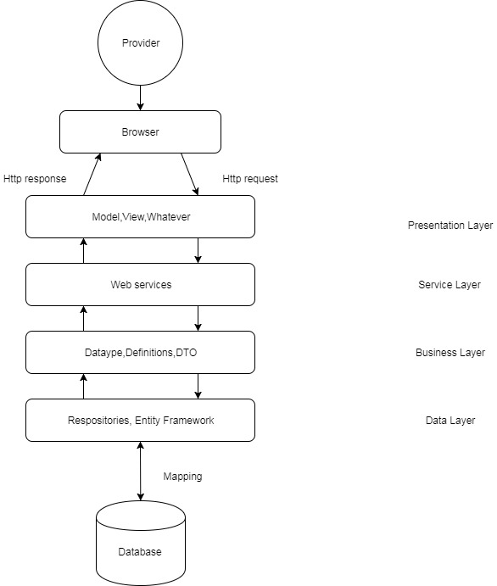

6. Database diagram

