CSE-543 Information Assurance
Fuzz Them All – Final Project
Carolina Rojas – 1228937881

Overview
The program for this assignment was written in GoLang, if go is not installed in your machine, please run:
- sudo snap install go --classic
In case you need to recompile the program, please run:
- go build fuzzer.go, or
- go build -o fuzzer.exe fuzzer.go
No other dependencies needed.

Input generation strategy
For this assignment I manually wrote the prng_seed and num_of_iterations until I found the right input. Most of the time, the same input crashed other programs.
On WLS, I ran the following inputs:
./fuzzer.exe 29045 4500 | ./prog_0
./fuzzer.exe 29045 4500 | ./prog_1
./fuzzer.exe 785400 5000 | ./prog_2
./fuzzer.exe 2905455 14000 | ./prog_3
./fuzzer.exe 2905455 14000 | ./prog_4
./fuzzer.exe 2905455 14000 | ./prog_5
./fuzzer.exe 2905455 14000 | ./prog_6
./fuzzer.exe 2905455 14000 | ./prog_7
./fuzzer.exe 2905455 25000 | ./prog_8
./fuzzer.exe 2905455 25000 | ./prog_9
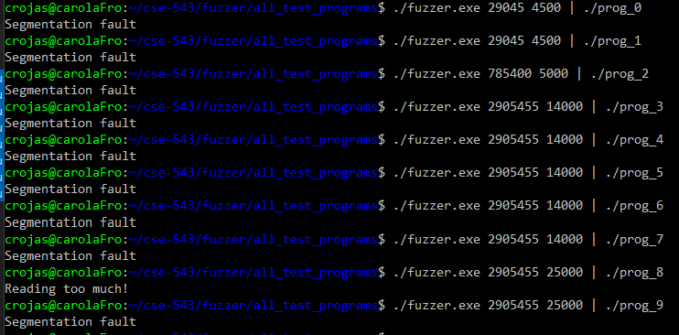
Fig. 1 – Ubuntu 22.04 crashing outputs fuzzer.exe vs prog_N

