[https://carolafaccio.github.io/PIZZA/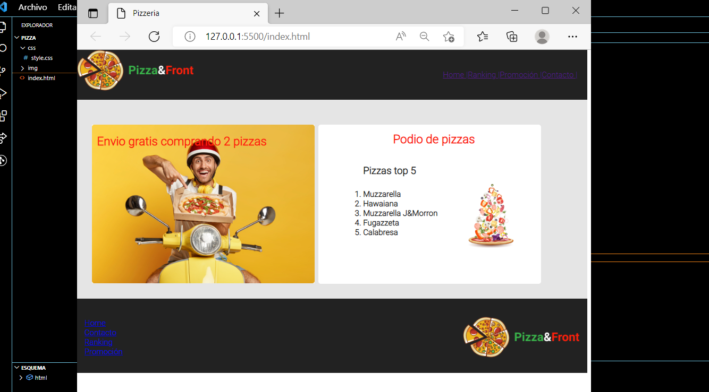](https://carolafaccio.github.io/PIZZA/#)

<https://carolafaccio.github.io/HEROES/>

