User Manual

Tornado Creator

Carola Gille

The Tornado Creator program creates a highly user definable tornado.

Required Libraries:

Image Magick Library

NGL Library

(Nuke) for image to video conversion

To install this program the user must download the program and run qmake.

When using Qt one can use the Argument field to choose if the would like to have a advanced UI or a simplified UI.

0 -> advanced UI

1 -> simplified UI

how to use it with the terminal

The program than creates two windows. The first window is the Tornado creator displaying the scene with the tornado. The second is the UI connected to the Tornado. The User can than use the UI to alter the movement of the tornado.

**Simple User Interface**

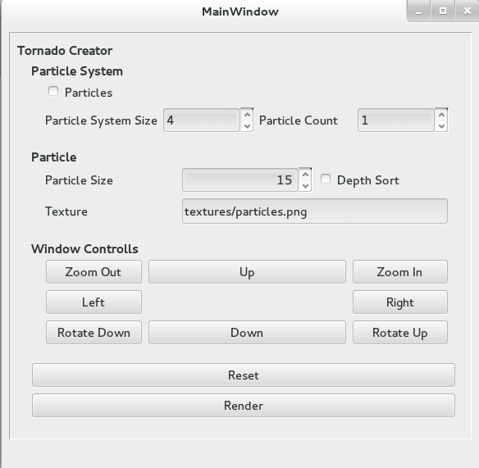

**Advanced User Inter Face**

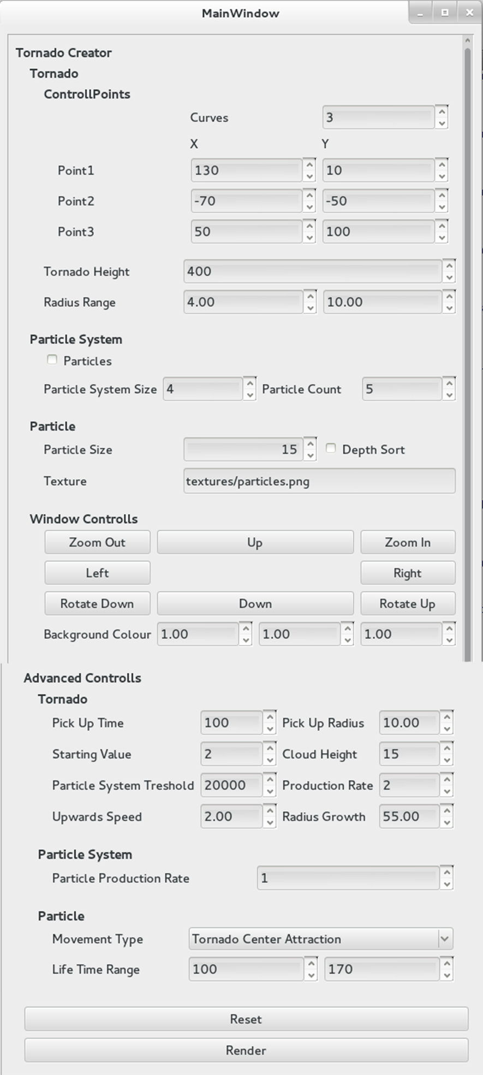

The **curve count** field controls how many control points are active

The **control points** are coordinates that the tornado will meet half way up to the top

Because it the program interpolates between them you get a constant movement of the Tornado

This is the **maximum height** of the Tornado

This represents the range from which a a **particle systems radius** can be picked

**Particles** will turn on and off particles

**Particle system size** controls the size of the Particle system points

**Particle count** represents how man particle can be in a particle system

**Particle Size** controls the size of the particles

**Depth sort** needs to be enabled for alpha textures

**Texture** field can be used to load textures for the particle shader.

Those buttons can be used to move around in the scene

**Rotate Up and Down** will only rotate the object in one direction

**Background colour** can be changed here

**Pick Up Time** controls how long it will take to pick up particles from the ground**; Pick up radius** defines the radius on the ground

**Starting Value** defines the starting Radius; **Cloud height** controls how height and large the cloud on top of the tornado should be

**Particle System Threshold** defines how many particle systems can be in the scene at once**, Production rate** controls how fast the are produced

**Upwards Speed** controls how fast the particles move upwards**; Radius Growth** controls how fast the tornado increases its radius

**Particle Production Rate** controls how many the particle are produced per frame

**The Movement Type** controls how the particle movement is calculated : **Tornado Centre Attraction** attracts and pushes the particle from the centre, **Random point** places them around their parent particle system and imitates fuzzy objects

Life Time Range controls a range for the life time of each particle which is than randomly chosen.

**Reset Button** resets all values and restarts the tornado.

**Render Button** will toggle between rendering image or not. The images are saved in the render folder of the Program. If rendering is active “Rendering …” will be shown in the terminal or execution window.

To achieve a realistic look it is recommended to use a texture with an alpha value that somehow represents smoke, dust or particles. Suggested Textures can be found in the textures folder.

As a high amount of particles will slow down the process of the program it is also recommended to first adjust the movement of the tornado and than activate the particles. This can than be rendered to view the tornado in real time. The renders are saved as images and are not correctly oriented to get a video of your tornado open the Nuke File in the renders folder and read in the images into the prepared nuke network. Than click the render button in the write node.

Examples of Render Results