BASIC QUANTUM CIRCUIT CONSTRUCTION

1. **What 2 options are the correct method to create a quantum circuit?**
2. QuantumCircuit([2,2])
3. QuantumCircuit(2,2)
4. QuantumCircuit(2)
5. QuantumCircuit[2,2]

1. **What 2 options are the correct method to create a quantum circuit?**
2. qr =QuantumRegister(2)  
    cr= ClassicalRegister(2)  
    qc = QuantumCircuit(2,2)
3. qr = QuantumRegister(2,2)
4. qr = ClassicalRegister(2,2)
5. qr =QuantumRegister(2)  
    cr= ClassicalRegister(2)  
    qc = QuantumCircuit(qr,cr)

1. **What options are the correct method to create a quantum circuit?**
2. qr = QuantumRegister(2,2)
3. qr =QuantumRegister(2 , ‘Hi’)  
    cr= ClassicalRegister(2 , ‘Hello’)  
    qc = QuantumCircuit(qr,cr)
4. qr =QuantumRegister(2)

cr= ClassicalRegister(2)  
 qc = QuantumCircuit(Hi,Hello)

d. qr =QuantumRegister(2 , ‘hi’, bits = None)

cr= ClassicalRegister(2 , ‘hello’, bits = None)  
 qc = QuantumCircuit(cr,qr)

1. **qc.draw(‘text’) is similar to which of the following?**
2. qc.draw(‘mpl)
3. qc.draw(output = ‘mpl’)
4. qc.draw( latex)
5. qc.draw()

1. **Which circuits are correct?**
2. QuantumCircuit(QuantumRegister(4))
3. QuantumCircuit(QuantumRegister(4), ClassicalRegister(4))
4. QuantumCircuit(QuantumRegister(4 , ‘hi), ClassicalRegister(4, ‘hey’))
5. All the above.

1. Which code template (more than one) will raise an error?

a. qc = QuantumCircuit(2)  
 circuit_drawer(qc , output = 'matplotlib')

b. qc = QuantumCircuit(2)

circuit_drawer(qc ,  output = None)

c. qc.circuit_drawer(qc , output =  ‘mpl’)

d. qc = QuantumCircuit(2)

Circuit_drawer(qc ,  output = None)

1. **Which code fragments runs when executed?**
2. qc = QuantumCircuit(2)  
    circuit_drawer(qc ,  output = 'mpl' , initial_state = True)
3. qc = QuantumCircuit(2)

circuit_drawer(qc , ‘latex_source’ )

c. qc = QuantumCircuit(2)

circuit_drawer(qc , ‘latex_source’ , filename = ‘hi’ )

d. All the above.

1. **What is executed when qc.draw(‘mpl’) is executed?**
2. Str
3. TextDrawing
4. matplotlib.figure.Figure
5. PIL.Image
6. None

1. **Is VisualizationError and MissingOptionalLibraryError raised when a quantumcircuit is executed  ?**
2. True
3. False

**10.   What is the correct code for this circuit?**

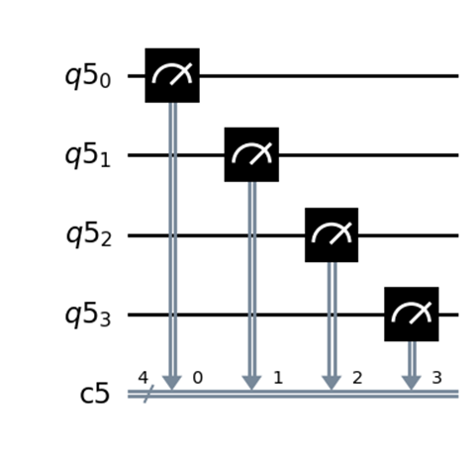

a.  qc = QuantumCircuit(4)  
qc.measure_all()  
qc.draw(‘mpl’)

b.  qc = QuantumCircuit(4,4)  
qc.measure([0,1,2,3] ,[0,1,2,3])  
qc.draw()

c.  qc = QuantumCircuit(4)  
qc.measure([0,1,2,3] ,[0,1,2,3])  
qc.draw()

d.  qc = QuantumCircuit(4,4)  
qc.measure([0,1,2,3] ,[0,1,2,3])  
qc.draw(output =‘mpl’)

e.  qc = QuantumCircuit(4,4)  
qc.measure(0,0)  
qc.measure(1,1)  
qc.measure(2,2)  
qc.measure(3,3)  
qc.draw(‘mpl’)

11.  **qc = QuantumCircuit(3)  
qc.barrier(-2)  
qc.draw(‘mpl’)**

1. 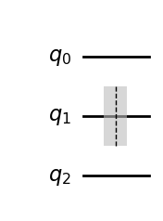
2. 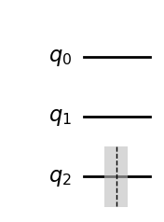

1. 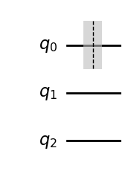
2. Index error out of range.

**12. What are the following code fragments are true to the circuit**

**displayed below:**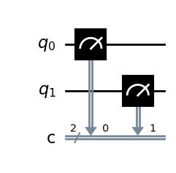

1. q = QuantumCircuit(2,2)  
   q.measure(0,0)  
   q.measure(-1,-1)  
    q.draw(‘mpl’)
2. q = QuantumCircuit(2,2)  
   q.measure(-2,-2)  
   q.measure(-1,-1)  
   q.draw(‘mpl’)
3. q = QuantumCircuit(2,2)  
   q.measure([0,1],[1,0])  
   q.draw(‘mpl’)
4. a and c

**SOLUTION:**

1. b,c
2. a,d
3. b,d
4. d
5. d
6. a,c,d
7. d
8. c
9. a
10. d,e
11. a
12. a,b