PCB standards (in HC, healthy controls), Discovery Sample - T0 / August 2017

HC-PCB - T0: Equivalent scores (using best model)

PCB standards (in HC, healthy controls), Discovery Sample - T0 / August 2017 1

1. Copy-Score (ROCF): "Reduced-Model" 3

2. IM-Percent (ROCF): "Reduced-Model" 4

3. DM-Percent (ROCF): "Reduced-Model" 5

4. Copy-Seconds (ROCF): "0-Model" 6

5. DANVA (DANVA-2-AF): "Reduced-Model" 7

6. Score (ADS-F&B): "Reduced-Model" 8

7. B-Score (ADS-F&B): "Reduced-Model" 9

8. P-Words (VF-P&S): "Reduced-Model" 10

9. P-Repetitions (VF-P&S): "0-Model" 11

10. S-Words (VF-P&S): "Reduced-Model" 12

11. S-Repetitions (VF-P&S): "Reduced-Model" 13

12. Words (HVLT-R): "0-Model" 14

13. Repetitions (HVLT-R): "0-Model" 15

14. Words-A7 (HVLT-R): "0-Model" 16

15. Words (RAVLT): "Reduced-Model" 17

16. Repetitions (RAVLT): "Reduced-Model" 18

17. Words-A7 (RAVLT): "Complete-Model" 19

18. Switch (TM-A&B): "Reduced-Model" 20

19. EorV-done (TM-A&B): "Reduced-Model" 21

20. Time-A (TM-A&B): "Reduced-Model" 22

21. Correct-RT-ALL (CPT-IP): "0-Model" 23

22. Commission-D-ALL (CPT-IP): "Reduced-Model" 24

23. Random-D-ALL (CPT-IP): "Reduced-Model" 25

24. Commission-D-Slope (CPT-IP): "0-Model" 26

25. Random-D-Slope (CPT-IP): "0-Model" 27

26. Span-10 (SOPT): "Reduced-Model" 28

27. Perseveration-10 (SOPT): "0-Model" 29

28. Score (DSST): "Reduced-Model" 30

29. Ex-Adapt (SAT-SV): "Reduced-Model" 31

30. Ex-Aberr (SAT-SV): "0-Model" 32

31. Im-Adapt (SAT-SV): "0-Model" 33

32. Im-Aberr (SAT-SV): "0-Model" 34

* 1. Copy-Score (ROCF): "Reduced-Model"

Score, copy condition [0, 36]

In PRONIA-Portal: GROCF_Score_whole

In data-sets: ROCF_C_SCO

Corretion-formula:

"Copy-Score"  
 = 33.825  
 + ( -0.457 x "Sex (Male=1)" )  
 + ( -0.039 x "Age (years)" )  
 + ( 0.014 x "Estimate-IQ" )  
 + ( 0.820 x "English" )  
 + ( 1.344 x "Finnish" )  
 + ( 0.707 x "Italian" )  
 + ( 0.777 x "Other-language" )

| **ES-Levels** | **Cut-off** |
| --- | --- |
| Deficit (<5%) | <31.19 |
| Borderline (<15%) | <32.95 |
| Poor (<25%) | <33.92 |
| Sub-optimal (<50%) | <35.07 |
| Norm (>=50%) | >=35.07 |

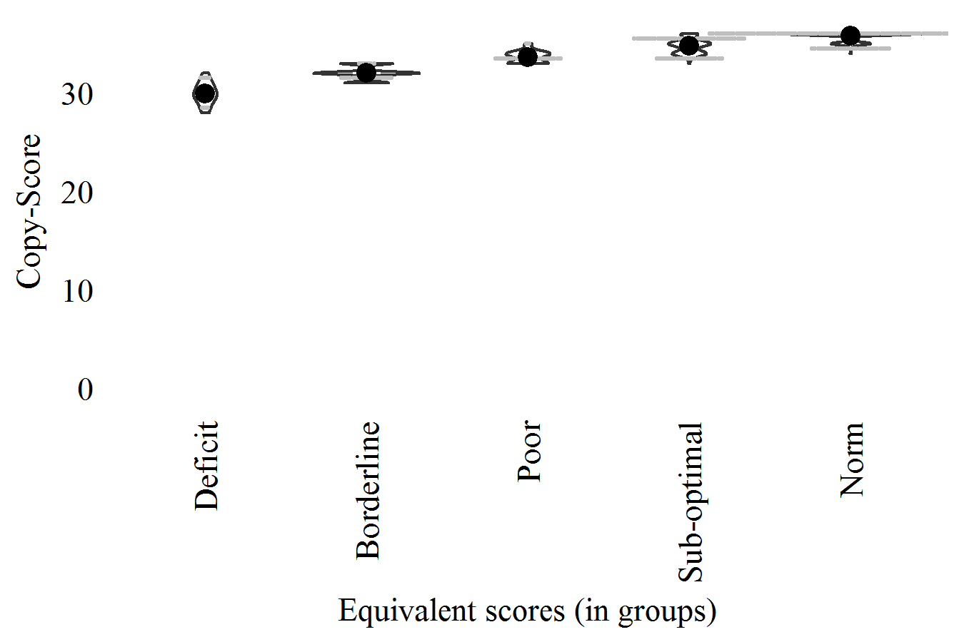

* 1. IM-Percent (ROCF): "Reduced-Model"

Proportion of score, immediate memory condition (IM on copy) [0, 1+]

In PRONIA-Portal: Calculated (not in PRONIA-Portal)

In data-sets: ROCF_I_SCO_perc

Corretion-formula:

"IM-Percent"  
 = 0.501  
 + ( 0.031 x "Sex (Male=1)" )  
 + ( -0.004 x "Age (years)" )  
 + ( 0.003 x "Estimate-IQ" )  
 + ( 0.053 x "English" )

| **ES-Levels** | **Cut-off** |
| --- | --- |
| Deficit (<5%) | <0.44 |
| Borderline (<15%) | <0.55 |
| Poor (<25%) | <0.62 |
| Sub-optimal (<50%) | <0.74 |
| Norm (>=50%) | >=0.74 |

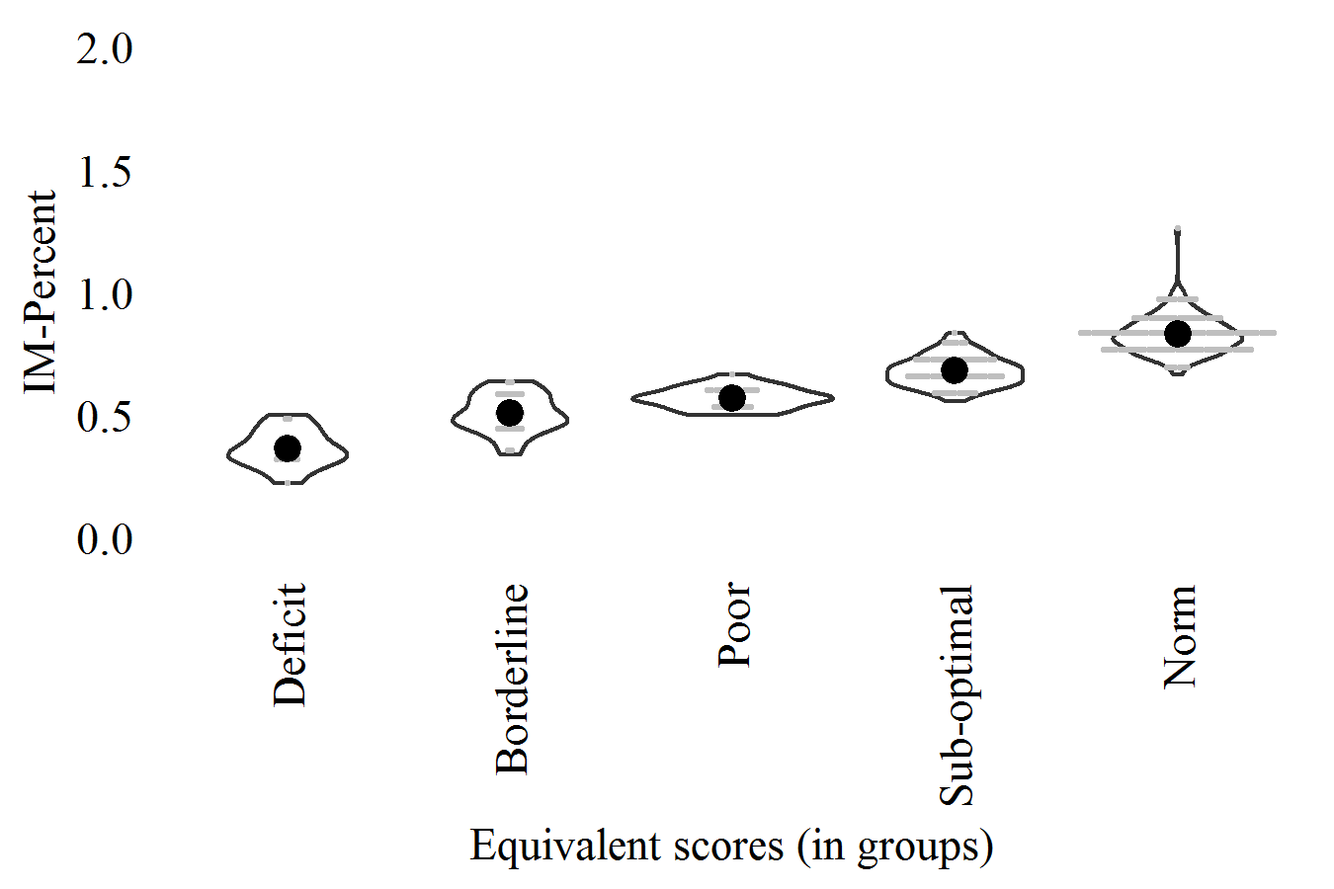

* 1. DM-Percent (ROCF): "Reduced-Model"

Proportion of score, delayed memory condition (IM on copy) [0, 1+]

In PRONIA-Portal: Calculated (not in PRONIA-Portal)

In data-sets: ROCF_D_SCO_perc

Corretion-formula:

"DM-Percent"  
 = 0.438  
 + ( -0.003 x "Age (years)" )  
 + ( 0.003 x "Estimate-IQ" )  
 + ( 0.054 x "English" )

| **ES-Levels** | **Cut-off** |
| --- | --- |
| Deficit (<5%) | <0.44 |
| Borderline (<15%) | <0.57 |
| Poor (<25%) | <0.63 |
| Sub-optimal (<50%) | <0.72 |
| Norm (>=50%) | >=0.72 |

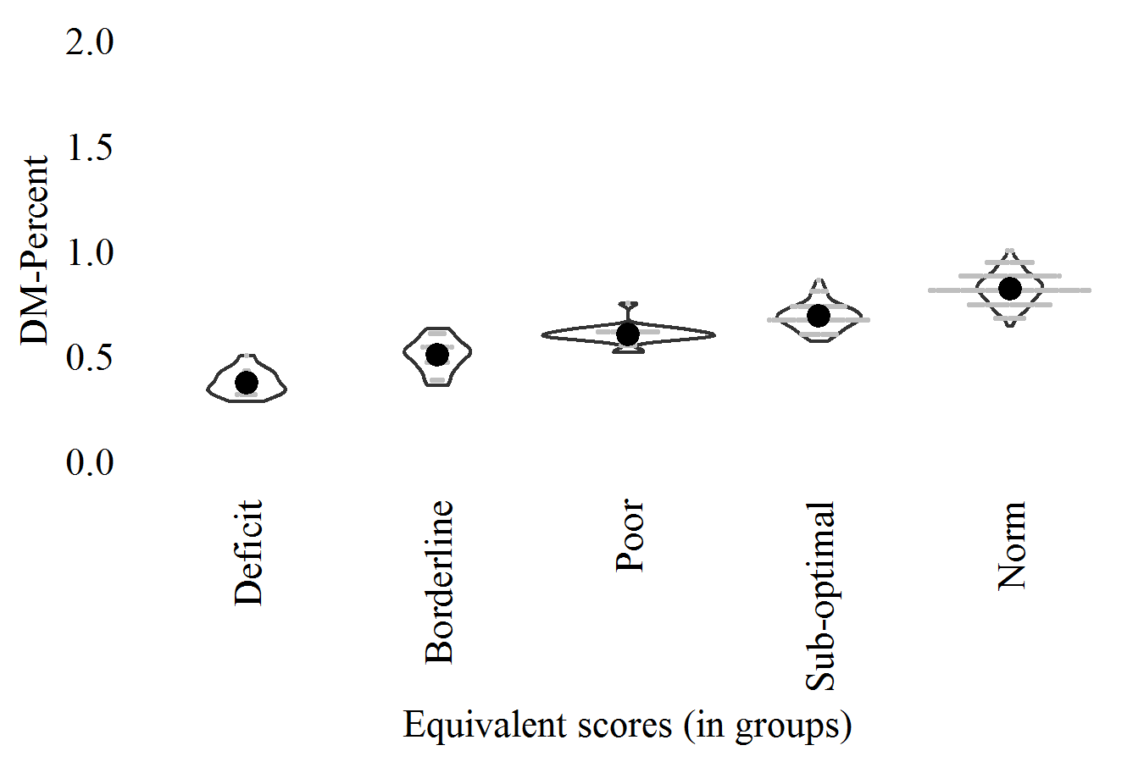

* 1. Copy-Seconds (ROCF): "0-Model"

Time, copy condition [seconds]

In PRONIA-Portal: GROCF_Time

In data-sets: ROCF_C_SEC

Corretion-formula:

"Copy-Seconds" (non-corrected)

| **ES-Levels** | **Cut-off** |
| --- | --- |
| Deficit (>95%) | >422.96 |
| Borderline (>85%) | >310.15 |
| Poor (>75%) | >265.63 |
| Sub-optimal (>50%) | >200.79 |
| Norm (<=50%) | <=200.79 |

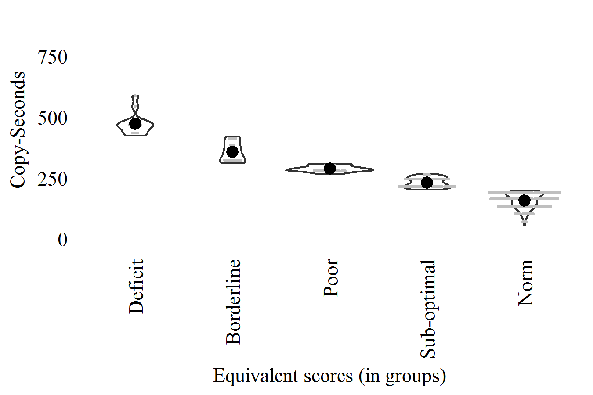

* 1. DANVA (DANVA-2-AF): "Reduced-Model"

Score [0-24]

In PRONIA-Portal: GDANVA_Number_correct_Faces_condition

In data-sets: DANVA

Corretion-formula:

"DANVA"  
 = 15.471  
 + ( -0.035 x "Age (years)" )  
 + ( 0.044 x "Estimate-IQ" )  
 + ( 0.470 x "Italian" )

| **ES-Levels** | **Cut-off** |
| --- | --- |
| Deficit (<5%) | <16.17 |
| Borderline (<15%) | <17.58 |
| Poor (<25%) | <18.25 |
| Sub-optimal (<50%) | <19.72 |
| Norm (>=50%) | >=19.72 |

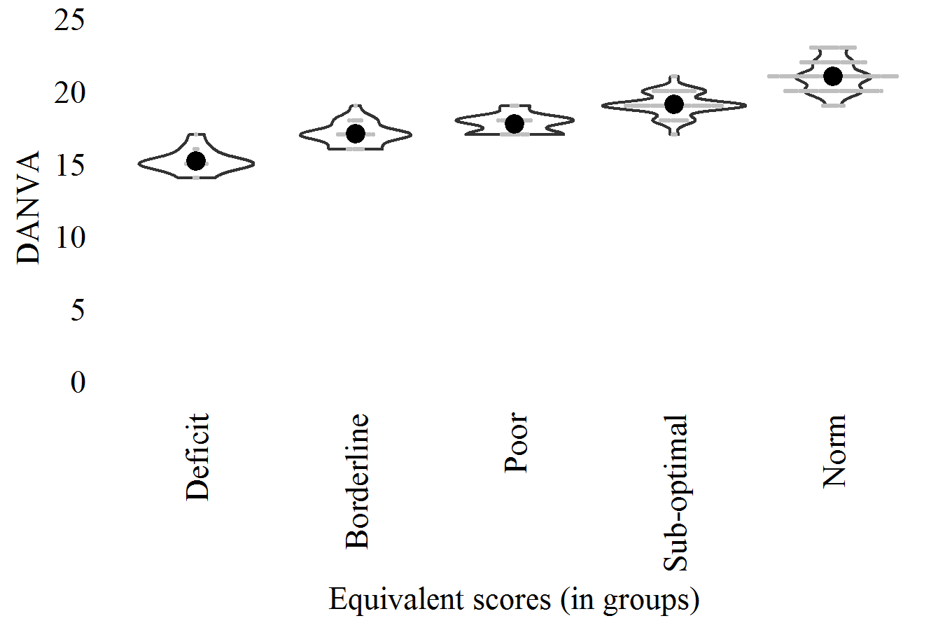

* 1. Score (ADS-F&B): "Reduced-Model"

Total score [0, 34]

In PRONIA-Portal: Calculated (not in PRONIA-Portal)

In data-sets: DS

Corretion-formula:

"Score"  
 = 10.923  
 + ( -0.086 x "Age (years)" )  
 + ( 0.063 x "Estimate-IQ" )  
 + ( 0.767 x "Education (grade)" )

| **ES-Levels** | **Cut-off** |
| --- | --- |
| Deficit (<5%) | <11.84 |
| Borderline (<15%) | <13.90 |
| Poor (<25%) | <15.03 |
| Sub-optimal (<50%) | <17.71 |
| Norm (>=50%) | >=17.71 |

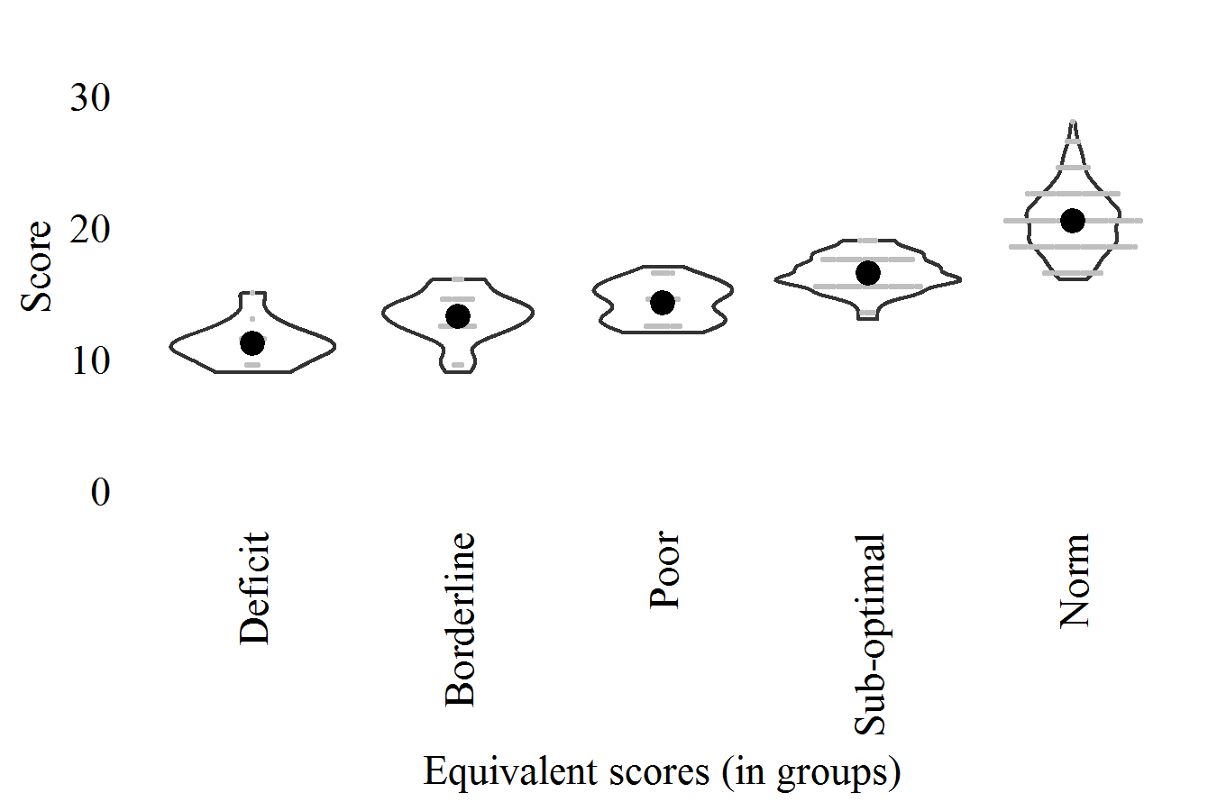

* 1. B-Score (ADS-F&B): "Reduced-Model"

Backward [0, 16]

In PRONIA-Portal: GBDS_Number_of_correct_trials

In data-sets: BDS_T

Corretion-formula:

"B-Score"  
 = 3.454  
 + ( -0.058 x "Age (years)" )  
 + ( 0.041 x "Estimate-IQ" )  
 + ( 0.528 x "Education (grade)" )

| **ES-Levels** | **Cut-off** |
| --- | --- |
| Deficit (<5%) | <4.23 |
| Borderline (<15%) | <5.34 |
| Poor (<25%) | <6.31 |
| Sub-optimal (<50%) | <7.73 |
| Norm (>=50%) | >=7.73 |

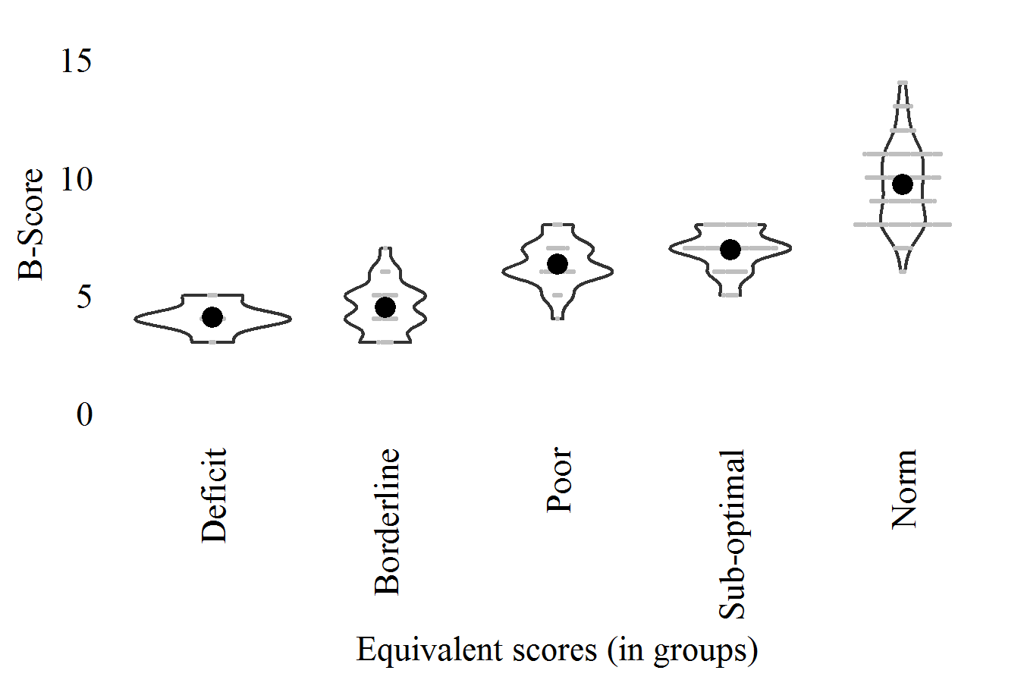

* 1. P-Words (VF-P&S): "Reduced-Model"

Total score, phonemic condition [number of words]

In PRONIA-Portal: GPVF_Correct_00_60_letter_1

In data-sets: PVF_WRD

Corretion-formula:

"P-Words"  
 = 7.383  
 + ( 0.051 x "Estimate-IQ" )  
 + ( 0.966 x "Education (grade)" )  
 + ( -2.967 x "English" )  
 + ( 4.355 x "Finnish" )  
 + ( 1.096 x "Italian" )

| **ES-Levels** | **Cut-off** |
| --- | --- |
| Deficit (<5%) | < 9.23 |
| Borderline (<15%) | <11.39 |
| Poor (<25%) | <12.57 |
| Sub-optimal (<50%) | <15.37 |
| Norm (>=50%) | >=15.37 |

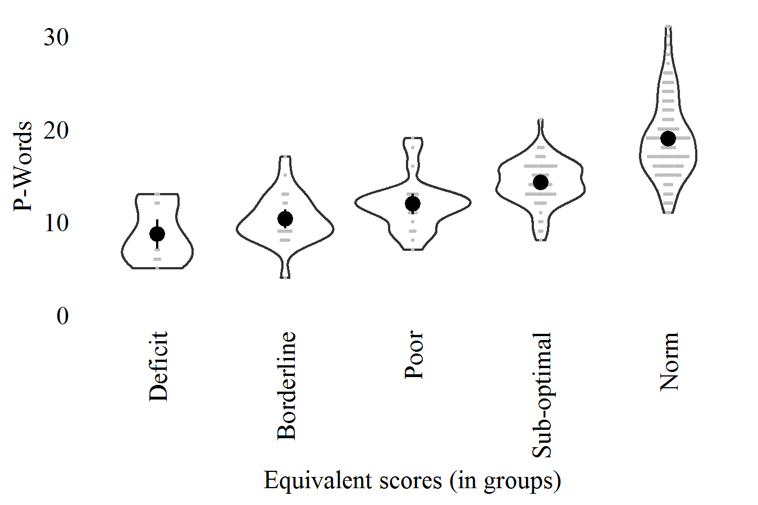

* 1. P-Repetitions (VF-P&S): "0-Model"

Total repetitions, phonemic condition [number of words]

In PRONIA-Portal: GPVF_Repetition_00_60_letter_1

In data-sets: PVF_REP

Corretion-formula:

"P-Repetitions" (non-corrected)

| **ES-Levels** | **Cut-off** |
| --- | --- |
| Deficit (>95%) | >2.00 |
| Borderline (>85%) | >1.00 |
| Poor (>75%) | >1.00 |
| Sub-optimal (>50%) | >0.00 |
| Norm (<=50%) | <=0.00 |

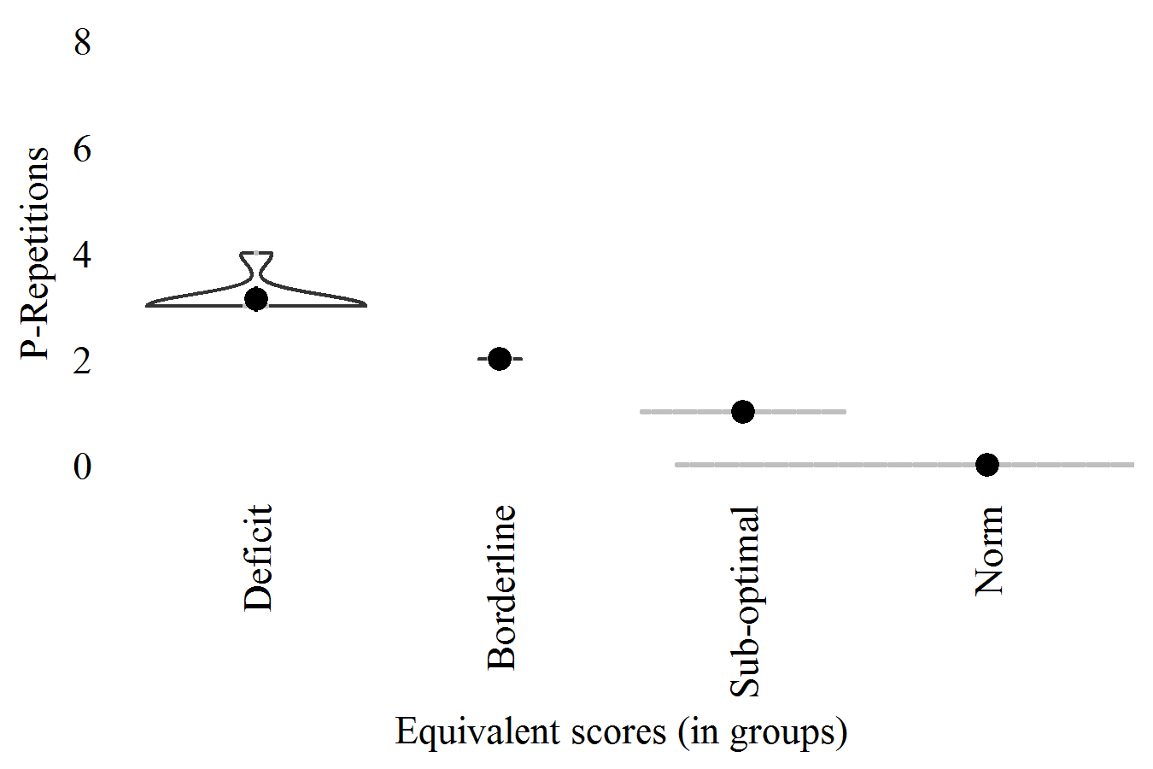

* 1. S-Words (VF-P&S): "Reduced-Model"

Total score, semantic condition [number of words]

In PRONIA-Portal: GSVF_Correct_00_60_category_1

In data-sets: SVF_WRD

Corretion-formula:

"S-Words"  
 = 7.679  
 + ( 0.139 x "Estimate-IQ" )  
 + ( 0.868 x "Education (grade)" )  
 + ( 2.395 x "Finnish" )  
 + ( -4.140 x "Other-language" )

| **ES-Levels** | **Cut-off** |
| --- | --- |
| Deficit (<5%) | <17.47 |
| Borderline (<15%) | <19.89 |
| Poor (<25%) | <22.15 |
| Sub-optimal (<50%) | <25.49 |
| Norm (>=50%) | >=25.49 |

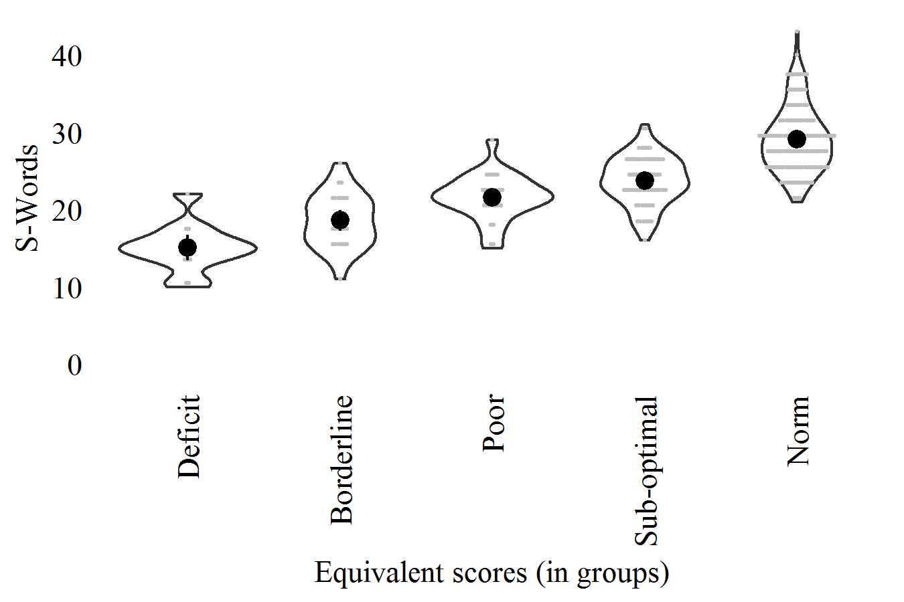

* 1. S-Repetitions (VF-P&S): "Reduced-Model"

Total repetitions, semantic condition [number of words]

In PRONIA-Portal: GSVF_Repetition_00_60_category_1

In data-sets: SVF_REP

Corretion-formula:

"S-Repetitions"  
 = 0.298  
 + ( 0.181 x "Sex (Male=1)" )  
 + ( 0.438 x "English" )  
 + ( 0.220 x "Italian" )

| **ES-Levels** | **Cut-off** |
| --- | --- |
| Deficit (>95%) | >1.98 |
| Borderline (>85%) | >1.16 |
| Poor (>75%) | >0.94 |
| Sub-optimal (>50%) | >0.16 |
| Norm (<=50%) | <=0.16 |

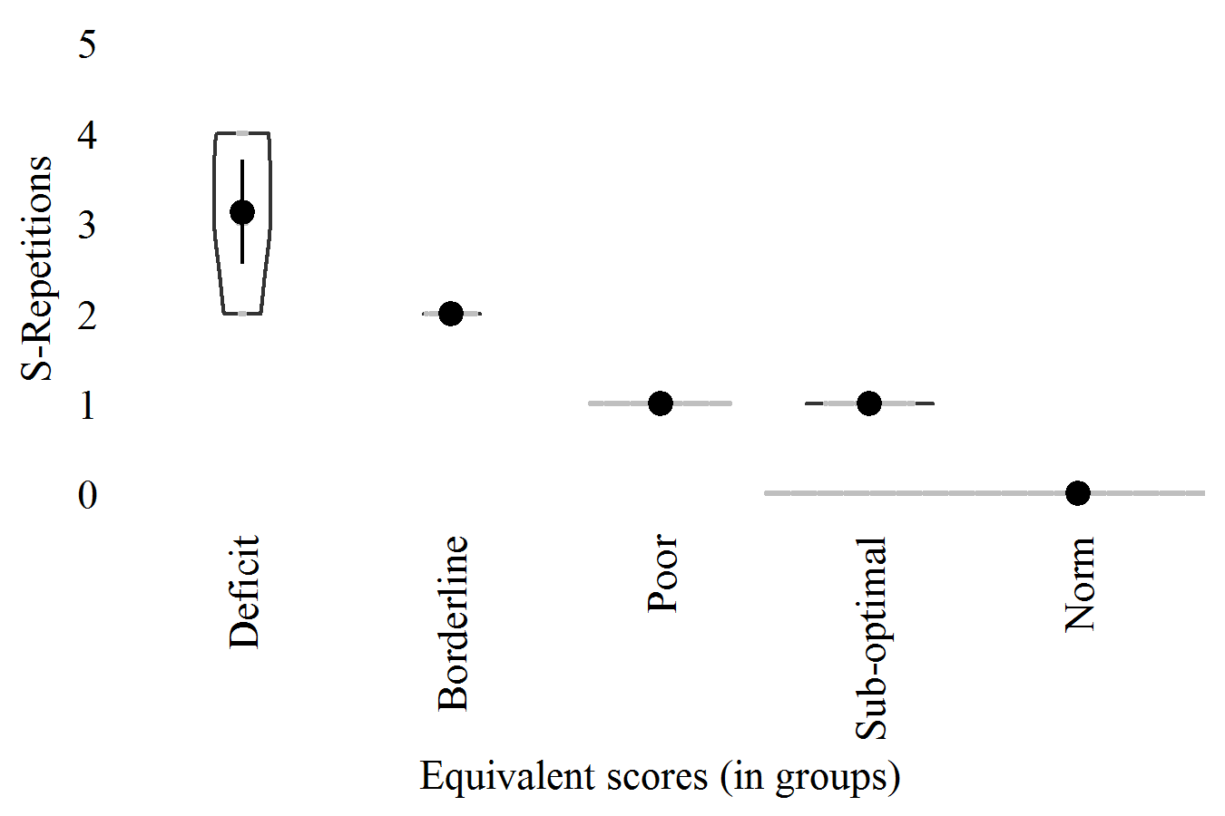

* 1. Words (HVLT-R): "0-Model"

Total immediate score, with A [0, 36]

In PRONIA-Portal: Calculated (not in PRONIA-Portal)

In data-sets: HAVLT_WRD

Corretion-formula:

"Words" (non-corrected)

| **ES-Levels** | **Cut-off** |
| --- | --- |
| Deficit (<5%) | <26.00 |
| Borderline (<15%) | <29.00 |
| Poor (<25%) | <30.00 |
| Sub-optimal (<50%) | <32.00 |
| Norm (>=50%) | >=32.00 |

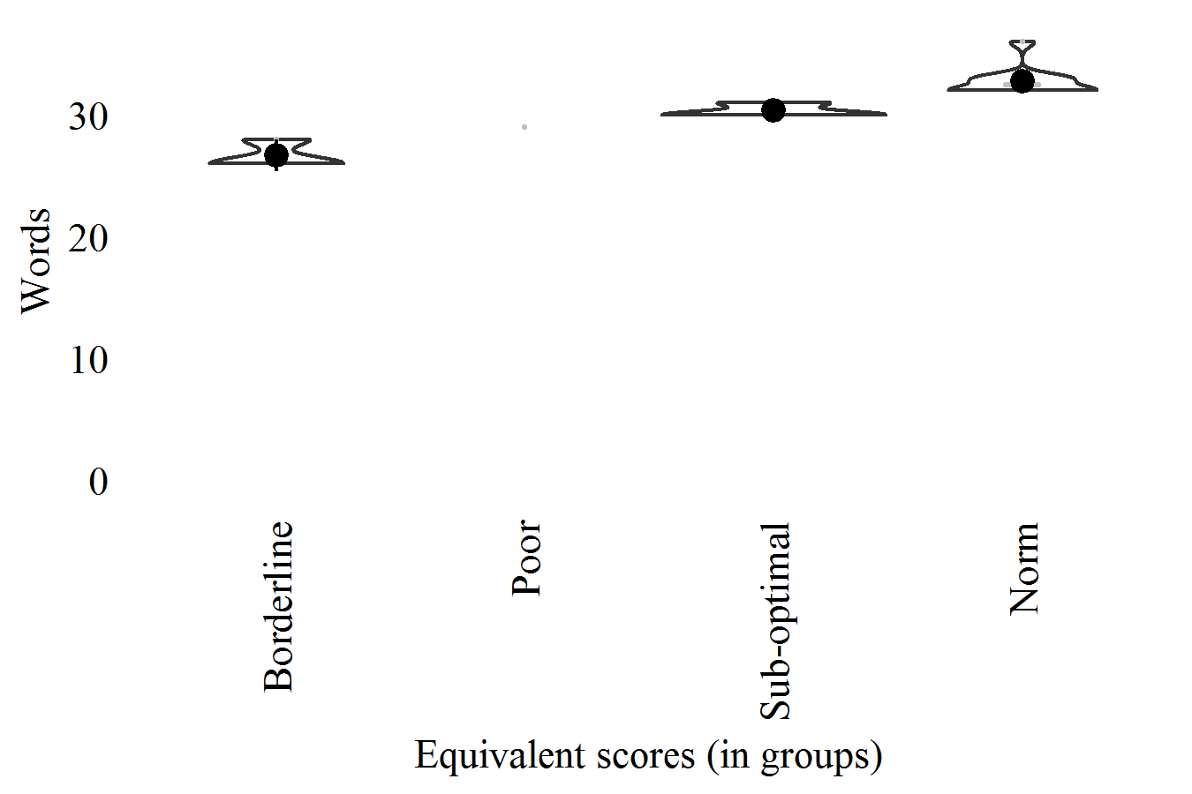

* 1. Repetitions (HVLT-R): "0-Model"

Total immediate and delayed repetitions, with A [number of words]

In PRONIA-Portal: Calculated (not in PRONIA-Portal)

In data-sets: HAVLT_REP

Corretion-formula:

"Repetitions" (non-corrected)

| **ES-Levels** | **Cut-off** |
| --- | --- |
| Deficit (>95%) | >1.95 |
| Borderline (>85%) | >1.00 |
| Poor (>75%) | >1.00 |
| Sub-optimal (>50%) | >0.00 |
| Norm (<=50%) | <=0.00 |

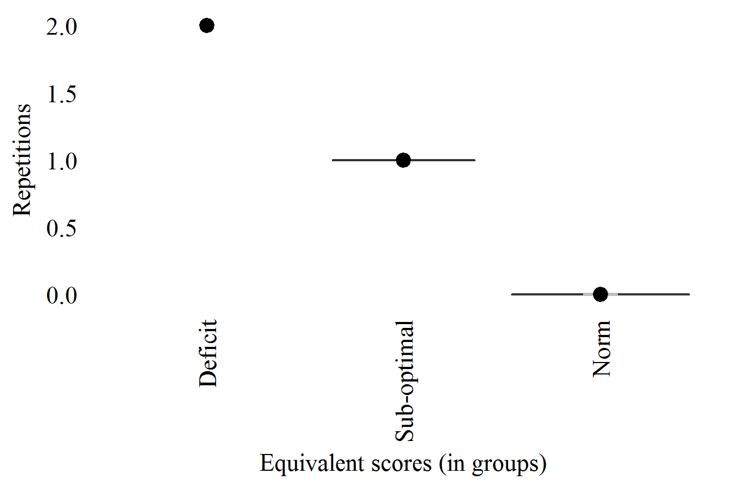

* 1. Words-A7 (HVLT-R): "0-Model"

Delayed trial score, 4th with A [0, 12]

In PRONIA-Portal: GAVLT_Delayed_repetition_list_A

In data-sets: HAVLT_A7W

Corretion-formula:

"Words-A7" (non-corrected)

| **ES-Levels** | **Cut-off** |
| --- | --- |
| Deficit (<5%) | <10.00 |
| Borderline (<15%) | <11.00 |
| Poor (<25%) | <11.00 |
| Sub-optimal (<50%) | <12.00 |
| Norm (>=50%) | >=12.00 |

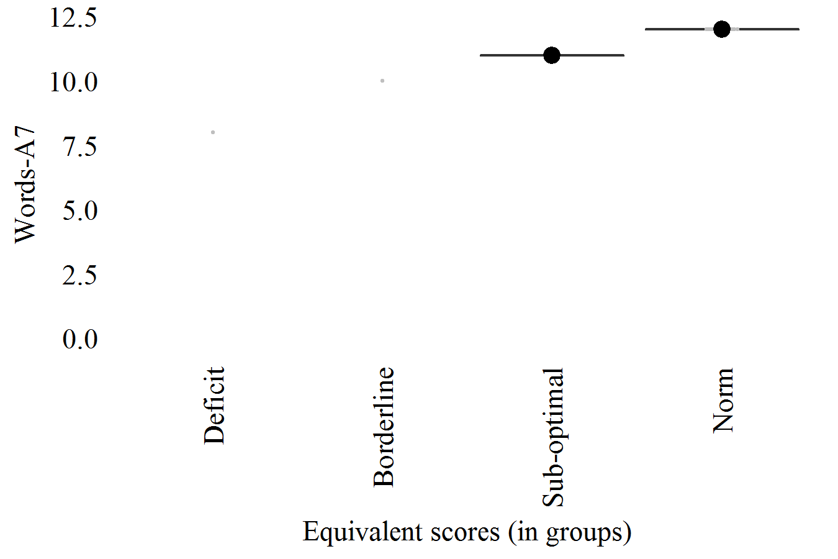

* 1. Words (RAVLT): "Reduced-Model"

Total immediate score, with A [0, 75]

In PRONIA-Portal: Calculated (not in PRONIA-Portal)

In data-sets: AVLT_WRD

Corretion-formula:

"Words"  
 = 49.339  
 + ( -2.479 x "Sex (Male=1)" )  
 + ( -0.378 x "Age (years)" )  
 + ( 0.174 x "Estimate-IQ" )  
 + ( 1.566 x "Education (grade)" )  
 + ( -3.475 x "English" )  
 + ( -5.389 x "Italian" )

| **ES-Levels** | **Cut-off** |
| --- | --- |
| Deficit (<5%) | <49.96 |
| Borderline (<15%) | <54.06 |
| Poor (<25%) | <56.75 |
| Sub-optimal (<50%) | <61.59 |
| Norm (>=50%) | >=61.59 |

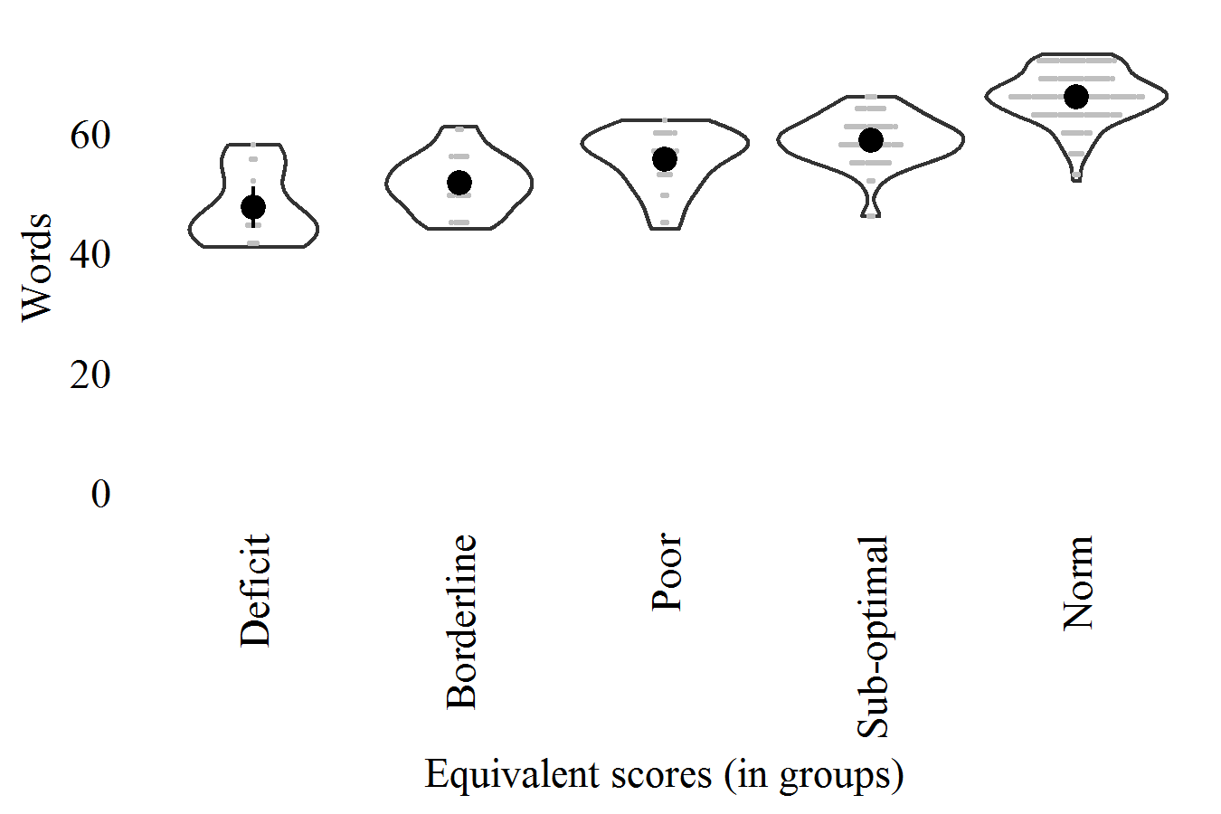

* 1. Repetitions (RAVLT): "Reduced-Model"

Total immediate and delayed repetitions, with A or B [number of words]

In PRONIA-Portal: Calculated (not in PRONIA-Portal)

In data-sets: AVLT_REP

Corretion-formula:

"Repetitions"  
 = 2.102  
 + ( 0.075 x "Age (years)" )  
 + ( 1.495 x "English" )  
 + ( 2.443 x "Italian" )

| **ES-Levels** | **Cut-off** |
| --- | --- |
| Deficit (>95%) | >12.46 |
| Borderline (>85%) | > 8.72 |
| Poor (>75%) | > 6.76 |
| Sub-optimal (>50%) | > 3.57 |
| Norm (<=50%) | <= 3.57 |

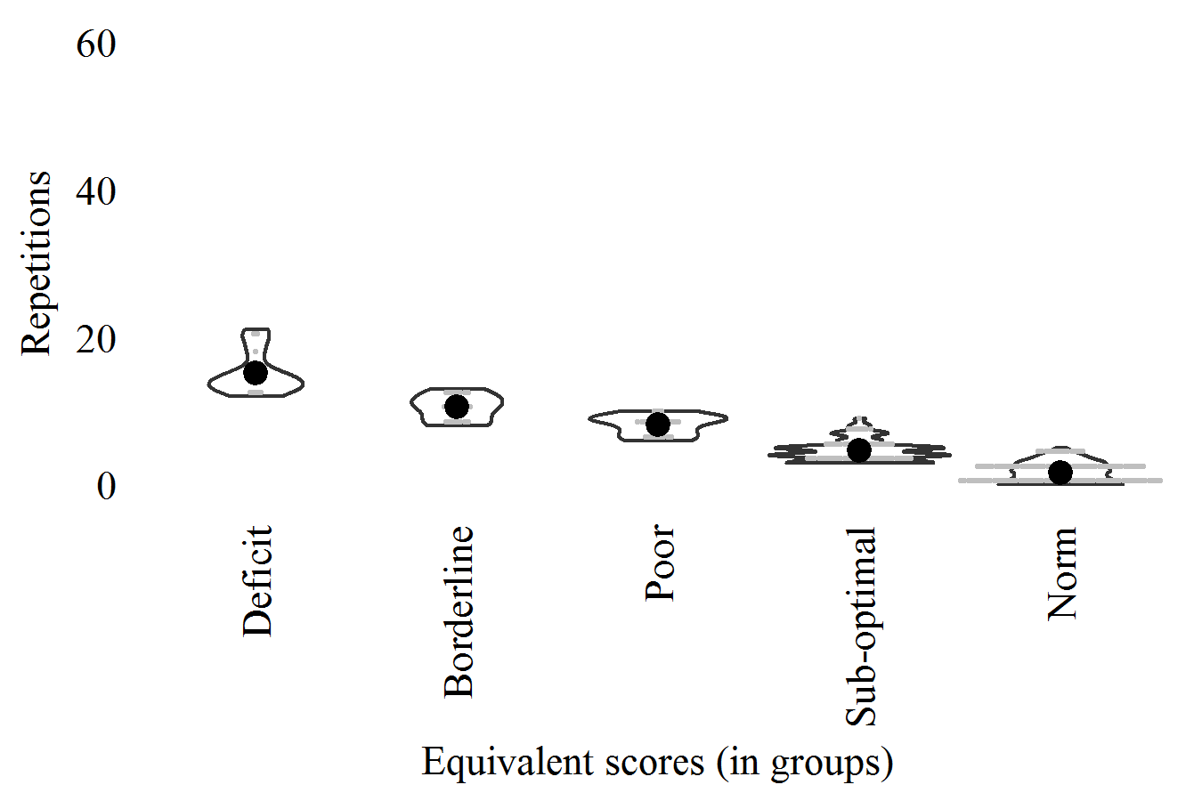

* 1. Words-A7 (RAVLT): "Complete-Model"

Delayed trial score, 7th with A [0, 15]

In PRONIA-Portal: GAVLT_Delayed_repetition_list_A

In data-sets: AVLT_A7W

Corretion-formula:

"Words-A7"  
 = 11.690  
 + ( -0.682 x "Sex (Male=1)" )  
 + ( -0.110 x "Age (years)" )  
 + ( 0.035 x "Estimate-IQ" )  
 + ( 0.408 x "Education (grade)" )  
 + ( -1.218 x "English" )  
 + ( -0.918 x "Italian" )  
 + ( -0.653 x "Other-language" )

| **ES-Levels** | **Cut-off** |
| --- | --- |
| Deficit (<5%) | <10.11 |
| Borderline (<15%) | <11.62 |
| Poor (<25%) | <12.32 |
| Sub-optimal (<50%) | <13.55 |
| Norm (>=50%) | >=13.55 |

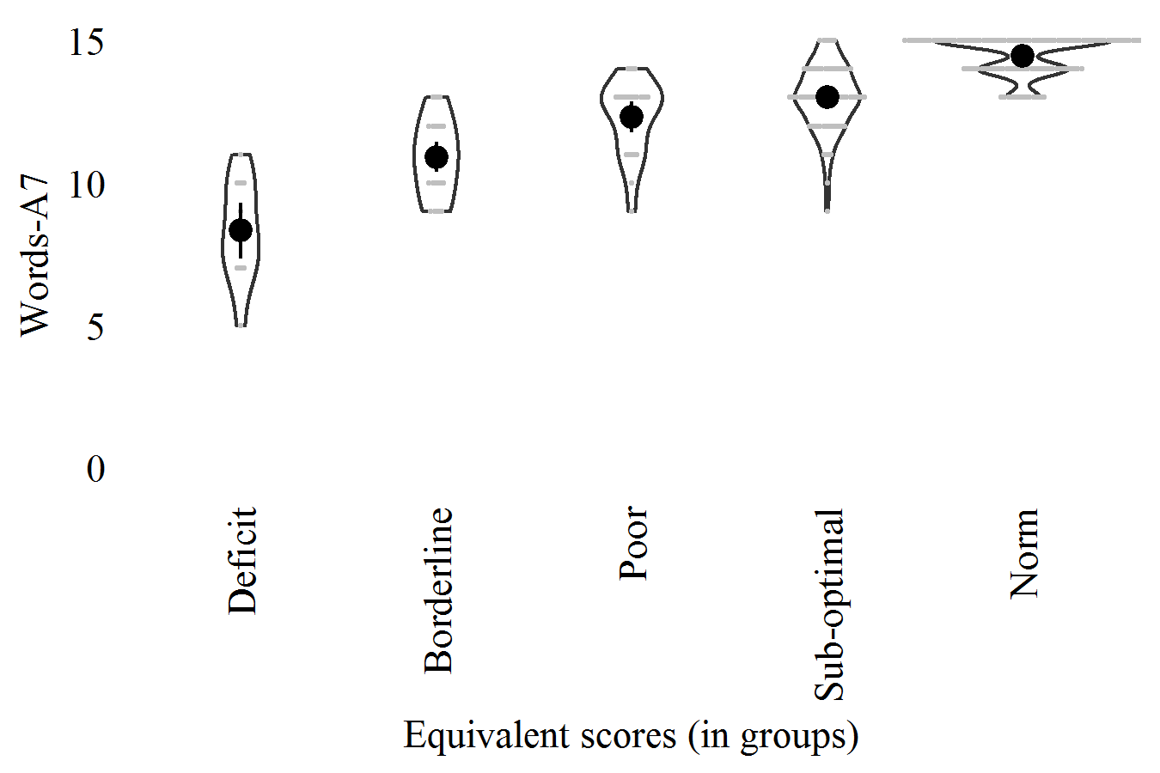

* 1. Switch (TM-A&B): "Reduced-Model"

Switch time (B-A) [seconds]

In PRONIA-Portal: Calculated (not in PRONIA-Portal)

In data-sets: SWITCH

Corretion-formula:

"Switch"  
 = 49.367  
 + ( 4.909 x "Sex (Male=1)" )  
 + ( -0.219 x "Estimate-IQ" )

| **ES-Levels** | **Cut-off** |
| --- | --- |
| Deficit (>95%) | >47.18 |
| Borderline (>85%) | >39.04 |
| Poor (>75%) | >33.41 |
| Sub-optimal (>50%) | >24.86 |
| Norm (<=50%) | <=24.86 |

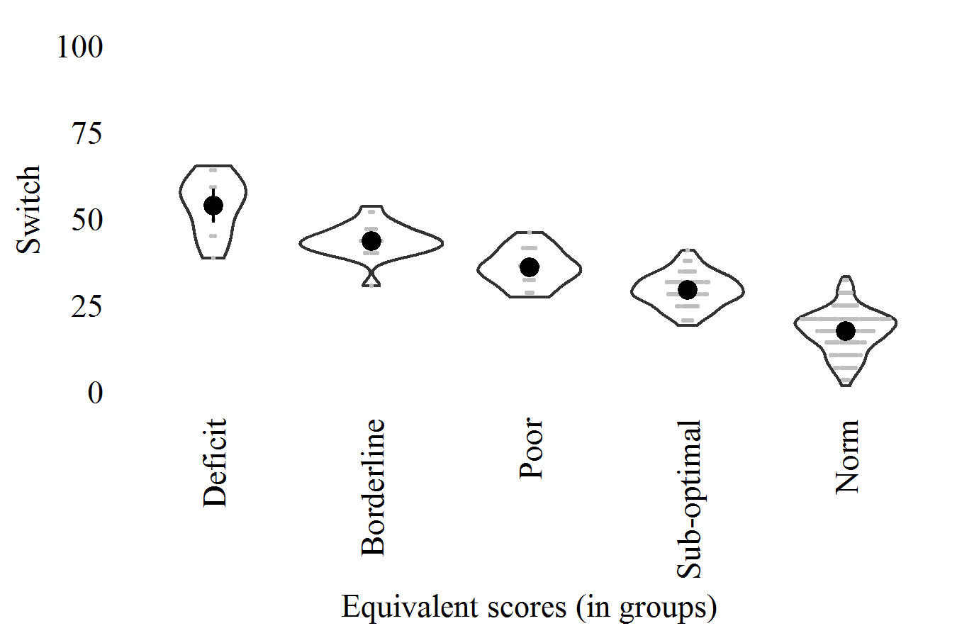

* 1. EorV-done (TM-A&B): "Reduced-Model"

Sum of errors and violations [count]

In PRONIA-Portal: Calculated (not in Pronia-Portal)

In data-sets: TM_isEV

Corretion-formula:

"EorV-done"  
 = 1.994  
 + ( 0.487 x "Sex (Male=1)" )  
 + ( -0.018 x "Age (years)" )  
 + ( -0.008 x "Estimate-IQ" )  
 + ( -0.756 x "Finnish" )

| **ES-Levels** | **Cut-off** |
| --- | --- |
| Deficit (>95%) | >2.97 |
| Borderline (>85%) | >1.80 |
| Poor (>75%) | >1.11 |
| Sub-optimal (>50%) | >0.29 |
| Norm (<=50%) | <=0.29 |

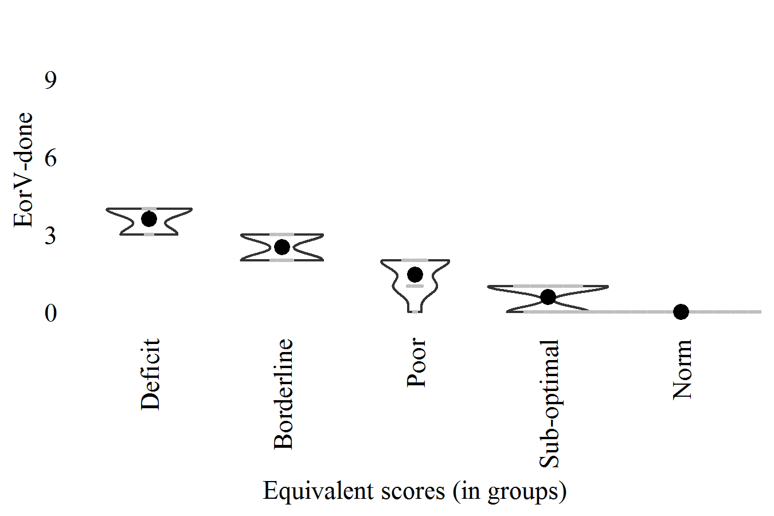

* 1. Time-A (TM-A&B): "Reduced-Model"

Time in A [seconds]

In PRONIA-Portal: GTMA_1_Time_of_execution

In data-sets: TM_TA

Corretion-formula:

"Time-A"  
 = 50.335  
 + ( -0.212 x "Estimate-IQ" )  
 + ( 4.817 x "Italian" )

| **ES-Levels** | **Cut-off** |
| --- | --- |
| Deficit (>95%) | >43.54 |
| Borderline (>85%) | >36.19 |
| Poor (>75%) | >32.02 |
| Sub-optimal (>50%) | >25.86 |
| Norm (<=50%) | <=25.86 |

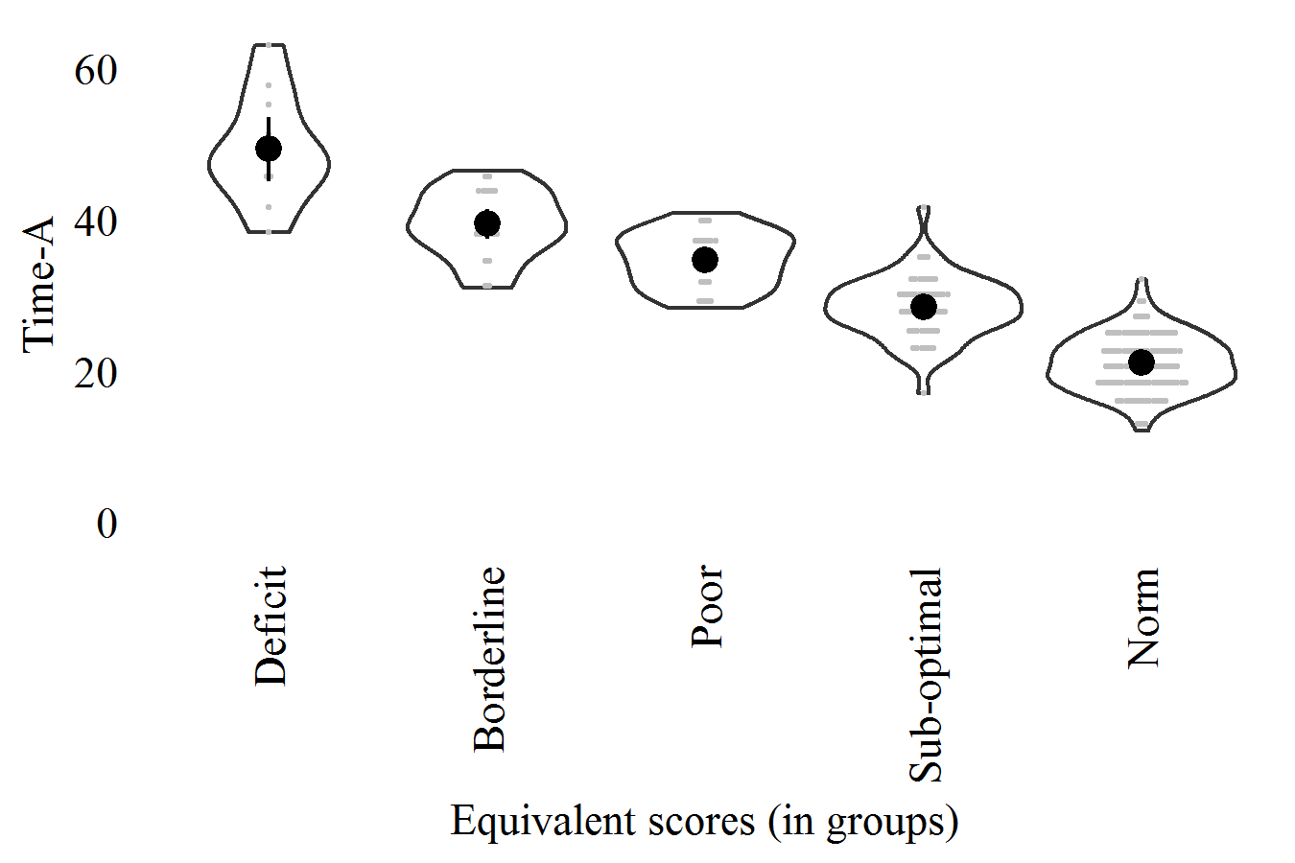

* 1. Correct-RT-ALL (CPT-IP): "0-Model"

Time in hit responses (HIT) [milliseconds]

In PRONIA-Portal: CPTIP_Reaction_times_correct_whole_test

In data-sets: CPT_CT_ALL

Corretion-formula:

"Correct-RT-ALL" (non-corrected)

| **ES-Levels** | **Cut-off** |
| --- | --- |
| Deficit (>95%) | >631.50 |
| Borderline (>85%) | >592.63 |
| Poor (>75%) | >568.92 |
| Sub-optimal (>50%) | >536.71 |
| Norm (<=50%) | <=536.71 |

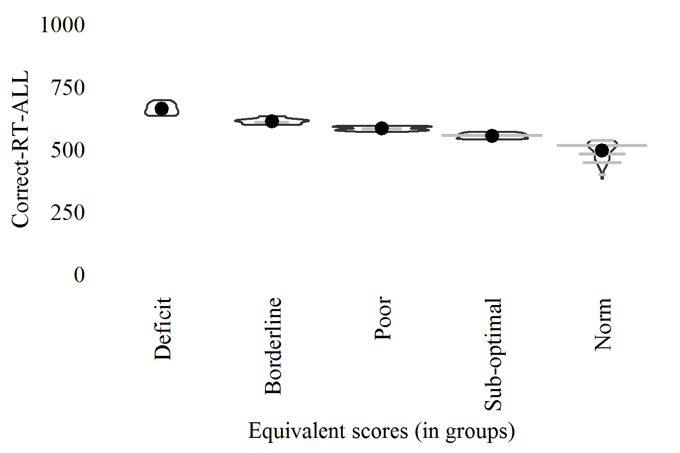

* 1. Commission-D-ALL (CPT-IP): "Reduced-Model"

Sensitivity index (d-prime) for commission errors [-8.5, +8.5]

In PRONIA-Portal: Calculated (not in PRONIA-Portal)

In data-sets: CPT_Dprime_Commission_ALL

Corretion-formula:

"Commission-D-ALL"  
 = 0.480  
 + ( 0.008 x "Estimate-IQ" )  
 + ( 0.130 x "Education (grade)" )  
 + ( 0.206 x "Italian" )

| **ES-Levels** | **Cut-off** |
| --- | --- |
| Deficit (<5%) | <0.74 |
| Borderline (<15%) | <1.05 |
| Poor (<25%) | <1.39 |
| Sub-optimal (<50%) | <1.71 |
| Norm (>=50%) | >=1.71 |

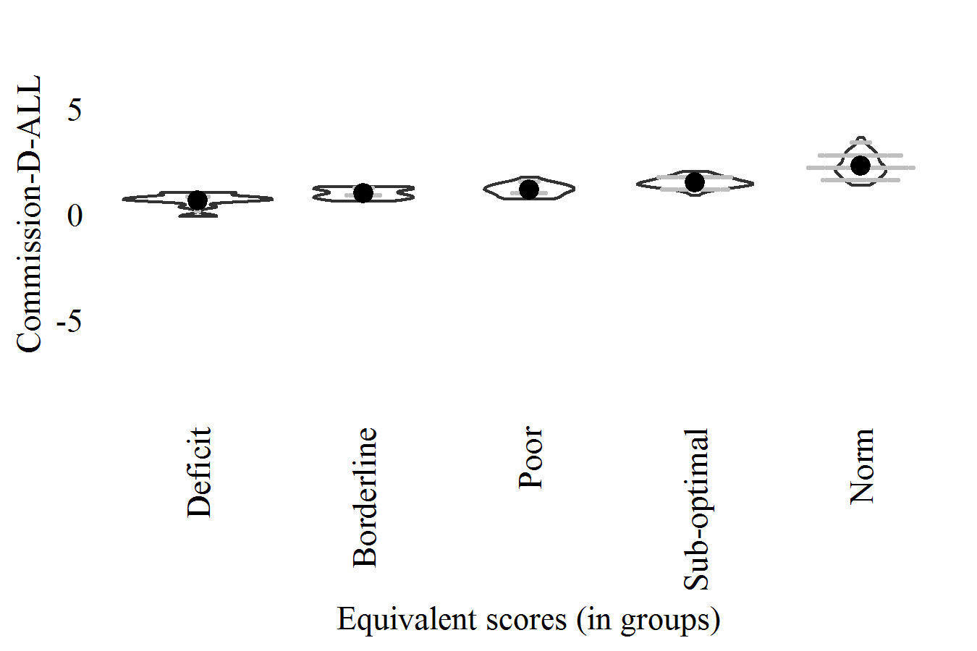

* 1. Random-D-ALL (CPT-IP): "Reduced-Model"

Sensitivity index (d-prime) for random/distraction errors [-8.5, +8.5]

In PRONIA-Portal: Calculated (not in PRONIA-Portal)

In data-sets: CPT_Dprime_Random_ALL

Corretion-formula:

"Random-D-ALL"  
 = 1.624  
 + ( 0.157 x "Sex (Male=1)" )  
 + ( 0.009 x "Estimate-IQ" )  
 + ( 0.110 x "Education (grade)" )

| **ES-Levels** | **Cut-off** |
| --- | --- |
| Deficit (<5%) | <1.88 |
| Borderline (<15%) | <2.32 |
| Poor (<25%) | <2.57 |
| Sub-optimal (<50%) | <3.01 |
| Norm (>=50%) | >=3.01 |

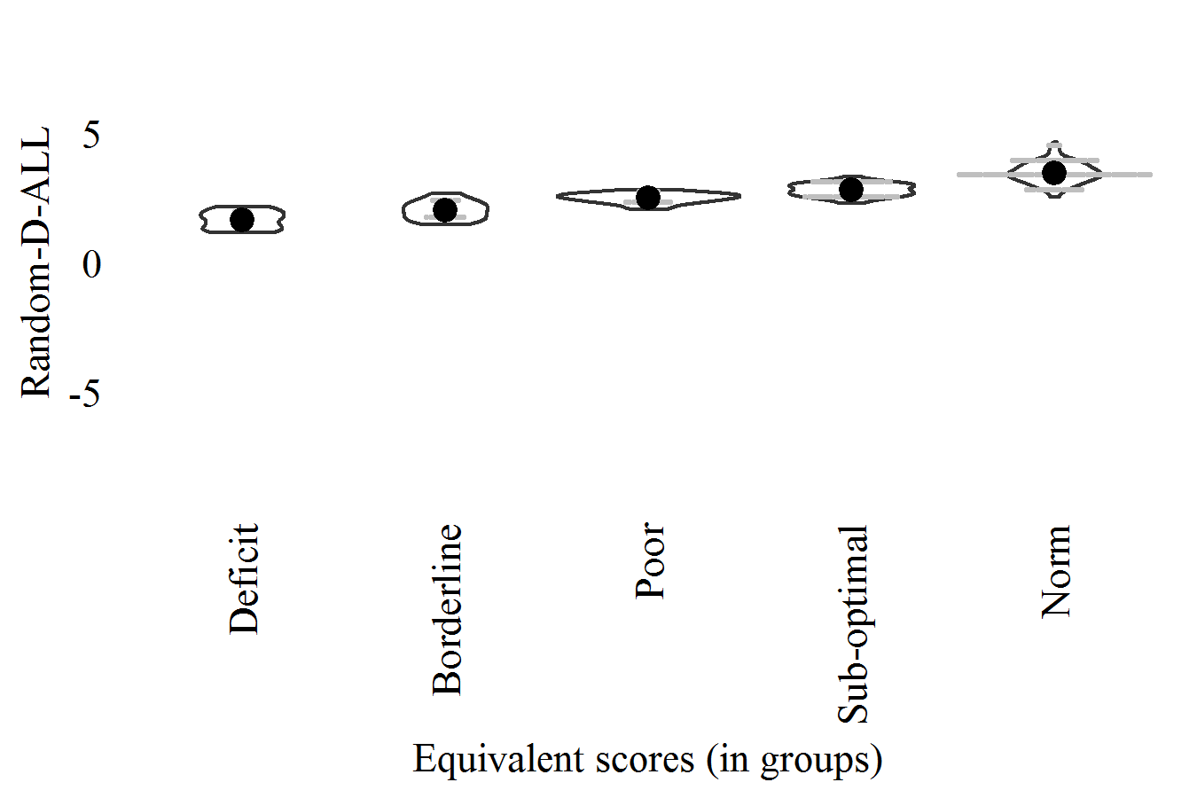

* 1. Commission-D-Slope (CPT-IP): "0-Model"

Slope, sensitivity index (d-prime) for commission errors [-1,1]

In PRONIA-Portal: Calculated (not in PRONIA-Portal)

In data-sets: CPT_Dprime_Commission_slope

Corretion-formula:

"Commission-D-Slope" (non-corrected)

| **ES-Levels** | **Cut-off** |
| --- | --- |
| Deficit (<5%) | <-0.83 |
| Borderline (<15%) | <-0.67 |
| Poor (<25%) | <-0.56 |
| Sub-optimal (<50%) | <-0.30 |
| Norm (>=50%) | >=-0.30 |

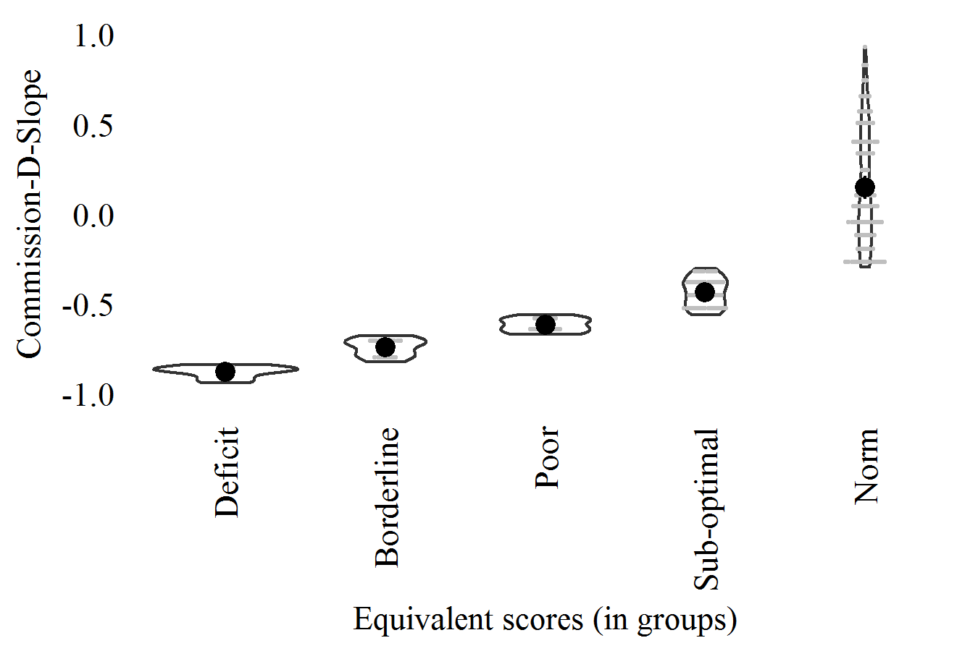

* 1. Random-D-Slope (CPT-IP): "0-Model"

Slope, sensitivity index (d-prime) for random/distraction errors [-1,1]

In PRONIA-Portal: Calculated (not in PRONIA-Portal)

In data-sets: CPT_Dprime_Random_slope

Corretion-formula:

"Random-D-Slope" (non-corrected)

| **ES-Levels** | **Cut-off** |
| --- | --- |
| Deficit (<5%) | <-0.88 |
| Borderline (<15%) | <-0.77 |
| Poor (<25%) | <-0.66 |
| Sub-optimal (<50%) | <-0.36 |
| Norm (>=50%) | >=-0.36 |

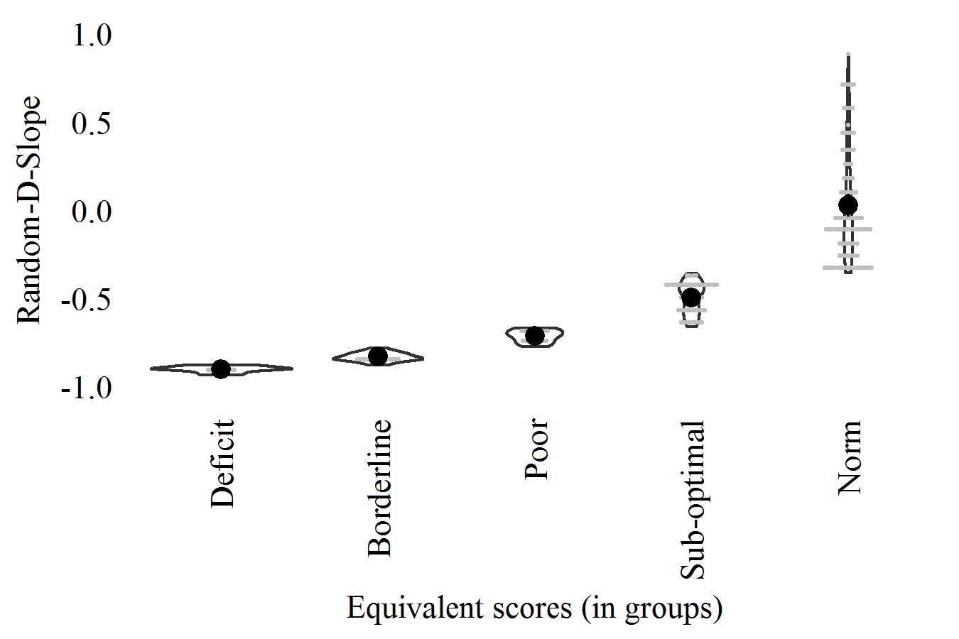

* 1. Span-10 (SOPT): "Reduced-Model"

Span (2nd maximum) in 10-figures trials [1, 10]

In PRONIA-Portal: Calculated (not in PRONIA-Portal)

In data-sets: SOPT_Span10

Corretion-formula:

"Span-10"  
 = 3.571  
 + ( 0.036 x "Estimate-IQ" )  
 + ( -1.083 x "English" )  
 + ( -0.701 x "Italian" )

| **ES-Levels** | **Cut-off** |
| --- | --- |
| Deficit (<5%) | <3.79 |
| Borderline (<15%) | <5.04 |
| Poor (<25%) | <5.85 |
| Sub-optimal (<50%) | <7.49 |
| Norm (>=50%) | >=7.49 |

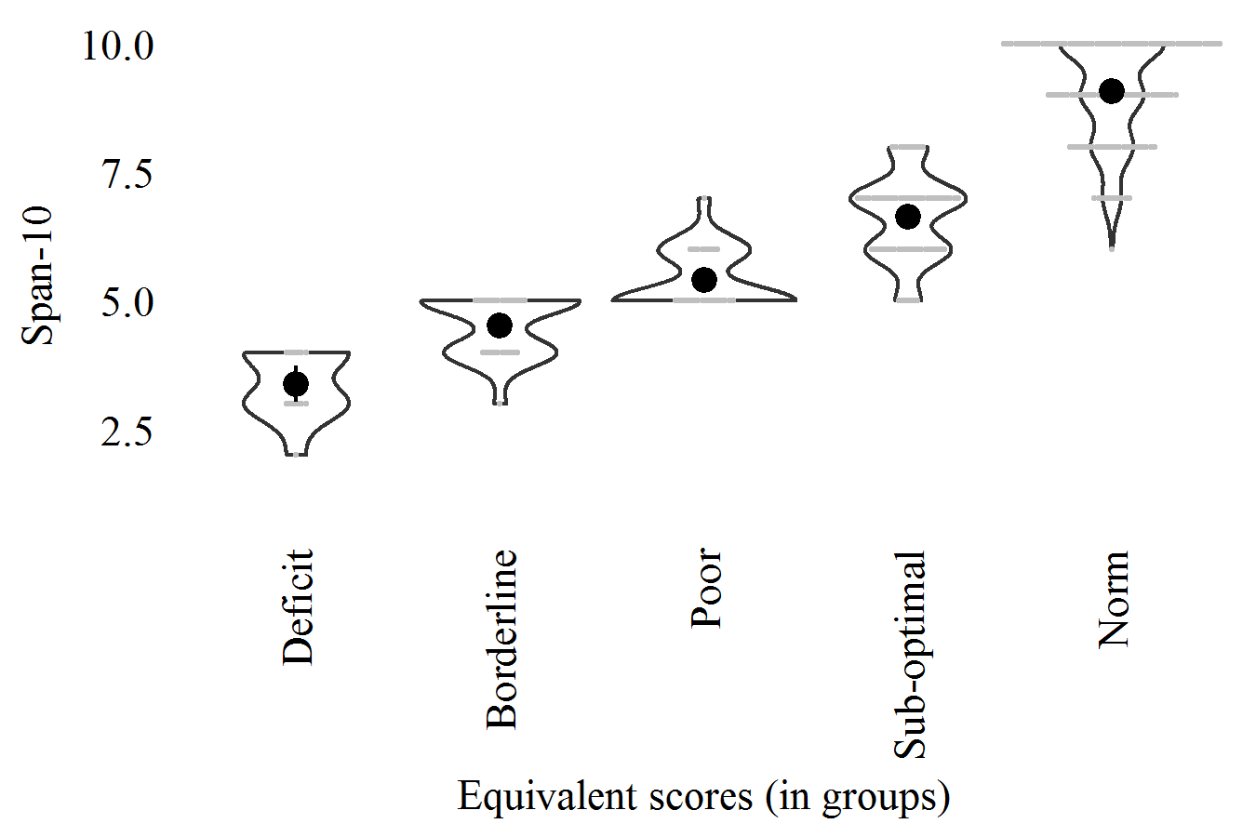

* 1. Perseveration-10 (SOPT): "0-Model"

Perseverative errors in 10-figures trials [0, 8]

In PRONIA-Portal: Calculated (not in PRONIA-Portal)

In data-sets: SOPT_P10

Corretion-formula:

"Perseveration-10" (non-corrected)

| **ES-Levels** | **Cut-off** |
| --- | --- |
| Deficit (>95%) | >1.00 |
| Borderline (>85%) | >0.67 |
| Poor (>75%) | >0.33 |
| Sub-optimal (>50%) | >0.33 |
| Norm (<=50%) | <=0.33 |

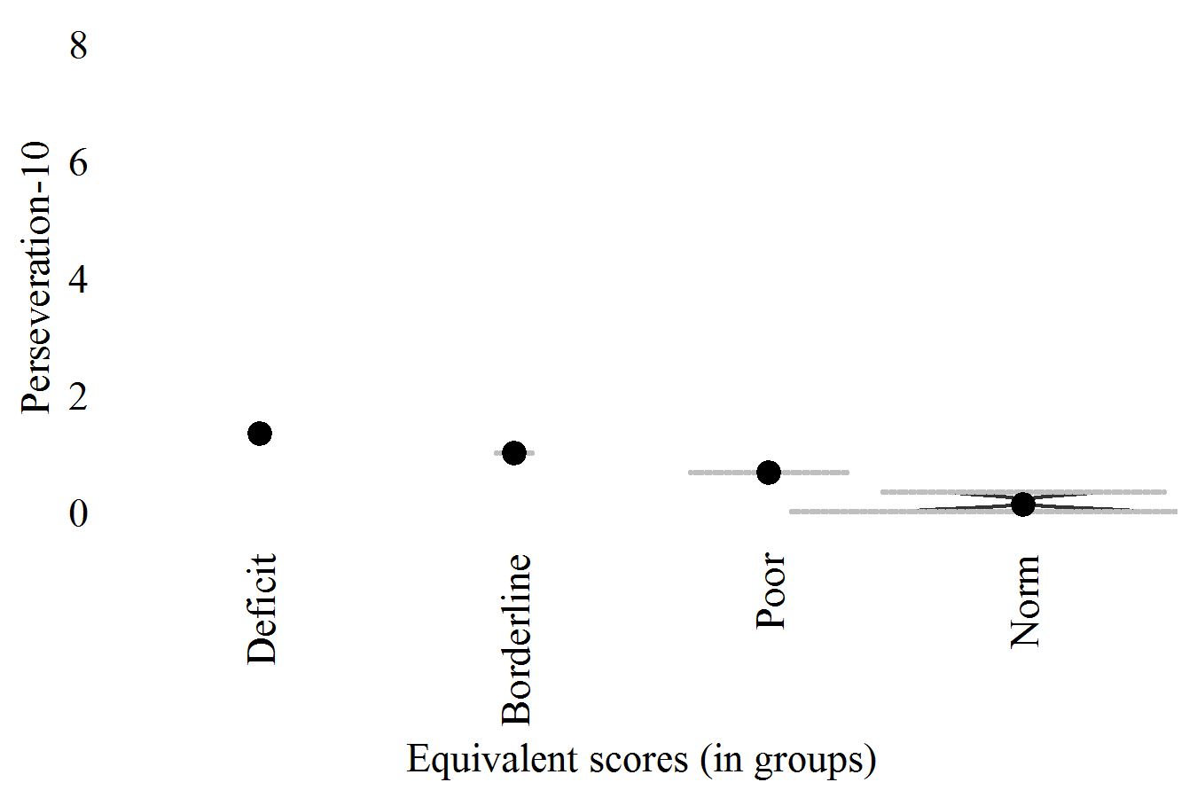

* 1. Score (DSST): "Reduced-Model"

Score [-110, +110]

In PRONIA-Portal: GDSST_Score_symbol_matchings

In data-sets: DSST_S

Corretion-formula:

"Score"  
 = 46.259  
 + ( -3.569 x "Sex (Male=1)" )  
 + ( -0.275 x "Age (years)" )  
 + ( 0.218 x "Estimate-IQ" )  
 + ( 1.321 x "Education (grade)" )  
 + ( -2.443 x "Italian" )

| **ES-Levels** | **Cut-off** |
| --- | --- |
| Deficit (<5%) | <51.22 |
| Borderline (<15%) | <55.95 |
| Poor (<25%) | <58.54 |
| Sub-optimal (<50%) | <64.49 |
| Norm (>=50%) | >=64.49 |

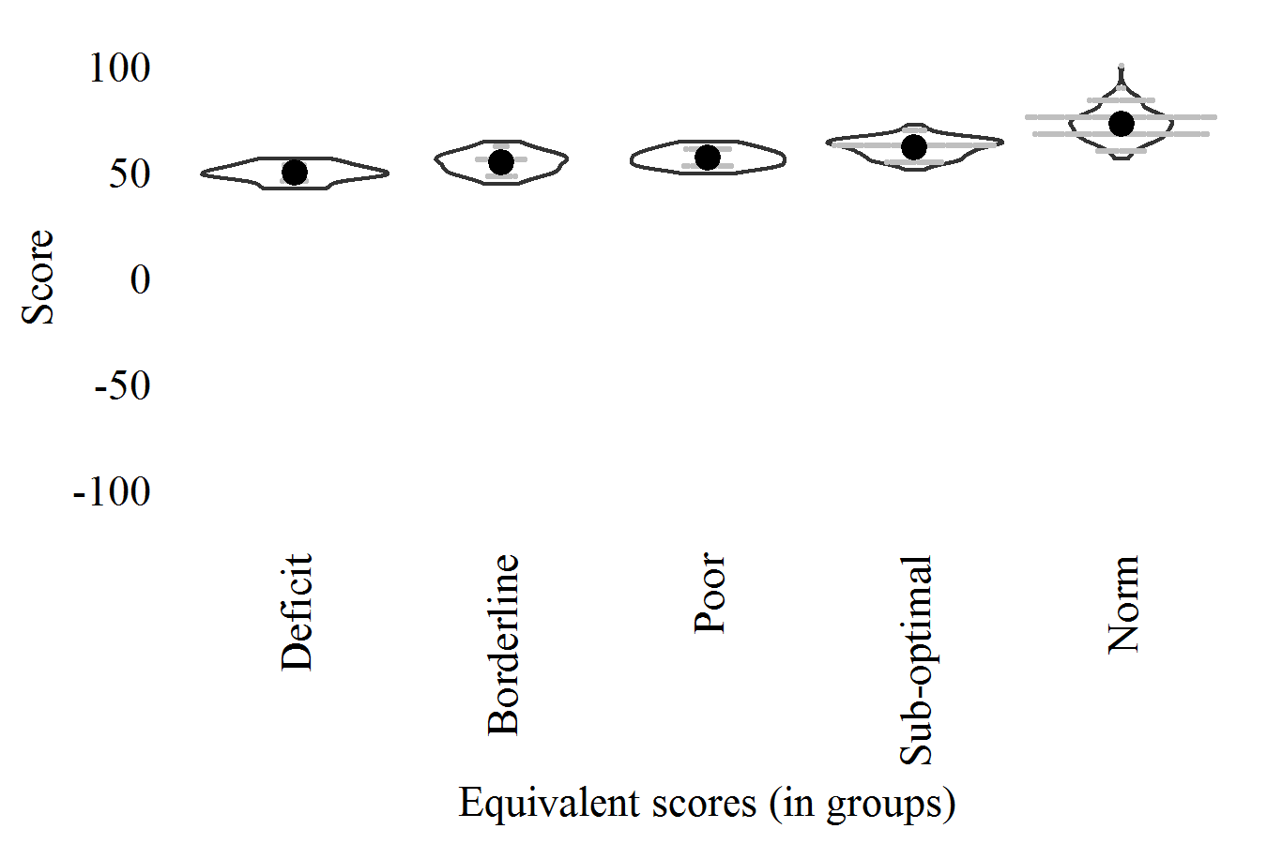

* 1. Ex-Adapt (SAT-SV): "Reduced-Model"

Explicit (VAS) adaptive salience [-100, 100]

In PRONIA-Portal: Calculated (not in PRONIA-Portal)

In data-sets: SAT_Explicit_adaptive_salience

Corretion-formula:

"Ex-Adapt"  
 = -1.427  
 + ( -0.913 x "Age (years)" )  
 + ( 0.502 x "Estimate-IQ" )  
 + ( 5.931 x "Education (grade)" )

| **ES-Levels** | **Cut-off** |
| --- | --- |
| Deficit (<5%) | <-1.34 |
| Borderline (<15%) | <14.18 |
| Poor (<25%) | <26.15 |
| Sub-optimal (<50%) | <47.31 |
| Norm (>=50%) | >=47.31 |

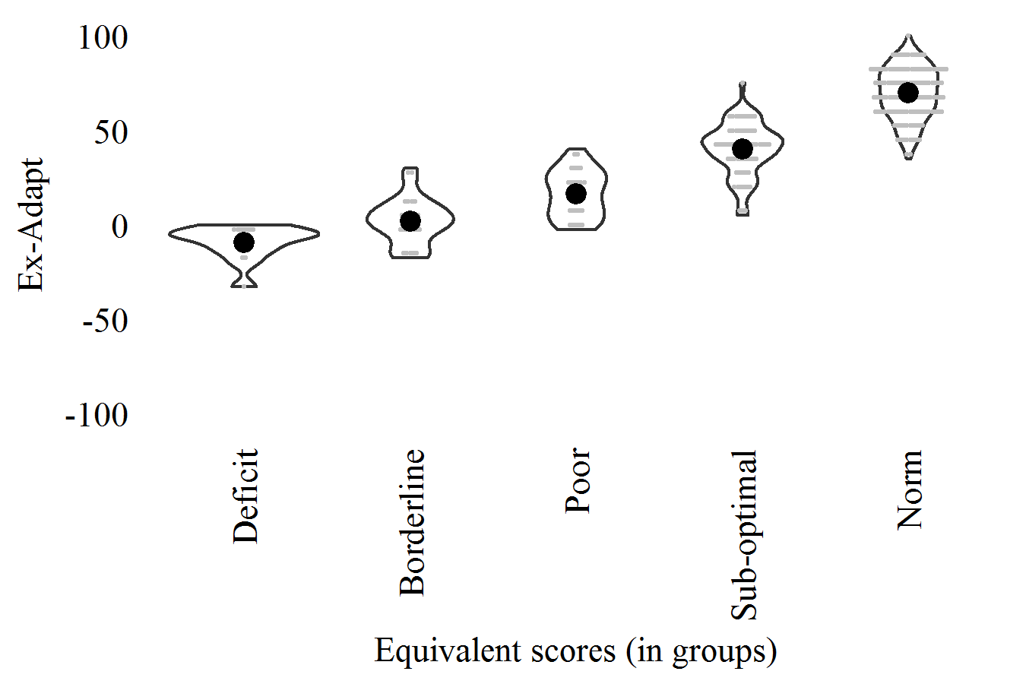

* 1. Ex-Aberr (SAT-SV): "0-Model"

Explicit (VAS) aberrant salience [-100, 100]

In PRONIA-Portal: Calculated (not in PRONIA-Portal)

In data-sets: SAT_Explicit_aberrant_salience

Corretion-formula:

"Ex-Aberr" (non-corrected)

| **ES-Levels** | **Cut-off** |
| --- | --- |
| Deficit (>95%) | >32.50 |
| Borderline (>85%) | >20.00 |
| Poor (>75%) | >17.50 |
| Sub-optimal (>50%) | > 7.50 |
| Norm (<=50%) | <= 7.50 |

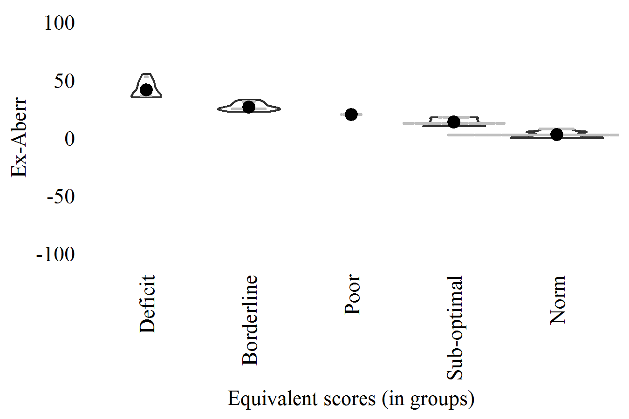

* 1. Im-Adapt (SAT-SV): "0-Model"

Implicit (RT) adaptive salience [differences in z-scores]

In PRONIA-Portal: Calculated (not in PRONIA-Portal)

In data-sets: SAT_Implicit_adaptive_salience

Corretion-formula:

"Im-Adapt" (non-corrected)

| **ES-Levels** | **Cut-off** |
| --- | --- |
| Deficit (<5%) | <-0.26 |
| Borderline (<15%) | <-0.14 |
| Poor (<25%) | <-0.08 |
| Sub-optimal (<50%) | < 0.00 |
| Norm (>=50%) | >= 0.00 |

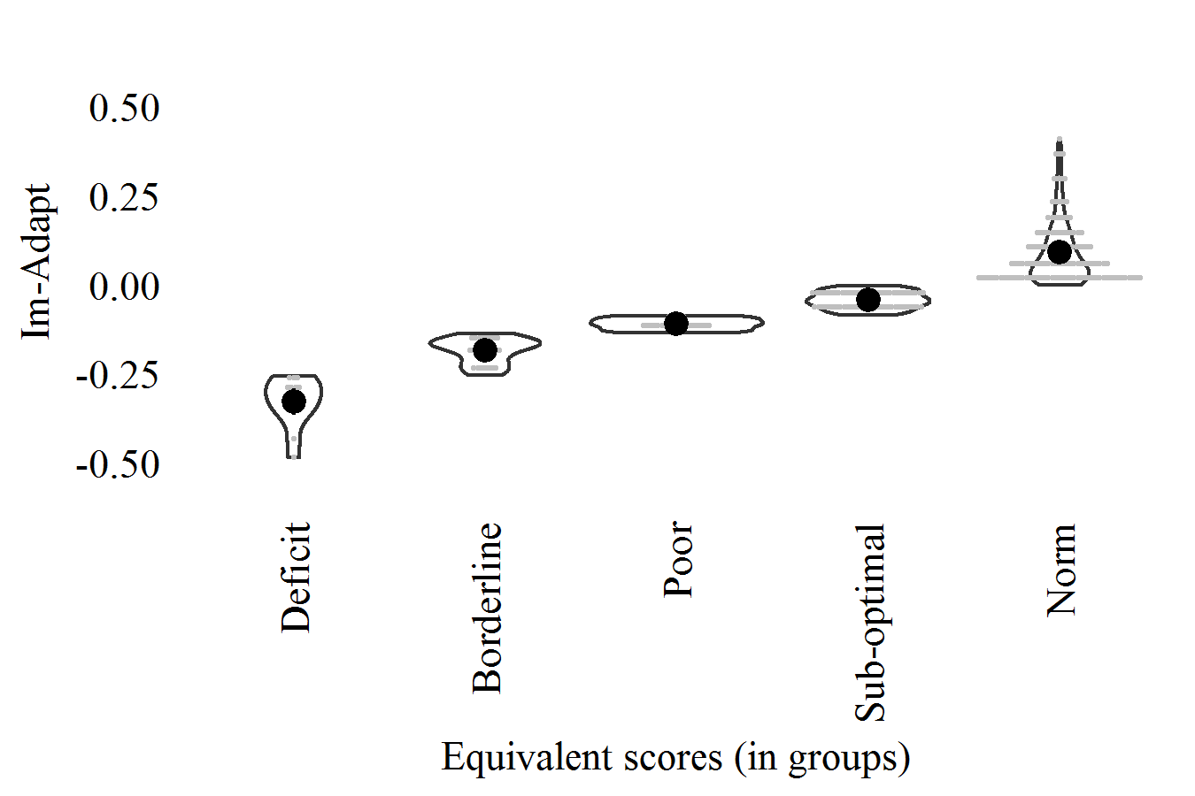

* 1. Im-Aberr (SAT-SV): "0-Model"

Implicit (RT) aberrant salience [differences in z-scores]

In PRONIA-Portal: Calculated (not in PRONIA-Portal)

In data-sets: SAT_Implicit_aberrant_salience

Corretion-formula:

"Im-Aberr" (non-corrected)

| **ES-Levels** | **Cut-off** |
| --- | --- |
| Deficit (>95%) | >0.32 |
| Borderline (>85%) | >0.19 |
| Poor (>75%) | >0.14 |
| Sub-optimal (>50%) | >0.07 |
| Norm (<=50%) | <=0.07 |

