**Preface

Since user guides tend to be boring to write and then boring to read, we've tried to have fun writing this one and hopefully you'll have also fun reading it, in between you'll discover how Deepamehta works!

**Introduction

Let's play a short game, look to your right for 10 seconds, then write down what you remember with as many details as possible.
Probably you will remember an image and then try to describe it. We draw upon our visual memory to fix information, then we probably establish some references, top-right, bottom, etc .. we divide the information into smaller pieces and create the relation between them. Our brain keeps building maps of information, we extract the important info let's says they are the "dots" in our map, and we establish relations, the lines in our map. Knowledge is not stored in our brain as thousands of full pages of text, but as concepts and relationships between them, so that when we want to retrieve information we recreate the situation, by bringing up just the concepts and relationships needed.

** The situation
If we think DM as a whole of situations, then the best way to start would be to create a first situation.
Let's imagine we've got an appointment with some friends to talk about a possible business, normally you would take somewhow structure notes, with some side notations that come up later.
So the notes taken look like this:

Marina(Barcelona) is doing a project with the neighbourhood organization AAVVB
Participants: Marina, the group XXX from the University UOA, Pep and Rosa
The goal: Map the changes in the neighborhood in the last decades
How: Going for a walk around the neighborhood with old people
At the end of the walk photos will be taken and uploaded and associated to their location in a map on the website
Maybe there is a possibility to create a collaborative project with a neighborhood in Berlin
The project will last for one year

Let's proceed -- In the guide we won't cover the installation process, because that is already very good explained in the README file [https://github.com/jri/deepamehta#readme]. Here we will just remind you the way to start DM, it depends on your platform

deepamehta-linux.sh # if you are under a GNU/Linux system choose "Run in terminal"
deepamehta-macosx.command # if you are under MacOS double-click it
deepamehta-windows.bat # if you are under Windows double-click it

So now you should be seeing this

[dm_1.png]

Now in order to get things done we need to log in, so click on the login link and introduce "admin" as user and leave the password blank. To dive better in DM, a suggestion is to set your browser to full screen, so you enter in DM mode ;-)

On the top menu you'll see a Create drop menu. If you take a look at what there is, you will see that by default it appears "Person", "Institution", "Notes", "Web Resource" ..mmm actually probably for the moment that is enough to write down our notes from the meeting in a DM way.

From there we can create 3 Person, Marina, Pep and Rosa

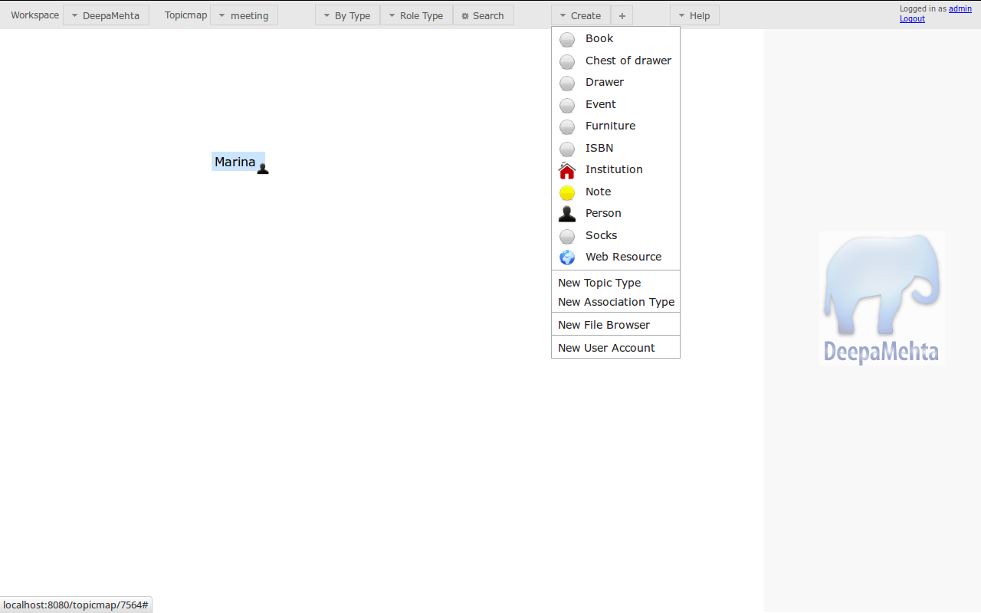
[dm2_example01.png]

[dm2_example02.png]

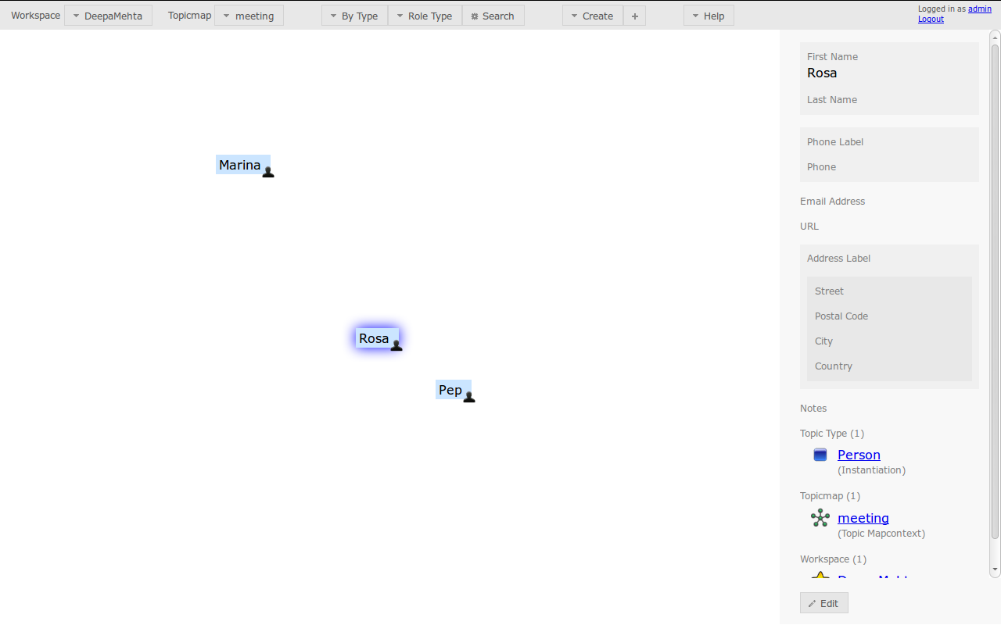

We can create 2 Institutions, AAVVB, University UOA

[dm2_example04.png]

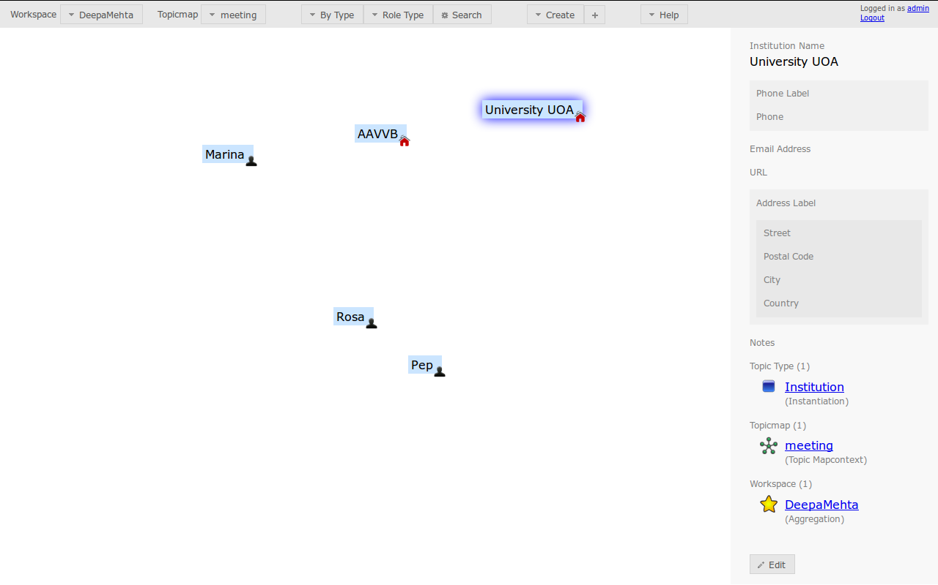
We can create a note with the name of the group from the University

[dm2_example05.png]

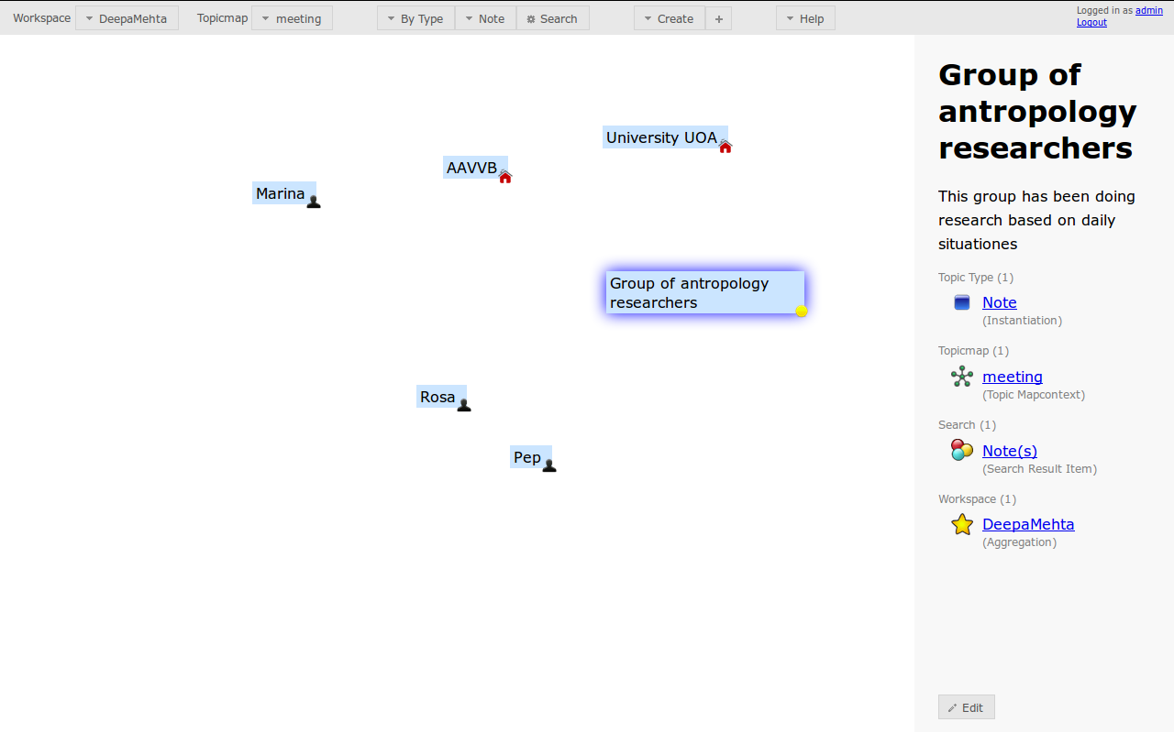

Now that we have the main elements on our left panel, the Topicmap, let's see what are the relations between them.

Until now, we have drawn 3 Persons, 2 Institutions, 1 Note which in DM language would be 6 Topics
Now we want to establish the relations between the Topics, and in DM language the relations are called associations.

Marina, Pep and Rosa work together, so we could say that Marina works with Rosa and Marina works with Pep, and in the same way could we do with Rosa and Pep.
If you right click on Marina, a menu will display and you will see the "Associate" option, click on it.

[dm2_example06.png]

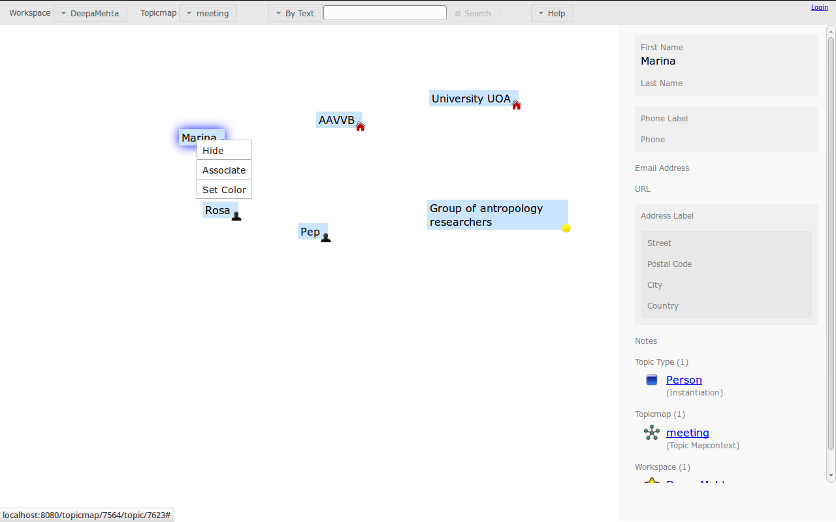

A line will appear, drag it to Rosa so an association is created. So now Marina is associated with Rosa.

[dm2_example07.png]

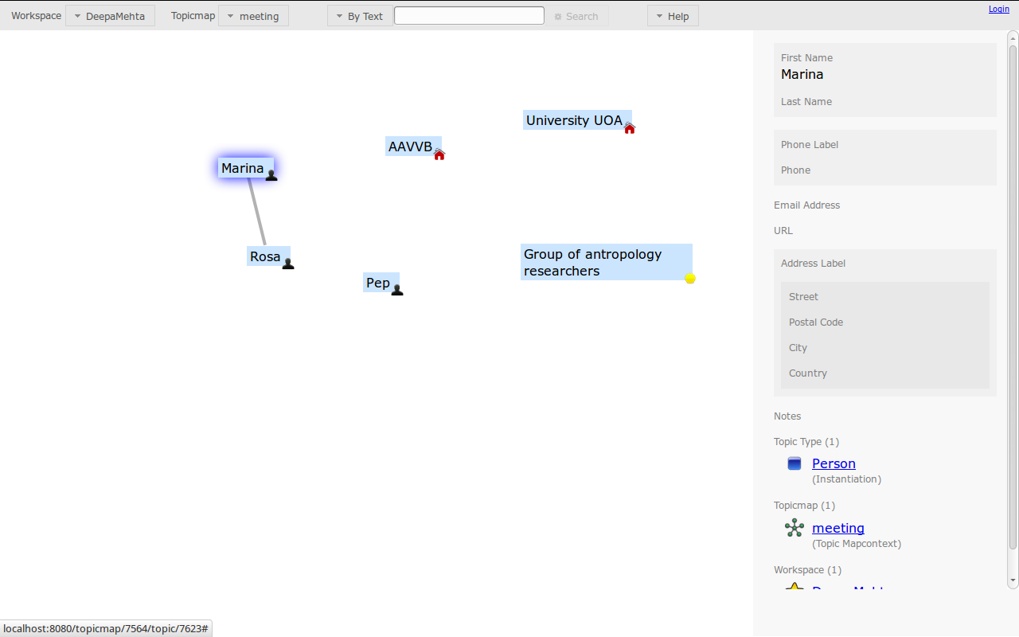

We repeat the same process to create the Relation between Marina and Pep, and Rosa and Pep. Now the three of them are connected.

[dm2_example08.png]
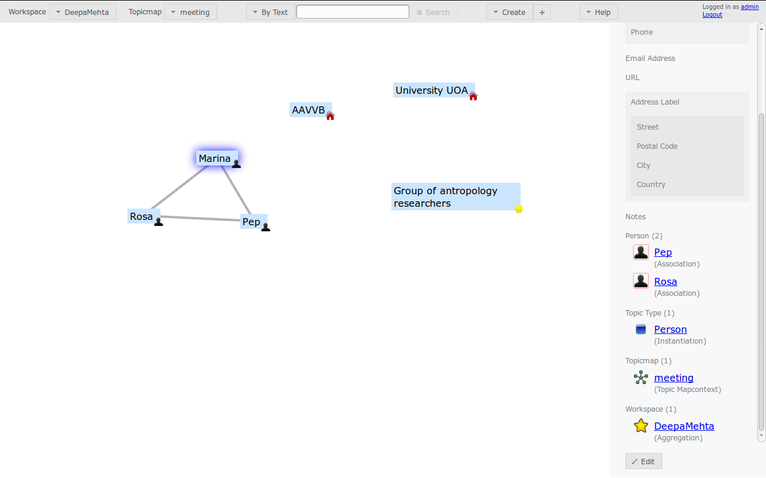

Another cool thing we can do, is to name the association, because associations are also editable, let's do it in a descriptive way, and write "works with".

[dm2_example09.png]

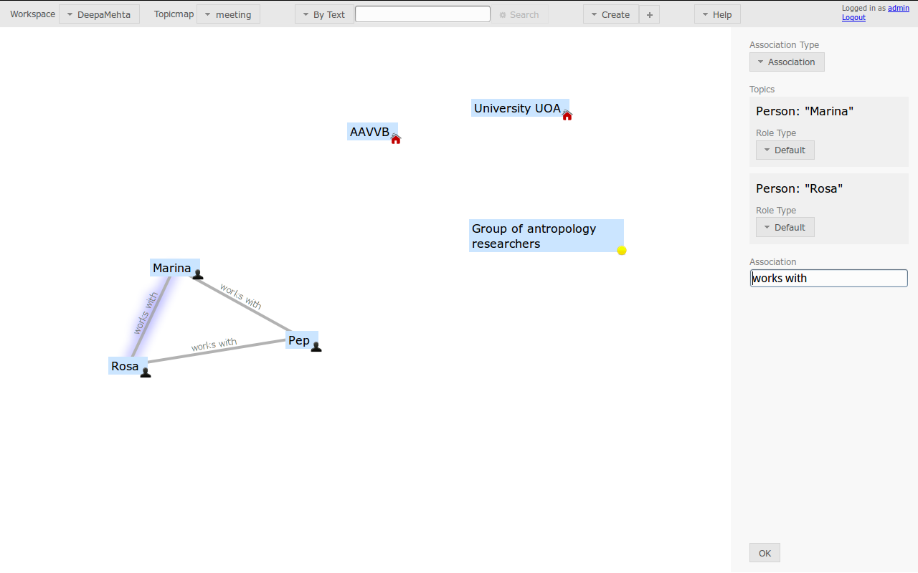

You can edit each of the other associations, to also name it.

*Tip*
If you double click on the Associations or the Topics they will become editable

Now let's create the associations between the Note "Group of researchers" and Person Pep and Person Rosa

[dm2_example10.png]
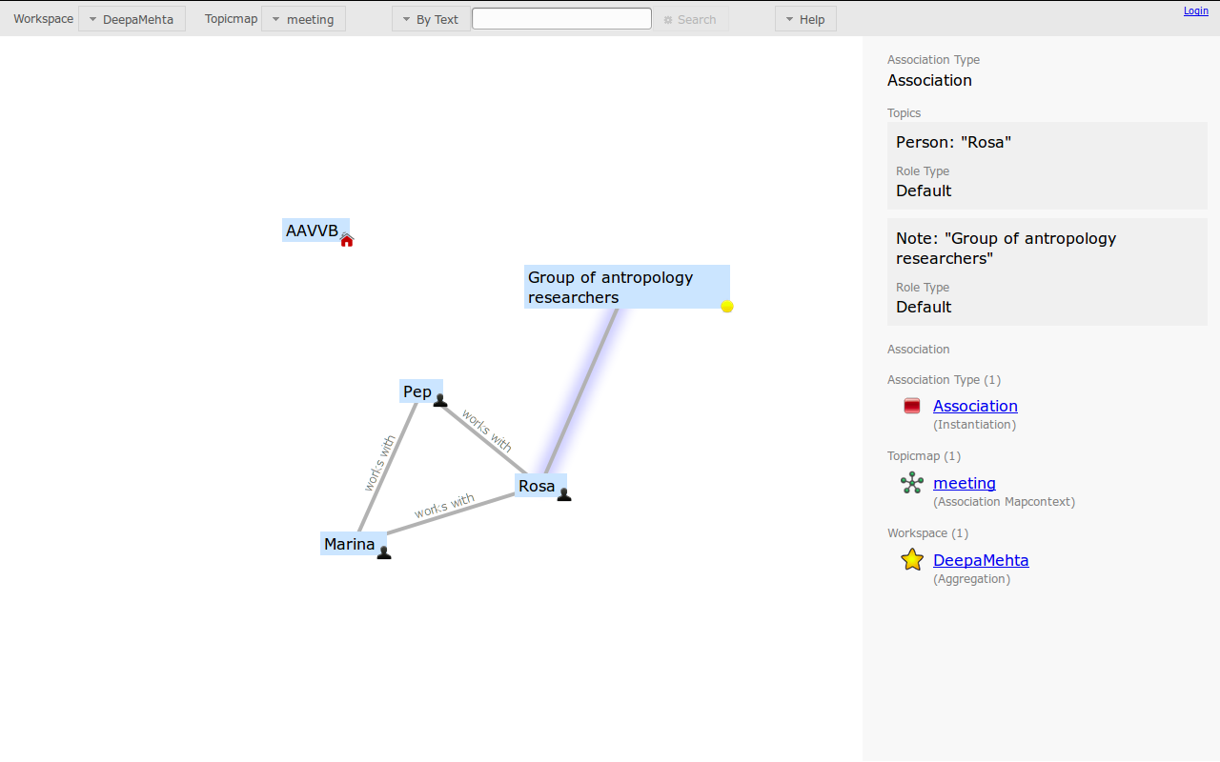

But we know that the Group of researchers belong to the UOA University, so we can also establish the association between them, and name it, for example, isParOf, since the Group of researchers is part of the University.

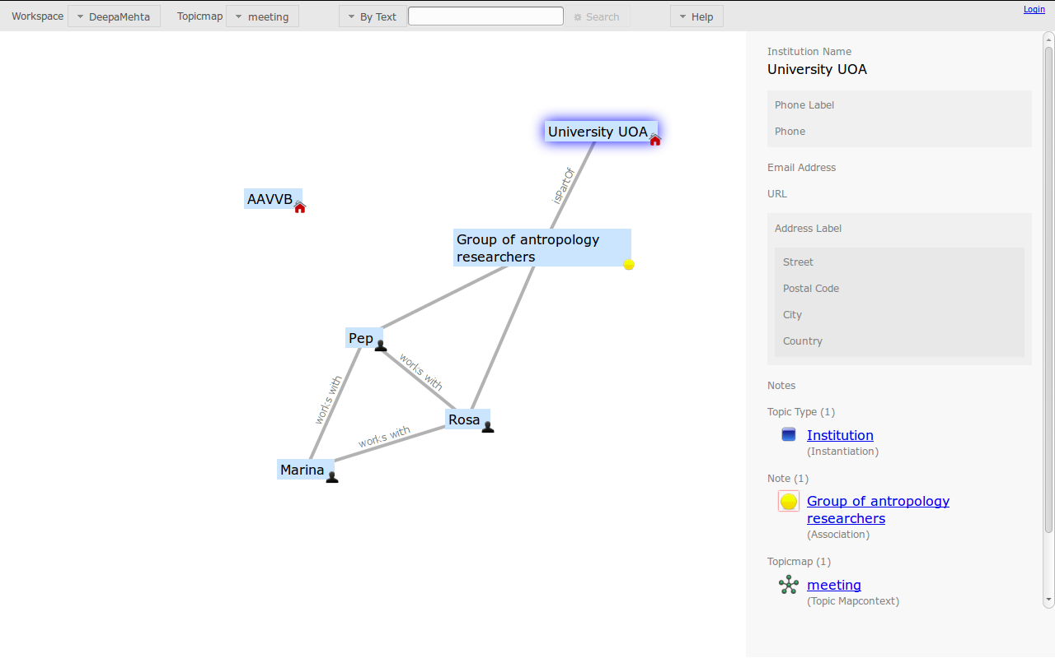
[dm2_example12.png]

Now that we've been doing things, lets stop and put certain names to those things.

The screen is divided in three parts,
a toolbar at the top,
a left panel that is called Topicmap Panel, there you have the Topics and Associations
a right panel that is called Detail Panel and shows the details about the item currently selected

Let's have a feeling of we can see in the Detail Panel. If we click on the Note "Group of researchers", on the Detail Panel we can see on top we have a block of information that is the Name and the Description of the Note, below we can see that the Note is associated with other topics in the DM world, we'll go in detail later.

[dm2_example11.png]
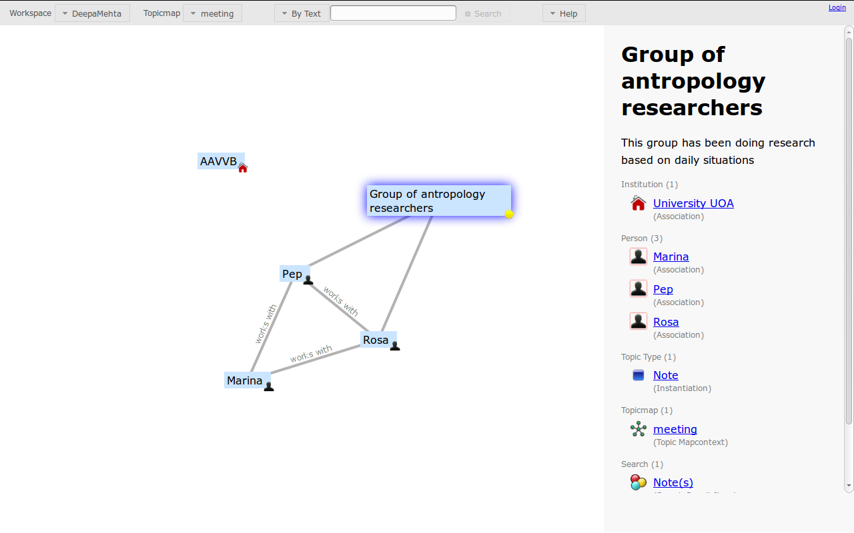

No need to retain all this information, is just a first introduction to the information that appears in the Detail Panel, so let's do a break, get a cup of tea and back in a few minutes

Tea time!!!
[cup_of_tea_bagieu-bio.jpg]


Feeling better now, right? Ok, next thing we want to create is the project, how is related to the people and the web resource where we can find more information.

Probably you main area in the left panel is quite full, but if you click on it and drag it, it will move :)

*Tip*
If you want to move the canvas, so that you can see better the topic map, you just have to click on the canvas and drag it untill you locate the topic map where you want.
You can resize the Panels. You just need to put the mouse on the border between the two panels and when appears (put here the icon) just drag the panel to the size you want.

Once we've situated the canvas, we create another Note. We call it "Tornaralloc", the name of the project.

[dm2_example13.png]
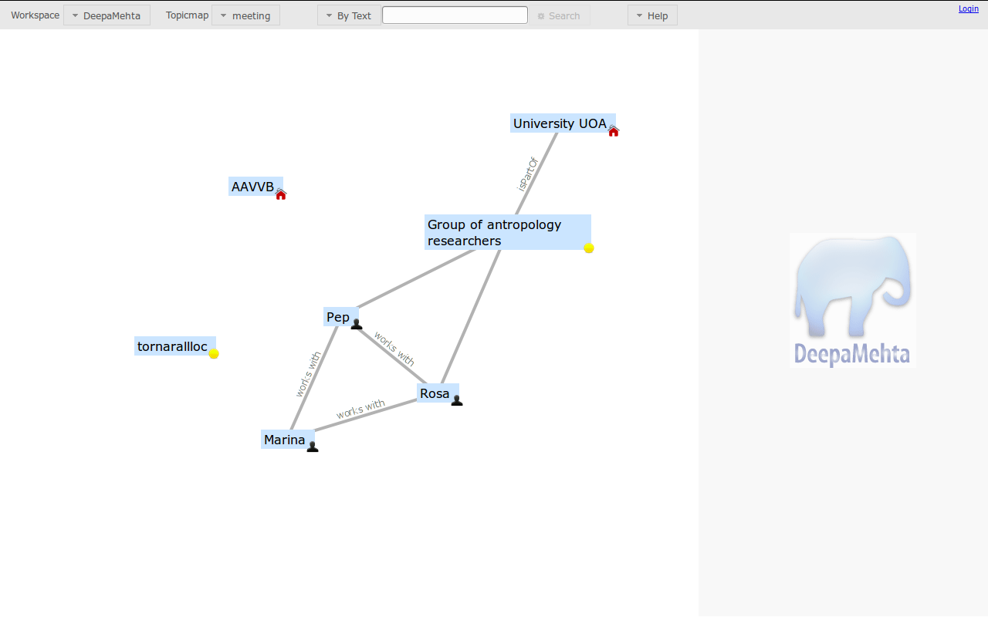

Next we associate it to Marina, we wil call the association "An idea of"

[dm2_example16.png]
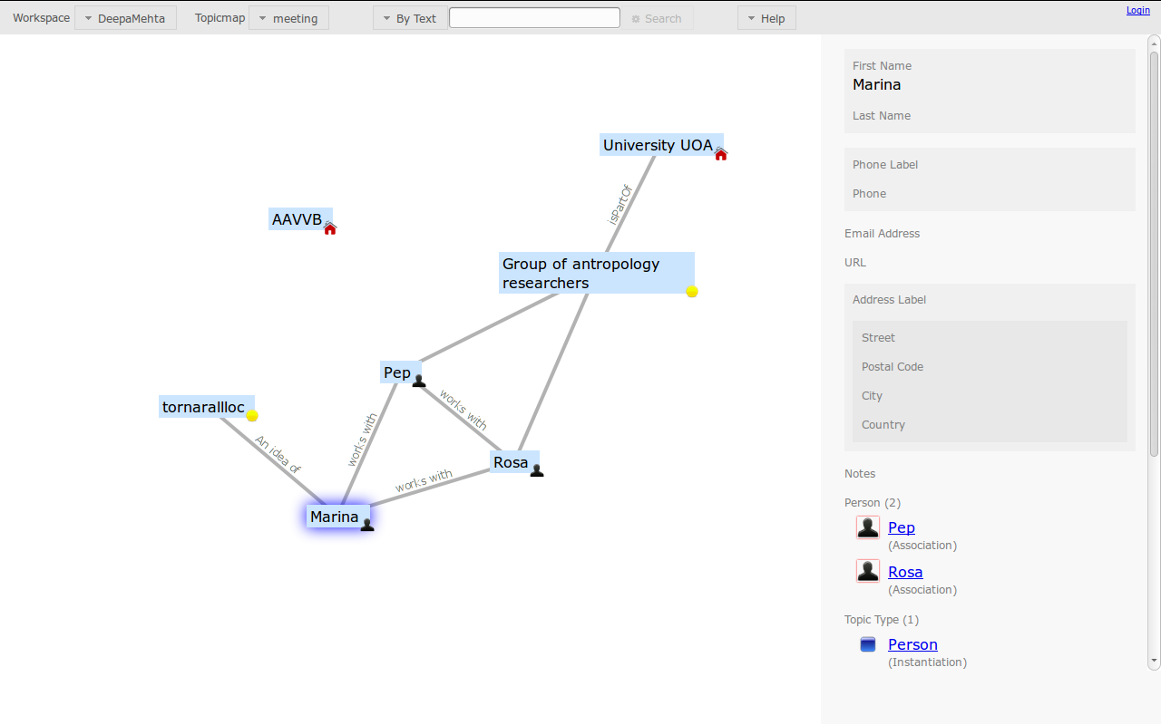

Next go to the Create menu in the toolbar and select Web resource, and we write the URL of the project

[dm2_example17.png]
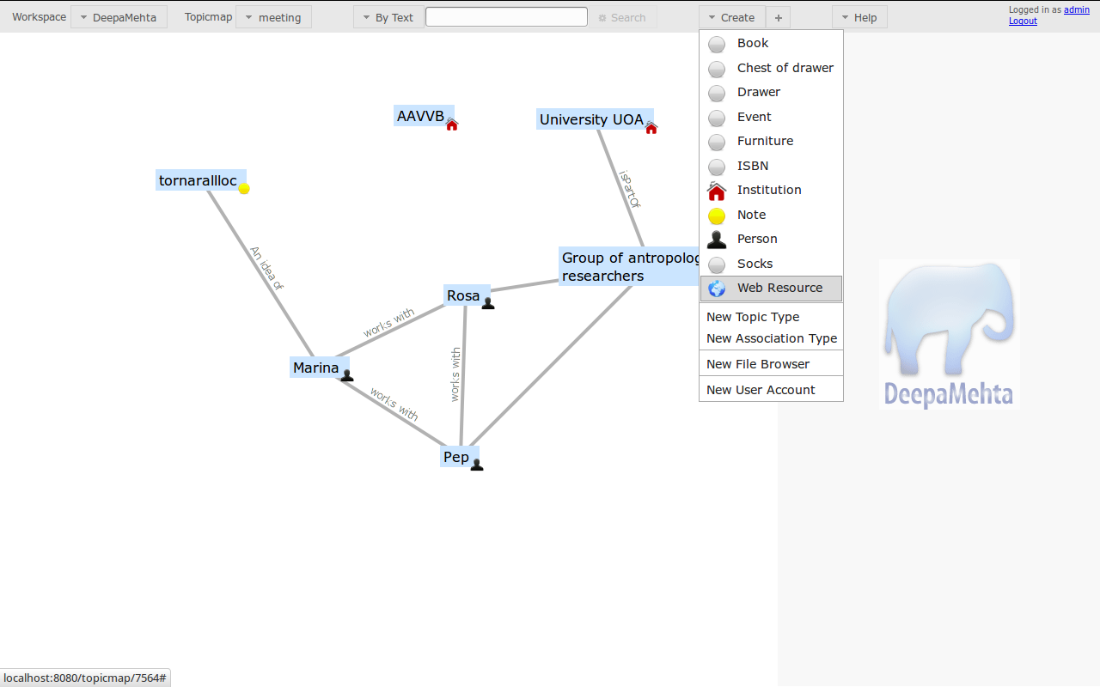
Now we have a webresource associated to the project

[dm2_example18.png]

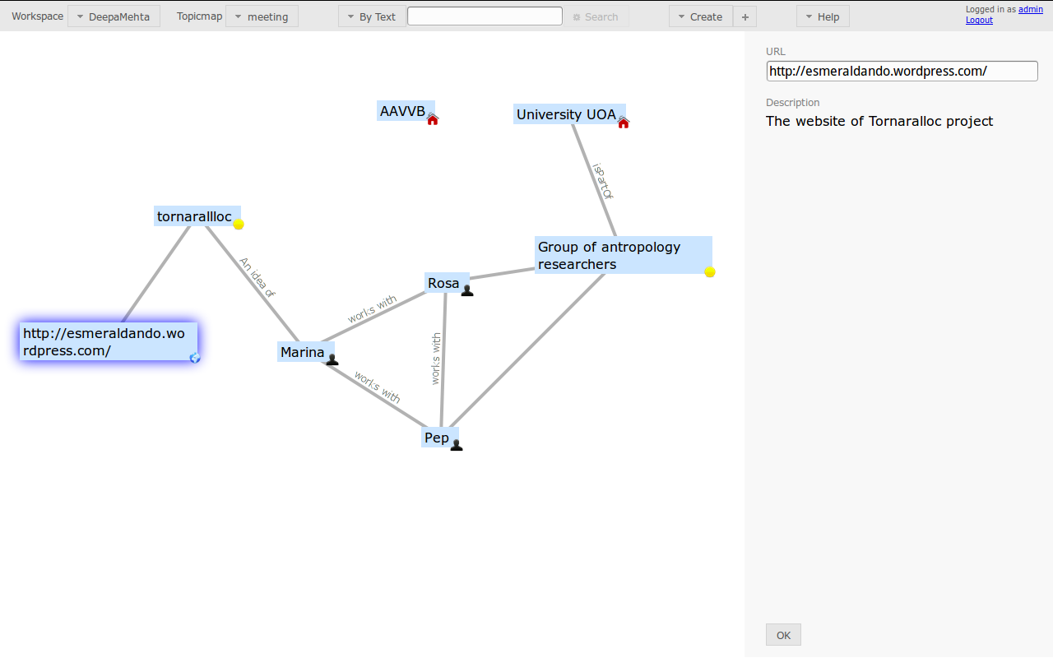
We still have not defined the relation between AAVVB with the project. The AAVVB would be institution that will finance the project.

[dm2_example19.png]

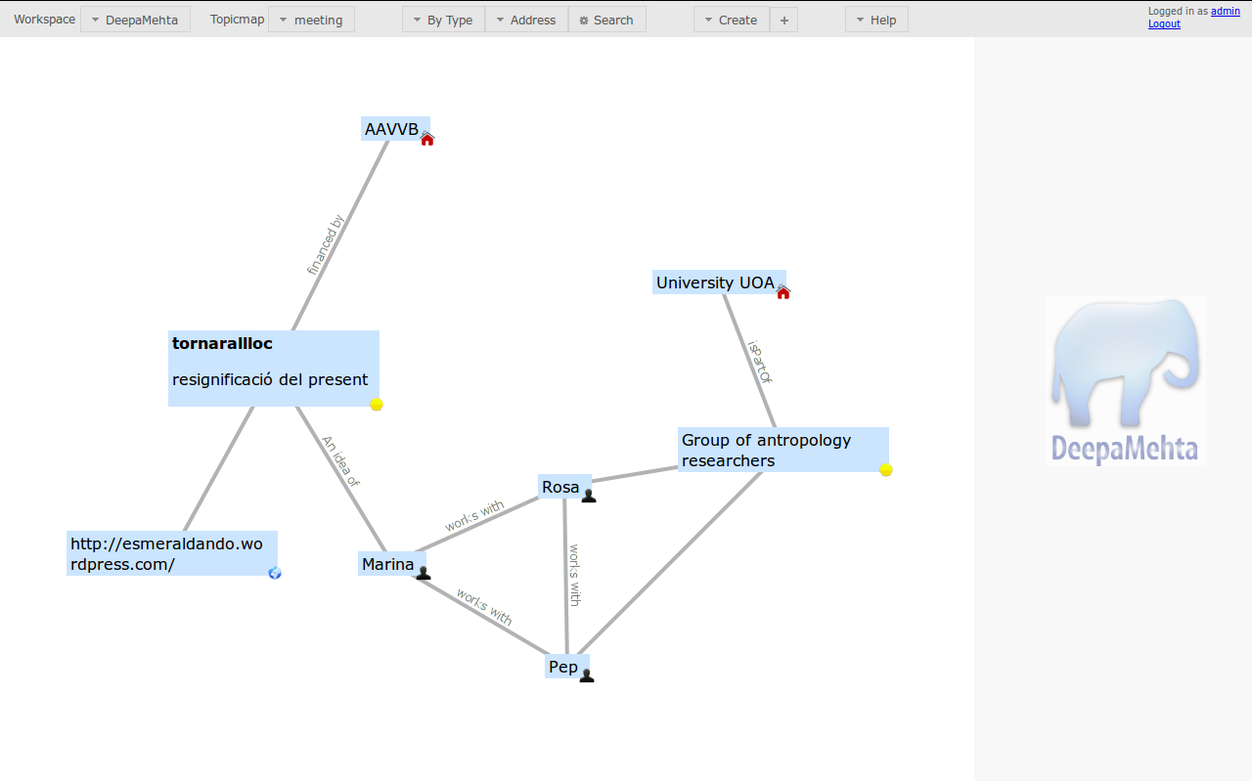

Ok, now we have a map of the people and institutions involved in the project, and what are their roles in it.

The next thing we want to do, is actually define what will the project consist on. That is a bit different thing, so we need to start from scratch, from a clean screen, so to do that in DM we will create a new Topicmap.

Go to the toolbar menu, click on Topicmap, a drop down will be displayed, click on "New Topicmap", we will call it "tornarallloc"

[dm2_example20.png]

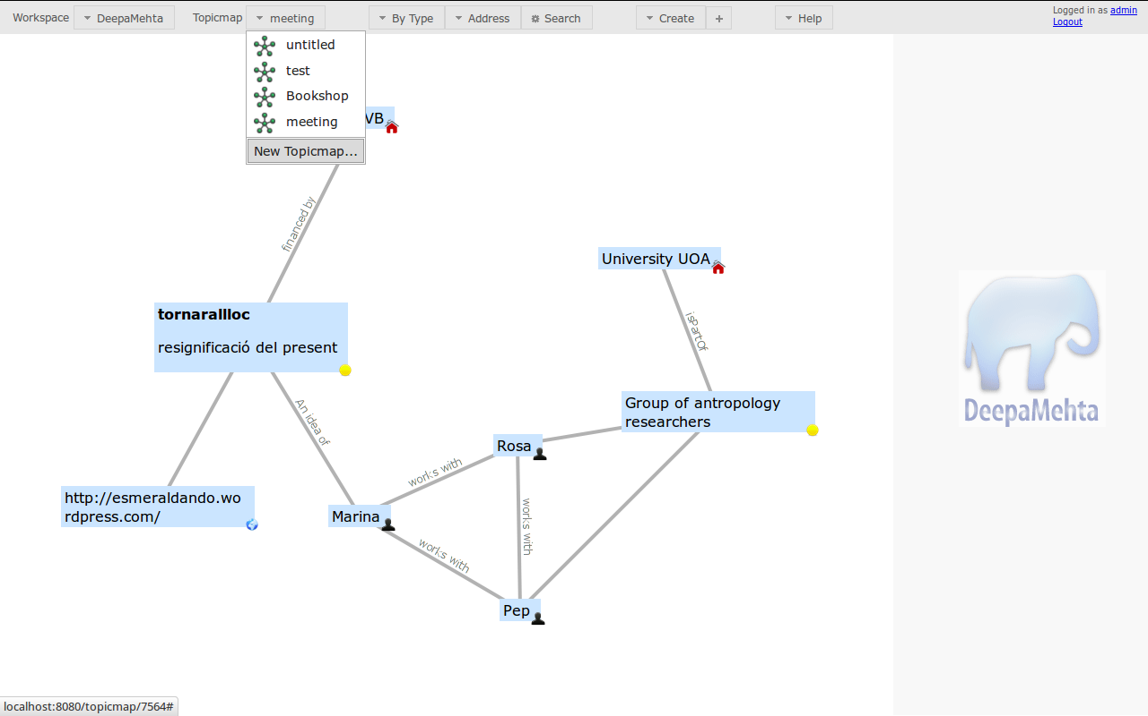
You will a brand new screen

[dm2_example27.png]

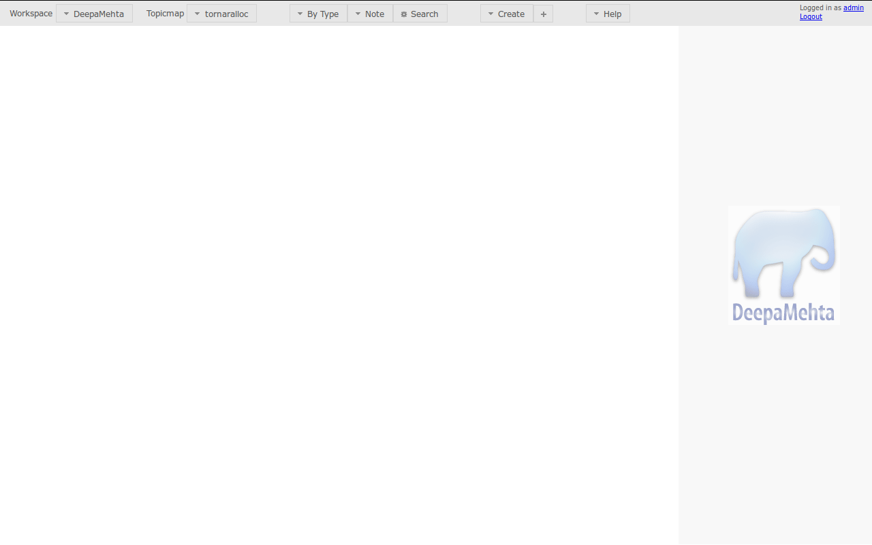

But one of the great things in DM is that, when creating a new Topicmap you still have all the previous topics created available :-)
so let's recover them!

We want to recover the Note "tornarallloc" and the reference to its web resource. Let's stop a moment and introduce a new concept, "Type". Until now, we've been talking about Topics. Topic is a generic idea, adding the "Type" means defining exactly what it is, specifying its properties. In the case of Note these are "Name" and "Text". So Topic Type Note would be a Topic defined by a Name and a Text.

Why we do need to know this, we were at the point of trying to bring back "tornallloc" Note to our new Topicmap, so on the top toolbar menu, you have a search option, you can search by Text or by Type. We are going to search by Type, now we know that are Note is a Topic Type Note, so

[dm2_example26.png]

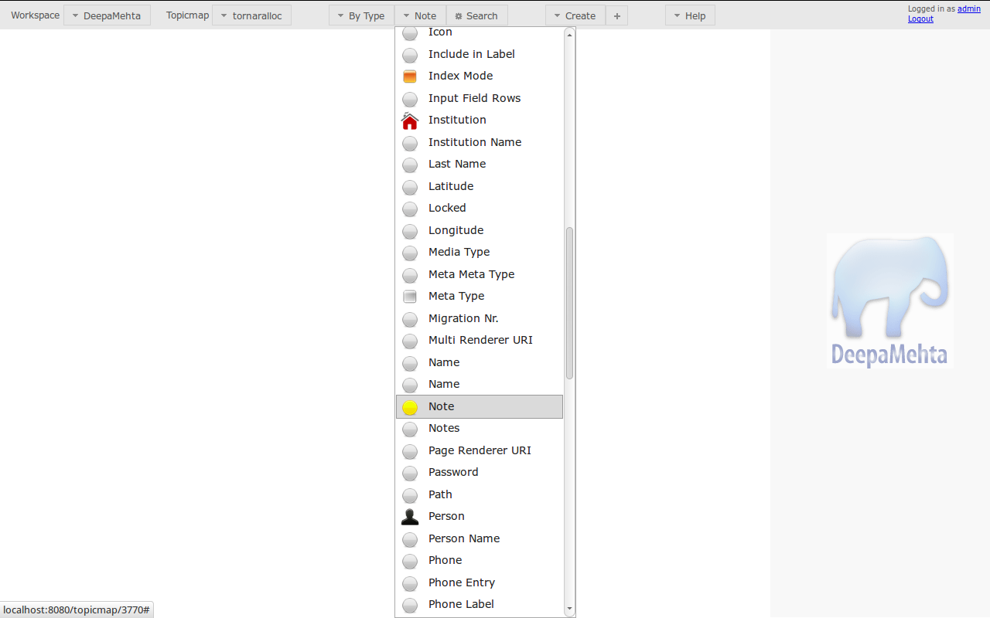

And what will see after is

[dm2_example21.png]

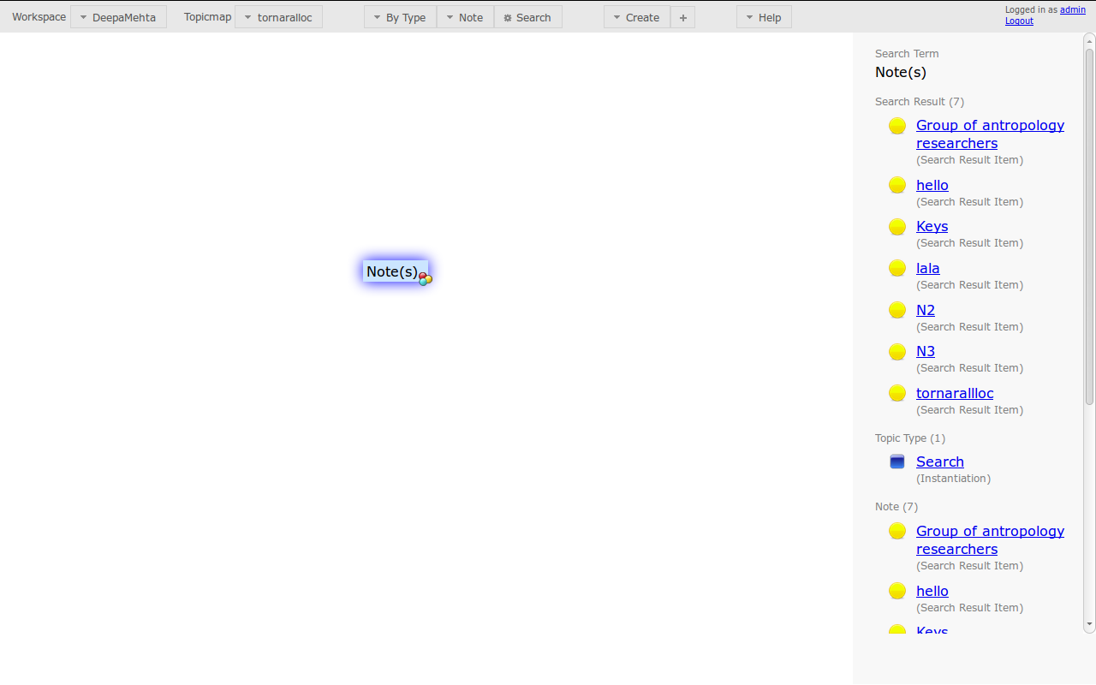

Now look at the Detail Panel, you will see all the Notes that have been created on your DM world. Look for "tornarllloc" Note on the Detail Panel, click on it and then it will appear in your brand new Topicmap :-)

[dm2_example22.png]

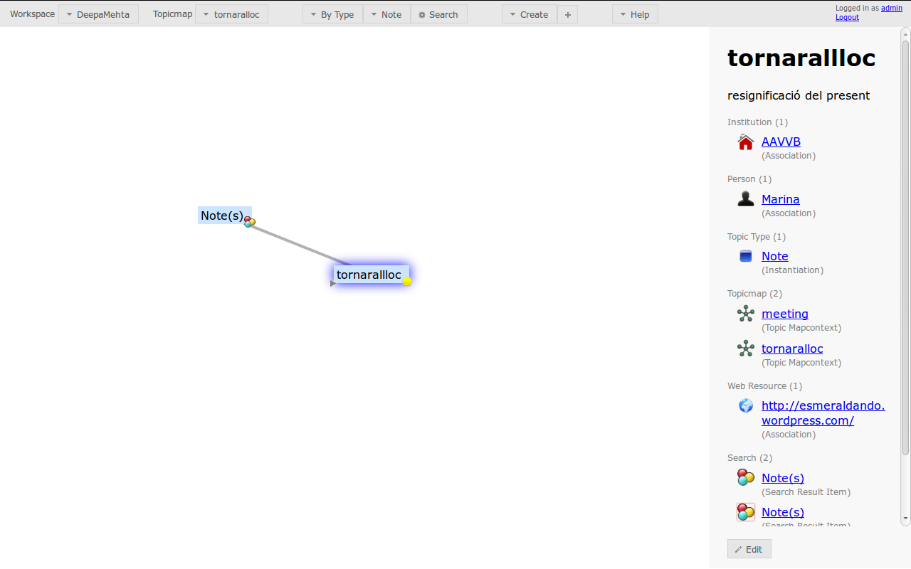

If you want to show in the Topicmap, any of the info associated with the Note "tornarallloc", just take a look at the Detail Panel, and for example, let's recover the Webresource, click where says Webresource and hop!! the URL of tornarallloc website will be shown on your Topicmap.

[dm2_example23.png]

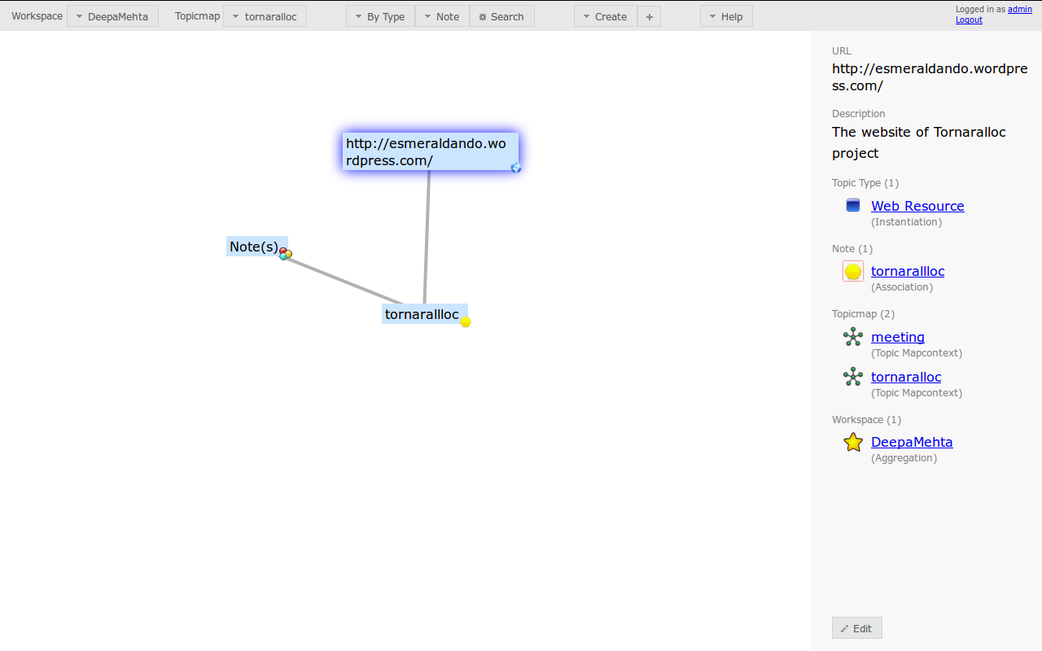

Probably you've noticed that you still see your search "Note(s)" but is not really something that interests us to see, so let's hide it :). DM let's you hide and show Topics and Associations at any moment.

Right click on the Topic "Note(s)" and click on Hide. Hidding the Topic will hide also the Association. If at some point you want to see the Topic Type but not the Association, you can right click on the association, click hide and then just the association will be hidden.

[dm2_example24.png]

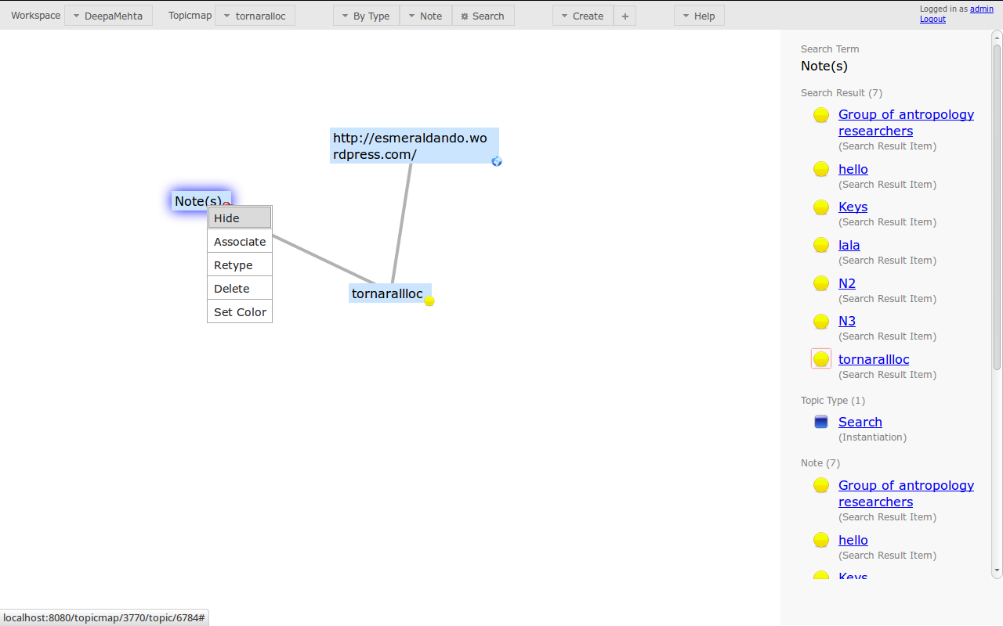

So by now, your new Topicmap will just show the Note "tornarallloc" and the webResource associated to it, which is the URL of its website.

[dm2_example25.png]

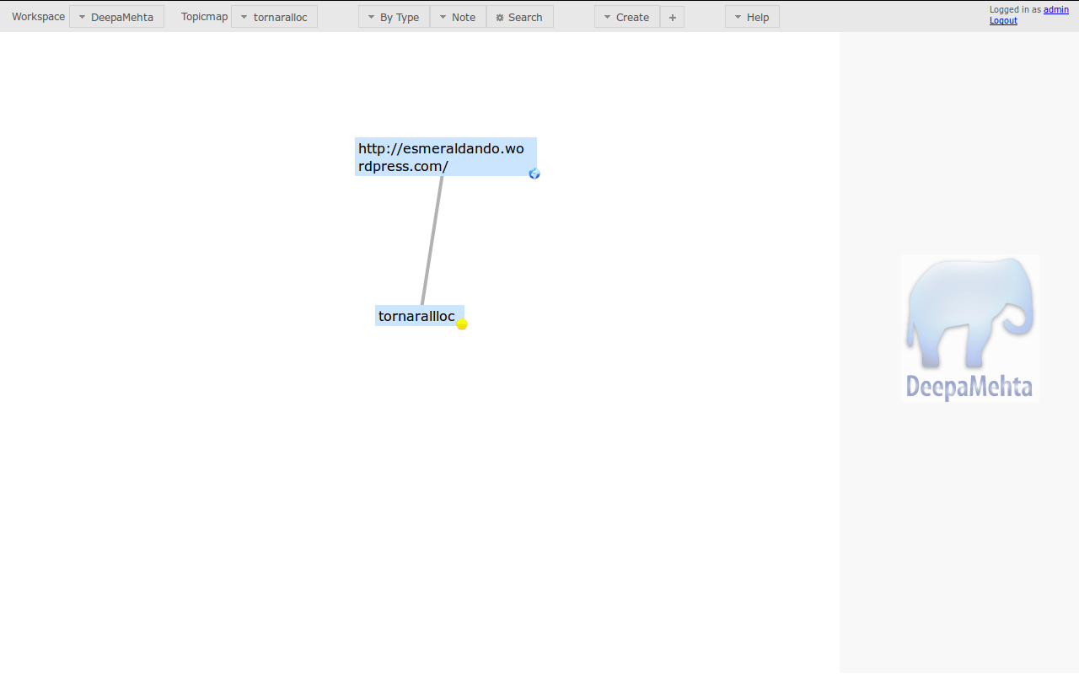

We've done quite a lot of things, so Tea time!!!
[cup_of_tea_bagieu-bio.jpg]

