Ministerul Educației și Cercetării al Republicii Moldova
Universitatea Tehnică a Moldovei
Facultatea Calculatoare, Informatică și Microelectronică

Raport
la
Lucrarea de laborator Nr. 2

Disciplina: Tehnici de programare

Tema: ” pwn.college”

A efectuat : st. gr.SI – Malai Carolina

A verificat : asistent universitar – Reitman Patricia

Chișinău – 2026

SARCINA LUCRĂRII
Flag 1. Try it now: launch the terminal, copy the flag (drag-selecting it with your mouse will automatically copy it to your clipboard), and paste it into the Flag textbox below!
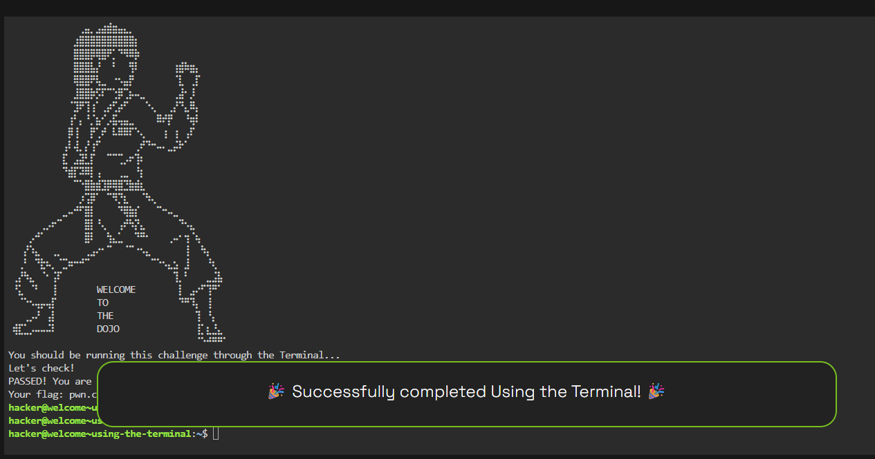
Flag 2 You can use the workspace selector on the bar below the Terminal (e.g., the button that says "Terminal") to select "Code" and bring up the Visual Studio Code interface in place of the terminal. Again, you can use it as-is, or you can click the "fullscreen" button (⛶) to full-screen the interface for more room.
Once VSCode loads, launch a terminal (press Control-Shift-Backtick or click the ☰ button in VSCode's left panel, and select the Terminal menu, and click New Terminal). When we detect that you have launched the terminal in VSCode, we will give you the flag!

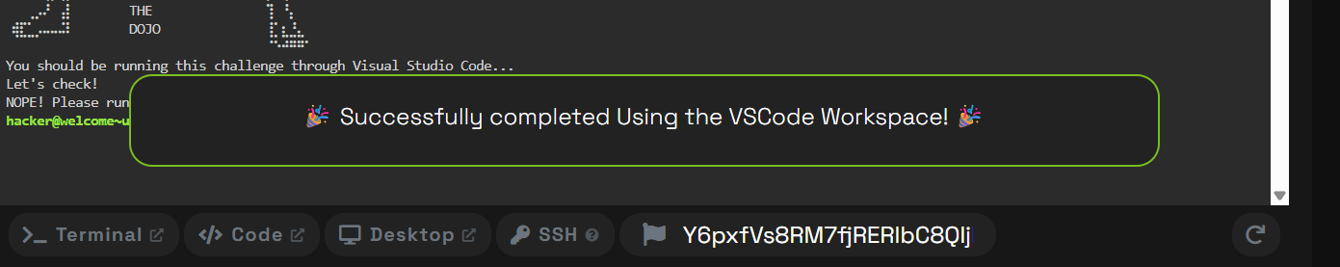

Flag 3
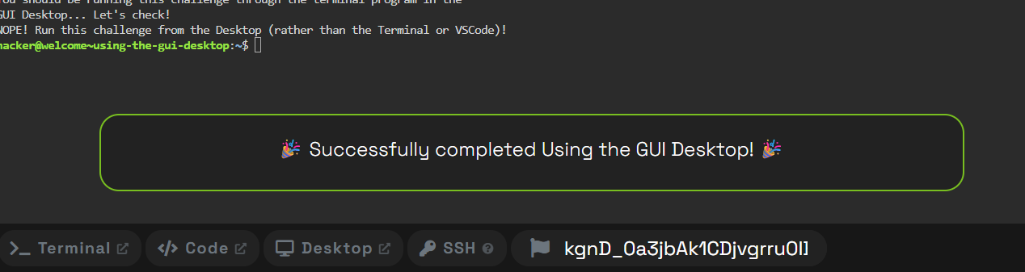
Flag 4
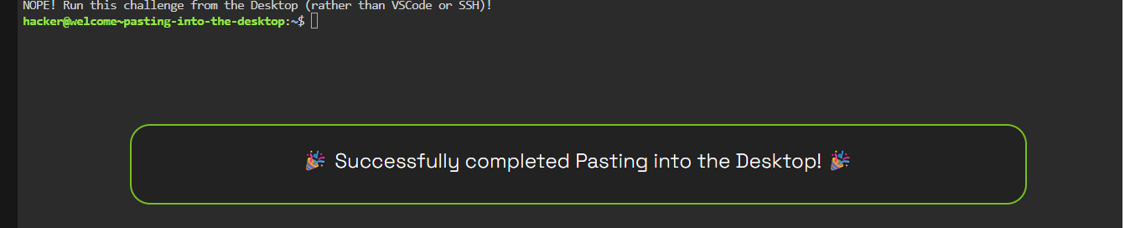
Flag 5
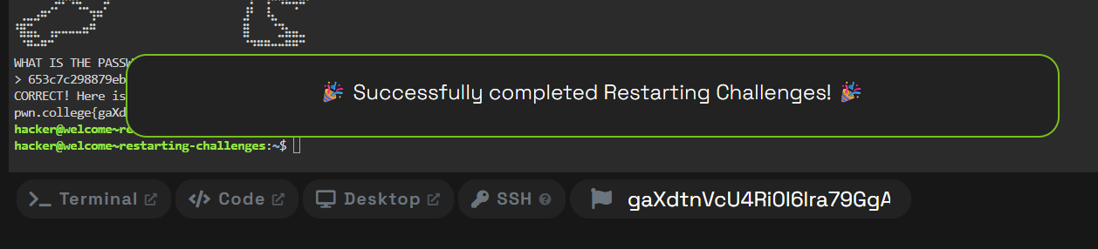

Flag 6
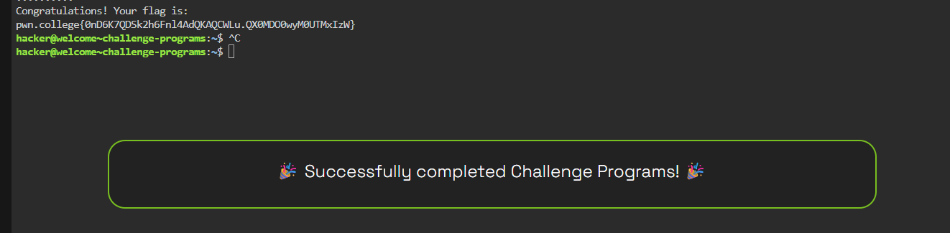
Flag 7
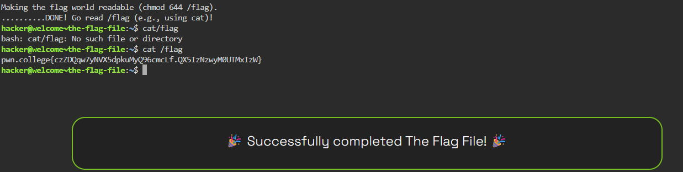

Flag 8

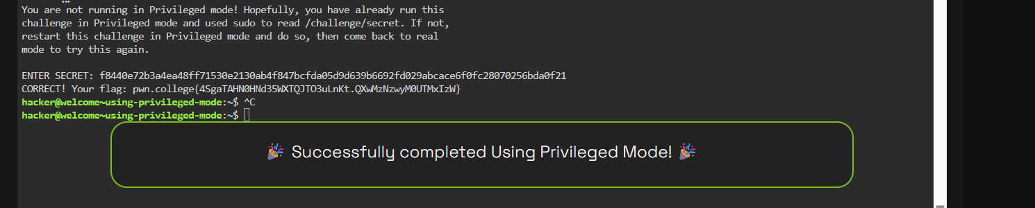

Flag 9
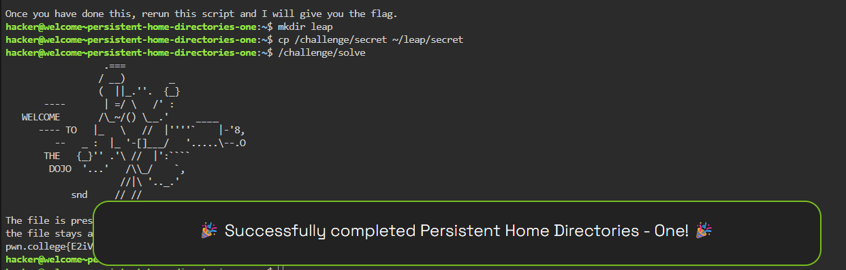
Flag 10
