Week 5

I created a 100 proteins dataset that is representative of my whole dataset in terms of number of proteins containing signal peptides. Knowing that 38% of my huge dataset have a signal peptide, I randomly choose 38 proteins with signal peptide and 62 proteins without (only Gs).
Optimization of the predictor:
Window size is 31 all the time. I decide this size because now my proteins are 70 aa long, and it’s half. I obtain better results with a higher window size but for me it makes no sense to have a window size bigger than half the length of the protein.
100 aa data

1- KERNELS
Linear SVC
Accuracy: 0.95 (+/- 0.02) svm.LinearSVC, class_weight=balanced
Train_test_split score: 0.945
precision recall f1-score support

1 0.98 0.96 0.97 1231
2 0.74 0.85 0.79 169

avg / total 0.95 0.94 0.95 1400

[[1180 51]
[ 26 143]]
linear kernel
Accuracy: 0.95 (+/- 0.02)C=1.0, kernel=linear, class_weight=balanced
Train_test_split score: 0.947857142857
precision recall f1-score support

1 0.98 0.96 0.97 1231
2 0.76 0.84 0.80 169

avg / total 0.95 0.95 0.95 1400

[[1185 46]
[ 27 142]]
rbf kernel
clf=svm.SVC(C=1.0, kernel='rbf', class_weight='balanced', decision_function_shape='ovr')

Accuracy: 0.93 (+/- 0.04)C=1.0, kernel=rbf, class_weight=balanced
Train_test_split score: 0.939285714286
precision recall f1-score support

1 0.99 0.94 0.96 1231
2 0.68 0.93 0.79 169

avg / total 0.95 0.94 0.94 1400

[[1157 74]
[ 11 158]]
With or without ovr gives exactly the same result.

Polynomial kernel
C=1.0, kernel=rbf, class_weight=balanced, decision_function_shape=ovr
Accuracy: 0.27 (+/- 0.61)C=1.0, kernel=poly, class_weight=balanced
Train_test_split score: 0.879285714286
precision recall f1-score support

1 0.88 1.00 0.94 1231
2 0.00 0.00 0.00 169

avg / total 0.77 0.88 0.82 1400

[[1231 0]
[ 169 0]]
NO predicted samples here (even in bash I had a warning: UndefinedMetricWarning: Precision and F-score are ill-defined and being set to 0.0 in labels with no predicted samples.)
Sigmoid kernel
Accuracy: 0.93 (+/- 0.05)C=1.0, kernel=sigmoid, class_weight=balanced
Train_test_split score: 0.935714285714
precision recall f1-score support

1 0.99 0.93 0.96 1231
2 0.66 0.95 0.78 169

avg / total 0.95 0.94 0.94 1400

[[1150 81]
[ 9 160]]

I create a new data set with 500 proteins because I think that to have a representative dataset I need to have around 10% of the original data.

OPTIMIZEW SLIDING WINDOW with 70aadata

Literature: SignalIP 3.0, sliding window of 27. Signal IP 4.0 sliding window of 29 to 41.

So I start with 25 as ws and will go up to 41. I plot the average accuracy vs the ws. Gives no much information. So I plot the f1 score vs window size. Does not help much either. For now I take 35 as ws.

35?????

Then I try to optimize the C value using ws=35. For that I use the GridSearchCV from klearn.model_selection, setting parameters = {'C':[1, 10, 100]} as a start and adapt the C value score as I iterate.
C=16

Matthews correlation coefficient
Another thing that helps to optimize is the Matthews correlation coefficient which is used in machine learning as a measure of the quality of binary (two-class) classifications.
Ws=35
accuracy_score=0.962614401658
Using the truncated dataset (70aadata): 0.840795476327
Screenshot of the result:
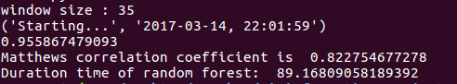

Random Forest Classifier
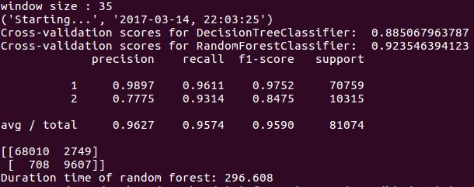
Using 70aadata

