Carolina Lopes | CSE306 | Spring 2020

Geometry Processing

CSE306

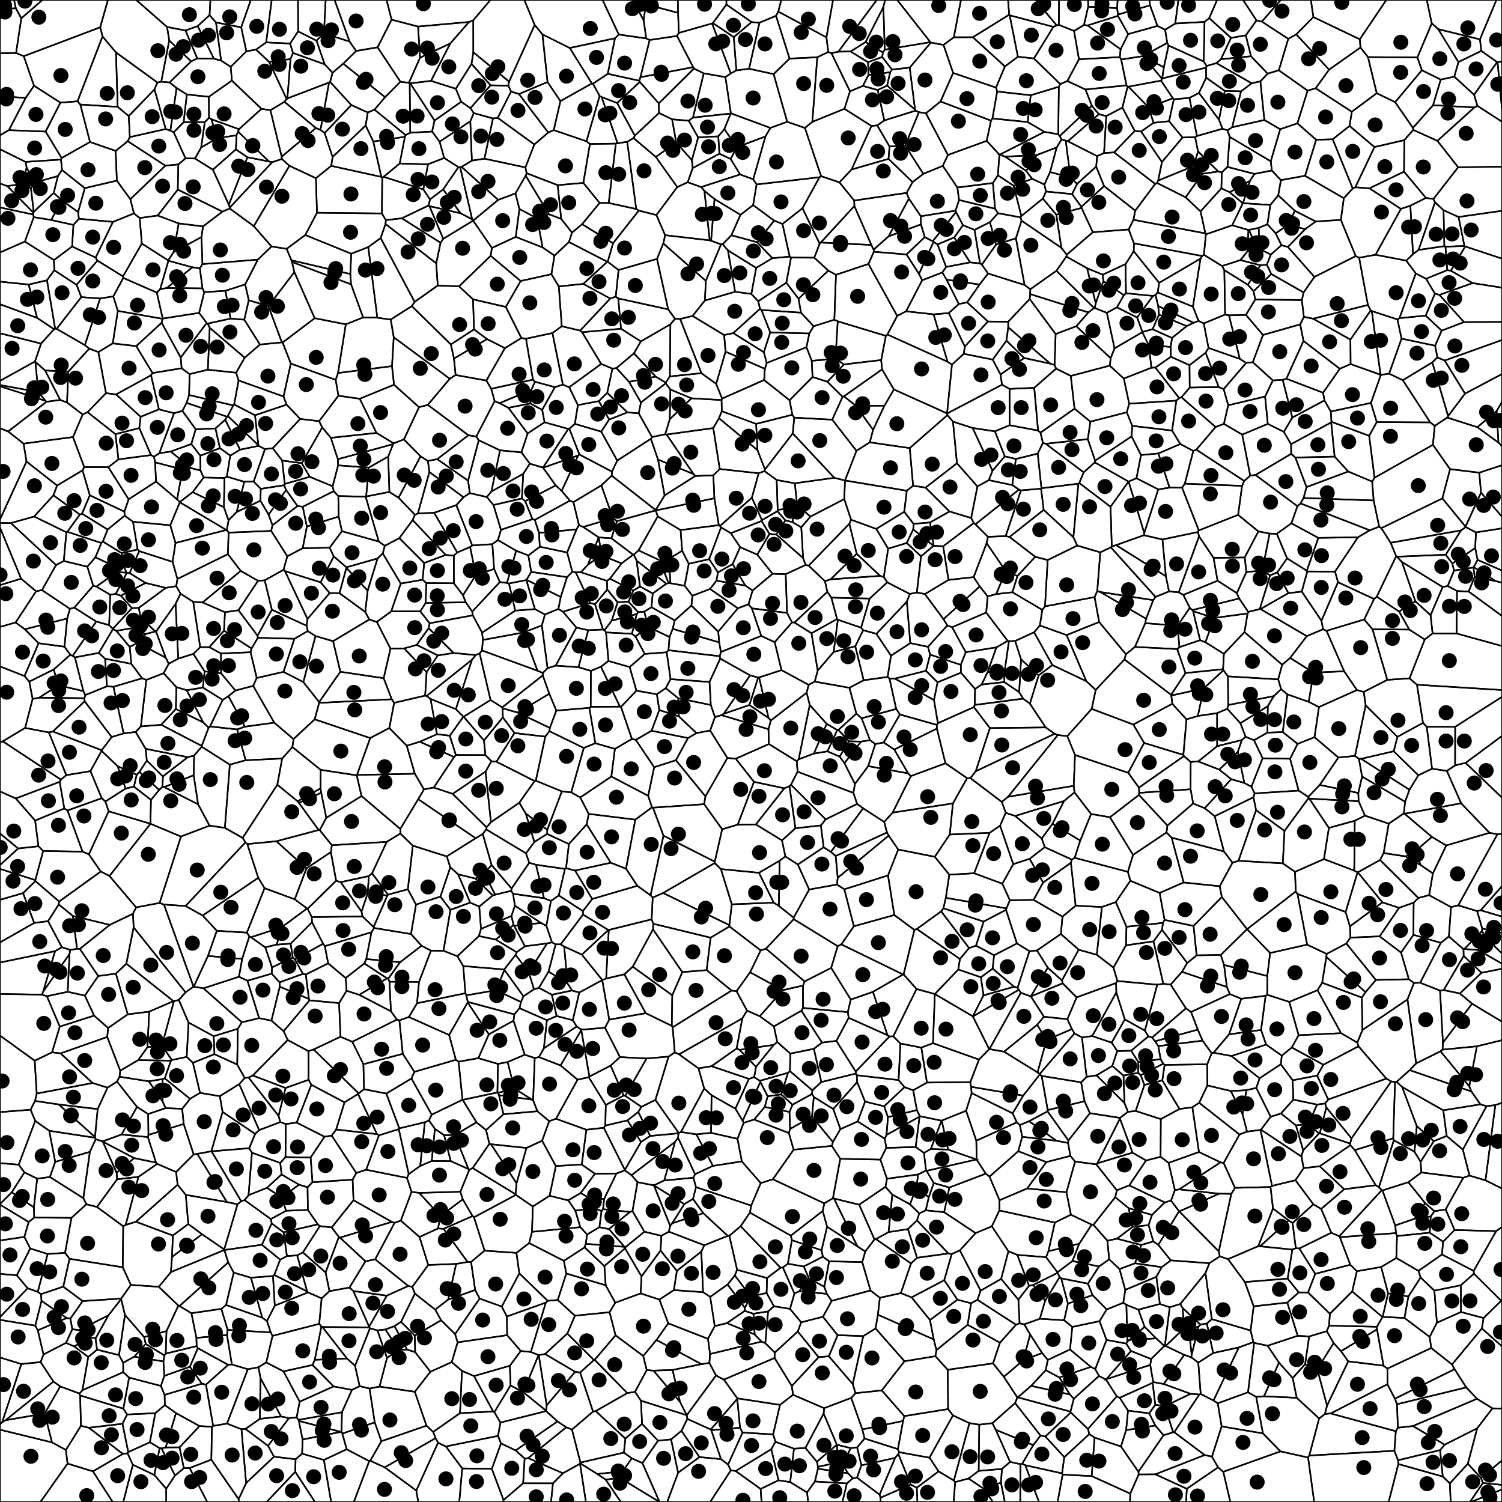

# Polygon Clipping – Sutherland Algorithm

|  |  |
| --- | --- |
|  | Showing Polygon clipping using the Sutherland algorithm.  Top image shows both polygons overlapping.  Bottom image shows the clipped polygon. |

# Voronoi diagram

|  |  |
| --- | --- |
|  | *4 non-random samples*  *Naïve O(n2)*  *Time taken: 7ms* |
|  | *200 random samples*  *Naïve O(n2)*  ***Time taken: 37ms*** |
|  | *2000 random samples*  *Naïve O(n2)*  ***Time taken: 2207ms*** |
| Power Diagram | |
|  | *4 non-random samples*  *Vector 1 = (0.1,0.2,0) Weight = 0.03*  *Vector 2 = (0.2,0.3,0) Weight = 0.03*  *Vector 3 = (0.3,0.2,0) Weight = 0.03*  *Vector 1 = (0.3,0.1,0) Weight = 0.03*  *Vector 1 = (0.1,0.2,0) Weight = 0.01*  *Vector 2 = (0.2,0.3,0) Weight = 0.03*  *Vector 3 = (0.3,0.2,0) Weight = 0.05*  *Vector 1 = (0.3,0.1,0) Weight = 0.03*  *Vector 1 = (0.1,0.2,0) Weight = 0.01*  *Vector 2 = (0.2,0.3,0) Weight = 0.03*  *Vector 3 = (0.3,0.2,0) Weight = 0.08*  *Vector 1 = (0.3,0.1,0) Weight = 0.03*  ***Time taken: 3ms (each)*** |

## LBFGS – semi discrete optimal transport

The code for this optimisation is almost complete. The maths was confusing for me, so I am not sure that the formulas I have written are correct. I also looked at Sebastian’s code for aid and have got some of his code copied and pasted and commented out in my file. I take no ownership for this code, I was using it for help.

Please refer to the following functions:

File Polygon.hpp

Area()

Integral()

## Fluids via Semi-Discrete Optimal Transport

I have implemented the majority of the Gallouet Merigot algorithm, but since I couldn’t finish the semi optimal transport function I was not able to continue further.