Carolina Lopes | CSE306 | Spring 2020

Ray-tracer

CSE306

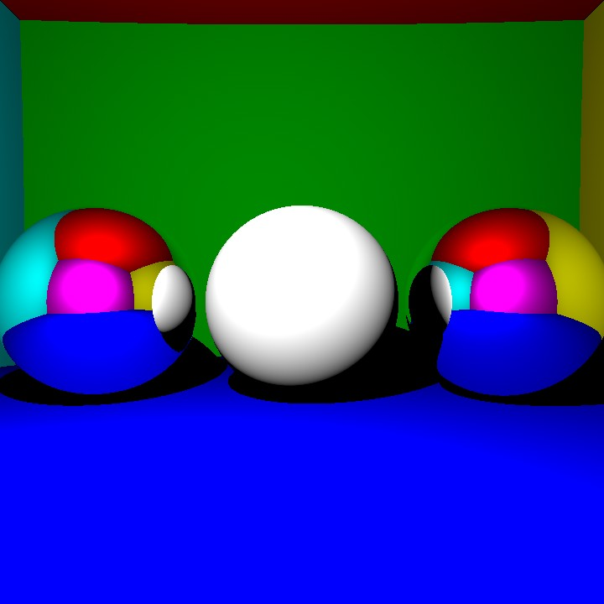

*Disclaimer: Basis of code up to and including reflection were copied from Guillaume Loranchet. This was in order to aid me since I did not have a strong knowledge of C++ and was struggling to begin. All work from refraction onwards is my own.*

|  |  |
| --- | --- |
| Mirror – reflection | |
|  | Image created by Guillaume Loranchet |
|  | Image created by Guillaume Loranchet  Light Intensity 105  Time to render: |
|  | Light intensity seemed far too strong so lowered it.  Light intensity 2.1010  Time to render: |
| Transparency – refraction | |
|  | Transparency without code to impede rays from entering the sphere |
|  | Transparency |
| Hollow Spheres | |
|  | Add a hollow circle inside, no flip of normal |
|  | Sphere_right and sphere_right_hollow both set to hollow |
|  | Max depth length = 2 |
|  | Max depth length = 10  Has total internal reflection |
|  | Hollow sphere (RHS)  Fixed total internal reflection  Time to render: ~197 milliseconds |
| Fresnel Law | |
|  | Fresnel Law implemented  Time to render : 88925 milliseconds |
| Indirect Lighting | |
|  |  |
| Antialiasing |  |
|  |  |
|  |  |
| Cat Triangle Mesh | |
|  |  |
|  | Max depth length = 5  Rays per pixel = 32  Time taken = 47 minutes |

Beginning of code for the albedo of triangle mesh is commented out in the code.