Caroline Buske

Seattle Weather Project Analysis

This brief analysis answers the question: Does it rain more in Seattle, Washington or Portland, Maine? These cities are located on opposite northern coasts of the United States, and experience some differences in precipitation patterns. These differences are best highlighted by looking at each city’s average rainfall from month to month, as well as the proportion of days that receive any rainfall by month. For simplicity, only daily precipitation data (in inches) from 2018 to 2022 was used in this project, sourced from the National Centers for Environmental Information NOAA Climate Data search tool.

Looking purely at mean rainfall, Portland receives 0.134 inches per day on average, and Seattle receives 0.112 inches per day on average. So, strictly considering quantity (and not distribution), it rains more in Portland than in Seattle. However, the standard deviation for rainfall in Portland is 0.341 inches, as opposed to 0.249 inches for Seattle. This tells us that while Portland may receive more total rain, the distribution of rainfall varies more than it does in Seattle. For example, you may have one day where it rains a lot, then go several days without any rain. It is helpful to look at monthly patterns to explain this variation. In the graph below, we can see that Seattle tends to get more rainfall than Portland in the colder months (November through February), while Portland gets more in the warmer months (March through October). The lines protruding from the bars represent error, so the longer the line, the more variation in the data (and uncertainty about the true mean). In months with long error bars, there was a lot of variation in rain from day to day. Portland’s error bars look to be longer for most months.

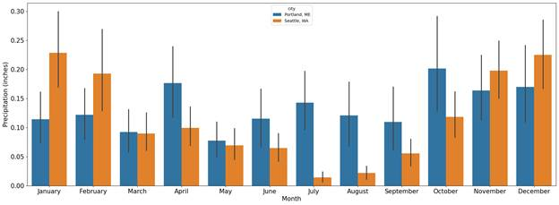

Another question to consider is: What proportion of days does it rain? In the graph below, each bar tells us the proportion of days that received rainfall in a month. For all months excluding July, August, and September, Seattle had a higher proportion of rainy days than Portland.

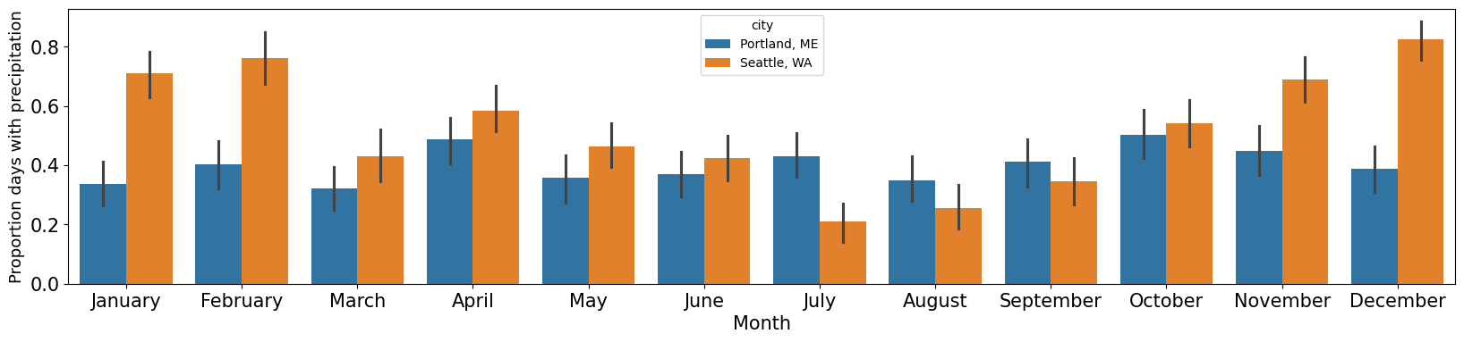

This graph indicates that Seattle experiences a dry season in the summer months, which influences the mean rainfall for the city. Looking at the average rainfall values doesn’t inform you of patterns like this, or for what to expect on a daily basis if you lived in either one of these cities.

All things considered, the data indicates that Portland, Maine gets more rainfall than Seattle, Washington. However, someone living in Seattle may get the experience of near constant rain (excepting the summer months), whereas someone living in Portland may get to experience more dry days.