**The Relationship Between Country GDP and CO2 Emissions Is Changing Over Time**

**Background**

Historically, increases in countries’ gross domestic products (GDPs) have been strongly positively correlated with increases in their carbon dioxide (CO2) emissions, which is concerning because CO2 emissions are a primary cause of global warming (Ritchie, 2021). We investigated if this relationship between countries’ GDPs and CO2 emissions has changed over time. Our results will improve understanding of the relationship between a country’s economic growth and its CO2 emissions.

**Data and Methods**

Our data – which contains countries’ GDPs, CO2 emissions, populations, geographical regions, and income groups – primarily come from World Bank datasets. We merged the raw datasets, selected the years 1990-2019, and adjusted the GDP and CO2 values onto the same scales.

To prepare the data, we researched and manually filled in missing values. We limited our dataset to cover only currently UN-recognized countries (195 countries), and then further restricted it to countries with populations of 50,000 or more in the year 1990, due to concerns about the accuracy of small countries’ data. We also dropped Kosovo from the dataset because there was no CO2 emissions data, leaving 186 countries. Lastly, we imputed the six remaining missing values (two GDP values for North Korea, two CO2 values for Micronesia, one CO2 value for Mali, one CO2 value for Namibia), assuming linear change over time.

Because we were concerned that the great variance in population size amongst different countries might impact the potential trend between GDP and CO2 emissions, we made two versions of our data, one with total country data and one with per capita data, to decide which to proceed with. We plotted both datasets in line graphs on log scales to see which scale was better suited for a linear model. Of the visualizations, Figures 1 and 3 (the totals) seemed slightly more linear than Figures 2 and 4 (the corresponding per capita graphs), so we chose to proceed with country totals data.

After cleaning our data, we used a fixed effects model to run a linear regression on GDP, year (as a continuous variable), the interaction between GDP and year, and country.

**Visualization 1: GDP and CO2 Totals vs Per Capita for All Countries**

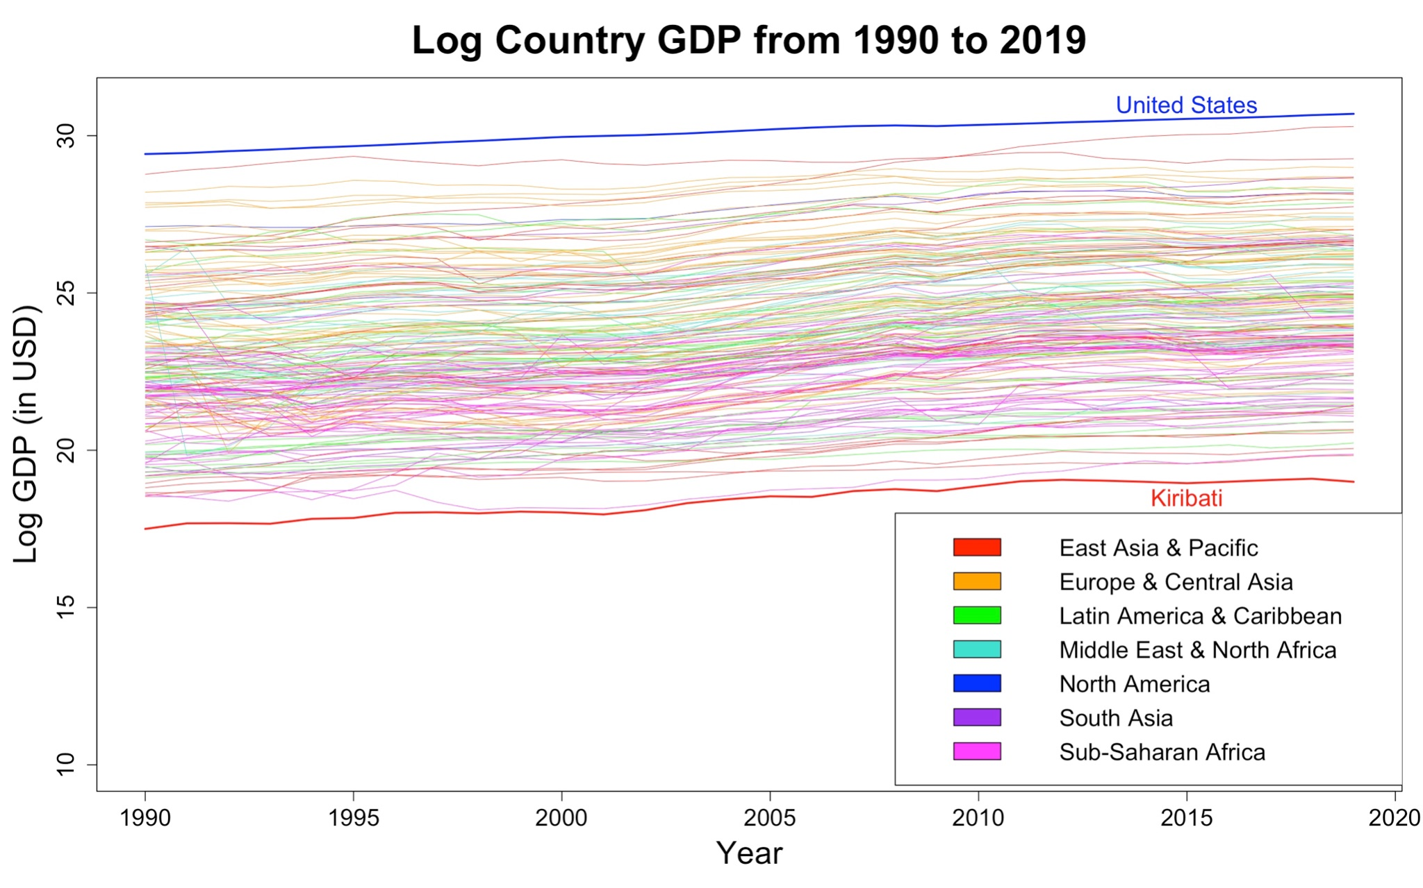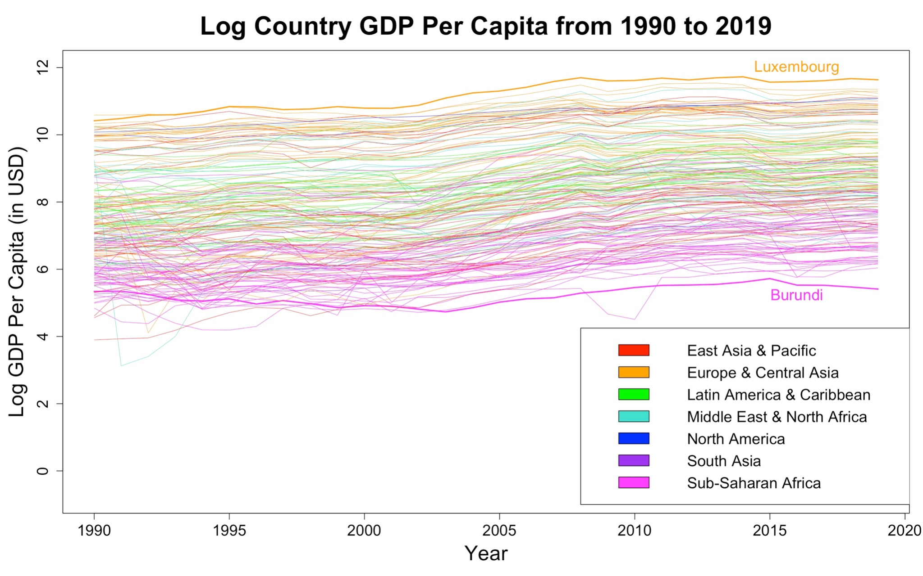

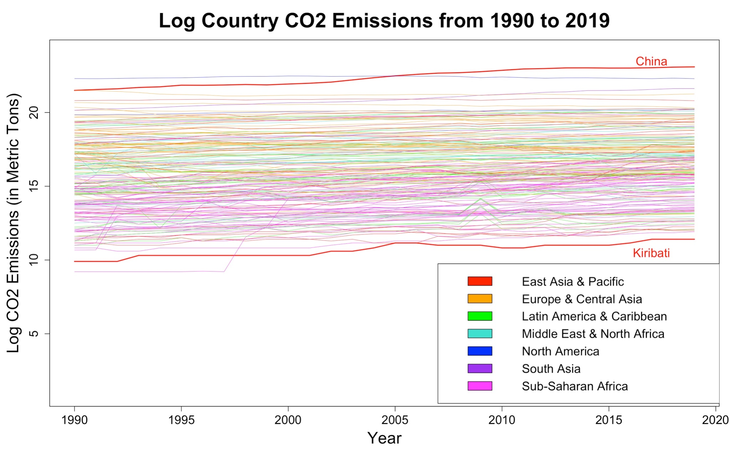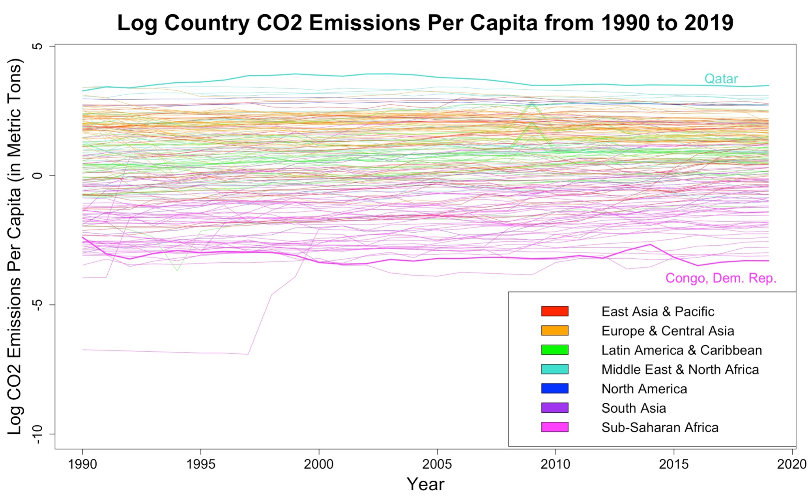

**Top row: Figures 1-2.** The log country GDP totals compared to the log country GDP per capita, from 1990 to 2019.

**Bottom row: Figures 3-4.** The log country CO2 emissions totals compared to the log country CO2 emissions per capita, from 1990 to 2019.

**All: Figures 1-4.** All graphs seem fairly linear, although the per capita graphs (Fig. 2 and 4) have more variation and are therefore less linear.

**Visualization 2: CO2 vs GDP Totals Every 5 Years**

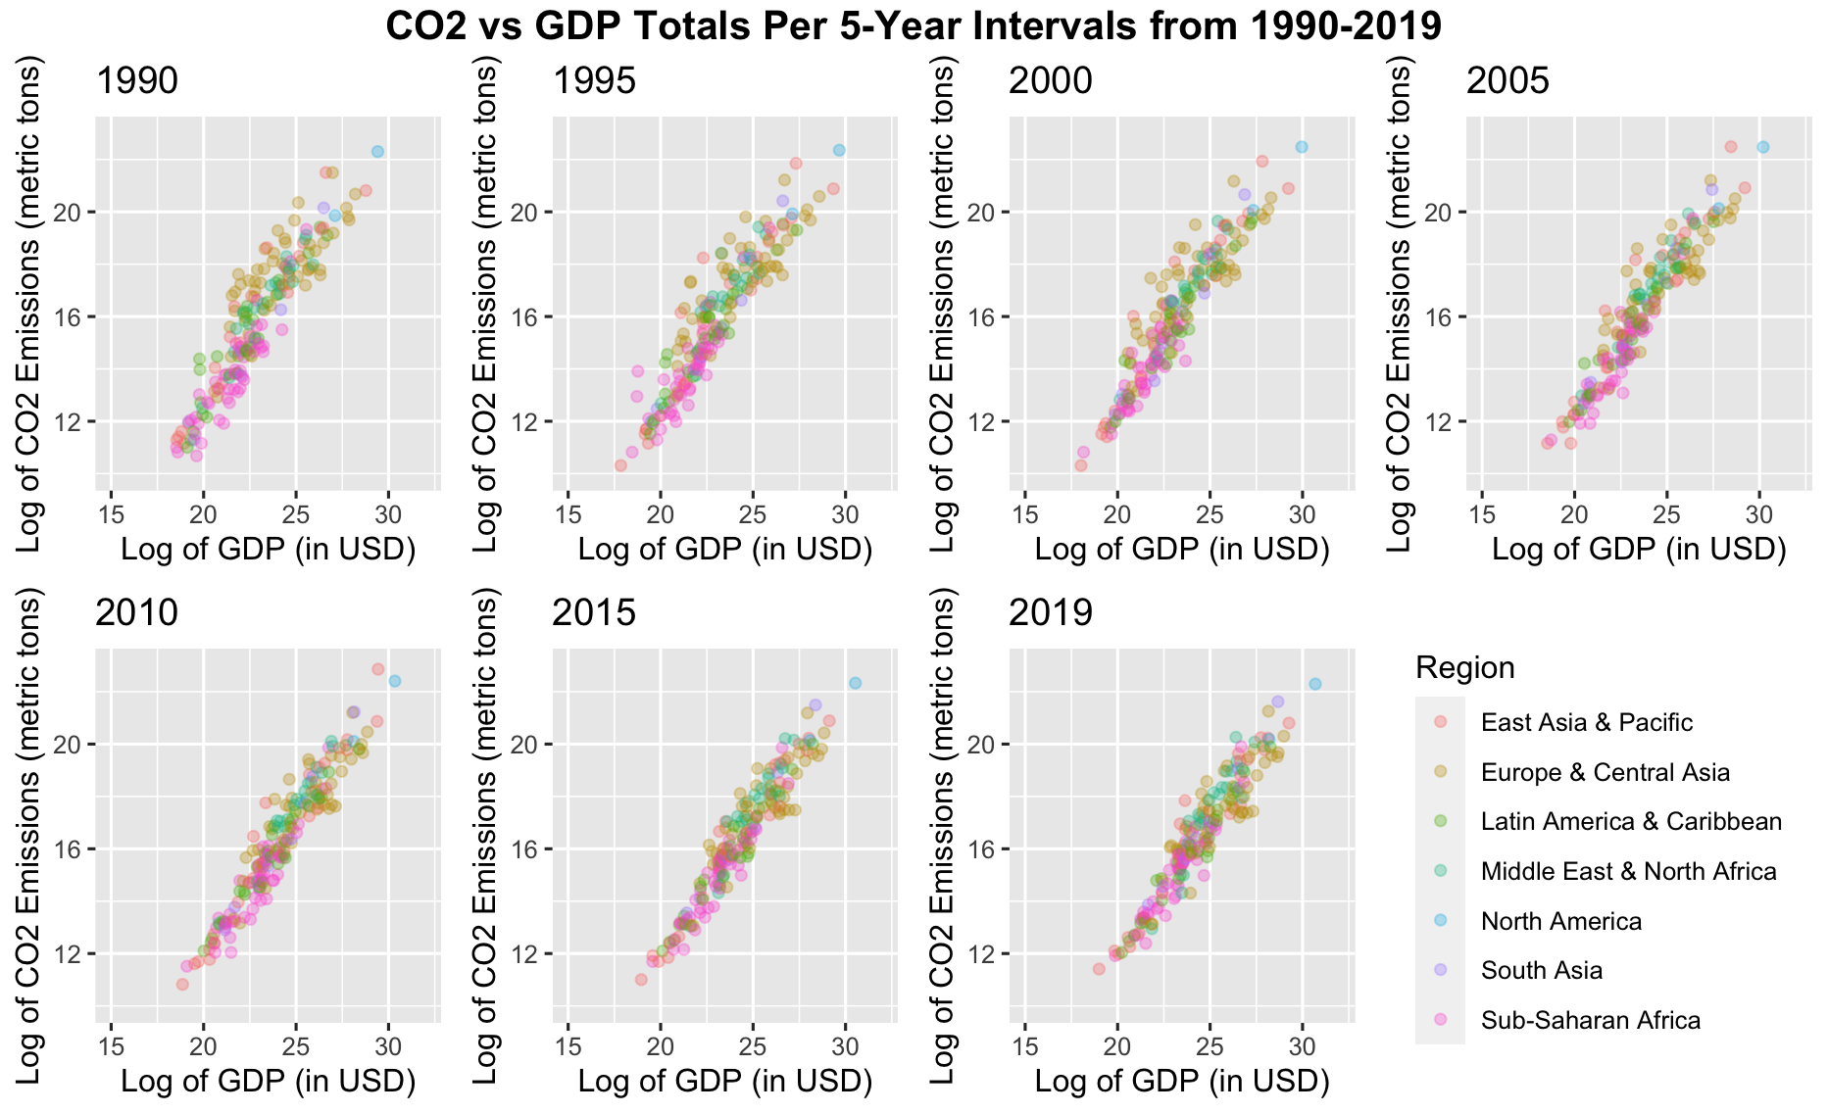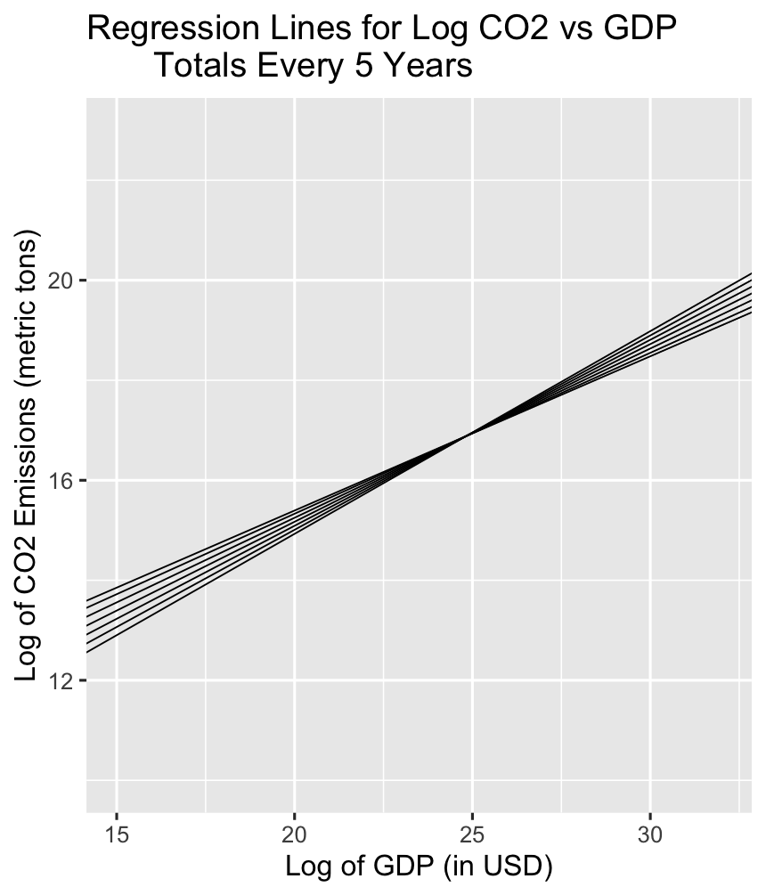

**Left: Figure 5.** Log GDP against log CO2 emissions in snapshots every five years from 1990 to 2019.

**Right: Figure 6.** The regression lines that model the mean log CO2 emissions for the median country in a given year. (The “median” country is estimated by Bolivia because Bolivia had approximately median CO2 emissions over the time period.) The seven lines correspond to the seven years shown in Figure 5 (every five years from 1990 to 2019). The line with the steepest slope (the lowest line on the left side and highest on the right side) is the regression for 1990. For each subsequent plotted year, there is a smaller slope.

**Results**

Based on our regression, the predictors log GDP, year, and the interaction between log GDP and year do have an effect on the mean log CO2 outcome (their p-values were close to 0). Additionally, our scatterplots that capture log CO2 emissions against log GDP every five years from 1990 to 2019 seem to show that the correlation has strengthened over time. Specifically, it appears that European and Central Asian countries’ growth in log CO2 emissions has decreased relative to their growth in their log GDPs over time (as represented in orange). Furthermore, when we derived a general linear regression equation that can be used to model log CO2 emissions for each year (Equation 1), we observed that for the same increase in log GDP, there is a smaller increase in log CO2 emissions in recent years.

To test if our model that includes interaction between log GDP and year is well-fit, we compared its BIC with the BIC of a model without the interaction between log GDP and year. The BIC for the model with interaction is smaller than the other model’s BIC (5040 and 5253, respectively), suggesting that the model with interaction is not overfit compared to the model without.



**Equation 1.** This equation predicts the mean log CO2 emissions for a given year and models how the relationship between log GDP and year changed over time. It uses Bolivia, which had approximately median CO2 emissions over the time period, as an estimate for the median country.

**Discussion**

Our research question investigates the relationship between GDP and CO2 emissions and whether it has changed over time. However, our analysis had some limitations. First, we did not fully account for spatial and temporal relationships. Second, we were constrained by the availability and accuracy of CO2 emissions data, especially for smaller states. To account for this, we researched and imputed as many of those values as possible. Since GDP and CO2 values progressed linearly over time, as exemplified in both our line graphs (Figures 1 and 3) and scatterplots (Figure 5), we assumed linear change over time for the imputation of missing values. We also created a population minimum cutoff since the countries under this cut-off seemed to have questionable data, which condensed our dataset to 186 countries. For countries that did not exist until recently (i.e. after 1990), we used only the data for the relevant years.

**Conclusion**

Overall, our model adds understanding to the relationship between countries’ GDPs and CO2 emissions and how this relationship has changed over time from 1990 to 2019. We found that the relationship between GDP and CO2 emissions has changed over time, as evidenced by the statistical significance of the interaction between log GDP and year. Specifically, our analysis shows that in recent years, for the same increase in GDP, there is a smaller increase in CO2 emissions overall. This is consistent with recent findings that some wealthier countries have decoupled their GDP from CO2 emissions in recent decades, meaning that as their GDPs have increased, their CO2 emissions have actually decreased (Ritchie, 2021).

**References**

Ritchie, H. (2021, December 1). *Many countries have decoupled economic growth from CO₂ emissions, even if we take offshored production into account*. Our World in Data. Retrieved December 12, 2022, from https://ourworldindata.org/co2-gdp-decoupling

**Primary data sources**

The World Bank Group. (2022). *CO2 emissions (metric tons per capita)* [Data set]. https://data.worldbank.org/indicator/EN.ATM.CO2E.PC

The World Bank Group. (2022). *GDP (current US$)* [Data set]. https://data.worldbank.org/indicator/NY.GDP.MKTP.CD

The World Bank Group. (2022). *Population, total* [Data set]. https://data.worldbank.org/indicator/SP.POP.TOTL

**Additional data sources (used to fill in missing data – see Appendix 1)**

*Eritrea CO2 emissions.* Worldometer. (n.d.). Retrieved December 13, 2022, from https://www.worldometers.info/co2-emissions/eritrea-co2-emissions/

*GDP - gross domestic product 2022*. countryeconomy.com. (n.d.). Retrieved December 13, 2022, from https://countryeconomy.com/gdp

*Graph: Carbon dioxide emissions for Mali*. Chart: carbon dioxide emissions for Mali. (n.d.). Retrieved December 13, 2022, from https://rainforests.mongabay.com/carbon-emissions/mali.html

Ritchie, H., Roser, M., & Rosado, P. (2020, May 11). *CO₂ and greenhouse gas emissions*. Our World in Data. Retrieved December 13, 2022, from https://ourworldindata.org/co2-and-other-greenhouse-gas-emissions#co2-and-greenhouse-gas-emissions-country-profiles

**Appendix 1.**

| Country name | Values | Data source |
| --- | --- | --- |
| Afghanistan | GDP 1990-2001 | (Countryeconomy.com) |
| Bosnia and Herzegovina | GDP 1990-1993 | (Countryeconomy.com) |
| Eritrea | GDP 1990-1991;  CO2 1990-1991, 2012-2019 | (Countryeconomy.com), (Eritrea CO2 emissions) |
| Estonia | GDP 1990-1994 | (Countryeconomy.com) |
| Greenland | CO2 1990-2019 | (Our World in Data, 2020) |
| Croatia | GDP 1990-1994 | (Countryeconomy.com) |
| Hungary | GDP 1990 | (Countryeconomy.com) |
| Iran, Islamic Rep. | GDP 1991-1992 | (Countryeconomy.com) |
| Israel | GDP 1990-1994 | (Countryeconomy.com) |
| Cambodia | GDP 1990-1993 | (Countryeconomy.com) |
| Kuwait | CO2 1992-1994 | (Our World in Data, 2020) |
| Liberia | GDP 1990-1999 | (Countryeconomy.com) |
| Lithuania | GDP 1990-1994 | (Countryeconomy.com) |
| Latvia | GDP 1990-1994 | (Countryeconomy.com) |
| Moldova | GDP 1990-1994 | (Countryeconomy.com) |
| Mali | CO2 1998-1999 | (Graph: Carbon dioxide emissions for Mali) |
| Montenegro | GDP 1990-1999 | (Countryeconomy.com) |
| Mozambique | GDP 1990 | (Countryeconomy.com) |
| Korea, Dem. People’s Rep. | GDP 1990-2017 | (Countryeconomy.com) |
| West Bank and Gaza | GDP 1990-1993;  CO2 1990-2019 | (Countryeconomy.com), (Our World in Data, 2020) |
| Somalia | GDP 1991-2012 | (Countryeconomy.com) |
| Serbia | GDP 1990-1994 | (Countryeconomy.com) |
| South Sudan | GDP 2016-2019 | (Countryeconomy.com) |
| Sao Tome and Principe | GDP 1990-2000 | (Countryeconomy.com) |
| Slovenia | GDP 1990-1993 | (Countryeconomy.com) |
| Syrian Arab Republic | GDP 2019 | (Countryeconomy.com) |