**R Module 8 Assignment - Simple Linear Regression**

1. For the following graphs, estimate the linear correlation (do not use a computer program).

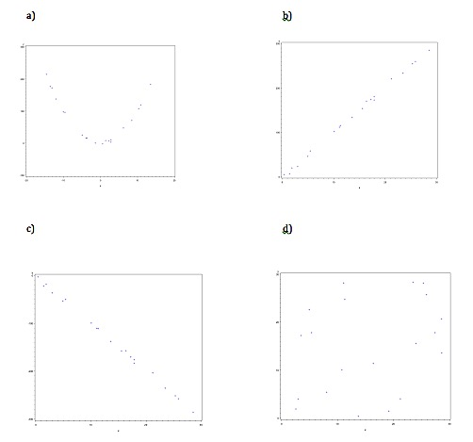

1. Download the fev2.DAT dataset. For this week, we are only interested in the variables *FEV* and *HGT*
2. Graph the data first. (submit the graph for part a)
3. Based on the graph, what do you expect the correlation to be? Compute the correlation include your relevant output (the table that shows the correlation)
4. Based on the graph from (a), do we meet the assumptions for simple linear regression in this dataset? (Address all 4 assumptions, even if the graph doesn’t tell you the answer for that assumption)
5. We will use a simple linear regression model for this data now. Write out the model we will fit.
6. Perform a simple linear regression as shown in the module. For your answer, submit the table of parameter estimates, and give an interpretation a non-statistician could understand.
7. Make a plot of the predicted values of the model