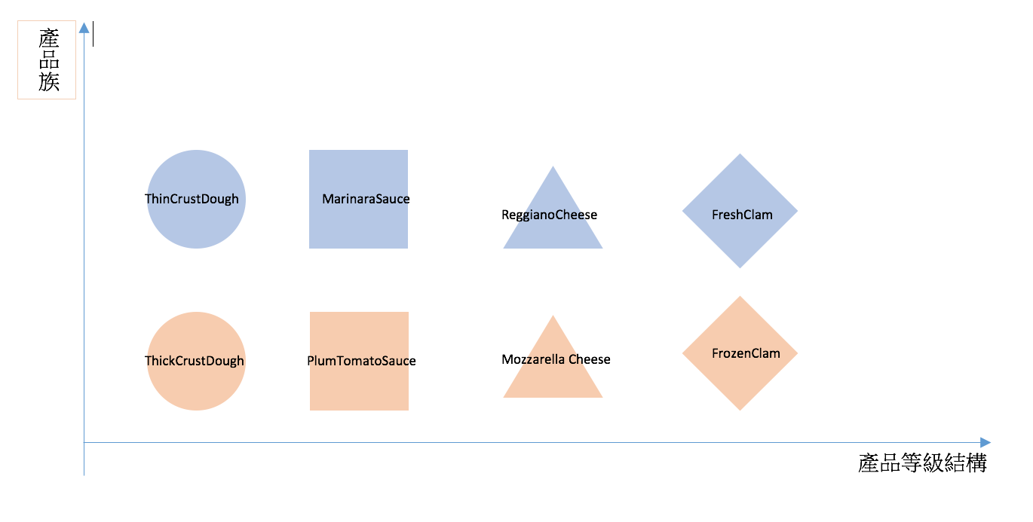

Pizza

IngredientFactory

每個具體工廠都要按照

抽象工廠的定義來實作

一個具體工廠創建一個產品族

Cheese

Interface

Sauce

Interface

Dough

Interface

Clam

Interface

ChicagoPizza

IngredientFactory

NYPizza

IngredientFactory

FrozenClam

FreshClam

Mozzarella Cheese

ReggianoCheese

PlumTomatoSauce

MarinaraSauce

ThickCrustDough

ThinCrustDough

產品等級結構

產品族

d