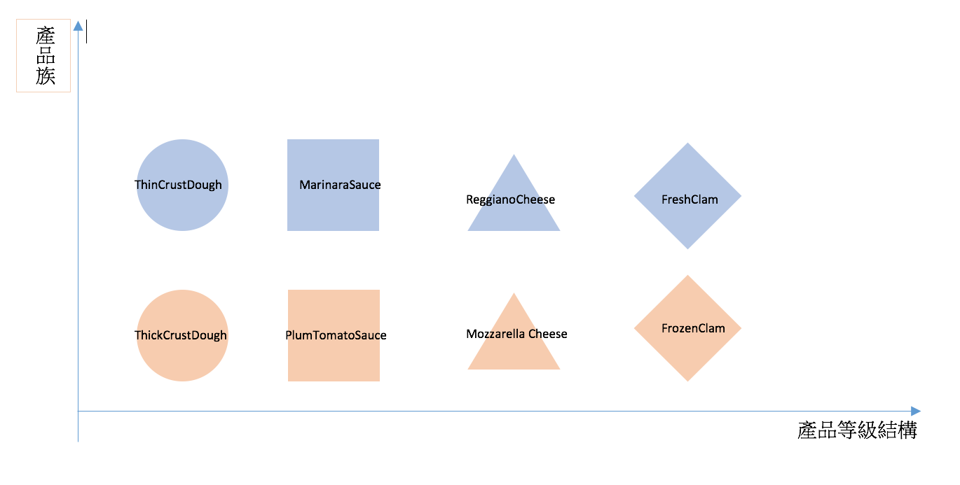

Pizza

IngredientFactory

Cheese

Interface

Sauce

Interface

Dough

Interface

Clam

Interface

Pizza

IngredientFactory

FrozenClam

Mozzarella Cheese

PlumTomatoSauce

ThickCrustDough

產品等級結構

產品族

d



Dough

Factory

Dough

Interface

ChicagoDough

Factory

NYDough

Factory

ThickCrustDough

ThinCrustDough

產品等級結構

產品族

d