lecture4.R

carolinemackey

2021-10-10

#a plot from week 3:   
x <- 1:50  
plot (x, sin(x))

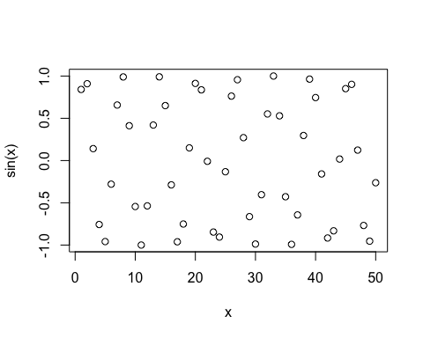

# make this a bit nicer:   
plot (x, sin(x), typ="l", col="blue", lwd=3, xlab="my values")

