MORE ADVANCED CSS
As you move forward with your layouts, you may want to remove the colored backgrounds and outline your divs.
Up to this point your page should look like this:
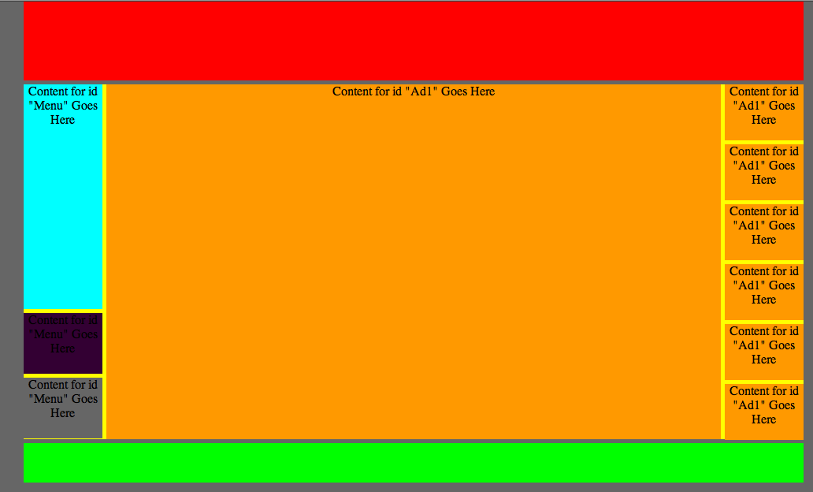
Click on the Header div, and remove the background color in the Property Inspector (clear the color, don’t use white)
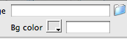
In Dreamweaver, when you are clicked on a div, the rule for that div is outlined at the bottom of your workspace
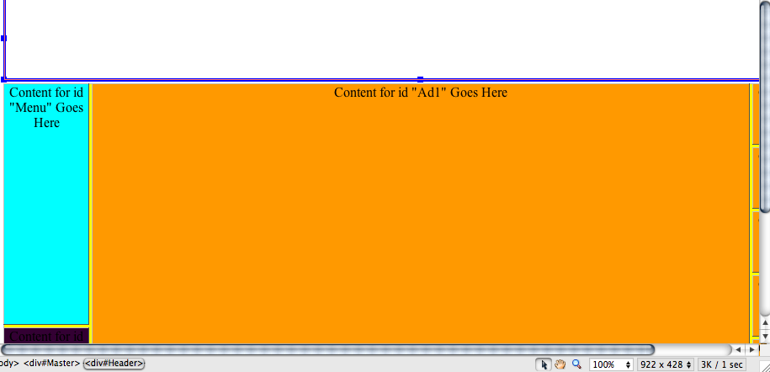
To add a black, one pixel border around the Header div, double click on the #Header in the CSS panel
In the CSS Rule Definition dialog box, choose solid for Style, 1 pix for Width, and black for Color, click OK
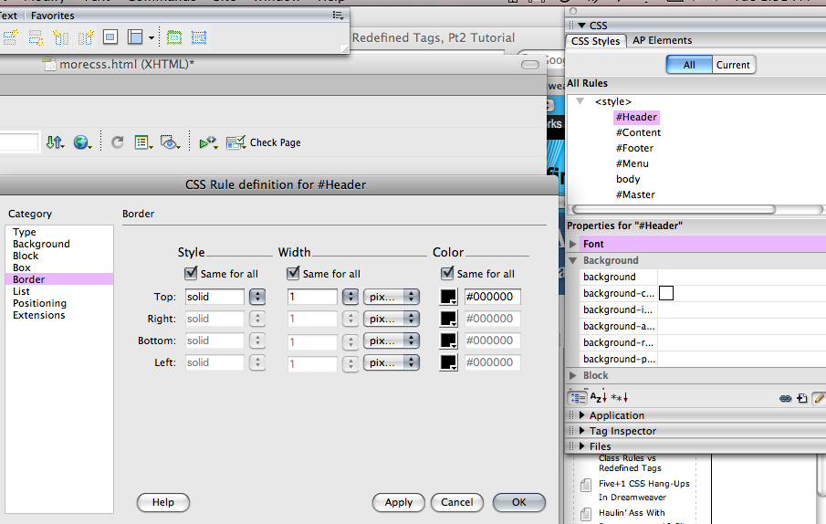

When you set the border of a div, it changes the size of the div because it added the thickness of the border.
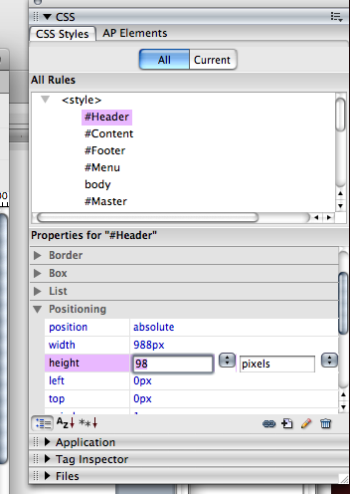
Since you added a 1 pix border, you increased the width of the div 2 pix and the height 2 pix
Reduce the height and width of the Header div by 2 in the Properties for “#Header” panel

Click on all the other divs and reduce their width and height by 2 pix, and remove the background color (you can do this in the Property Inspector).
To create one rule that will put all of the borders on all of the divs, click on the New CSS rule icon
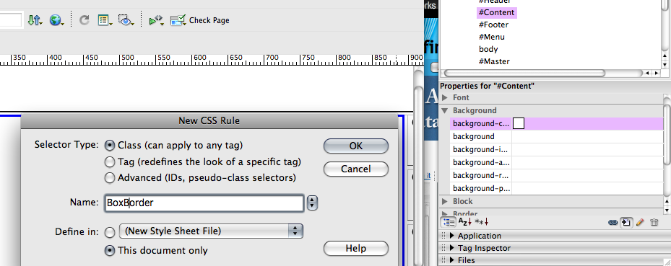
In the New CSS Rule dialog box, choose Selector Type: Class, and Name: BoxBorder (no spaces), click OK
In the CSS Rule Definition dialog box, choose the Border category
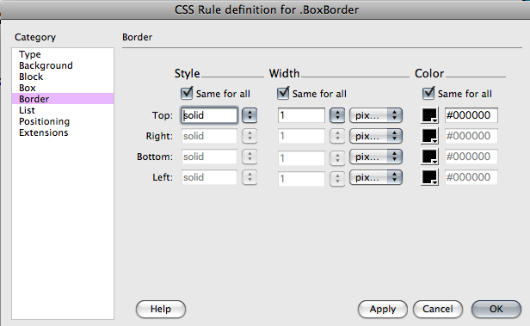
Style is solid, Width is 1 pix, Color is black, click OK

A Class rule can be applied to multiple divs
Click on a div, in the Properties Inspector, click on the Class dropdown and choose BoxBorder
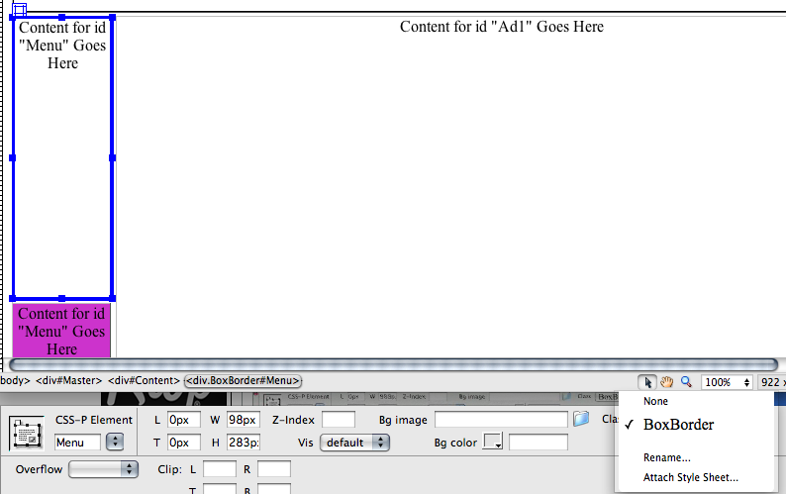
Complete this step for all of your divs
Preview in Browser
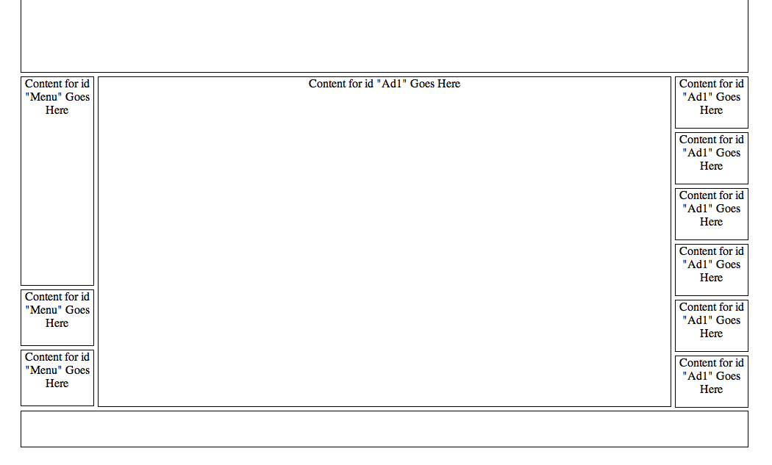
To set a background color for your page, go to Modify → Page Properties → Appearance, and choose a background color, click OK

The divs will also have this color, to change the background color of the divs, double click on .BoxBorder in the CSS Styles panel, choose the Background category and choose a different background color. Click OK
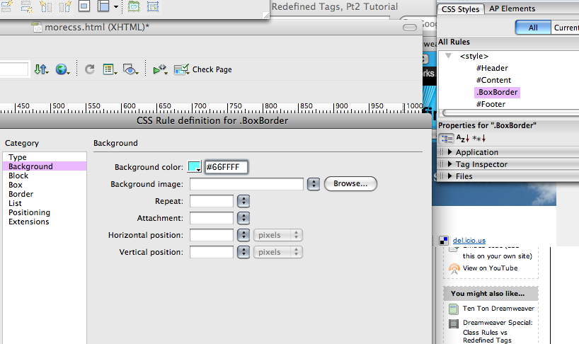

CONVERTING AN INTERNAL STYLE SHEET TO AN EXTERNAL STYLE SHEET
Up to this point, the work on this page has been saved as in Internal Style Sheet. The styles and rules only apply to this page. If you want to use the same styles and rules on all the pages of a site, you can convert the Internal Style Sheet to and External Style sheet.
In the CSS panel, highlight all the styles you want to move to an External Style Sheet.

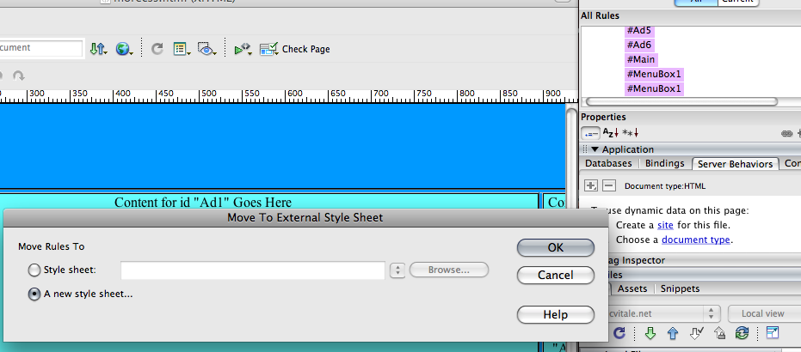

Right click (control, click for Mac) and choose Move CSS Rules. The Move to External Style Sheet dialog box opens. If you have not created the External Style Sheet, choose A new style sheet…., click OK
A new dialog box appears, letting you name and save a new CSS file. Name it main.css and save it in the appropriate folder.
To apply an External Style Sheet to a page, open the page in Dreamweaver. Click the Attach Style Sheet button at the bottom of the CSS Styles panel.
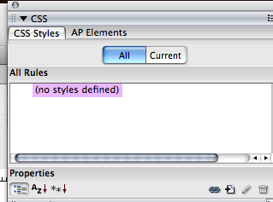
In the Attach External Style Sheet dialog box, browse to the folder where you saved the External Style Sheet (main.css), Add as: Link (links External Style Sheet to page, Import will import the styles and create an Internal Style Sheet), click OK.
