Poker Test – Home Assignment

* The first screen you need to choose how many players you will include. You can choose a number between 2 and 10.



Note: It will validate if you try to input any different number or char.

* After choosing the quantity of players the system will ask you to input the player’s information. Note that in this case you will need to follow the input format: **[player’s name], [card’s number] [card’s suit], [card’s number] [card’s suit], [card’s number] [card’s suit], [card’s number] [card’s suit], [card’s number] [card’s suit]**

**Example:**

* + **Joe, 3H, 4H, 5H, 6H, 8H**



* If the information is not formatted as required, the player will be automatically excluded. The system will request the next player’s information, though.

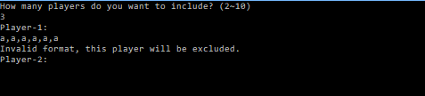

* Including the next players with a valid information the system will analyze the hands and will return the winner(s) name(s) and his poker hand.

Note that the system will ask you if you want to play again (pressing any key) or just exit (pressing ESC).

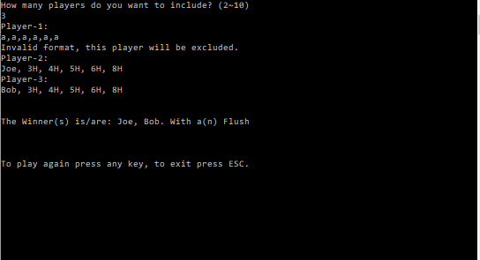

Note: This example was a tie, both players had a flush (Five cards of the same suit).

**Game Rules**

Cards have a **suit** and a number (called the value or **rank**). The possible suits are hearts (H), clubs (C), spades (S), and diamonds (D). The possible ranks are 2, 3, 4, 5, 6, 7, 8, 9,10, Jack (J), Queen (Q), King (K), and Ace (A).

*Poker hands:* The following are the poker hands, from best to worst:

* **Flush**: Five cards of the same suit
* **Three of a kind:** Three cards of the same rank
* **One pair:** Two cards of the same rank
* **High card:** If no one has one pair or a better hand, the highest card wins