# Arabianranta Project

## Administrator guide

### Exporting models and zipping

The 3D models have to be exported within the modeling program one by one. The following example will be using 3ds max 2013.

Select only one model and click on the File (logo of 3ds max) menu button to see the options.

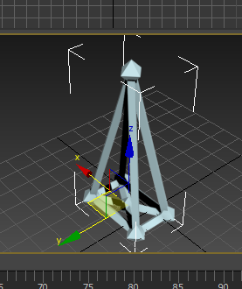 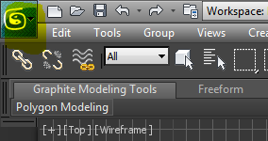

Click with the mouse in the arrow next to **Export** and when a submenu appears, click in **Export Selected**.

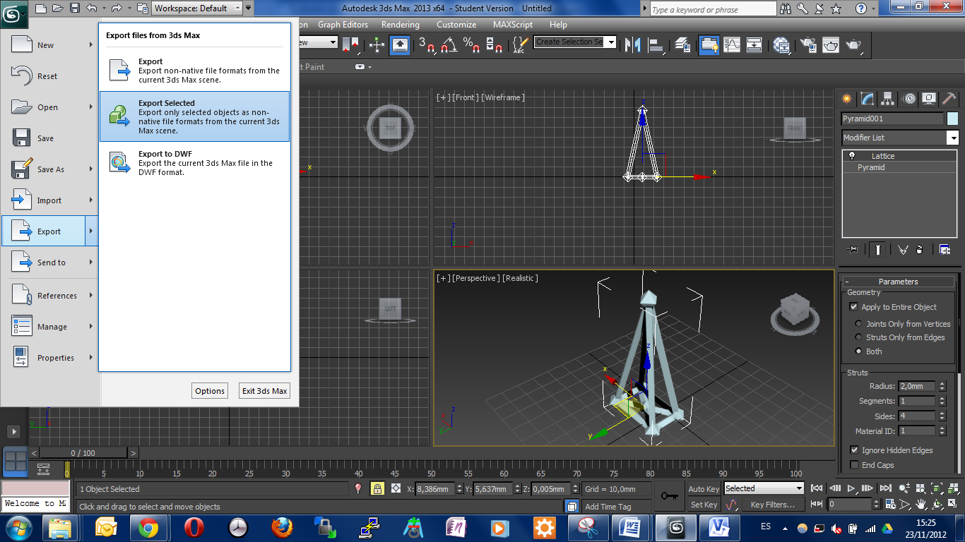

Create a new folder for the content of that model. E.g. pyramid/

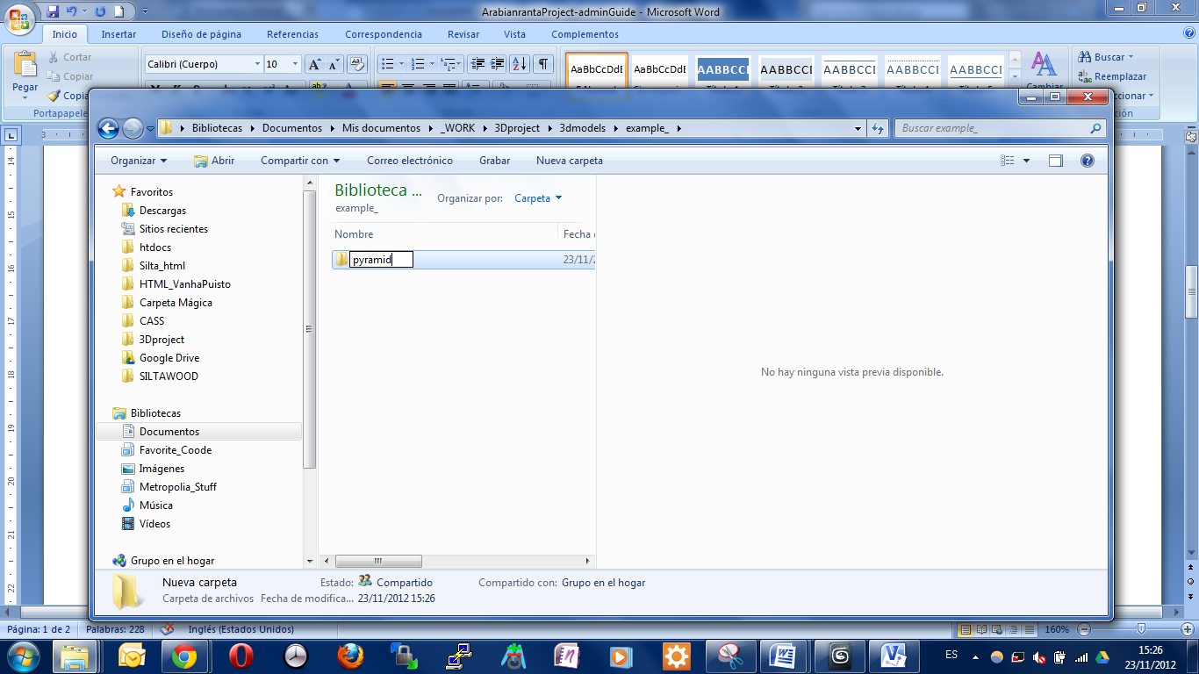

After giving the object a name, select from the select menu **Save as type**, the following type:(*.OBJ). Then, **save** it.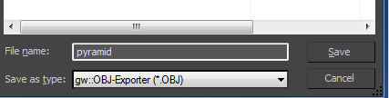

After it will appear a window of **OBJ Export Options**.

After setting up the first window, click on Map-Export… After setting up the Map-Export options, click on Setup… When it is ready, export it.

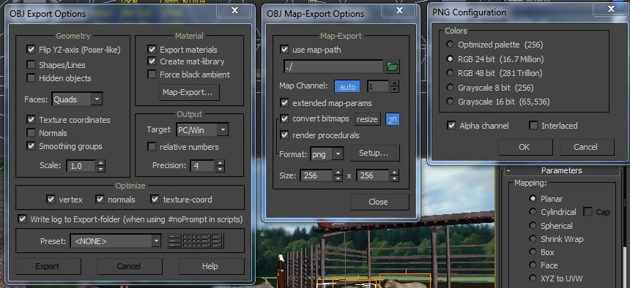

After selecting the right settings, click **Export**.

Next step is to zip the folder pyramid, which should contain:

* the material file (.mtl)
* the object file (.obj)
* the material file (.png –recommended- or .jpg)
* the marker –picture file-

### Administrator page

After you have in a known location the zipped file open the browser and go to this page: <http://54.247.2.103/page/>

#### New model

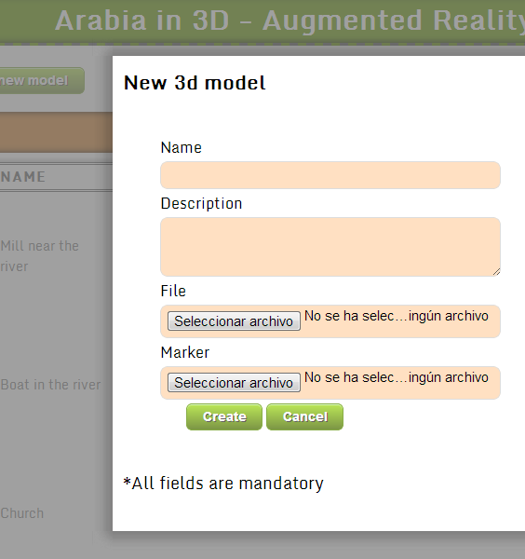Click in the Add new model button. A form will appear and all the fields have to be filled to proceed.

In the file option, select the created and zipped file (.zip) with the object and material files.

