|  |  |
| --- | --- |
| Logo(新) | 密　　级：机　　密  文档编号：UltraMSP-MR-01  项目编号：UltraMSP |

UlraMSP代付账单模块

业务需求和摘要设计说明书

神州泰岳软件股份有限公司

UltraPower Software Co.,Ltd.

2019年10月

文档说明

本文档所涉及到的文字、图表等，仅限于北京神州泰岳软件股份有限公司及被呈送方内部使用，未经北京神州泰岳软件股份有限公司书面许可，请勿扩散到第三方。

文档属性

|  |  |
| --- | --- |
| 属性 | 内容 |
| 项目名称： | **UlraMSP代付账单模块** |
| 项目编号： | UltraMSP |
| 文档名称： | 《业务需求和摘要设计说明书》 |
| 文档编号： | UltraMSP-MR-01 |
| 文档作者： | 北京神州泰岳软件股份有限公司 |

目　录

UlraMSP代付账单模块 I

1 2

1.1 2

1.1.1 c 2

# 背景

出发点差异、数据来源差异，重新开发，因此原有功能有较大调整，不做依据。

# 概念和术语

## 代付账户[Payer Account]

## 客户[Customer]

## AWS账户[Linked Account]

## 月度报告[Monthly Report]

## 收据[Invoice]

## 代付账单[Bill]

## 抵扣券[Credit]

## 预留实例[RI]

## AWS Support

分为ES、BS和DS

# 业务场景

## 代付账户、客户和账户

泰岳有多个代付账户，一个代付账户下有一个或多个客户、一个客户有一个或多个账户。

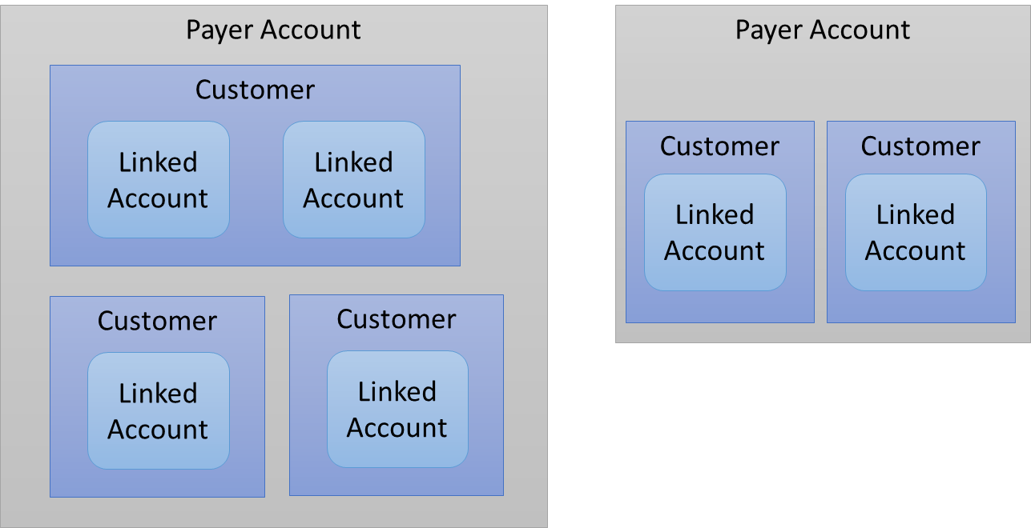

# 业务需求

## 扣除Credit

## 泰岳折扣

## AWS Support拆分

## 按客户出收据

## 按客户和账户出账单

Xls和csv格式，以客户为单位邮件发给马玲

# 管理要求

## 维护信息，json接口

### Payer Account是否共享Credit

## 客户账号Credit无效

# 安装

## 启动EC2虚机

### 虚机镜像

miniconda3-4.5.12-on-amazon-linux-20190102.1620-ca3060e3-7bdf-4f0f-b605-74aed91899f7-ami-022b610071acb9988.4 - ami-001de559aaf3c974a

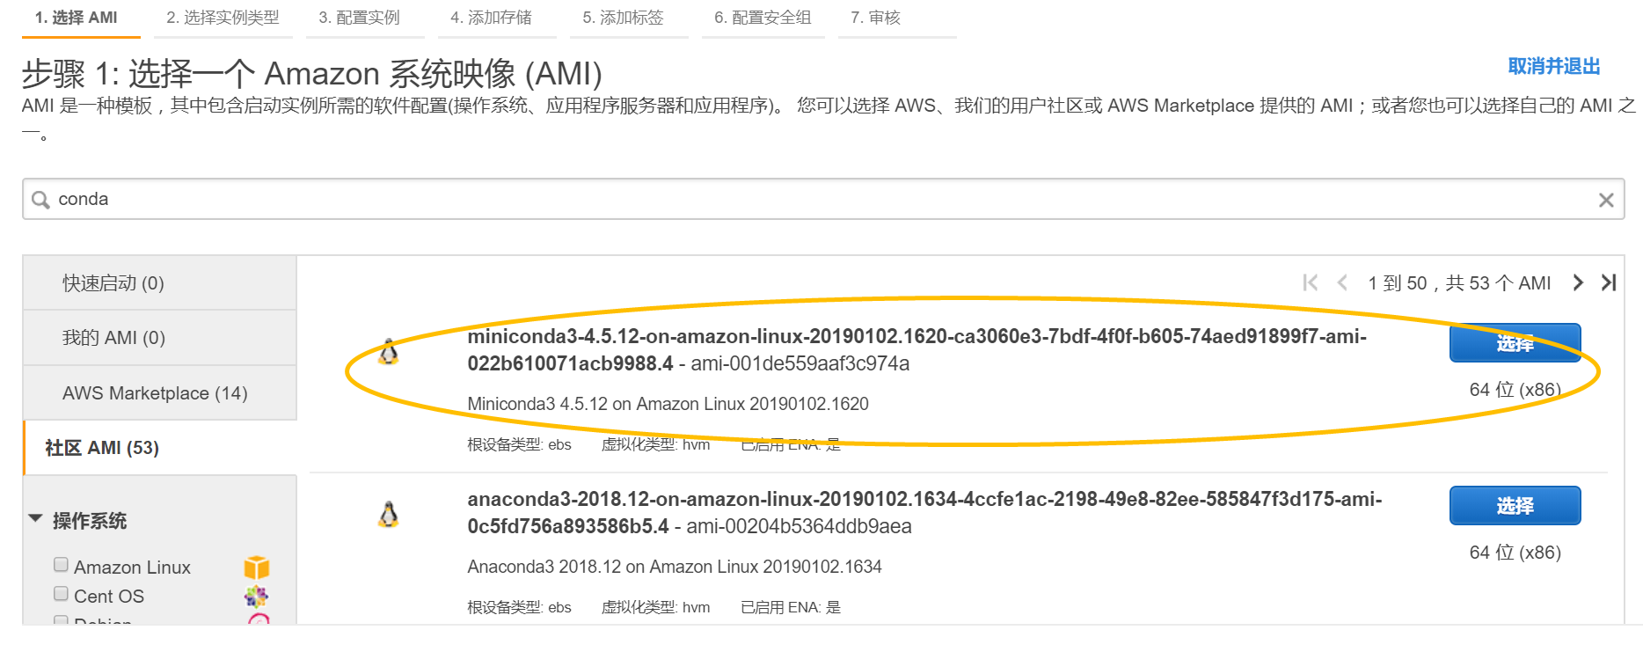

### 机型选择

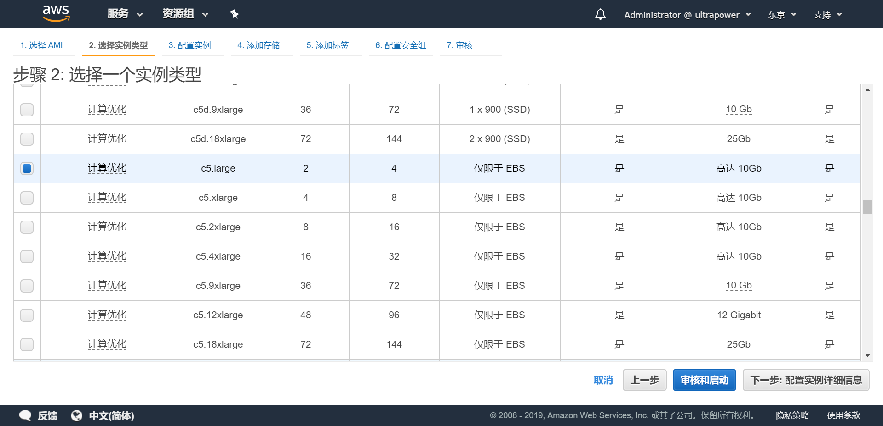

### 虚机配置

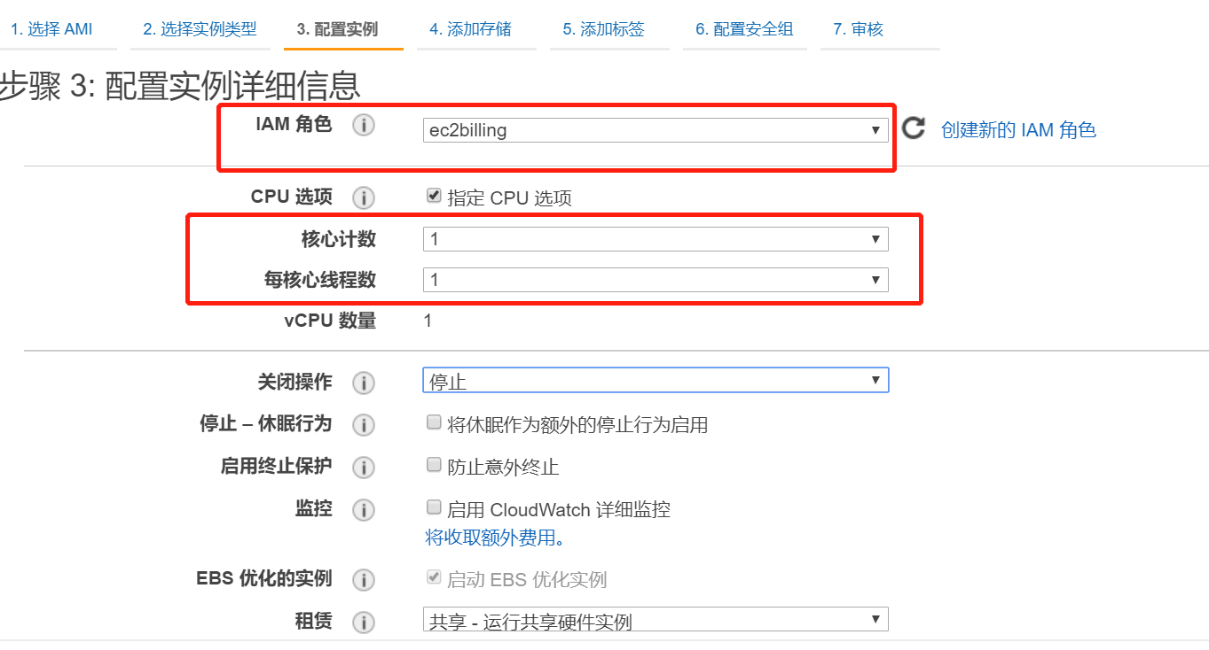

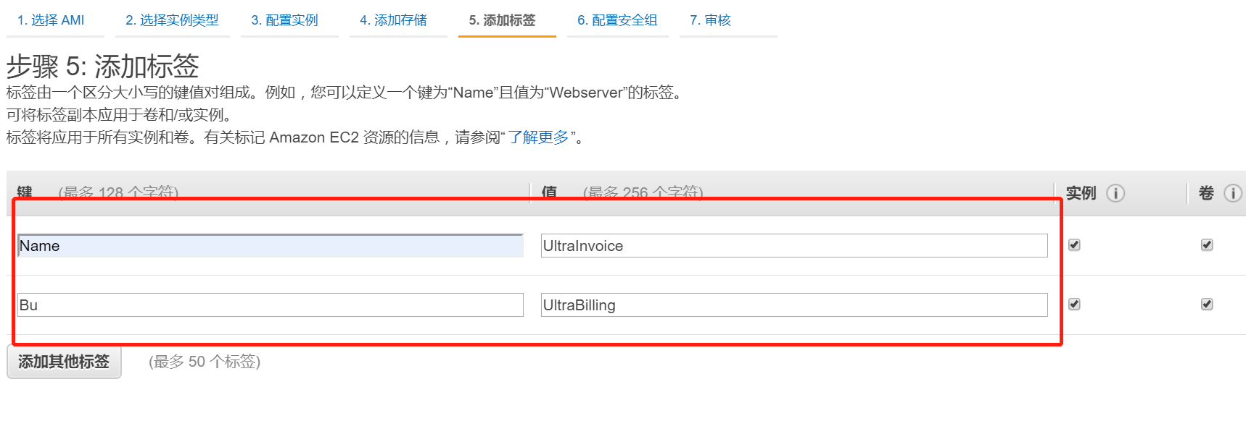

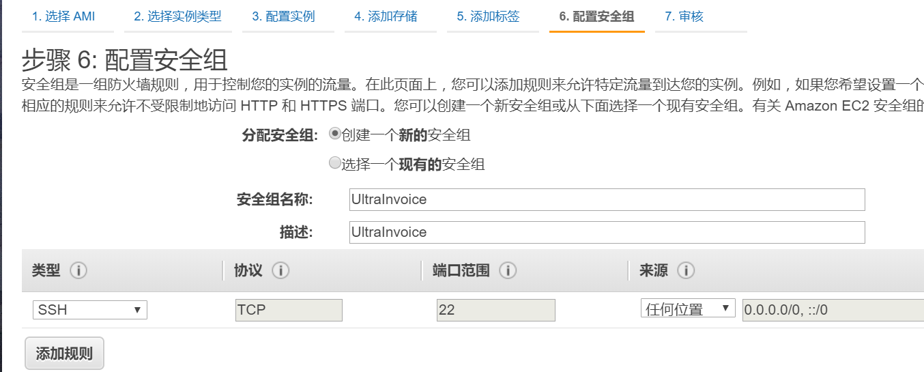

## 运行环境

### 安装Python包

[ec2-user@ip-172-31-7-110 ~]$ sudo passwd root

Changing password for user root.

New password:

BAD PASSWORD: The password is shorter than 7 characters

Retype new password:

passwd: all authentication tokens updated successfully.

[ec2-user@ip-172-31-7-110 ~]$ su - root

Password:

[root@ip-172-31-7-110 ~]# pip install boto3

Collecting boto3

Using cached https://files.pythonhosted.org/packages/fc/8f/20eff269d6092029821349858e0ff4c40ad558962557bfc3fae63f26e630/boto3-1.9.252-py2.py3-none-any.whl

Collecting jmespath<1.0.0,>=0.7.1 (from boto3)

Downloading https://files.pythonhosted.org/packages/83/94/7179c3832a6d45b266ddb2aac329e101367fbdb11f425f13771d27f225bb/jmespath-0.9.4-py2.py3-none-any.whl

Collecting botocore<1.13.0,>=1.12.252 (from boto3)

Using cached https://files.pythonhosted.org/packages/87/7d/58613fb1b75254770767f1e5e37f812ba27e9bac7d2bd8446dcae6f4d44e/botocore-1.12.252-py2.py3-none-any.whl

Collecting s3transfer<0.3.0,>=0.2.0 (from boto3)

Using cached https://files.pythonhosted.org/packages/16/8a/1fc3dba0c4923c2a76e1ff0d52b305c44606da63f718d14d3231e21c51b0/s3transfer-0.2.1-py2.py3-none-any.whl

Requirement already satisfied: urllib3<1.26,>=1.20; python_version >= "3.4" in /opt/conda/lib/python3.7/site-packages (from botocore<1.13.0,>=1.12.252->boto3) (1.24.1)

Collecting python-dateutil<3.0.0,>=2.1; python_version >= "2.7" (from botocore<1.13.0,>=1.12.252->boto3)

Downloading https://files.pythonhosted.org/packages/41/17/c62faccbfbd163c7f57f3844689e3a78bae1f403648a6afb1d0866d87fbb/python_dateutil-2.8.0-py2.py3-none-any.whl (226kB)

100% |████████████████████████████████| 235kB 17.8MB/s

Collecting docutils<0.16,>=0.10 (from botocore<1.13.0,>=1.12.252->boto3)

Downloading https://files.pythonhosted.org/packages/22/cd/a6aa959dca619918ccb55023b4cb151949c64d4d5d55b3f4ffd7eee0c6e8/docutils-0.15.2-py3-none-any.whl (547kB)

100% |████████████████████████████████| 552kB 24.2MB/s

Requirement already satisfied: six>=1.5 in /opt/conda/lib/python3.7/site-packages (from python-dateutil<3.0.0,>=2.1; python_version >= "2.7"->botocore<1.13.0,>=1.12.252->boto3) (1.12.0)

Installing collected packages: jmespath, python-dateutil, docutils, botocore, s3transfer, boto3

Successfully installed boto3-1.9.252 botocore-1.12.252 docutils-0.15.2 jmespath-0.9.4 python-dateutil-2.8.0 s3transfer-0.2.1

[root@ip-172-31-7-110 ~]# pip install xlrd

Collecting xlrd

Downloading https://files.pythonhosted.org/packages/b0/16/63576a1a001752e34bf8ea62e367997530dc553b689356b9879339cf45a4/xlrd-1.2.0-py2.py3-none-any.whl (103kB)

100% |████████████████████████████████| 112kB 11.3MB/s

Installing collected packages: xlrd

Successfully installed xlrd-1.2.0

[root@ip-172-31-7-110 ~]# pip install xlwt

Collecting xlwt

Downloading https://files.pythonhosted.org/packages/44/48/def306413b25c3d01753603b1a222a011b8621aed27cd7f89cbc27e6b0f4/xlwt-1.3.0-py2.py3-none-any.whl (99kB)

100% |████████████████████████████████| 102kB 5.2MB/s

Installing collected packages: xlwt

Successfully installed xlwt-1.3.0

[root@ip-172-31-7-110 ~]# pip install xlutils

Collecting xlutils

Downloading https://files.pythonhosted.org/packages/c7/55/e22ac73dbb316cabb5db28bef6c87044a95914f713a6e81b593f8a0d2f79/xlutils-2.0.0-py2.py3-none-any.whl (55kB)

100% |████████████████████████████████| 61kB 3.8MB/s

Requirement already satisfied: xlrd>=0.7.2 in /opt/conda/lib/python3.7/site-packages (from xlutils) (1.2.0)

Requirement already satisfied: xlwt>=0.7.4 in /opt/conda/lib/python3.7/site-packages (from xlutils) (1.3.0)

Installing collected packages: xlutils

Successfully installed xlutils-2.0.0

### 设置开机启动

[ec2-user@ip-172-31-7-110 ~]$ pwd

/home/ec2-user

[ec2-user@ip-172-31-7-110 ~]$ ls -l

total 16

-rwxrwxr-x 1 ec2-user ec2-user 252 Oct 18 04:09 autorun.sh

drwxrwxr-x 2 ec2-user ec2-user 4096 Oct 18 04:28 meta

drwxrwxr-x 2 ec2-user ec2-user 4096 Oct 18 04:29 tmp

drwxrwxr-x 6 ec2-user ec2-user 4096 Oct 18 04:10 ultraInvoice

[ec2-user@ip-172-31-7-110 ~]$ cat autorun.sh

#!/bin/sh

#

echo "Starting MonthlyReport.py path=/home/ec2-user..."

python /home/ec2-user/ultraInvoice/MonthlyReport.py path=/home/ec2-user 2>>/home/ec2-user autorun.log

echo "MonthlyReport.py Finished. and shutdown after 3 minutes"

sudo shutdown -h +3 "3 minutes after shutdown"

[ec2-user@ip-172-31-7-110 ~]$ cat /etc/rc.local

#!/bin/sh

#

# This script will be executed *after* all the other init scripts.

# You can put your own initialization stuff in here if you don't

# want to do the full Sys V style init stuff.

touch /var/lock/subsys/local

su - ec2-user -c /home/ec2-user/autorun.sh