|  |  |
| --- | --- |
| Logo(新) | 密　　级：机　　密  文档编号：UltraMSP-MR-02  项目编号：UltraMSP |

UltraMSP代付账单模块

安装使用手册

神州泰岳软件股份有限公司

UltraPower Software Co.,Ltd.

2019年10月

文档说明

本文档所涉及到的文字、图表等，仅限于北京神州泰岳软件股份有限公司及被呈送方内部使用，未经北京神州泰岳软件股份有限公司书面许可，请勿扩散到第三方。

文档属性

|  |  |
| --- | --- |
| 属性 | 内容 |
| 项目名称： | **UltraMSP代付账单模块** |
| 项目编号： | UltraMSP |
| 文档名称： | 《安装使用手册》 |
| 文档编号： | UltraMSP-MR-02 |
| 文档作者： | 北京神州泰岳软件股份有限公司 |

目　录

UltraMSP代付账单模块 I

1 背景和概述 3

2 概念和术语 4

2.1 代付账户[Payer Account] 4

2.2 客户[Customer] 4

2.3 AWS账户[Linked Account] 4

2.4 月度报告[Monthly Report] 4

2.5 收据[Invoice] 4

2.6 代付账单[Bill] 4

2.7 抵扣券[Credit] 4

2.8 AWS Support 4

3 业务场景 5

3.1 代付账户、客户和账户 5

4 安装 6

4.1 Lambda方式安装 6

4.2 配置 12

4.2.1 配置个代付账号记录月度报告 12

4.2.2 配置月度报告复制到Ultrapower 13

4.2.3 配置出账Lamda 13

5 使用 14

6 维护 15

6.1 维护代付账户 15

6.2 维护客户和aws账户 16

7 监控和管理 23

7.1 手动启动出帐 23

7.2 监控错误 23

# 背景和概述

当前为代付客户生成收据和账单的目的和需求与前期有一定变化，以aws月度账单文件为基础，重新开发了收据和账单生成模块。主要功能包括：

* 从aws月度账单文件，按客户拆分形成收据和账单
* 同时支持Global和China客户
* 支持泰岳针对客户指定账号的折扣
* 支持指定代付账号下Credit的扣除
* 支持指定代付账号下AWS Support的拆分(业务逻辑未明确，尚未实现)
* 提供csv格式和xls格式账单
* 提供xls格式收据，包括收美元付美元、收人民币付美元、收人民币付人民币三种模板

该模块实现思路如下：

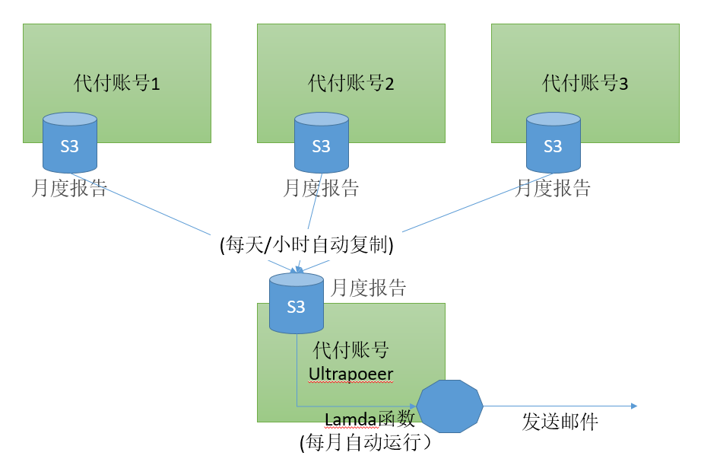

由于客户和aws账户的关系，以及代付账户、客户和aws账户的某些属性不包含在账单文件中，需要我方定期人工维护。

# 概念和术语

## 代付账户[Payer Account]

## 客户[Customer]

## AWS账户[Linked Account]

## 月度报告[Monthly Report]

## 收据[Invoice]

## 代付账单[Bill]

## 抵扣券[Credit]

## AWS Support

分为ES、BS和DS

# 业务场景

## 代付账户、客户和账户

泰岳有多个代付账户，一个代付账户下有一个或多个客户、一个客户有一个或多个账户。

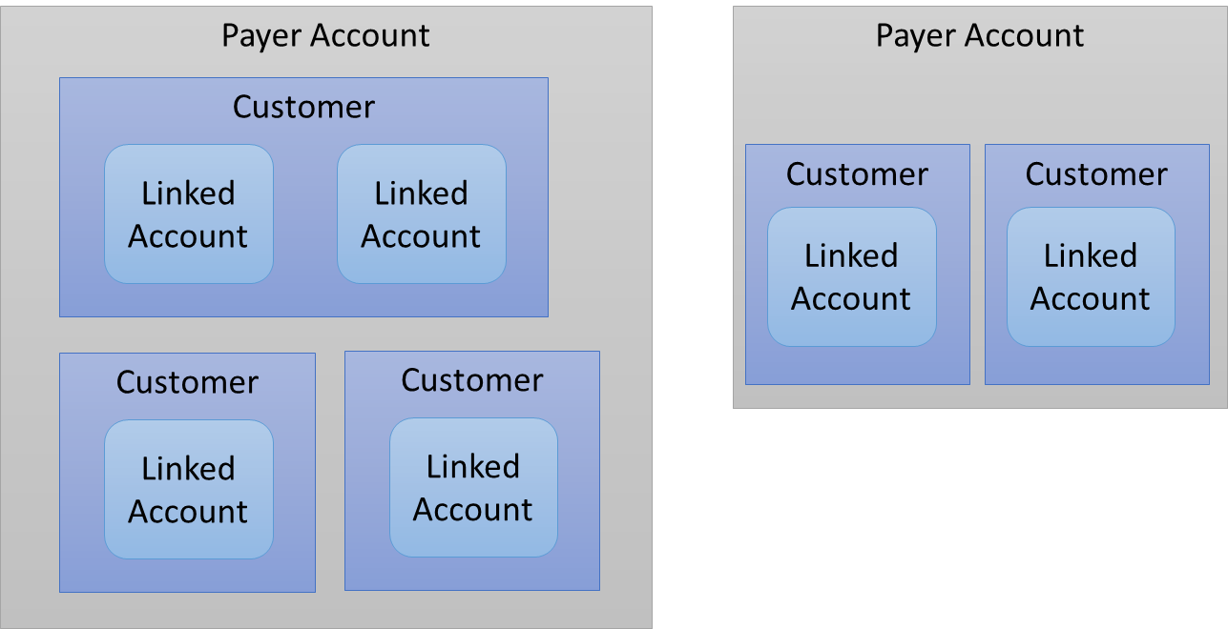

# 安装

## Lambda方式安装

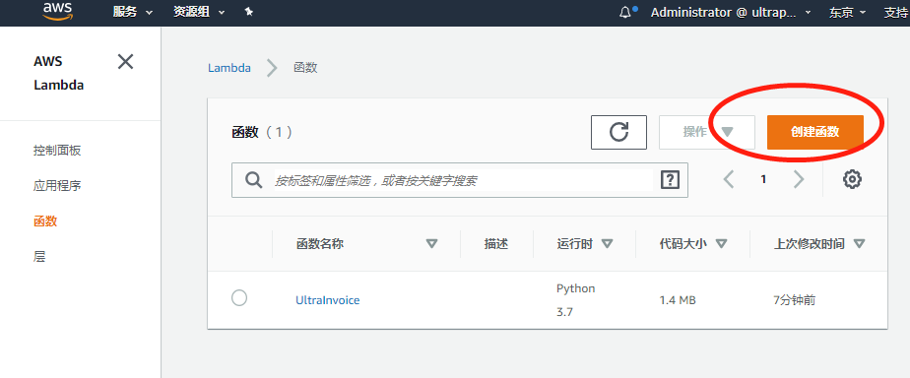

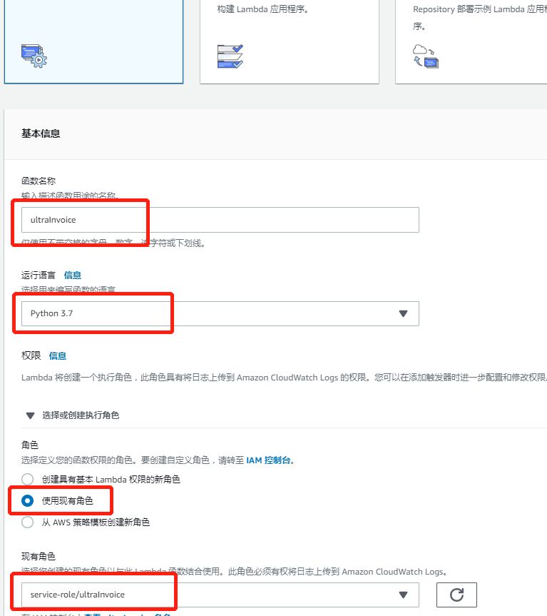

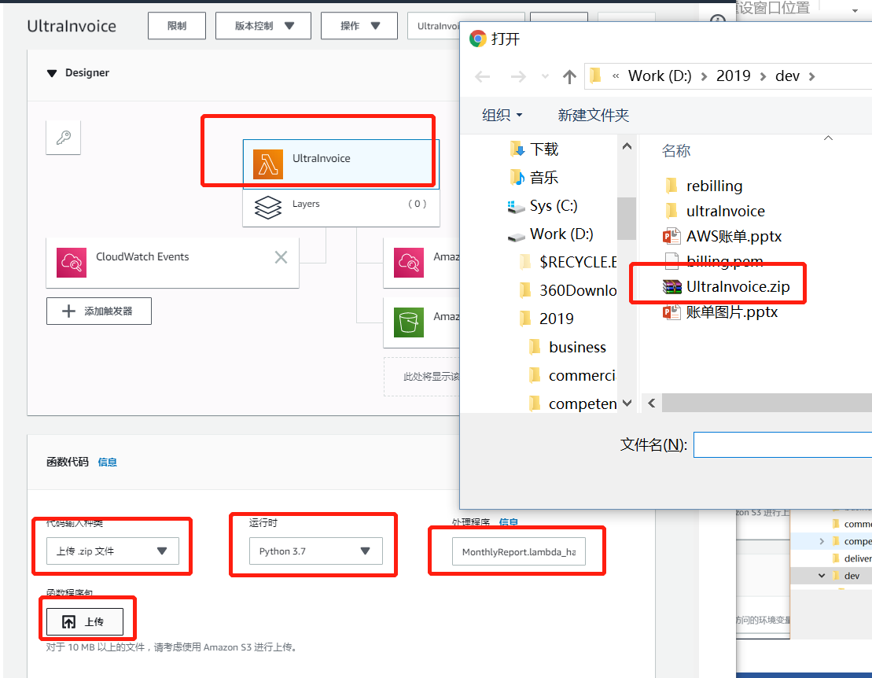

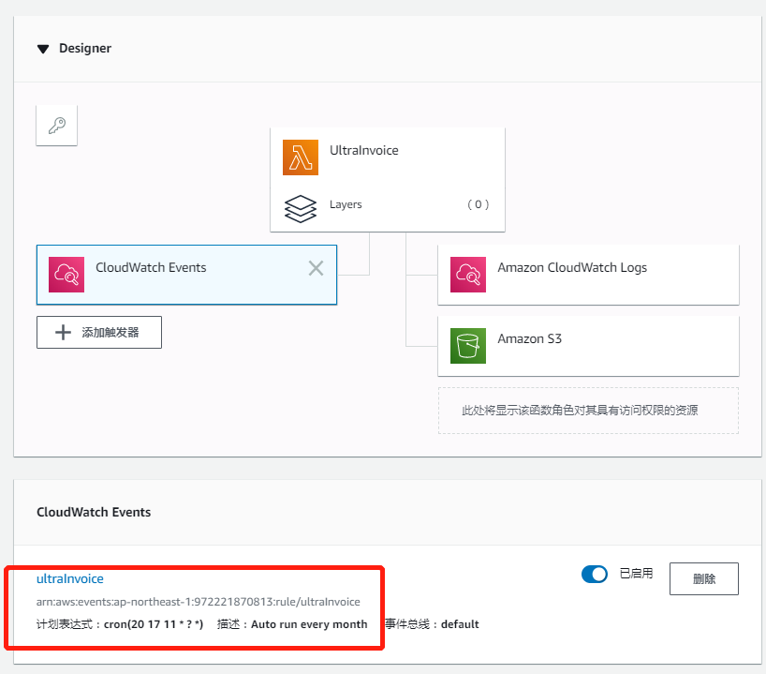

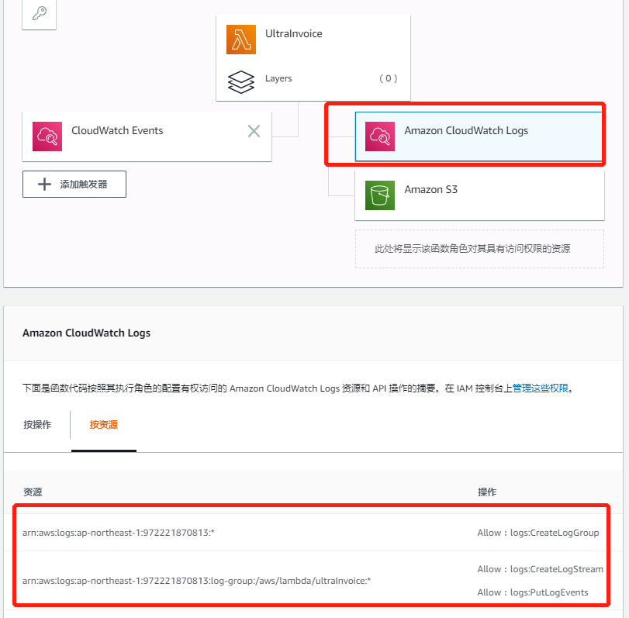

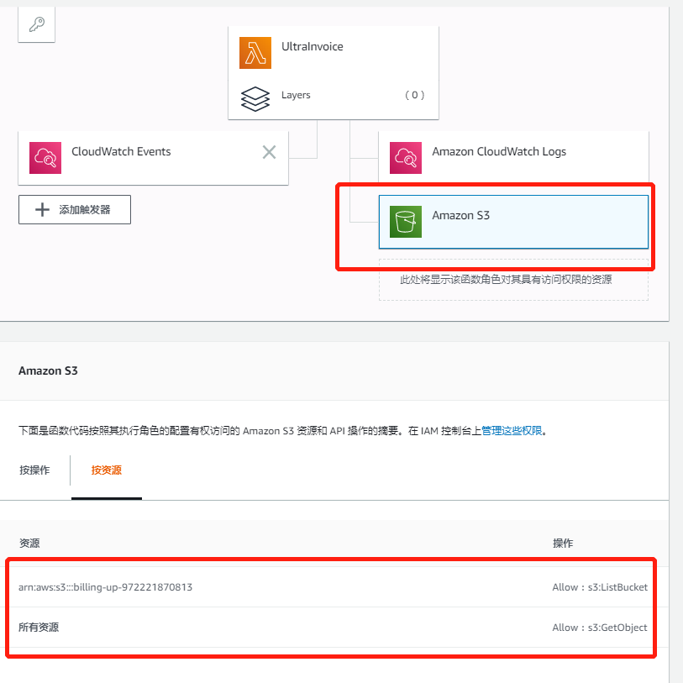

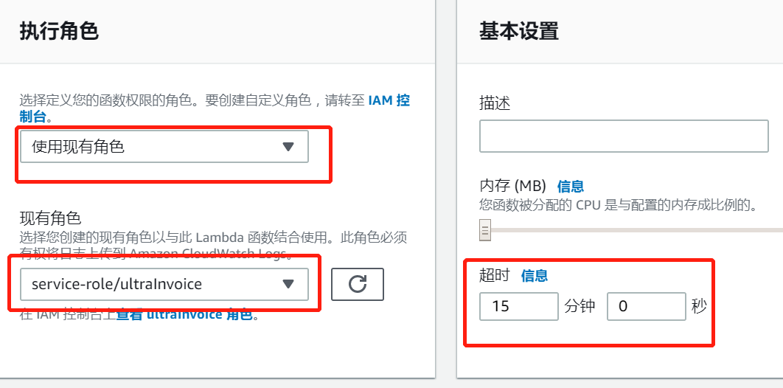

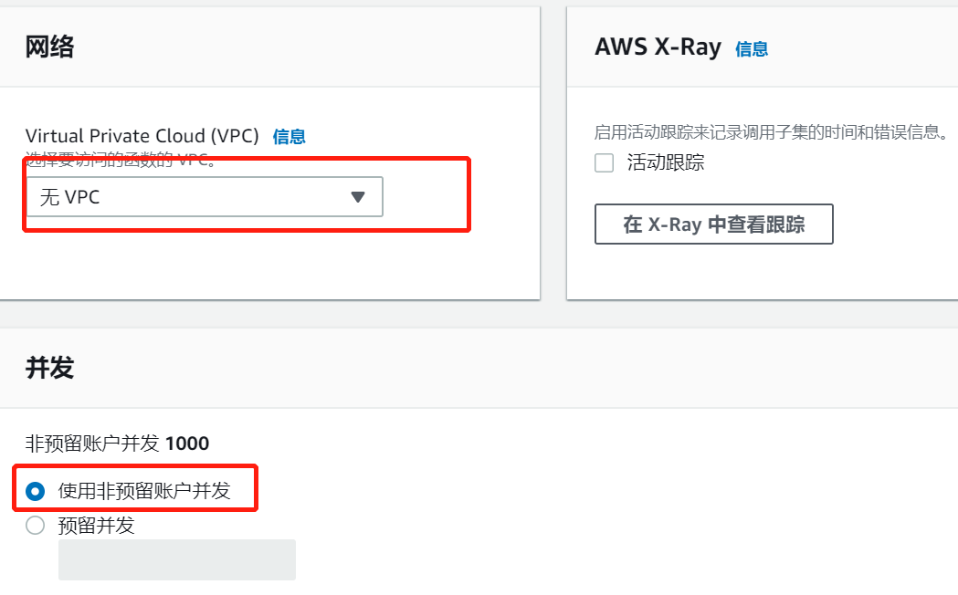

## 配置

### 配置个代付账号记录月度报告

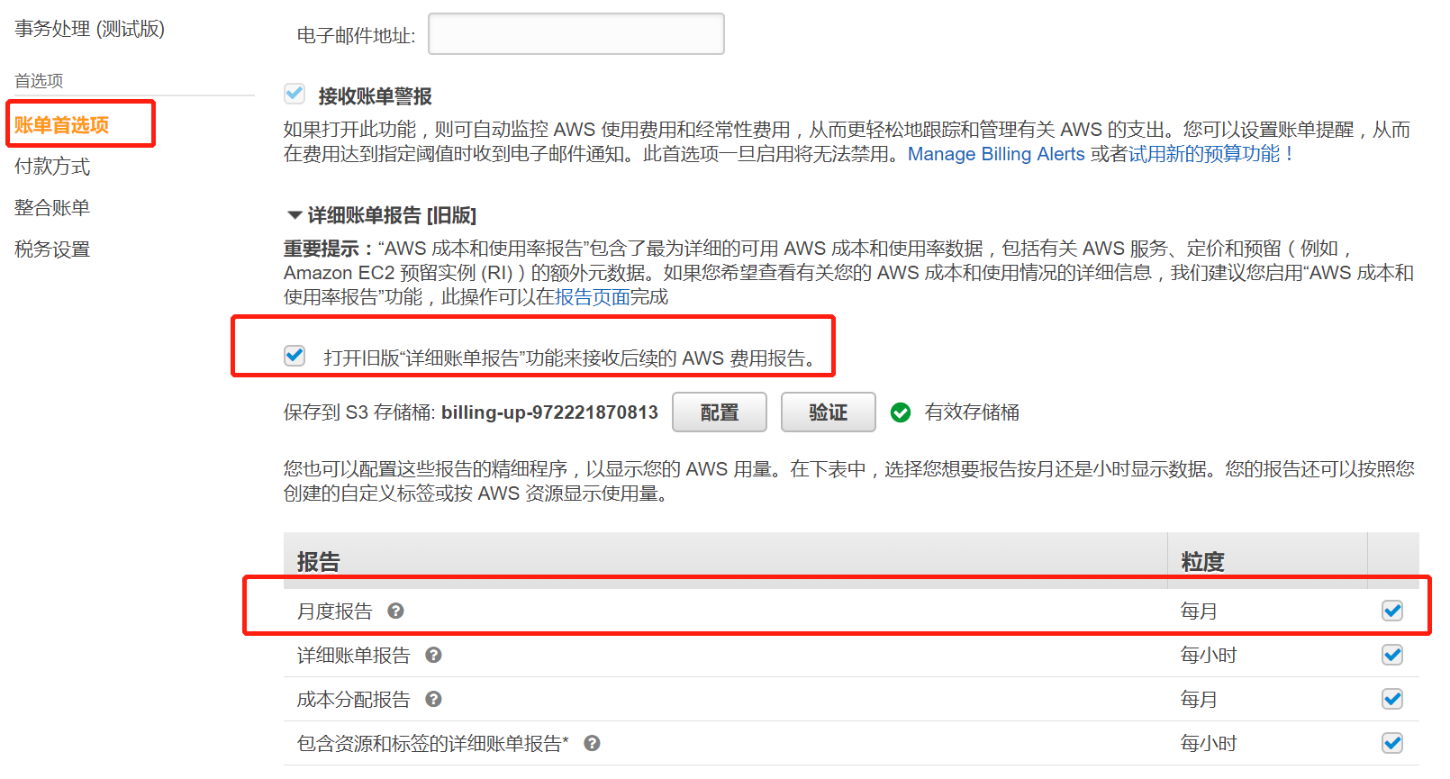

### 配置月度报告复制到Ultrapower

### 配置出账Lamda

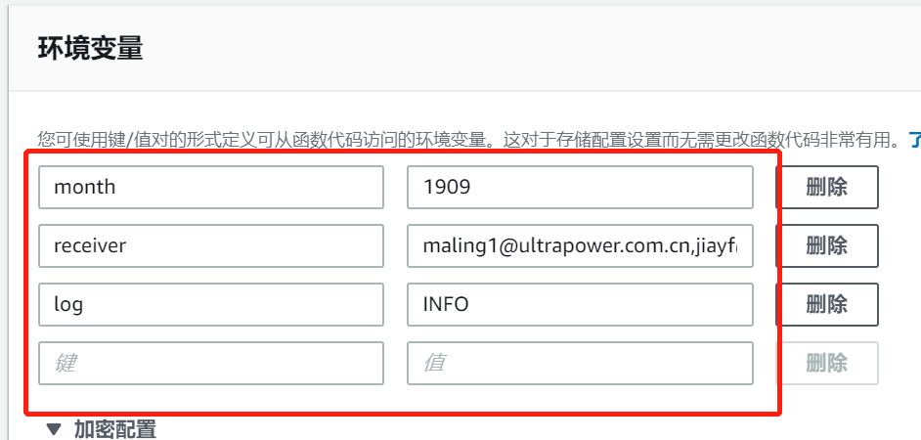

# 使用

上节配置的接收人每月收到客户的所有收据和账单。样例如下：



# 维护

需要维护的元数据位置。

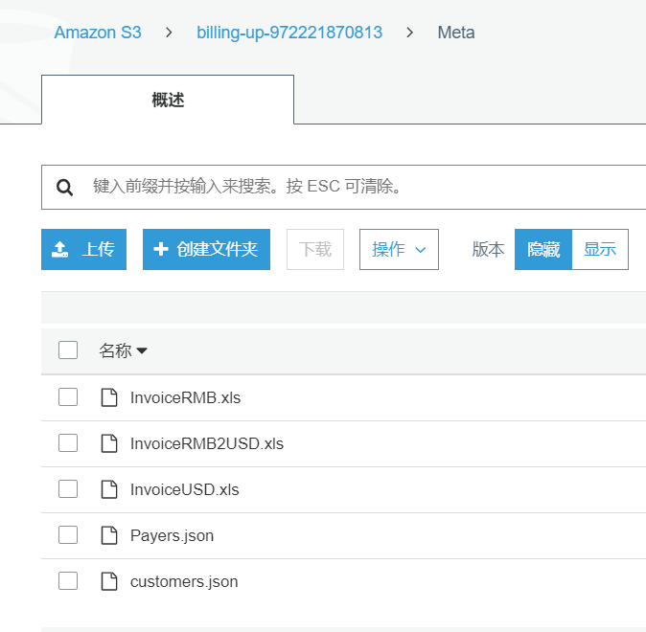

## 维护代付账户

<https://billing-up-972221870813.s3-ap-northeast-1.amazonaws.com/Meta/Payers.json>

{  
 "194461301570": {},  
 "694302255325": {},  
 "773095688257": {},  
 "785865712272": {  
 "removeCredit": **true** },  
 "790080318552": {  
 "removeCredit": **true** },  
 "972221870813": {}  
}

## 维护客户和aws账户

<https://billing-up-972221870813.s3-ap-northeast-1.amazonaws.com/Meta/customers.json>

{  
 "亿叁玩": {  
 "Accounts": {  
 "021086759490": {}  
 },  
 "FirstJoinedTime": "19-05-13",  
 "Currency": "RMB2USD"  
 },  
 "卡拉卡尔": {  
 "Accounts": {  
 "171267484006": {}  
 },  
 "FirstJoinedTime": "19-06-25",  
 "Currency": "RMB2USD"  
 },  
 "四九游": {  
 "Accounts": {  
 "117160278694": {}  
 },  
 "Addr": "Unit 807 Harcourt House , 39Gloucester Road , Wanchai , Hong Kong ",  
 "FirstJoinedTime": "19-08-05",  
 "Name": "49You Technology Hong Kong Limited",  
 "Tel": "+86 13112109168"  
 },  
 "壳木": {  
 "Accounts": {  
 "019957281835": {},  
 "091489790736": {},  
 "407489765042": {},  
 "591158394134": {},  
 "825632422495": {},  
 "848575739643": {}  
 },  
 "Addr": "1201 Orange Street, Suite 600 Wilmington, DE 19801, USA",  
 "FirstJoinedTime": "19-08-21",  
 "Name": "Camel Games Limited",  
 "Tel": "+86 13466580741"  
 },  
 "美百极致": {  
 "Accounts": {  
 "448880144775": {}  
 },  
 "FirstJoinedTime": "19-09-29",  
 "Addr": "No.1108, Wangjing SOHO Center T2 Building A, Chaoyang District Beijing",  
 "Name": "MBYTE EXTREME LTD",  
 "Tel": "+86 13601320726"  
 },  
 "小漫": {  
 "Accounts": {  
 "644082453638": {}  
 },  
 "FirstJoinedTime": "19-09-25",  
 "Addr": "21/F, Beijing Taiyue Tower, 13A, Beiyuan Road, Chaoyang Dist, Beijing, Bei 100107 CN",  
 "Name": "BEIJING ORANGE ROAM WIFI TECHNOLOGY CO.,LTD",  
 "Tel": "+86 13701167930"  
 },  
 "气吞云梦": {  
 "Accounts": {  
 "821950253708": {}  
 },  
 "FirstJoinedTime": "19-09-09"  
 },  
 "炫踪": {  
 "Accounts": {  
 "288705001091": {}  
 },  
 "Addr": "unit 2508A,25/F BANK OF AMERICA TOWER 12 HARCOURT ROAD CENTRAL HONG KONG CHINA",  
 "FirstJoinedTime": "19-08-19",  
 "Name": "Shinezone Group Limited",  
 "Tel": "+86 13918171734"  
 },  
 "甘普科技": {  
 "Accounts": {  
 "188015651676": {},  
 "321122529287": {},  
 "663327194198": {}  
 },  
 "Addr": "17/F Winsan Tower, 98 Thomson Road, Wanchai HK",  
 "FirstJoinedTime": "19-07-26",  
 "Name": "GUMP TECH CO., LIMITED",  
 "Tel": "+86 13910413092"  
 },  
 "益玩": {  
 "Accounts": {  
 "223981221836": {}  
 },  
 "Addr": "RM 702 7/F KOWLOON BUILDING 555 NATHAN RD KOWLOON HK",  
 "FirstJoinedTime": "19-09-19",  
 "Name": "Hong Kong Just Game Technology Limited",  
 "Tel": "18819292860"  
 },  
 "神州泰岳": {  
 "Accounts": {  
 "139260835254": {},  
 "209420368355": {},  
 "648637212927": {},  
 "750442077565": {},  
 "972221870813": {}  
 },  
 "FirstJoinedTime": "18-11-02",  
 "Name": "北京神州泰岳软件股份有限公司"  
 },  
 "米兰网": {  
 "Accounts": {  
 "076872229167": {}  
 },  
 "Addr": "3F, Building 9, Intime city, No.1999, Yizhou Avenue, Tianfu 4th Street, Hi-tech Zone, Chengdu, P. R. China",  
 "FirstJoinedTime": "19-09-10",  
 "Name": "MILANOO.COM.LTD",  
 "Tel": "028-86198523"  
 },  
 "绝地科技": {  
 "Accounts": {  
 "416943854918": {}  
 },  
 "Addr": "Room 1501, New Era Square (Low Block), No.181 Queen's Road Central, Hong Kong",  
 "FirstJoinedTime": "19-05-20",  
 "Name": "Anakin Universal Group Limited",  
 "Tel": "+86 15267120873"  
 },  
 "莉莉丝": {  
 "Accounts": {  
 "431339799619": {}  
 },  
 "Addr": "Unit 402, 4th Floor, Fairmont House, No.8 Cotton Tree Drive, Admiralty, Hong Kong",  
 "FirstJoinedTime": "19-06-10",  
 "Name": "Lilith Technology Hong Kong Limited",  
 "Tel": "+86 18988842198"  
 },  
 "阿哇龙": {  
 "Accounts": {  
 "388583281175": {},  
 "732997581574": {}  
 },  
 "FirstJoinedTime": "19-04-17",  
 "Currency": "RMB2USD"  
 },  
 "中手游": {  
 "Accounts": {  
 "887853071793": {}  
 },  
 "FirstJoinedTime": "19-09-12"  
 },  
 "君海": {  
 "Accounts": {  
 "692784811640": {}  
 },  
 "FirstJoinedTime": "19-09-29"  
 },  
 "诗悦": {  
 "Accounts": {  
 "361735289382": {}  
 },  
 "FirstJoinedTime": "19-09-29"  
 },  
 "万游网络": {  
 "Accounts": {  
 "449644015512": {}  
 },  
 "FirstJoinedTime": "19-10-08"  
 },  
 "七七游": {  
 "Accounts": {  
 "950174899702": {},  
 "857328109807": {}  
 },  
 "FirstJoinedTime": "19-09-29"  
 },  
 "TAP4FUN": {  
 "Accounts": {  
 "172169962929": {},  
 "457971589802": {},  
 "248286907261": {},  
 "738457323871": {},  
 "083847856979": {},  
 "769436410599": {},  
 "599372573053": {},  
 "467757004379": {},  
 "694302255325": {},  
 "598331460179": {}  
 },  
 "FirstJoinedTime": "19-09-20",  
 "Addr": "Unit 402, 4th Floor, Fairmont House, No.8 Cotton Tree Drive, Admiralty, Hong Kong",  
 "Name": "TAP4FUN (HONGKONG) LIMITED ",  
 "Tel": "+86 18988842198"  
 }  
}

# 监控和管理

## 手动启动出帐

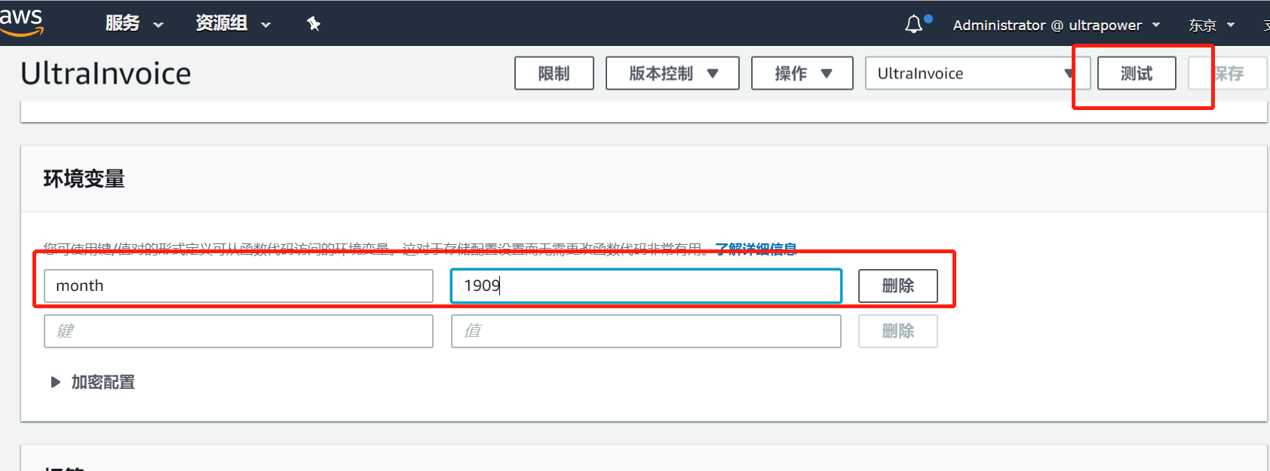

## 监控错误