N. CAROL PERSY

Highly Available Web Application on AWS
EC2 · Application Load Balancer · Auto Scaling · CloudWatch · SNS
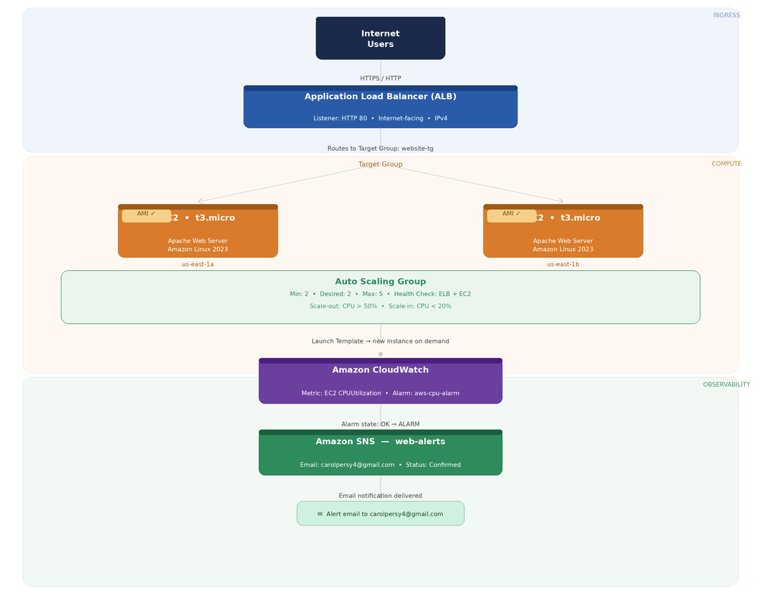
carolpersy4@gmail.com · +91 90429 13142 · linkedin.com/in/carol-persy

About This Project
I built this to get past the theory and actually understand what 'high availability' means when it runs — not just on paper. The goal was simple: host a website on AWS in a way that handles traffic spikes on its own, and keeps running even if a server goes down at 2am without anyone touching it.
Everything here was configured manually on the AWS Console. No automation shortcuts — deliberately, so I'd understand what each service actually does rather than just clicking through a wizard. The screenshots throughout this document are from my own AWS account, taken while the environment was live.

Architecture

Traffic flows in from the internet to the Application Load Balancer, which distributes requests only to EC2 instances that are passing health checks. The Auto Scaling Group keeps the instance count between 2 and 5, growing or shrinking based on CPU load. CloudWatch watches that CPU metric in the background and triggers an alarm when it crosses the defined threshold. SNS delivers the alert by email the moment the alarm fires.

AWS Services Used

Service | Role in this project
Amazon EC2 | Runs the Apache web server; receives traffic from the ALB
Application Load Balancer | Distributes HTTP traffic across targets; performs health checks
Target Group (website-tg) | Tracks per-instance health; routes only to healthy targets
Auto Scaling Group | Maintains 2–5 EC2 instances; replaces failed ones automatically
Amazon CloudWatch | Monitors CPUUtilization; triggers alarms on threshold breach
Amazon SNS (web-alerts) | Delivers email alert the moment an alarm changes state
AMI + Launch Template | Ensures every new instance boots identically, pre-configured

How I Built It
Not a click-by-click log — just the milestones that mattered, with console proof alongside each one.
1 Launched EC2 and installed Apache
Started with an Amazon Linux 2023 t3.micro instance, connected over SSH, and installed Apache. The httpd service came up as 'active (running)' and started serving requests straight away.
sudo yum update -y
sudo yum install httpd -y
sudo systemctl enable httpd
sudo systemctl start httpd
systemctl status httpd
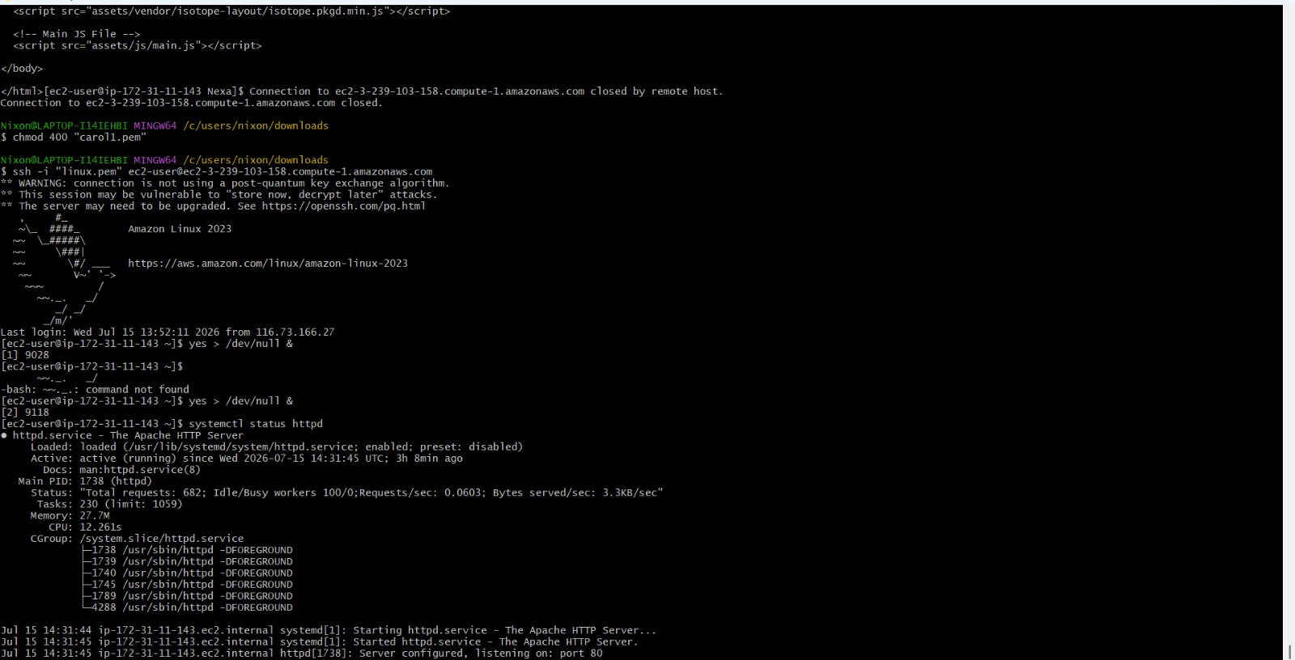
Apache (httpd) active and running on EC2 — confirmed via systemctl status
2 Created AMI and Launch Template
Once the web files were in place, I created an AMI from the configured instance. That AMI went into a Launch Template, which the Auto Scaling Group uses later to spin up new instances — identical to the original, with no manual setup required.
3 Configured Application Load Balancer
Set up an internet-facing ALB with a listener on port 80, forwarding to a Target Group. The ALB needed subnets in at least two Availability Zones — a hard requirement. Health check path set to '/', with a threshold of 2 consecutive checks.
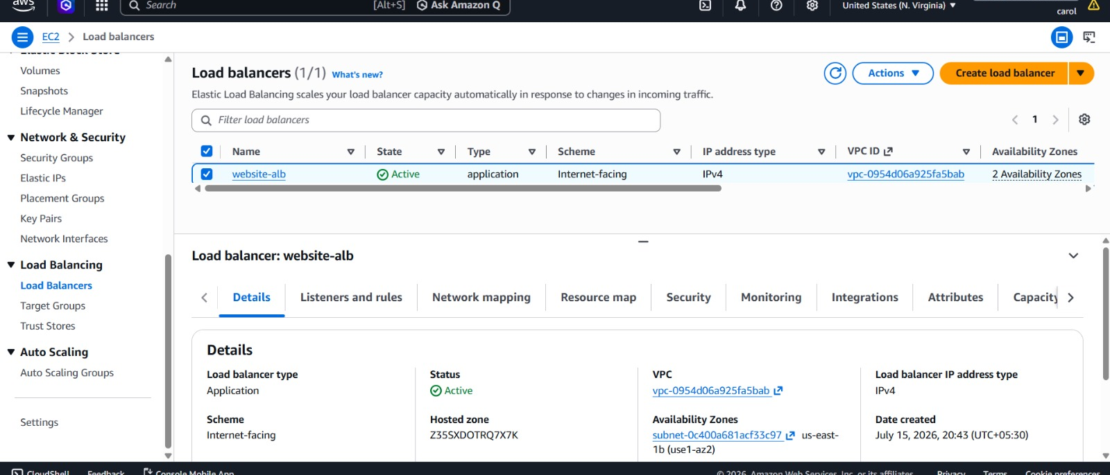
website-alb — Application type, Internet-facing, Active, across 2 AZs
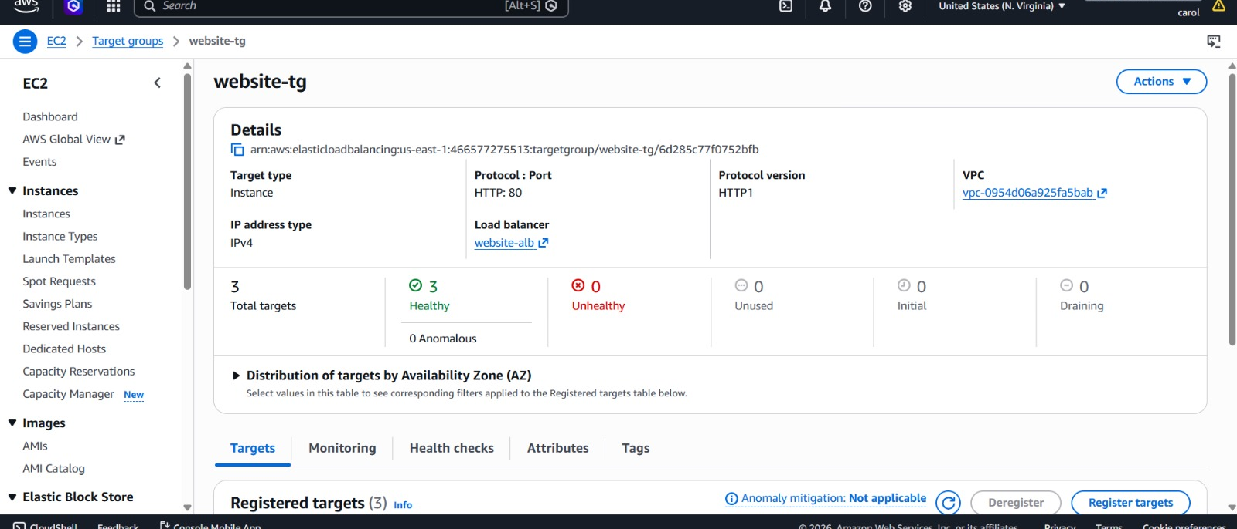
Target group website-tg — 3 registered targets, all Healthy
4 Set up Auto Scaling Group
Linked the ASG to the Launch Template and attached it to the ALB's Target Group. Health check type set to ELB + EC2 so that a target failing its ALB health check gets replaced — not just EC2-level failures.
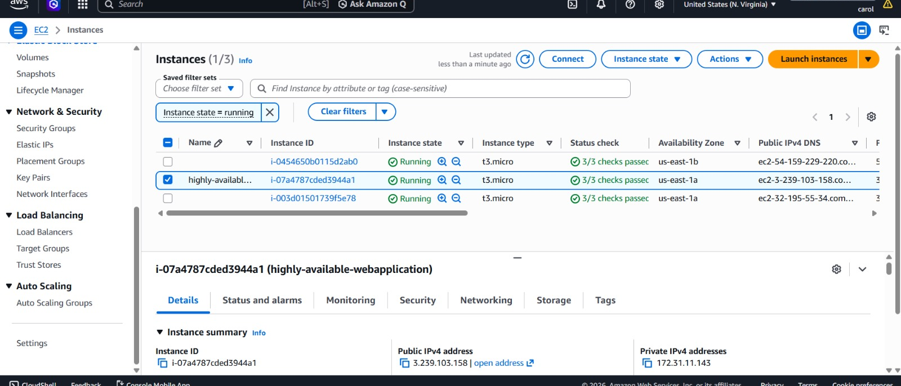
Three EC2 instances running — each passing 3/3 status checks across two AZs
5 Wired up CloudWatch Alarm and SNS
Created a CloudWatch alarm watching CPUUtilization. During load testing the alarm tripped from OK to ALARM within seconds. That alarm is tied to an SNS topic with my email subscribed and confirmed.
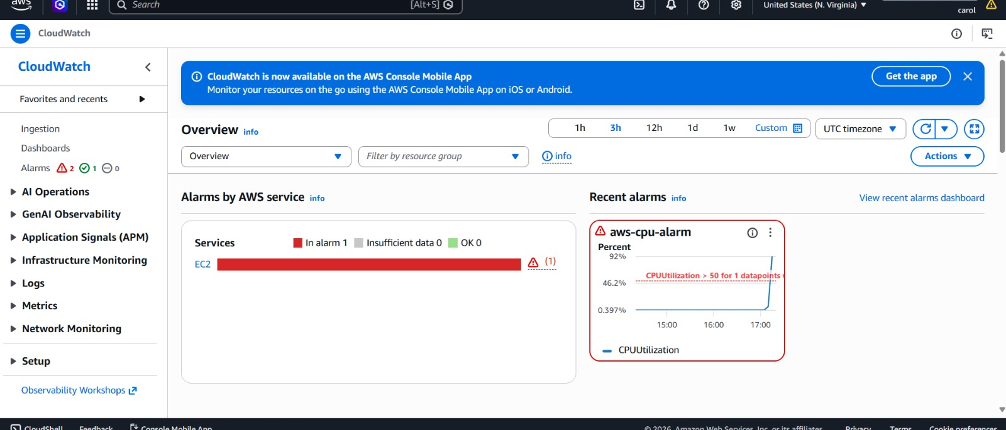
aws-cpu-alarm in ALARM state — CPU spike visible in graph after load test
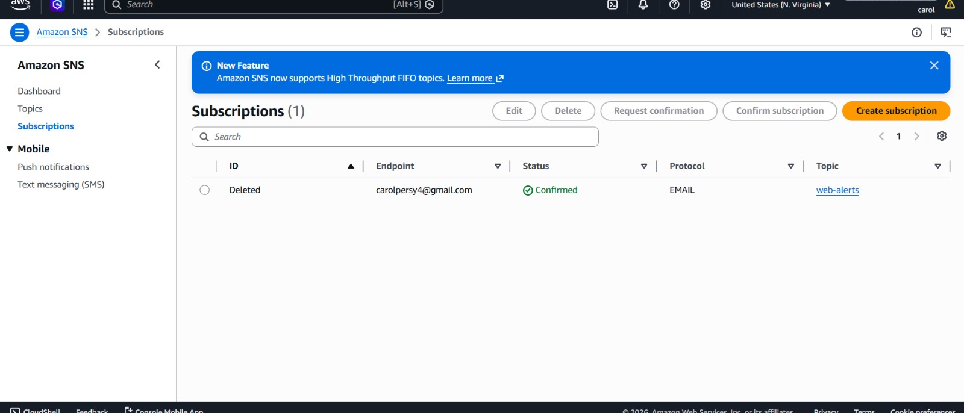
SNS subscription confirmed to carolpersy4@gmail.com via topic web-alerts
6 Tested end to end
Opened the ALB's DNS name directly in the browser to confirm traffic was being routed through the load balancer and not hitting an instance directly. To verify self-healing, I terminated one running instance manually — the ASG replaced it automatically, the new instance passed its health check, and the site stayed up the entire time.

Website live via ALB endpoint — website-alb-215288576.us-east-1.elb.amazonaws.com

What I Verified
- Site stayed reachable through a manual instance termination — no visible downtime
- Auto Scaling Group scaled from 2 to 4 instances under CPU load, then scaled back in
- CloudWatch alarm fired within seconds of the CPU threshold being crossed
- SNS delivered the alert email to my inbox within a minute of the alarm state changing
- ALB only ever routed requests to instances that were actively passing health checks

What This Taught Me
The console makes a lot of this look simple, but configuring each piece manually made it obvious how many small decisions go into 'high availability' — health check intervals, which AZs to spread across, what counts as unhealthy, when to scale. It's one thing to read about Auto Scaling; it's another to kill a server and watch the system replace it without a page going down.
If I take this further, next steps would be: HTTPS via ACM, moving the AMI build into a CI/CD pipeline, and putting the whole stack behind Terraform or CloudFormation so it's reproducible without manual console work.

Skills Demonstrated
- AWS: EC2, Application Load Balancer, Target Groups, Auto Scaling Groups, CloudWatch, SNS, AMI, Launch Templates
- Linux administration: Amazon Linux 2023, Apache/httpd, YUM, systemctl
- High availability and fault-tolerant architecture design
- Load testing, monitoring metric validation, alarm configuration
- End-to-end infrastructure testing under real failure conditions

