**Task 1:** Change the Duration

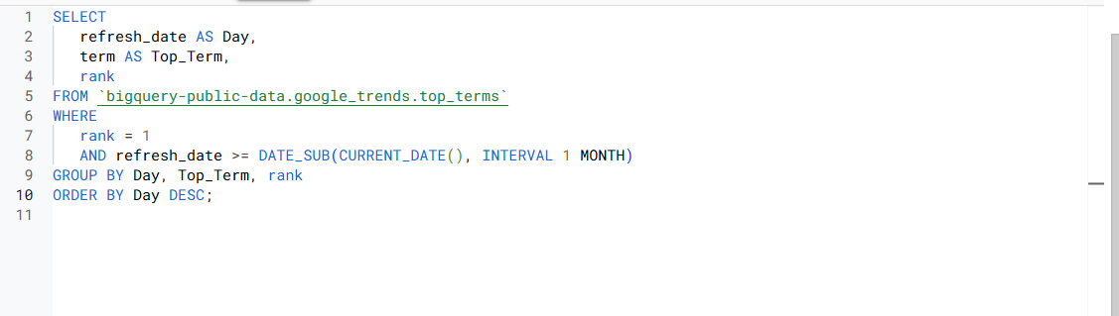

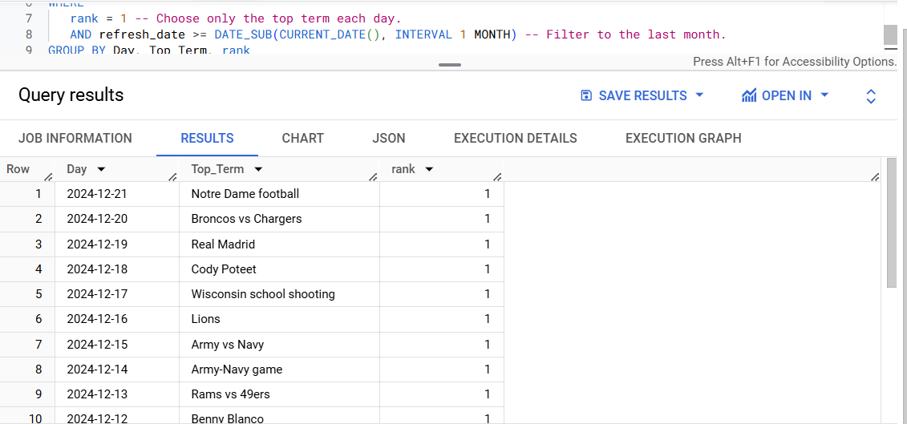

* The INTERVAL 2 WEEK was replaced with INTERVAL 1 MONTH.
* This extends the date range from two weeks to one month.

**Task 2:** Modify the Rank Filter

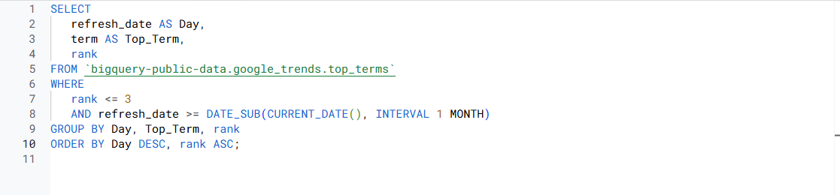

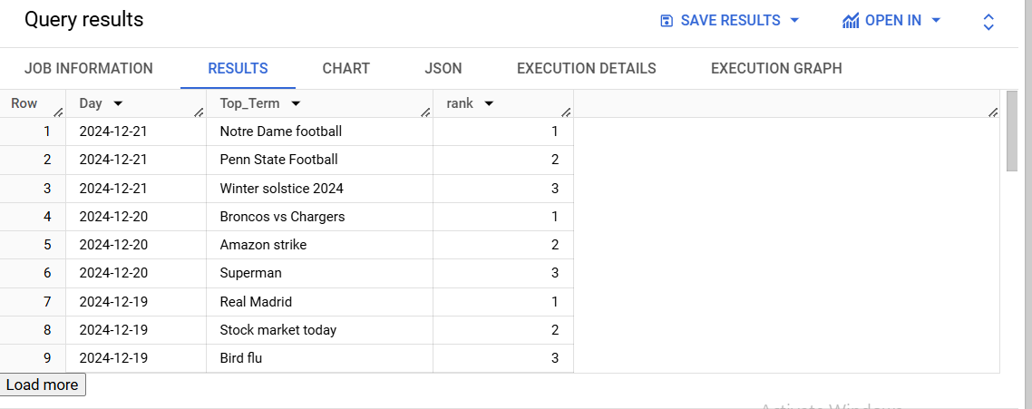

* The condition rank = 1 was changed to rank <= 3 to include the top 3 terms.
* The ORDER BY was adjusted to prioritize lower ranks (1 being highest).

**Task 3:** Add Region Filtering

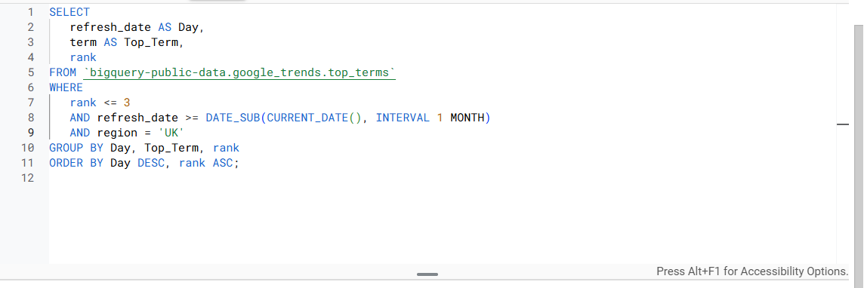

* Added an 🡪 AND region = “UK”

**Task 4:** Use a JOIN

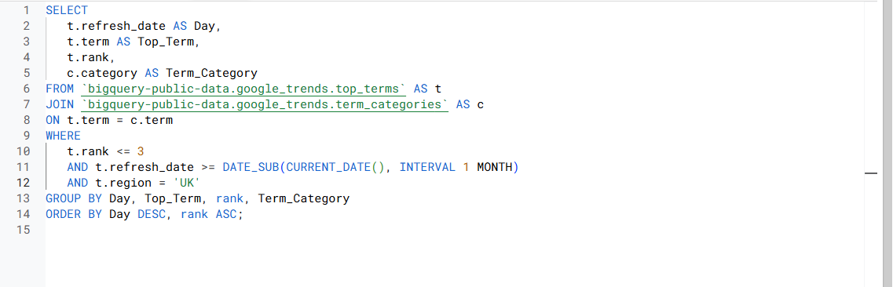

* Added a JOIN clause to connect the top_terms table with the term_categories table.
* Included the category column in the SELECT statement.

**Task 5:** Add Weekly Aggregation

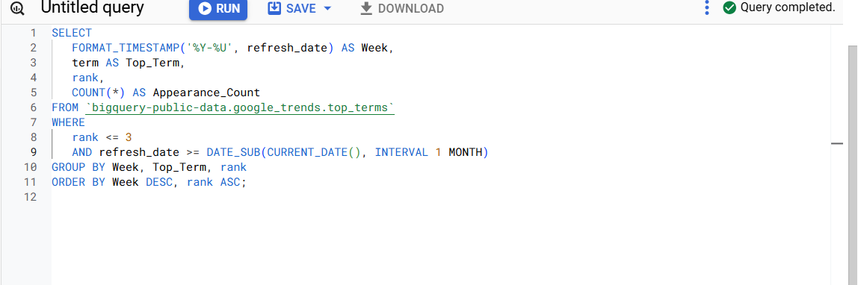

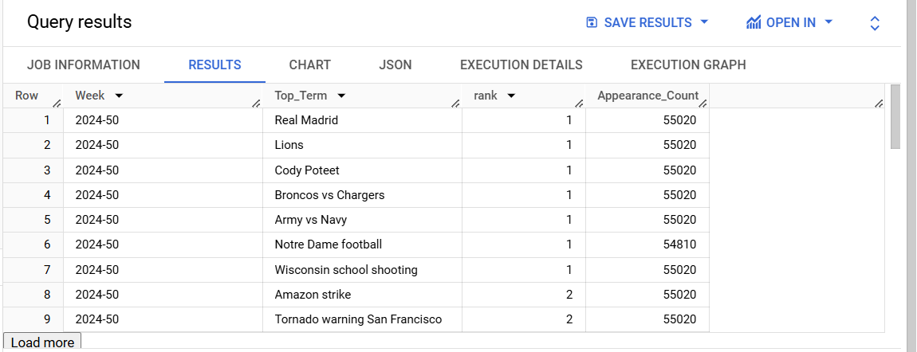

* Used FORMAT_TIMESTAMP('%Y-%U', refresh_date) to group data by week.
* Added COUNT(*) AS Appearance_Count to track how often each term appears in a week.