Field | Detail
Date | 30 September 2026
Team ID | SWTID-2026-2709
Project Name | FitBuddy AI Tool (FitBuddy-NM-AI-Tool)
Maximum Marks | 2 Marks

PROJECT DEMONSTRATION
Demonstration of Proposed Features
FitBuddy – AI Fitness Plan Generator

AI-powered personalized wellness and workout planning system
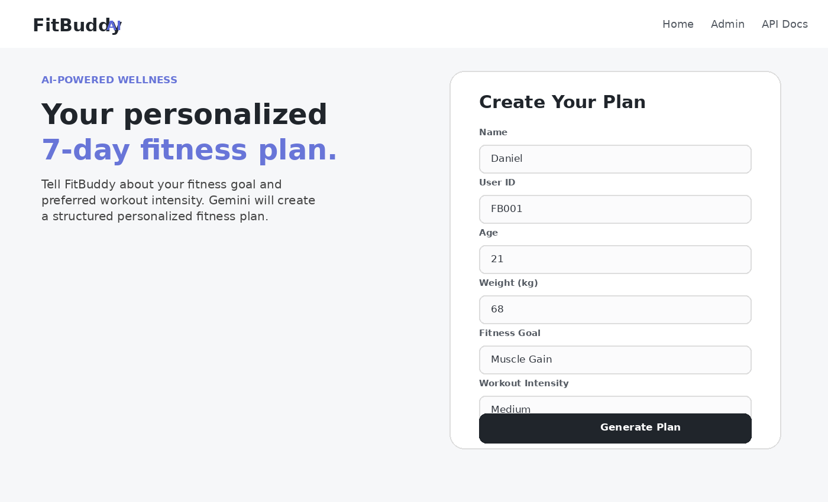
Figure 1: FitBuddy home page and proposed user workflow

1. Project Overview
FitBuddy is a web-based AI fitness planning application that collects a user's basic fitness profile, fitness goal, and preferred workout intensity, then generates a personalized 7-day workout plan. The application also provides a nutrition/recovery tip and allows the user to submit feedback so that the workout plan can be revised.
The implementation uses FastAPI for the web application, Jinja2 templates for the user interface, SQLAlchemy for persistent user records, and Gemini-powered generation for workout and nutrition content. Fallback logic is included so the application can still provide safe general wellness guidance when the AI service is unavailable.

2. Proposed Features Demonstrated
Feature | User Action | System Output
Personalized profile input | Enter name, ID, age, weight, goal and intensity | Validated fitness profile
AI workout generation | Submit the fitness form | Structured 7-day workout plan
Nutrition / recovery guidance | Generate a plan | Goal-specific wellness tip
Feedback-based revision | Enter requested changes | Updated workout plan
Persistent user records | Generate and update plans | Stored profile, plans and feedback
Validation and safety | Enter invalid or unsafe inputs | Validation errors and safe guidance
Admin/API access | Open Admin or API Docs | User records and FastAPI documentation

3. Personalized User Input
Purpose: Collect the minimum information needed to create a practical personalized fitness plan.

Demonstration Steps
- Open the FitBuddy home page.
- Enter the user's name and unique User ID.
- Enter age and body weight in kilograms.
- Select one fitness goal: Weight Loss, Muscle Gain, General Wellness, or Flexibility.
- Select workout intensity: Low, Medium, or High.
- Submit the form to generate the plan.

Expected / Observed Result
The application validates the submitted values with Pydantic rules. Age is restricted to 13–100, weight must be positive, and the goal/intensity must match the supported choices. A duplicate User ID is rejected.
Figure: FitBuddy feature demonstration

4. AI-Generated 7-Day Workout Plan
Purpose: Generate a structured weekly workout plan tailored to the user's profile.

Demonstration Steps
- FitBuddy converts the submitted profile into a structured UserInput object.
- The workout generator sends a personalized prompt to the Gemini model when available.
- The prompt requests Day 1 through Day 7, including warm-up, main workout, sets/repetitions or duration, rest guidance, cooldown/recovery, and at least one recovery/rest day.
- If Gemini is unavailable or returns no usable response, FitBuddy uses a built-in safe fallback plan.

Expected / Observed Result
The result page displays a personalized 7-day plan under the “7-Day Workout Plan” section. The plan is associated with the user's stored profile.
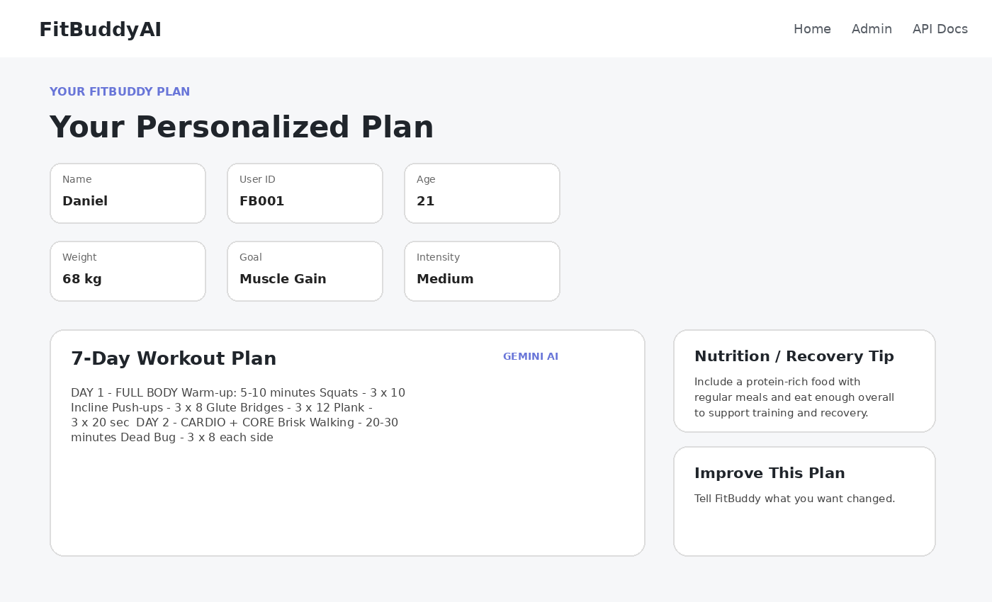
Figure: FitBuddy feature demonstration

5. Nutrition and Recovery Tip
Purpose: Provide a concise, goal-specific wellness suggestion alongside the workout plan.

Demonstration Steps
- FitBuddy identifies the user's selected fitness goal.
- A nutrition/recovery prompt is sent to the Gemini Flash model when available.
- The generated response is limited to practical general-wellness guidance.
- If the AI service is unavailable, a predefined safe fallback tip is returned.

Expected / Observed Result
The result page displays a Nutrition / Recovery Tip beside the workout plan. Examples include balanced meals and hydration for general wellness, or protein-rich foods and adequate energy intake for muscle gain.
Figure: FitBuddy feature demonstration

6. Feedback-Based Workout Plan Update
Purpose: Allow the user to refine the generated plan instead of starting over.

Demonstration Steps
- On the result page, select “Improve This Plan”.
- Enter specific feedback such as changing exercise difficulty or adding more cardio.
- FitBuddy locates the user's existing record using the User ID.
- The original workout plan and feedback are passed to the plan-update logic.
- The revised plan is stored as the updated plan and the submitted feedback is retained.

Expected / Observed Result
FitBuddy confirms that the feedback has been applied and presents the updated workout plan. The original plan remains available in the stored user record.
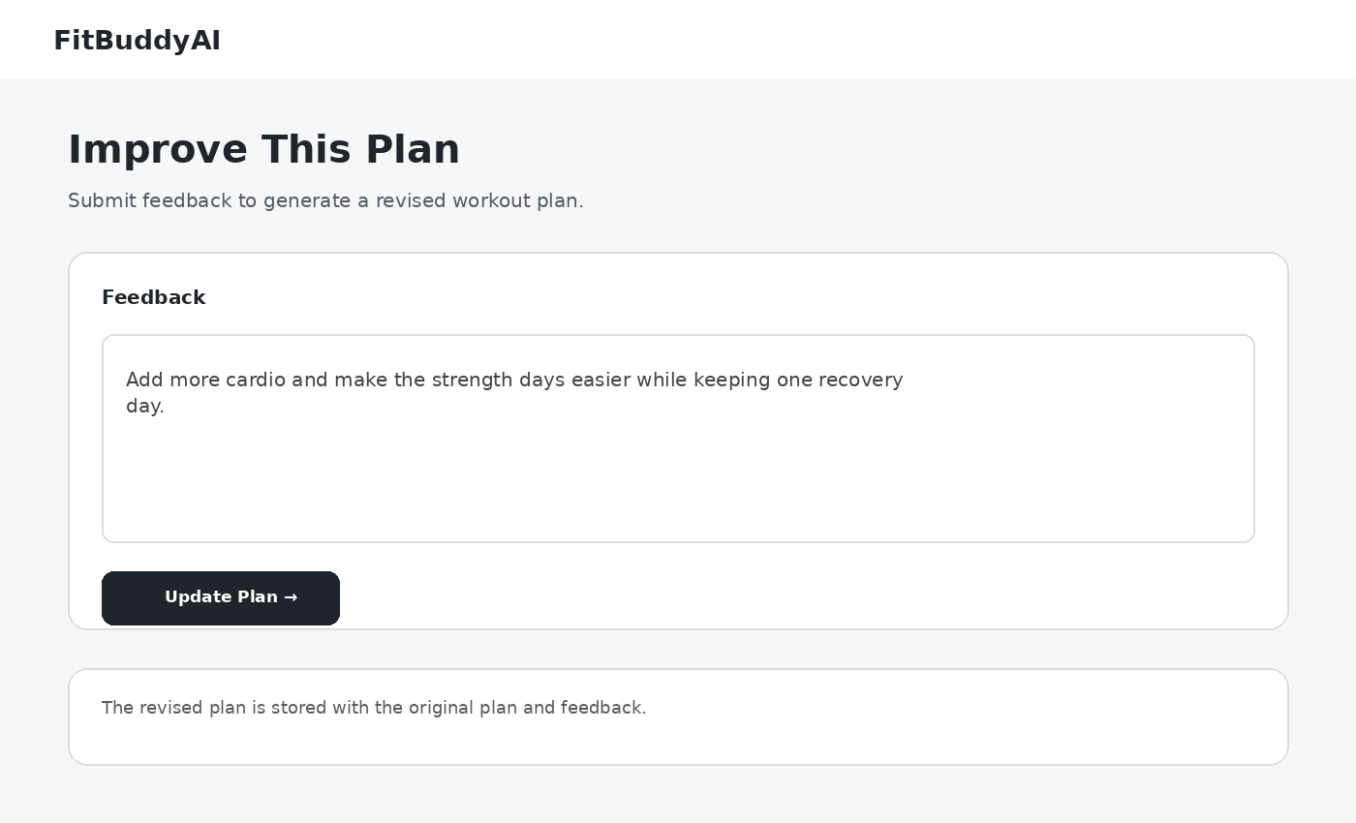
Figure: FitBuddy feature demonstration

7. Data Persistence and User Records
Purpose: Maintain a reliable record of profiles, generated plans, feedback, and timestamps.

Demonstration Steps
- When a new plan is generated, FitBuddy creates a User database record.
- The record stores User ID, name, age, weight, goal, intensity, original plan, nutrition tip, feedback, and timestamps.
- SQLAlchemy is used to create and query the database records.
- The User ID is unique, preventing accidental duplicate profiles.

Expected / Observed Result
User information and generated content can be retrieved through the application's user-management functionality. The data model supports both original and revised plans.

8. Validation, Error Handling and Safety
Purpose: Prevent invalid input and keep AI-generated wellness guidance within safe general-purpose boundaries.

Demonstration Steps
- Input fields are stripped and checked for empty values.
- Age and weight are range-validated.
- Fitness goal and workout intensity are restricted to supported values.
- Duplicate User IDs return a conflict response instead of overwriting a user.
- AI generation errors are caught and handled with safe fallback content.
- The workout generation system instruction prohibits medical diagnosis, medication advice, dangerous exercise extremes, and exercising through pain.

Expected / Observed Result
The application returns clear validation or error feedback and falls back to conservative general fitness guidance when the AI service cannot be reached.

9. Admin and API Documentation Access
Purpose: Provide project-maintenance and developer-facing access points.

Demonstration Steps
- Use the navigation bar to open the Admin page for user records.
- Use the API Docs link to open FastAPI's automatically generated documentation.
- Use these interfaces to inspect application behavior and available endpoints during demonstration.

Expected / Observed Result
The application exposes user-management functionality and FastAPI documentation, supporting testing, debugging, and demonstration of the implemented endpoints.

10. End-to-End Demonstration Flow
- Start the FitBuddy application.
- Open the home page.
- Enter a new user profile and choose a fitness goal and intensity.
- Submit the form.
- FitBuddy validates the data and generates the 7-day plan and nutrition/recovery tip.
- Review the personalized plan on the result page.
- Submit feedback to request a change.
- FitBuddy generates and stores the revised plan.
- Use the Admin page or API Docs to demonstrate the supporting application interfaces.

11. Technology Used
Technology | Role
Backend | FastAPI
Frontend | HTML, Jinja2 templates, CSS
AI | Google Gemini model integration
Database | SQLAlchemy ORM with the configured application database
Validation | Pydantic
Testing | Python test suite included in the project

12. Conclusion
The FitBuddy demonstration shows a complete AI-assisted wellness workflow: user profile collection, validated input, personalized 7-day workout generation, nutrition/recovery guidance, feedback-driven plan revision, persistent storage, and safety-oriented fallback behavior. The implementation is structured as a working web application rather than a static concept, making the proposed features suitable for live project demonstration.

FitBuddy – Demonstration of Proposed Features

