|  |
| --- |
| 2020/11/10 |
| Laravel documentation |
| 1. Migration |
| 1. Seeder |
| 1. Eloquent 2. Factory |

I. Migration 2

1. Migration overview: 2

2. Manipulations performed: 2

3. What went wrong: 4

II. Seeder 5

4. Seeder overview: 5

5. Manipulations performed: 5

6. What went wrong: 6

III. Eloquent 6

7. Eloquent overview: 6

8. Manipulations performed: 6

9. What went wrong: 6

IV. Factory 7

10. Factory overview: 7

11. Manipulations performed: 7

12. What went wrong: 7

# Migration

## Migration overview:

The first advantage of Migration is to create database in a Laravel script rather than in PhpMyAdmin or in a SQL file.

The second advantage is to be able to control versioning of our database and make easier collective work.

## Manipulations performed:

First of all, we have to go to migration files emplacement, in database/migration.

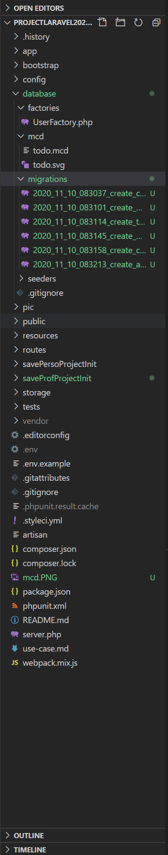

We have now to create one file by table with the following command:

* 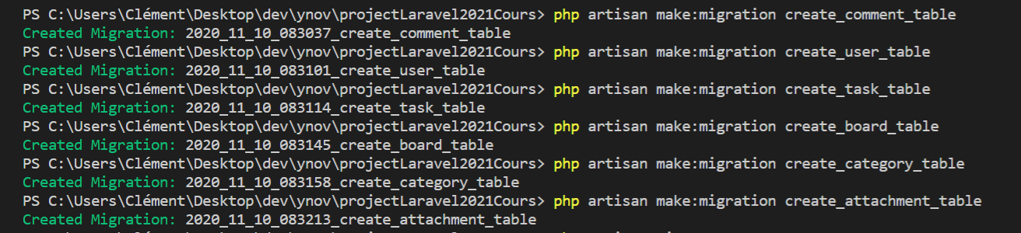php artisan make:migration create_tableName_table

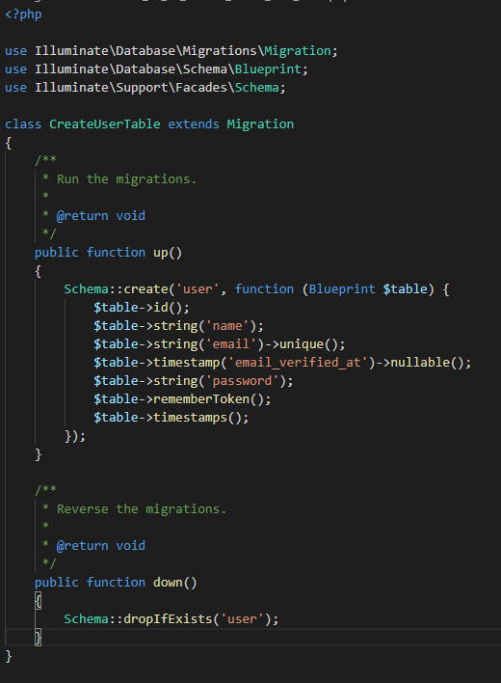In these created files we can add our tables.

Before to migrate our new tables, we have to create a new database in php MyAdmin and modify the following line with the database name in .env file:

* DB_DATABASE=databaseName

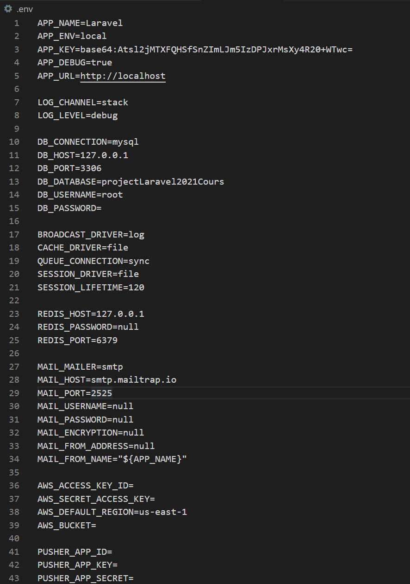

We are now ready to migrate our tables using this command:

* 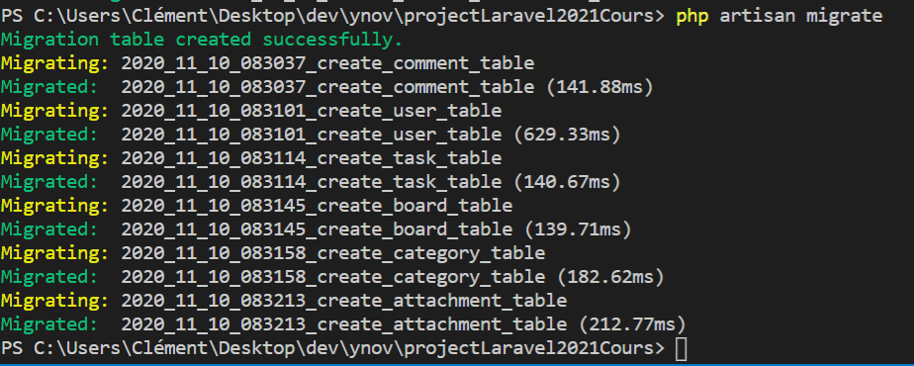php artisan migrate

The result in the database:

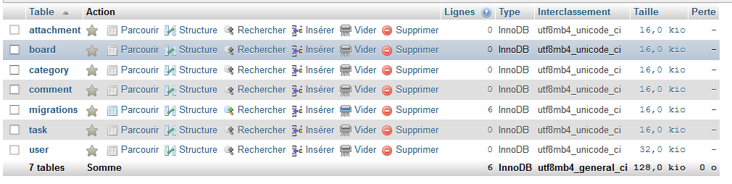

## What went wrong:

* Nothing particular.

# Seeder

## Seeder overview:

Seeders files allow to add initial and test data in the database.

## Manipulations performed:

We can accede to seeders in going to database/seeders.

The second step is to create new files:

* Php artisan make:seeder nameSeedTableSeeder

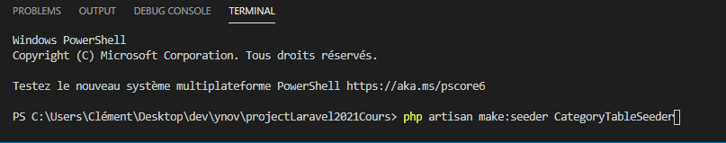

Dump-Autoload generates autoload of the project:

* 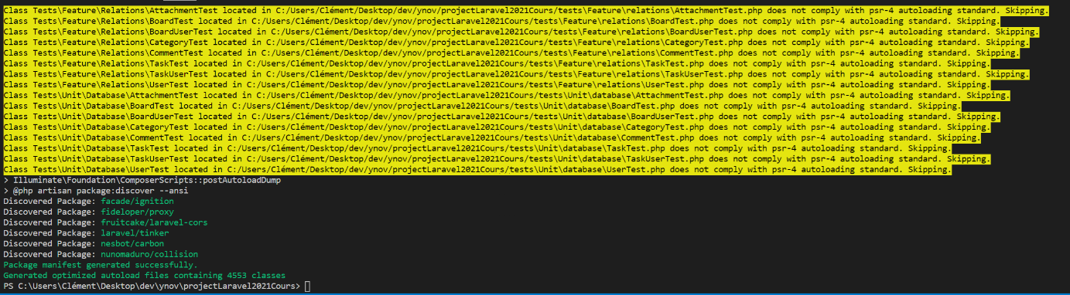composer dump-autoload

We can now add data to database:

* Php artisan db:seed

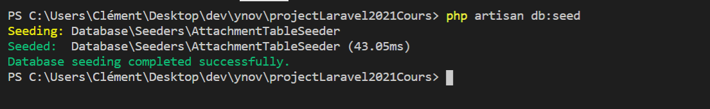

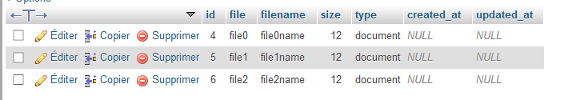

## What went wrong:

* I started to create seeders files manually without the php artisan command, so it does not work … Excepted that, everything was OK.

# Eloquent

## Eloquent overview:

## Manipulations performed:

## What went wrong:

# Factory

## Factory overview:

## Manipulations performed:

## What went wrong: