Carolyn Kennett
Urban and Business GIS
Dr. Zhou
26 September 2024

Lab 4: Network Analysis – Urban and Business GIS
Premise
This lab focused on network analysis in ArcGIS Pro, emphasizing real-world applications such as modeling drive-time service areas, optimizing store locations, and identifying the nearest facilities in emergency response scenarios. Using the Network Analyst extension, I generated service areas based on time of day, performed location-allocation modeling to choose optimal retail sites, and applied the closest facility tool to determine emergency station response times.
Part 1
Question: What differences can be observed between the two service area layers?
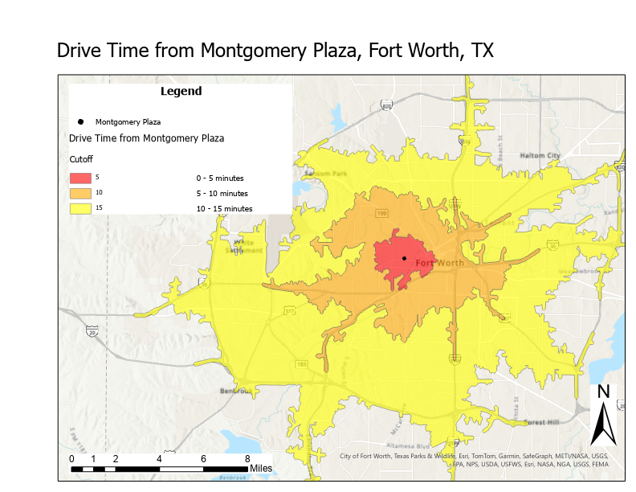
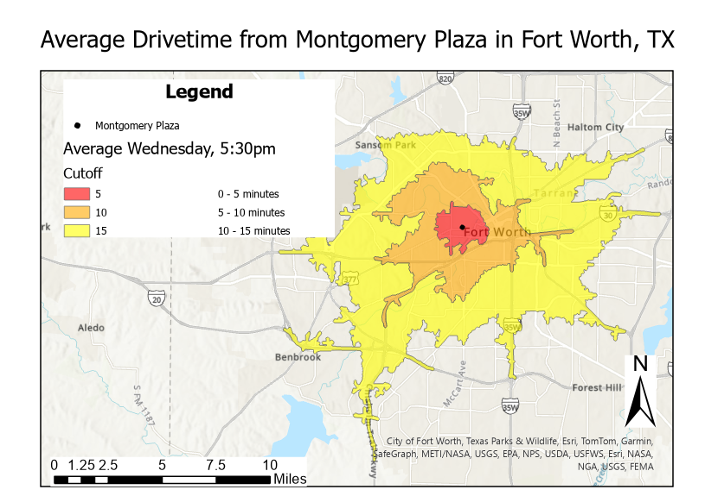
There is definitely a difference in these two Service Area layers. One is average drive time while one specifies that it is 5:30pm on a Wednesday - right during rush hour. Therefore, we can see that the drive time area is smaller for Wednesday at 5:30pm because there is lots of after-work traffic.

Part 2
Generate directions for a given route using the Network Analyst “Directions” output.
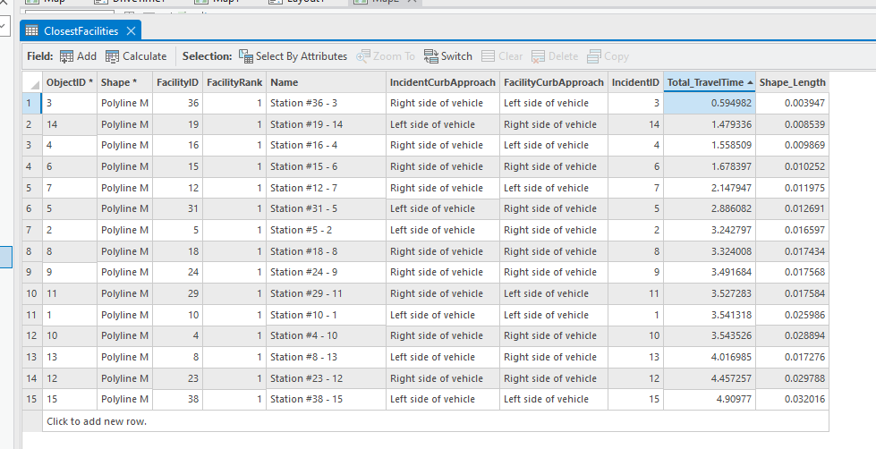
Directions
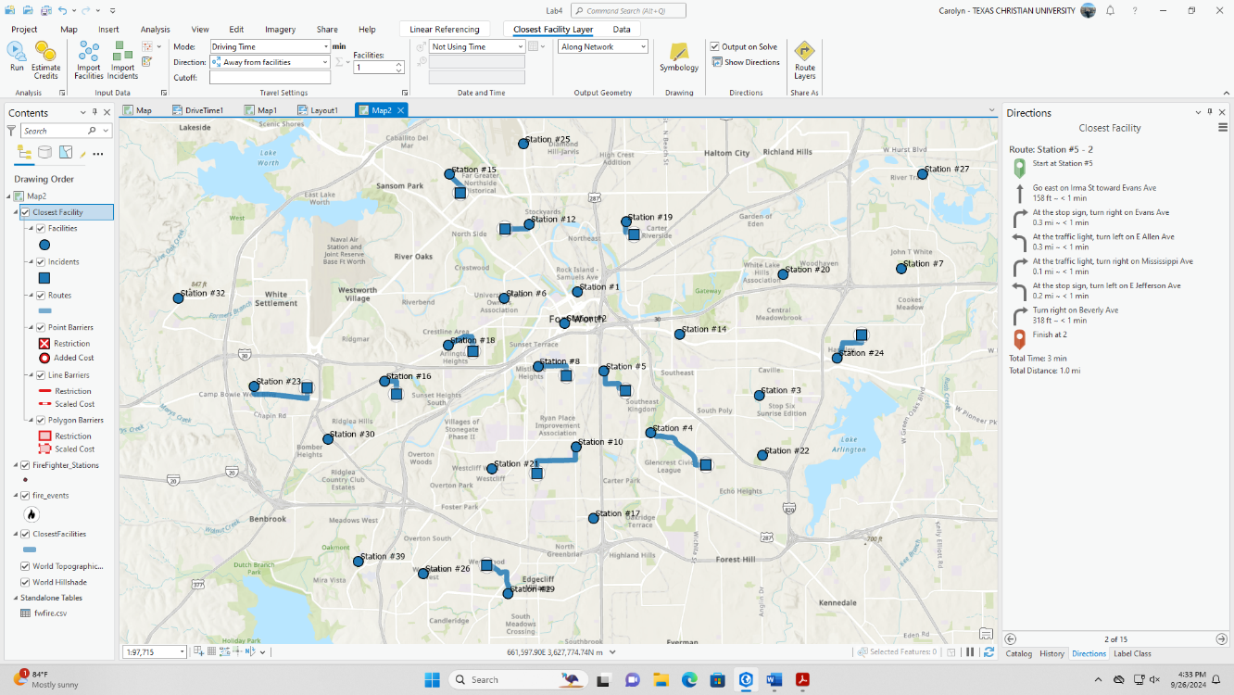

Part 3
Which stores were chosen as optimal facilities, and why?
My Location-Allocation Model chose Store #2, Store #14, and Store #15. Based on the information given to me on the chart, Store #15 was chosen as the Top Candidate because it has the shortest drive times along with a high number of tract centroids allocated to that site.
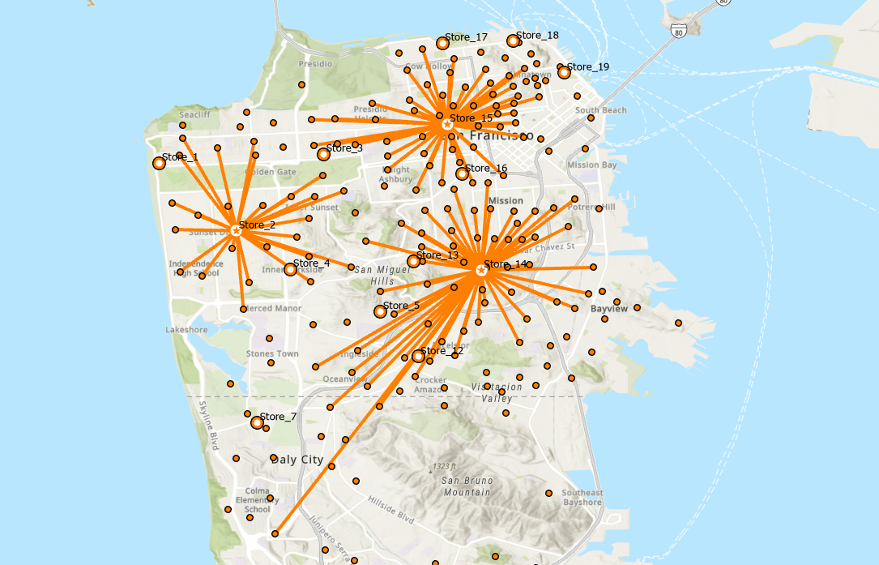

Part 4
Question: Which fire station is closest to the incident at 2323 Columbus Avenue, and what are the next best backup stations?
- The closest station to the fire at 2323 Columbus Avenue is Station #12, which is a 3.76 minute drive by car.
- If there are need for backups, I found four facilities that are less than 8 minutes away from the incident. Station #15 is 4.39 minutes away, Station #6 is 6.48 minutes away, and Station #25 is 6.50 minutes away.
Map is shown on the next page.
