Premise
This lab simulates a corporate real-estate analysis using ArcGIS Business Analyst Web App. The goal was to determine the best office location for a client among six potential sites in Washington (Everett, Olympia, Tacoma, Puyallup, Kent, and Redmond). Students imported address data, created 15-minute drive-time trade areas, compared sites using demographic variables, and conducted a suitability analysis incorporating both site-specific and demographic criteria.

Part 1
Context:
This section established the workspace and data foundation for later comparison and analysis. Each site was visualized on a map with its corresponding 15-minute drive-time polygon, allowing demographic and site-attribute information to be summarized spatially for later evaluation.
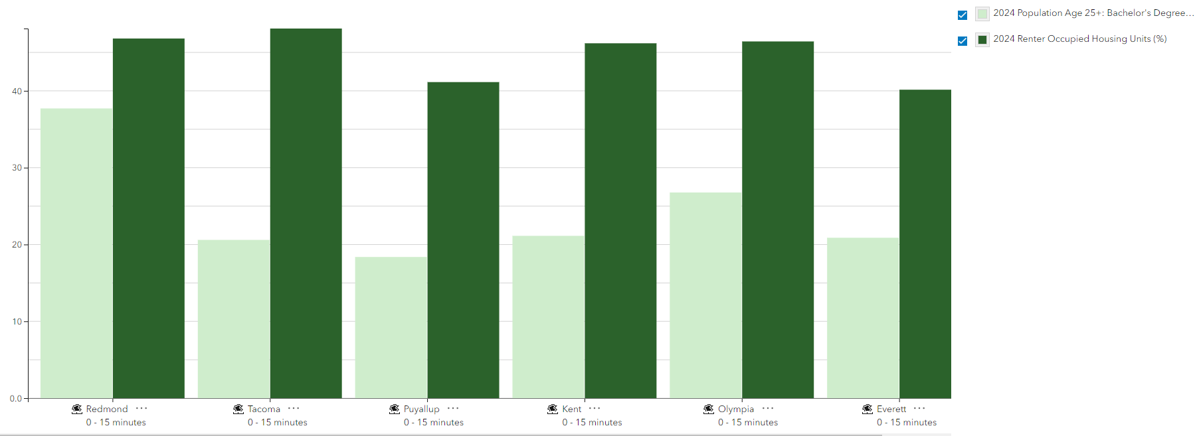

Part 2

Question:
Generate a Comparison Report using the variables Population Age 25+ with Bachelor’s Degree (%) and Renter-Occupied Housing Units (%). Use Everett as the benchmark and discuss what these results might suggest for site selection.
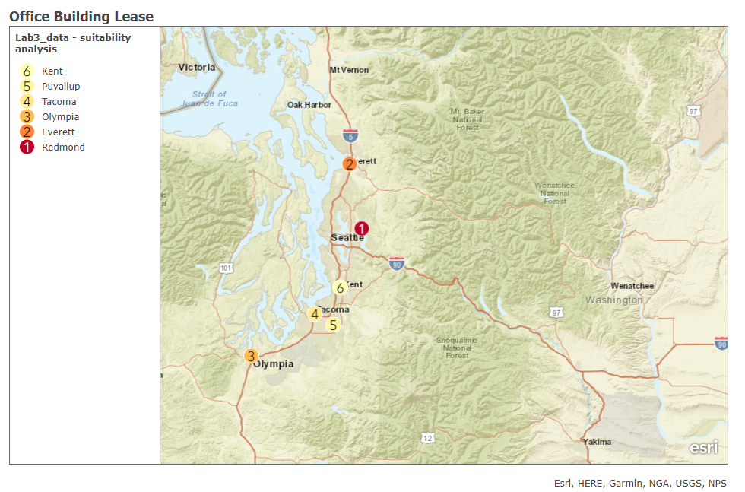

My weights:
- Cost per Foot: 45%
- Condition Rank: 15%
- Parking: 5%
- Population 25+ with Bachelor’s Degree: 25%
- Total Crime Index: 10%
Site name | Site area | Rank | Final score
Redmond | 15 minutes | 1 | 1.000
Everett | 15 minutes | 2 | 0.511
Olympia | 15 minutes | 3 | 0.315
Tacoma | 15 minutes | 4 | 0.142
Puyallup | 15 minutes | 5 | 0.065
Kent | 15 minutes | 6 | 0.000

Part 3
Question:
Which location is best for an office building location for a corporate real estate customer?
According to both the Comparison Report and the Suitability Analysis, I can confidently say that Redmond would be the best place to place the next office.
According to the Comparison Report, the average (%) renter-occupied housing units are similar in range, with the highest being 48.11% (Tacoma) and the lowest being 40.15% (Everett). Redmond sneaks right below Tacoma at 46.81%. This is above average within the United States, which hovers around 35%. Therefore, all six locations exceed expectations for renter-occupied units…but not too much where real estate would be impossible. In fact, I see these high numbers as a positive because these areas might be in higher demand.
Redmond skyrockets the other potential locations in education, with 37.71% of the 25+ population obtaining Bachelor Degrees. The next closest is Olympia at 26.77% - still over 10% lower. The lowest is Puyallup at 18.38%. Education is key because real estate offices need access to skilled workers who have successfully completed college and could benefit the company.
Next up is my Suitability Analysis.
As we know, rent in the Seattle area is pricy. Very pricy. Therefore, I decided to weigh “cost per foot” as the highest to keep the prices as low as possible. However, since I included four other important factors, my weight for “cost per foot” is less than 50%.
Parking, while useful, isn’t a much need when regarding business. It should not have a heavy influence on where businesses are placed…people can walk! Therefore, I put it as the lowest weight: 5%.
Just like my Comparison Report, I decided that adding education is crucial for a suitability analysis. It’s great that a certain area has lower rent, but does it have the right people to hire as employees? People who have a Bachelor’s Degree tend to make more money than those who don’t, so maybe they don’t live in the areas where rent is cheaper. Therefore, I decided to include “Population Age 25+: Bachelor’s Degree” to my Suitability Analysis with a 25% weight.
Next up is Condition Rank, which looks at the condition of the interior leasable area. Obviously, I would like my real estate office/building to look nice and to have the features/comfort to make my employees happy. However, it doesn’t have to be this newly-renovated/newly-built skyscraper with the best amenities.
The last factor I included was “Crime Index.” I believe, especially since parking is at a lower weight, that having a lower crime rate is critical in a business area to prevent unfortunate events from occurring. I want my employees to feel safe in office, which decreases stress and increases productivity. Therefore, I gave it at 10% weight. Don’t worry – I made sure to inverse the influence.
Based on these factors, Redmond was the best suitable option…with Everett being #2 and Kent ranked last.
As much as I would have loved to add other factors to the Suitability Analysis, like demographic characteristics or population change, I feel like adding too many variables would make the data confusing…and maybe contradictory. Therefore, I kept my analysis to five factors, and along with the Comparison Report, the data shows that Redmond would be the best location.

