stat 350

Assignment 2

Yuhan Zhang

301345627

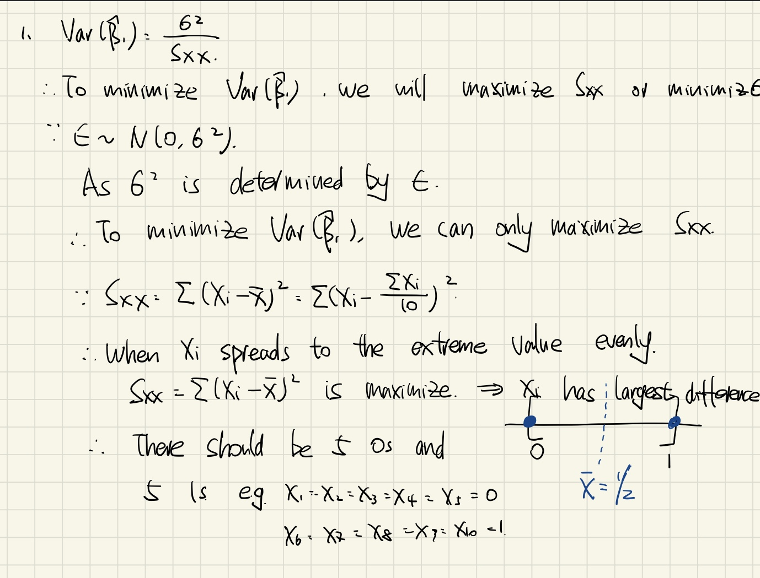

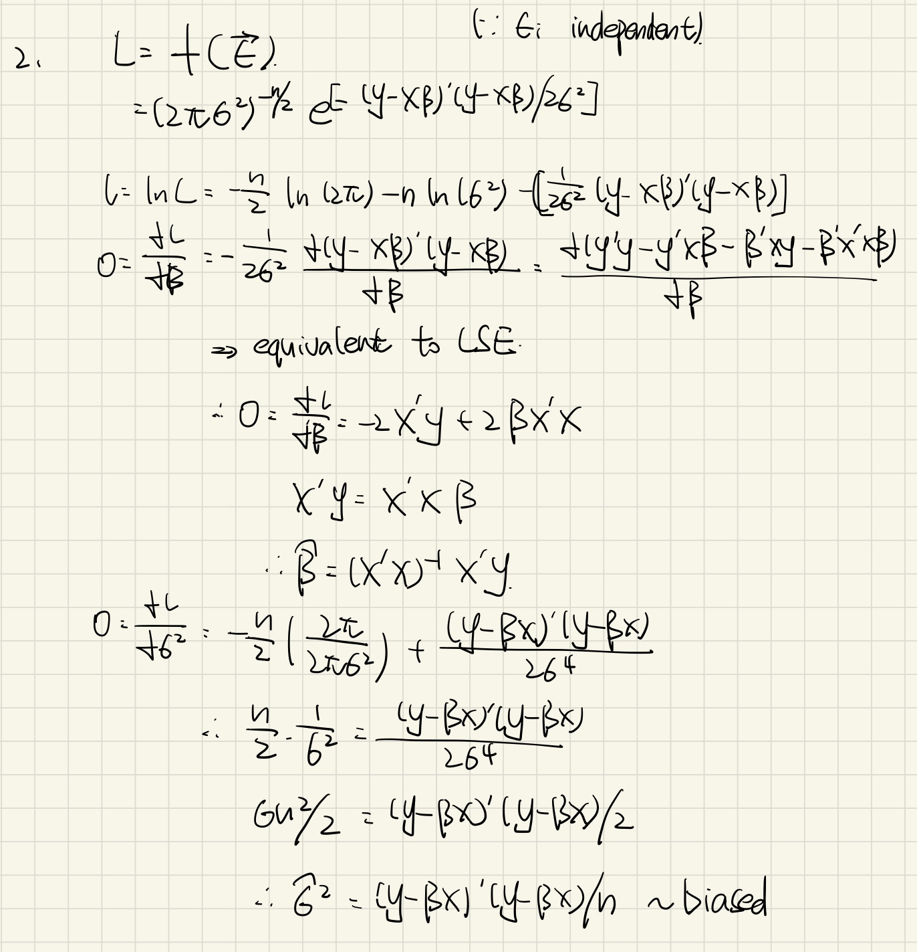

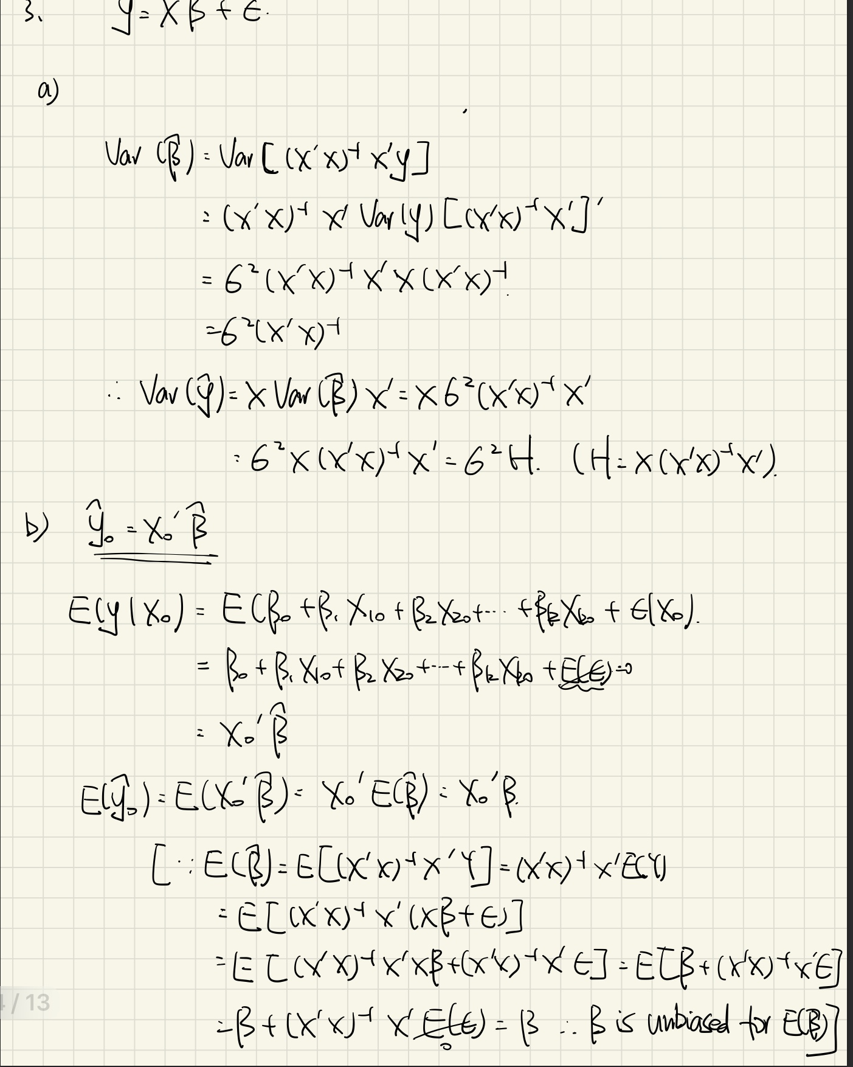

Q4a

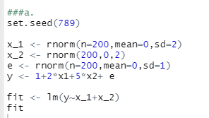

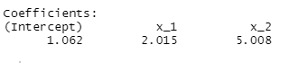

The estimated line is y=1.062+2.015x1+5.008x2+error.

Q4b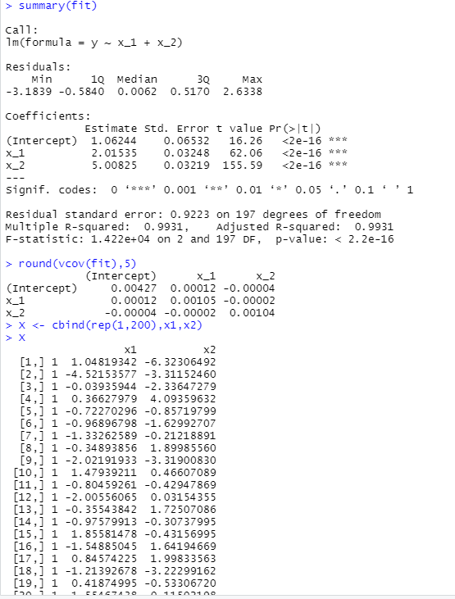

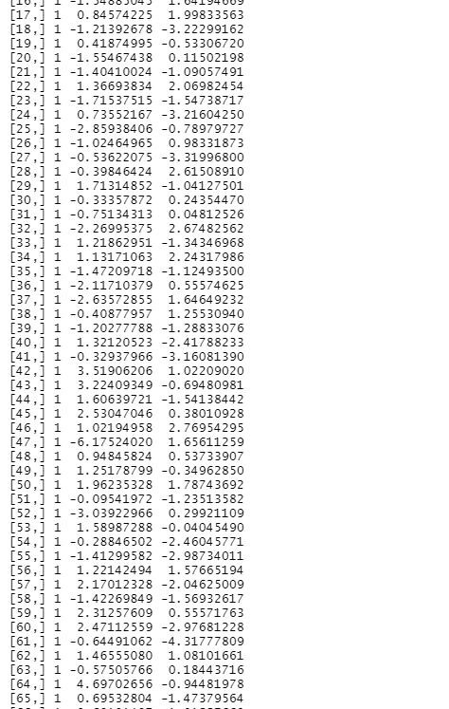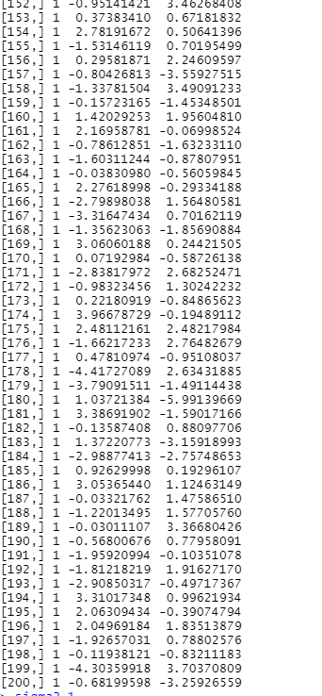

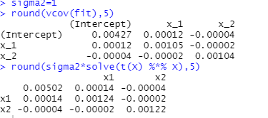

The variance for three regression coefficients is similar to the theoretical values of the variance of the predictors.

Q4c

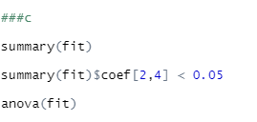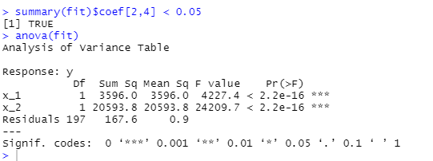

As the F values of both x1 and x2 are smaller than the critical value, we can conclude that we can reject H0 at significance level of 0.05.

Q4d

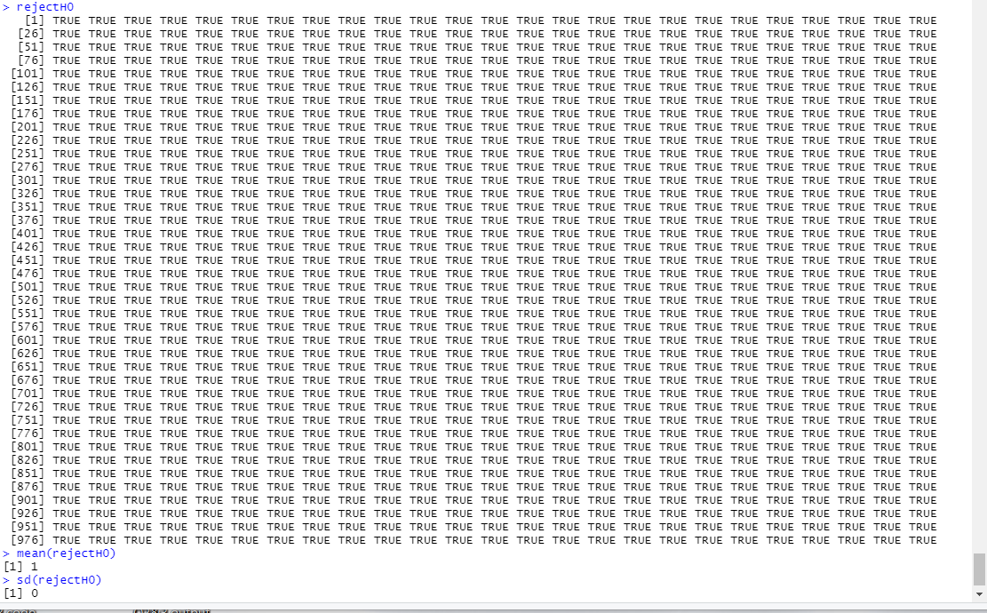

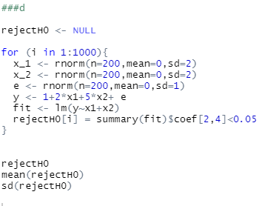

As all the outputs are TRUE, we can 100% reject H0.

Besides, the mean of times reject H0 is o and the variance is 0, which also means all the results return TRUE.