stat350

Assignment3

Yuhan Zhang

301345627

Q1 +Q2 a

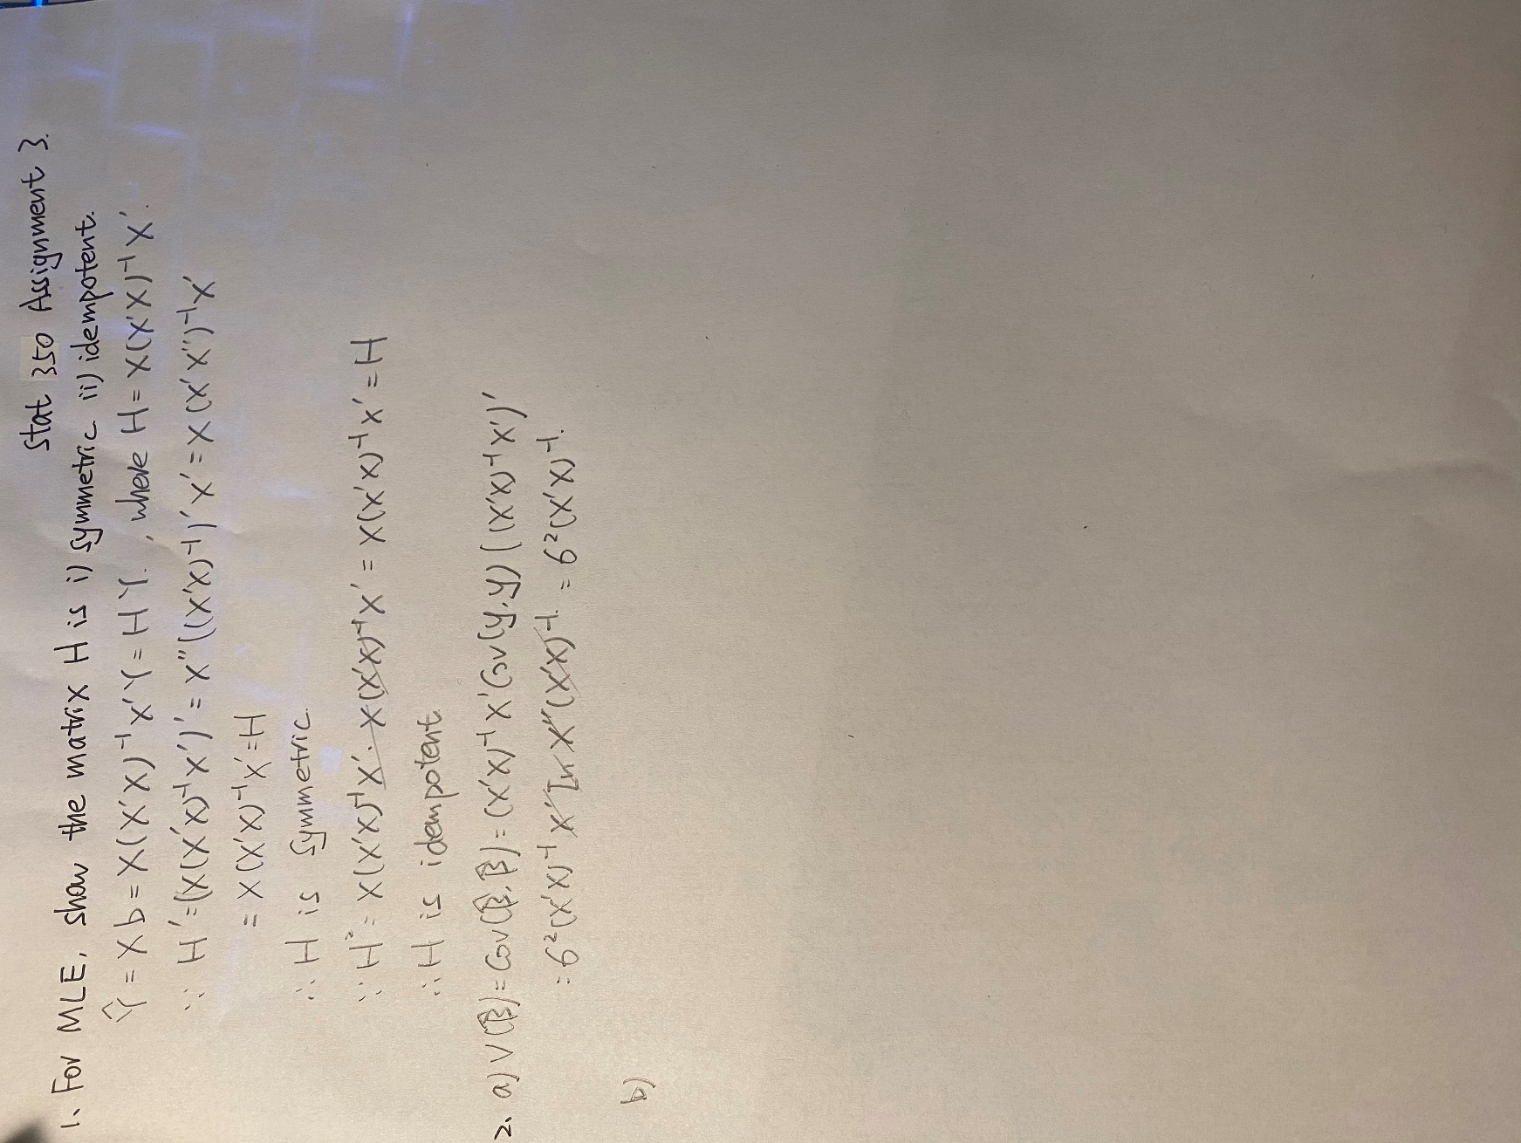

Q2 b

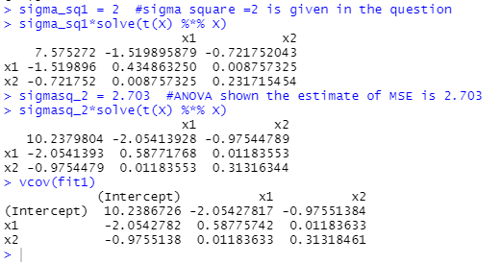

The estimate is the first graph when using sigma=2, which is given in the question.

(The estimate is the second graph when using sigma=2.703, which is the MSE shown by the ANOVA table. The estimate is the third graph when just calculating vcov using the data.)

Q2 c

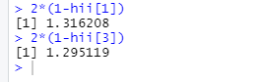

The variance is 1.3162 and 1.2951.

Q2 d



The covariance is -0.4239.

Q3 a

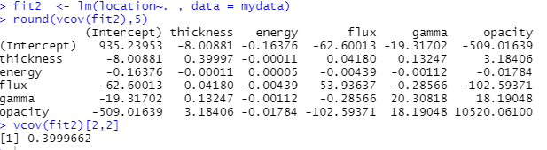

The estimated variance is 0.39997.

Q3 b



The estimated variance is 3.18406.

Q3 c

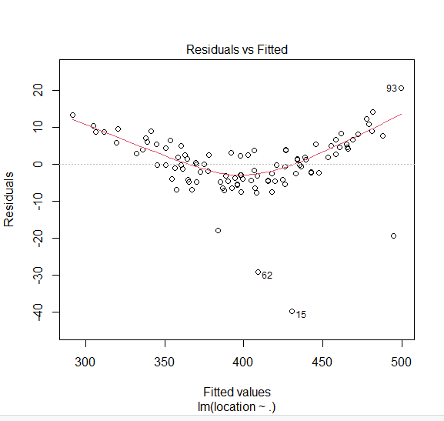

Plot (fit2, which=1)

1. The distribution has constant variance.
2. The distribution is non-linear in this graph.
3. There are some extreme outliers.

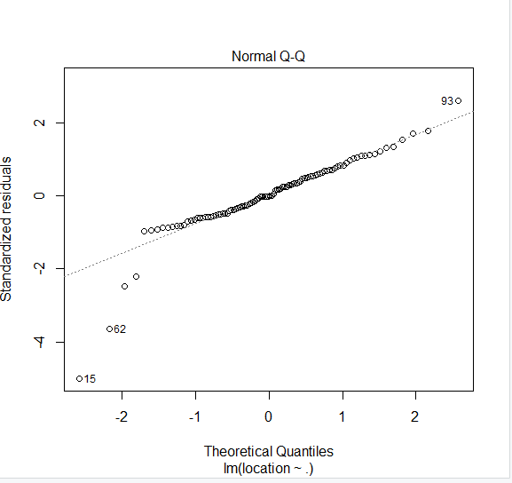

Plot (fit2, which=2)

1. The distribution is normal in general but obviously there are some extreme outliers

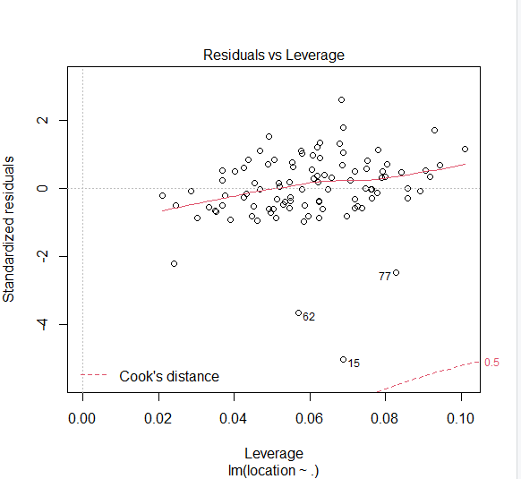

plot(fit2 ,which=5)

v) no influential observation cooks distance is small smaller than 0.5

iii) no leverage points

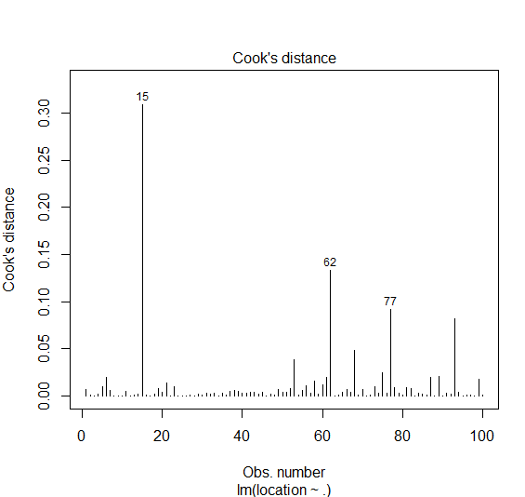

plot(fit2,which=4)

v) As the cook’s distance are all smaller than 0.5. The cook’s distance is small, so there is no influential observations

vi)

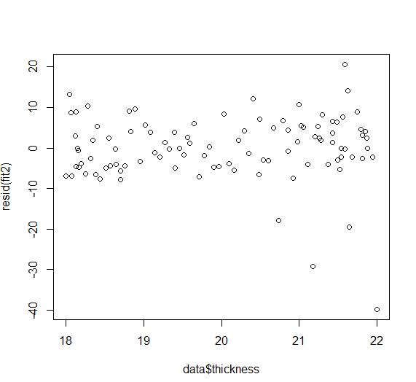

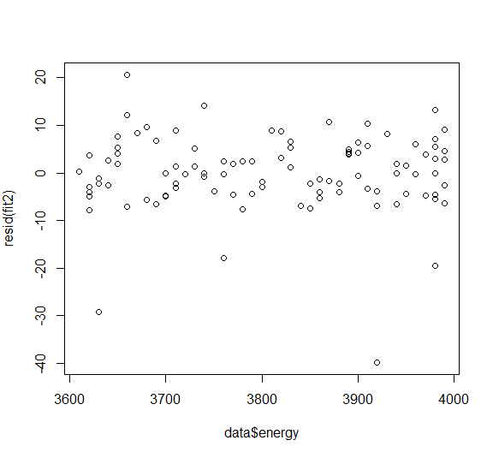  
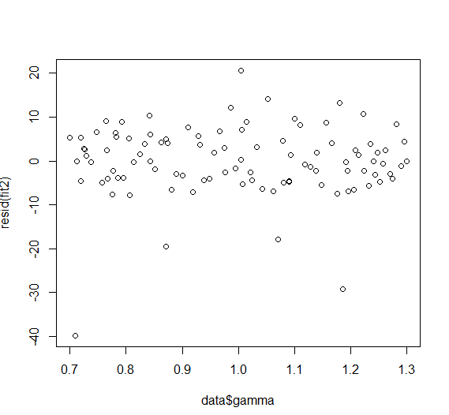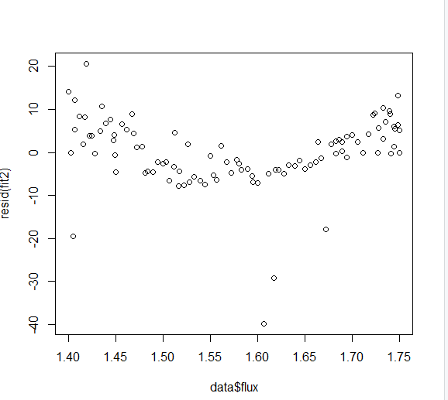

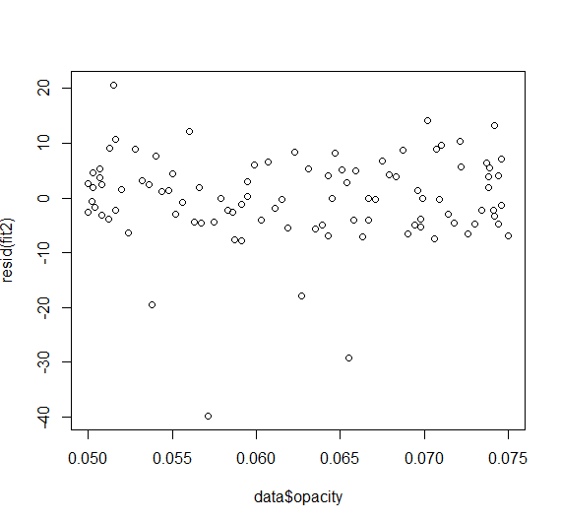

The relationship between predictors and variables are linear expect for **flux.** Therefore, some transformation is needed for flux.